A DFT study to develop a SiO2 mesoporous surface model

Ciellie Jansen van Vuuren

6/12/2017

Table of Contents

Introduction 1

Experimental work 2017 1

# Introduction

Grubbs catalysts for alkene metathesis have a vast range of advantages, but the fact that these catalysts are homogeneous makes extraction of the catalyst from the post-reaction mixtures very difficult. Because of cost implications, the re-use of the catalyst became very important [1].[**???**]

A heterogeneous catalyst can be a solution to the above-mentioned issue. In general, the activity and selectivity of heterogeneous catalysts are lower than homogeneous catalysts, but the advantage of separation, recovery and recycling outweigh these shortcomings.

According to literature mesoporous support materials, are ideal heterogeneous support materials [2,3]. In this study, we decided to focus on the SBA-15 and MCM-41 mesoporous support material.

The first step in modelling a SBA-15 or MCM-41 mesoporous surface is to create an amorphous SiO2 bulk using an alpha-quartz (space group 180). The 3X3X3 supercell was submitted to dynamics studies using Materials Studio’s CASTEP module and VASP 5.3 [4,5]. This was done and I will discuss the procedure that I followed to accomplish this.

To do surface calculations it became very difficult, using the amorphous SiO2 bulk. We decide to use a crystalline 3X3X3 SiO2 bulk, using VASP 5.3. An Ab Initio Molecular Dynamics study will be done on all surfaces using VASP 5.3. A comparison between the amorphous and crystalline surfaces will be discussed

# Experimental work 2017

1. Amorphous SiO2 Bulk

Method:

A 3x3x3 alpha-quartz, spacegroup 180, super-cell was built in the Materials Studio software package.

1. The annealing process of the alpha-quartz to obtain an amorphous solid was simulated using the CASTEP dynamic study module of the Materials Studio software package.
2. The bulk was heated to 4000, 5000 and 6000K in 50, 100 and 150 steps of 1fs each. After the heating step, the bulk was quenched to 1K in two 1fs steps.
3. Each resulting structure was again heated to 1000K in the same number of steps as in the first heating step and finally cooled down to 300K in the same number of steps.

The resulting structures (Figure 2) was each submitted to a DFT calculation to determine various indicating properties. The calculated and measured properties included:

* Energy
* Bond Angles
* Density of states
* Band Gap

##### Pagebreak

Results

|  |  |  |  |  |  |
| --- | --- | --- | --- | --- | --- |
| Step | Alpha Quartz | Melting | Quenching | Anealing | Cooling |
| Alpha Quartz | -79498.14 | -79498.14 | -79498.14 | -79498.14 | -79498.14 |
| 4000-50 | -79498.14 | -79483.27 | -79485.84 | -79631.61 | -79621.08 |
| 4000-100 | -79498.14 | -79490.75 | -79493.00 | -79629.45 | -79645.69 |
| 4000-150 | -79498.14 | -79525.15 | -79527.94 | -79624.82 | -79643.56 |
| 5000-50 | -79498.14 | -79420.75 | -79423.86 | -79611.74 | -79641.62 |
| 5000-100 | -79498.14 | -79439.78 | -79443.08 | -79614.09 | -79633.93 |
| 5000-150 | -79498.14 | -79464.65 | -79468.34 | -79617.96 | -79640.78 |
| 6000-50 | -79498.14 | -79395.97 | -79399.11 | -79590.41 | -79571.38 |
| 6000-100 | -79498.14 | -79408.26 | -79411.66 | -79612.83 | -79614.95 |
| 6000-150 | -79498.14 | -79370.25 | -79374.17 | -79576.86 | -79530.00 |

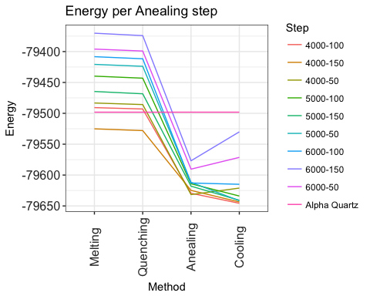

Energy diviation during the melt and quenching steps

|  |  |  |  |  |
| --- | --- | --- | --- | --- |
| Step | Melting | Quenching | Anealing | Cooling |
| 4000-50 | 14.868330 | 12.303313 | -133.47306 | -122.94020 |
| 4000-100 | 7.389067 | 5.143338 | -131.30382 | -147.54388 |
| 4000-150 | -27.006410 | -29.795691 | -126.67915 | -145.41787 |
| 5000-50 | 77.389310 | 74.280163 | -113.59576 | -143.47558 |
| 5000-100 | 58.360560 | 55.060881 | -115.94542 | -135.78931 |
| 5000-150 | 33.496077 | 29.797096 | -119.82338 | -142.63743 |
| 6000-50 | 102.169790 | 99.032252 | -92.27010 | -73.23567 |
| 6000-100 | 89.882010 | 86.476856 | -114.69271 | -116.81287 |
| 6000-150 | 127.892450 | 123.973285 | -78.72192 | -31.85867 |

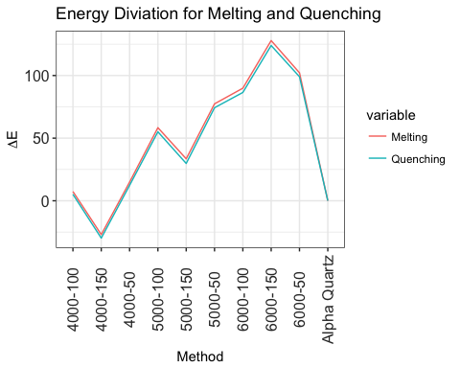

Bond Angle diviation

|  |  |  |  |  |
| --- | --- | --- | --- | --- |
| Step | Melting | Quenching | Annealing | Cooling |
| 4000-50 | 6.324 | 0.053 | 5.534 | 4.696 |
| 4000-100 | 19.665 | 0.088 | 17.712 | 8.709 |
| 4000-150 | 12.045 | 0.046 | 13.939 | 17.091 |
| 5000-50 | 19.225 | 0.021 | 29.387 | 7.732 |
| 5000-100 | 19.18 | 0.036 | 25.298 | 1.605 |
| 5000-150 | 30.07 | 0.069 | 20.726 | 20.795 |
| 6000-50 | 26.742 | 0.096 | 33.25 | 33.25 |
| 6000-100 | 35.009 | 0.071 | 11.684 | 5.086 |
| 6000-150 | 11.029 | 0.083 | 26.813 | 1.654 |

Experimental data

|  |  |  |  |
| --- | --- | --- | --- |
|  | Info | $Δθ$ deg | $Δ$ E |
| 1 | Experimental | 10.8 | 0.28 |
| 2 | Structural parameters of the unrelaxed amorphous silica | 17.7 | 0.19 |

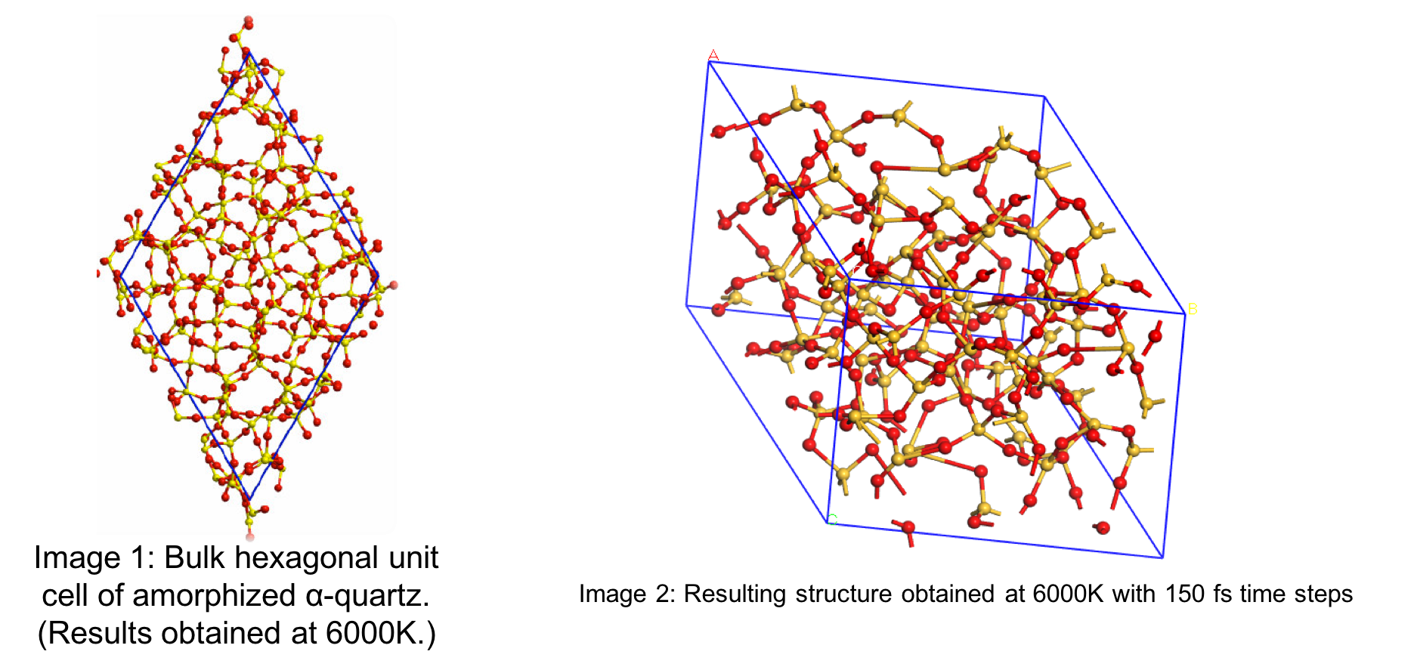

Figure 1: Literature vs Experimental structional results

The experimental and literature structure images corolate as seen in (Figure 1)[1]

2. K-point energy convergence

3. Determine surface energies

* This tutorials show the basic principals for calculating surface characteristics

1. Izumi S, Hara S, Kumagai T *et al.* Classification of amorphous-silicon microstructures by structural parameters: Molecular dynamics study. *Computational Materials Science* 2004;**31**:258–68.