This is the front page!!!!



Curabitur efficitur fringilla sapien in aliquet. Ut hendrerit volutpat luctus. Aenean semper mauris id quam scelerisque luctus. In sollicitudin risus libero, in ornare felis imperdiet ut. Nunc aliquet felis eros, sed hendrerit sem egestas vitae.

This should all still be on the front page

**Some other kind of header**

This should also be on front page

# Heading 1 ectended description longer than normal and maybe try and get it on 2 rows

Lorem ipsum dolor sit amet, consectetur adipiscing elit. Suspendisse id eros suscipit, convallis est sed, malesuada massa. Proin neque tellus, auctor sit amet tincidunt sed, molestie ut velit. Curabitur fermentum, tellus eu consectetur imperdiet, purus tellus egestas erat, quis eleifend nisl nisl vel leo. Sed dolor felis, rhoncus ac quam et, volutpat aliquam tellus. Ut auctor, leo cursus condimentum ultricies, justo ipsum consectetur est, varius ornare dui dolor non nibh. Nunc posuere, lacus sed laoreet venenatis, velit justo pellentesque tortor, vitae vehicula dolor nisi non nisl. Maecenas iaculis dictum neque, non sodales leo hendrerit vitae. Integer maximus tempor molestie. Ut dui tellus, mollis imperdiet lacus a, laoreet finibus dui. Nulla vitae neque non ipsum consectetur gravida id vel risus. Vestibulum vitae urna id dui ultrices faucibus. Fusce bibendum auctor sagittis. Fusce in tincidunt purus. Maecenas a ultricies arcu.

## Heading 2

Curabitur efficitur fringilla sapien in aliquet. Ut hendrerit volutpat luctus. Aenean semper mauris id quam scelerisque luctus. In sollicitudin risus libero, in ornare felis imperdiet ut. Nunc aliquet felis eros, sed hendrerit sem egestas vitae. Vestibulum arcu ipsum, aliquam ut consectetur id, malesuada non odio. Vestibulum sagittis mauris ipsum, vel venenatis ligula tempor pharetra. Mauris fringilla massa a consectetur feugiat. Quisque ornare, velit a iaculis commodo, sem velit aliquam ligula, in consectetur ante risus vel arcu. Aliquam blandit ipsum non eleifend placerat. Donec ullamcorper purus nisi, sit amet finibus mauris maximus a. Nulla facilisi.



# Heading 1B

Curabitur efficitur fringilla sapien in aliquet. Ut hendrerit volutpat luctus. Aenean semper mauris id quam scelerisque luctus. In sollicitudin risus libero, in ornare felis imperdiet ut. Nunc aliquet felis eros, sed hendrerit sem egestas vitae. Vestibulum arcu ipsum, aliquam ut consectetur id, malesuada non odio. Vestibulum sagittis mauris ipsum, vel venenatis ligula tempor pharetra. Mauris fringilla massa a consectetur feugiat. Quisque ornare, velit a iaculis commodo, sem velit aliquam ligula, in consectetur ante risus vel arcu. Aliquam blandit ipsum non eleifend placerat. Donec ullamcorper purus nisi, sit amet finibus mauris maximus a. Nulla facilisi.

### Heading 3

quam scelerisque luctus. In sollicitudin risus libero, in ornare felis imperdiet ut. Nunc aliquet felis eros, sed hendrerit sem egestas vitae. Vestibulum arcu ipsum, aliquam ut consectetur id, malesuada non odio. Vestibulum sagittis mauris ipsum, vel venenatis ligula tempor pharetra. Mauris fringilla massa a consectetur feugiat. Quisque ornare, velit a iaculis commodo, sem velit aliquam ligula, in consectetur ante risus vel arcu. Aliquam blandit ipsum non eleifend placerat. Donec ullamcorper purus nisi, sit amet finibus mauris maximus a. Nulla facilisi.

### Heading 3B

Its all good now. eros, sed hendrerit sem egestas vitae. Vestibulum arcu ipsum, aliquam ut consectetur id, malesuada non odio. Vestibulum sagittis mauris ipsum, vel venenatis ligula tempor pharetra. Mauris fringilla massa a consectetur feugiat. Quisque

### Heading 3C

When you link at the sky. Vestibulum arcu ipsum, aliquam ut consectetur id, malesuada non odio. Vestibulum sagittis mauris ipsum, vel venenatis ligula tempor pharetra. Mauris fringilla massa a consectetur feugiat. Quisque

## Heading 2b

This is going to be a sibling

Content will continue until we encounter another subpage.

### Heading 3 D

Silly stupid content

Lhkgskagkajsdgfagds hjfgsdhkjf gsf \dsf vsd

F sd

V

Sxcvz

Xc

V

S

Sd

Vzx

dv

# Heading 1 c, the hobbit goes forth on an adventure!

Designer and drafter Matt Rifenburg didn’t let anything stand in the way of becoming a skilled user of Autodesk Inventor and AutoCAD — not his early departure from high school, not his lack of a college education, not even a battle to overcome a brain tumor. And now, at the age of 52, he is pursuing his first degree.

Cadalyst: How did you become interested in engineering?

Matt Rifenburg: I had always been interested in how things work. I started working in a gas station at age 12, and quickly fell in love with cars. I eventually took a job as a painter to support my car habit, then got into building maintenance.

In 2000, I began working for BioSpectra, a small biotech company in Pennsylvania, as a maintenance technician. When the company brought all of its maintenance tasks in-house to save money — including electrical work and plumbing — I had to figure out how to keep the plant running, despite never having worked in any type of manufacturing environment before.

Over time I was able to design, build, and refurbish a variety of pharmaceutical processes and machines, including fluid bed dryers, screw conveyors, heating and cooling systems, and centrifuges. We used CAD to communicate and document ideas as we grew. Much of the equipment I created is still in use today.

One project I worked on was designing and building a continuous process to purify urea. I collaborated on the process design and layout with almost everyone at the company, sourced equipment, and designed a stainless steel and high-density polyethylene (HDPE) screw conveyor, plus two HDPE and structural fiberglass fluid bed dryers for drying the purified crystalline urea.

Material is fed continuously into the screw conveyor, moved into a tank where it is heated, then pumped through a set of filters to another tank to cool and crystallize. The resulting slurry is fed to a continuous centrifuge, where crystal and liquid are separated. The liquid is returned to the hot tank, and the crystal is dropped into a 20’ long dryer where it is dried, then a 10' dryer to be cooled before packaging.

Balancing the material flow through the process was a significant challenge since we previously had only batch-type processes, and we had no experience with continuous processes. The urea process can run continuously with minimal operator contact, reducing the risk of product contamination.

Two of the fluid bed dryers that Rifenburg designed for the purification process, which was the first FDA-registered, cGMP-compliant continuous process for urea ever built.

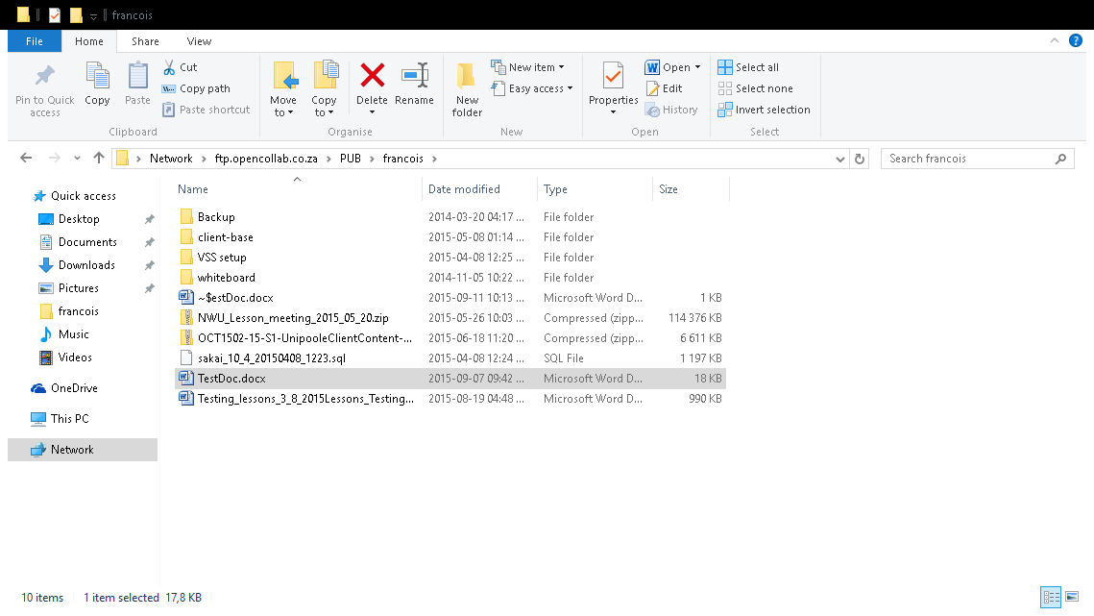

Process control panel for the continuous process that Rifenburg designed. Images courtesy of BioSpectra.

- See more at: <http://www.cadalyst.com/rifenburg#sthash.VvgulJ5F.dpuf>

## The Hobbit faught a Dragon

Lorem ipsum dolor sit amet, consectetur adipiscing elit. Suspendisse id eros suscipit, convallis est sed, malesuada massa. Proin neque tellus, auctor sit amet tincidunt sed, molestie ut velit. Curabitur fermentum, tellus eu consectetur imperdiet, purus tellus egestas erat, quis eleifend nisl nisl vel leo. Sed dolor felis, rhoncus ac quam et, volutpat aliquam tellus. Ut auctor, leo cursus condimentum ultricies, justo ipsum **consectetur est, varius ornare dui dolor non nibh. Nunc posuere, lacus sed laoreet venenatis, velit justo pellentesque tortor, vitae vehicula dolor nisi non nisl. Maecenas iaculis dictum neque, non sodales leo hendrerit vitae. Integer maximus tempor molestie. Ut dui tellus,** mollis imperdiet lacus a, laoreet finibus dui. Nulla vitae neque non ipsum consectetur gravida id vel risus. Vestibulum vitae urna id dui ultrices faucibus. Fusce bibendum auctor sagittis. Fusce in tincidunt purus. Maecenas a ultricies arcu.

|  |  |  |  |
| --- | --- | --- | --- |
| Heading 1 | Heading 2 | Heading 3 | Heading 4 |
| 1 | 2 |  | 4 |
| Lorem ipsum dolor sit amet, consectetur adipiscing elit. Suspendisse id eros suscipit, convallis est sed, malesuada massa. | C:\Program Files (x86)\Microsoft Office\MEDIA\CAGCAT10\j0157763.wmf | <http://beta.iol.co.za/> | 8888888888888888 |
| 89769786986789 | Safdf | C:\Program Files (x86)\Microsoft Office\MEDIA\CAGCAT10\j0199549.wmf |  |

# Required for vitory

Curabitur fermentum, tellus eu consectetur imperdiet, purus tellus egestas erat, quis eleifend nisl nisl vel leo. Sed dolor felis, rhoncus ac quam et, volutpat aliquam tellus. Ut auctor, leo cursus condimentum ultricies, justo ipsum **consectetur est, varius ornare dui dolor non nibh. Nunc posuere, lacus sed laoreet venenatis, velit justo pellentesque tortor, vitae vehicula dolor nisi non nisl. Maecenas iaculis dictum neque, non sodales leo hendrerit vitae. Integer maximus tempor molestie. Ut dui tellus,** mollis imperdiet lacus a, laoreet finibus dui. Nulla vitae neque non ipsum consectetur gravida id vel risus. Vestibulum vitae urna id dui ultrices faucibus. Fusce bibendum auctor sagittis. Fusce in tincidunt purus. Maecenas a ultricies arcu.

## And he Said. Play the best song in the world!

Curabitur fermentum, tellus eu consectetur imperdiet, purus tellus egestas erat, quis eleifend nisl nisl vel leo. Sed dolor felis, rhoncus ac quam et, volutpat aliquam tellus. Ut auctor, leo cursus condimentum ultricies, justo ipsum **consectetur est, varius ornare dui dolor non nibh. Nunc posuere, lacus sed laoreet venenatis, velit justo pellentesque tortor, vitae vehicula dolor nisi non nisl. Maecenas iaculis dictum neque, non sodales leo hendrerit vitae. Integer maximus tempor molestie. Ut dui tellus,** mollis imperdiet lacus a, laoreet finibus dui. Nulla vitae neque non ipsum consectetur gravida id vel risus. Vestibulum vitae urna id dui ultrices faucibus. Fusce bibendum auctor sagittis. Fusce in tincidunt purus. Maecenas a ultricies arcu.

C:\Program Files (x86)\Microsoft Office\MEDIA\CAGCAT10\j0240695.wmf

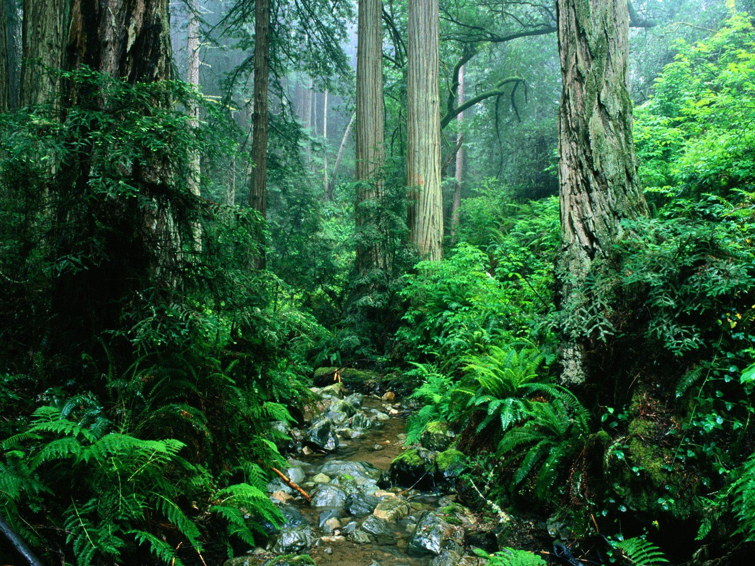

≥©©≥€☺Ωβµ×∞π