Merge

Ciellie Jansen van Vuuren

3/2/2018

Table of Contents

# Introduction

Grubbs catalysts for alkene metathesis have a vast range of advantages, but the fact that these catalysts are homogeneous makes extraction of the catalyst from the post-reaction mixtures very difficult. Because of cost implications, the re-use of the catalyst became very important (Jordaan, 2007).

A heterogeneous catalyst can be a solution to the above-mentioned issue. In general, the activity and selectivity of heterogeneous catalysts are lower than homogeneous catalysts, but the advantage of separation, recovery and recycling outweigh these shortcomings.

According to literature mesoporous support materials, are ideal heterogeneous support materials (Thielemann *et al.*, 2011),(Balcar & Čejka, 2013). In this study, we decided to focus on the SBA-15 and MCM-41 mesoporous support material.

The first step in modelling a SBA-15 or MCM-41 mesoporous surface is to create an amorphous SiO2 bulk using an alpha-quartz (space group 180). (Balcar & Čejka, 2013) The 3X3X3 super cell was submitted to dynamics studies using Materials Studio’s CASTEP module and VASP 5.3 (Izumi *et al.*, 2004),(Ugliengo *et al.*, 2008). This was done and I will discuss the procedure that I followed to accomplish this.

# Experimental work 2017

## 1. Amorphous SiO2 Bulk

### 1. Method:

A 3x3x3 alpha-quartz, space group 180, super-cell was built in the Materials Studio software package.

1. The annealing process of the alpha-quartz to obtain an amorphous solid was simulated using the CASTEP dynamic study module of the Materials Studio software package.
2. The bulk was heated to 4000, 5000 and 6000K in 50, 100 and 150 steps of 1fs each. After the heating step, the bulk was quenched to 1K in two 1fs steps.
3. Each resulting structure was again heated to 1000K in the same number of steps as in the first heating step and finally cooled down to 300K in the same number of steps.

The resulting structures (Figure 2) was each submitted to a DFT calculation to determine various indicating properties. The calculated and measured properties included:

* Energy
* Bond Angles
* Density of states (Izumi *et al.*, 2004)

### 2. Results:

According to (Group, 2014) if Alpha Quartz are melted and cooled down very quickly it will preserve the structure obtained during the melting phase, it is also seened in (Table 1) and in the results that will follow. We will focus only on the results obtained during the melting and quenching steps and compare these results to experimental data.

##### .

#### Energy diviation

|  |  |  |  |  |
| --- | --- | --- | --- | --- |
| Step | Melting | Quenching | Anealing | Cooling |
| B-4000-50 | 14.868330 | 12.303313 | -133.47306 | -122.94020 |
| C-4000-100 | 7.389067 | 5.143338 | -131.30382 | -147.54388 |
| D-4000-150 | -27.006410 | -29.795691 | -126.67915 | -145.41787 |
| E-5000-50 | 77.389310 | 74.280163 | -113.59576 | -143.47558 |
| F-5000-100 | 58.360560 | 55.060881 | -115.94542 | -135.78931 |
| G-5000-150 | 33.496077 | 29.797096 | -119.82338 | -142.63743 |
| H-6000-50 | 102.169790 | 99.032252 | -92.27010 | -73.23567 |
| I-6000-100 | 89.882010 | 86.476856 | -114.69271 | -116.81287 |
| J-6000-150 | 127.892450 | 123.973285 | -78.72192 | -31.85867 |

Table 1: Energy diviation.

#### Energy diviation during the melt and quenching steps

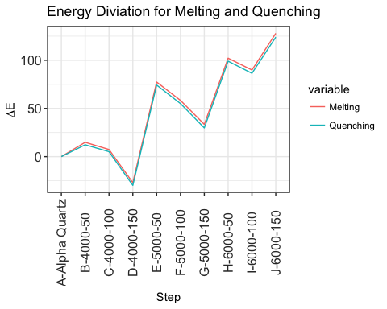

Figure 1: Energy per experemental step

##### .

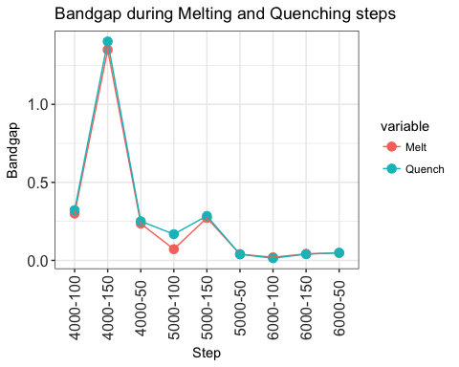

Figure 2: Bandgap during Melting and Quenching steps

As we expected (Figure 2) conclude that the band gap decreases as the temperature and reaction time increase. Therefore as the alpha-quartz become amorphous, there is also an increase in reactivity as seen in (Figure 1).

#### Bond Angle diviation

|  |  |  |  |  |  |
| --- | --- | --- | --- | --- | --- |
|  | Step | Melting | Quenching | Annealing | Cooling |
| 1 | 4000-50 | 6.324 | 6.271 | 0.737 | 5.433 |
| 2 | 4000-100 | 19.665 | 19.577 | 1.865 | 10.574 |
| 3 | 4000-150 | 12.045 | 11.999 | 1.940 | 15.151 |
| 4 | 5000-50 | 19.225 | 19.246 | 10.141 | 2.409 |
| 5 | 5000-100 | 19.180 | 19.144 | 6.154 | 4.549 |
| 6 | 5000-150 | 30.070 | 30.001 | 9.275 | 30.070 |
| 7 | 6000-50 | 26.742 | 26.646 | 6.604 | 26.646 |
| 8 | 6000-100 | 35.009 | 34.938 | 23.254 | 18.168 |
| 9 | 6000-150 | 11.029 | 10.946 | 15.867 | 15.867 |

Table 2: Bond angle diviation

##### .

### 3. Experimental data

|  |  |  |  |
| --- | --- | --- | --- |
|  | Info | deg | E |
| 1 | Experimental | 10.8 | 0.28 |
| 2 | Structural parameters of the unrelaxed amorphous silica | 17.7 | 0.19 |

Table 3: Literature results obtained at 4000K

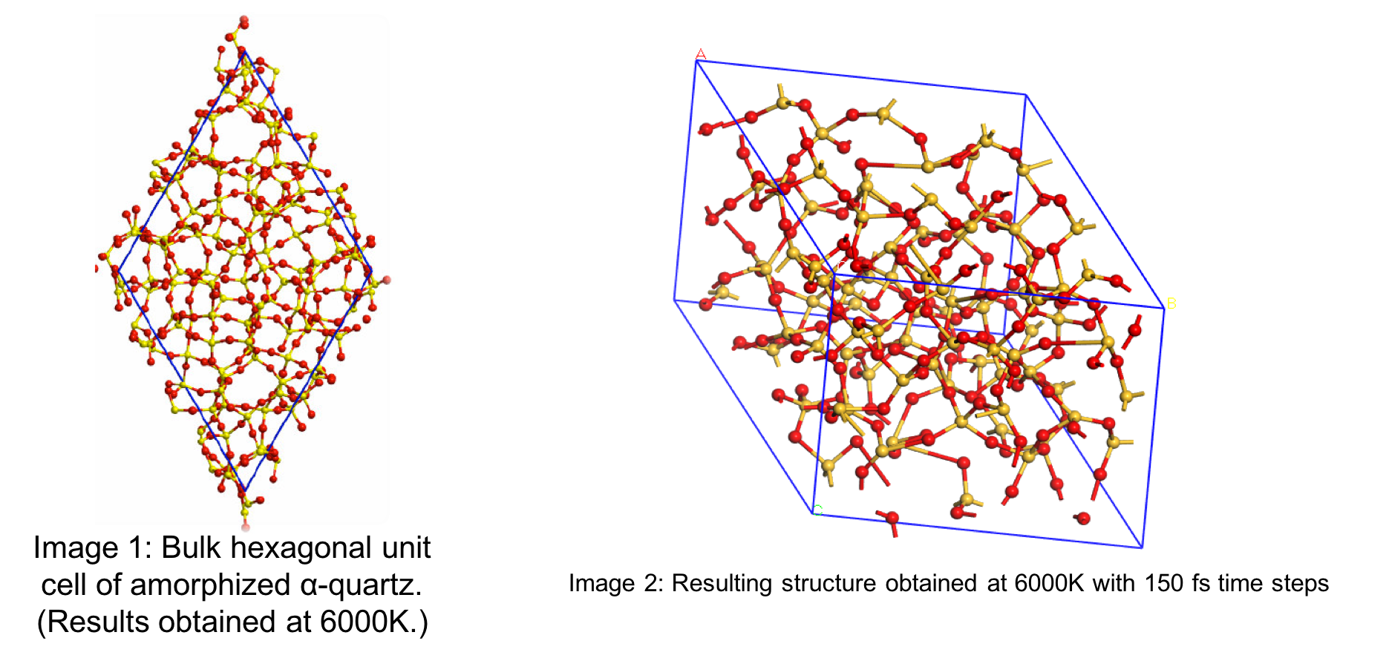

Figure 3: Literature vs Experimental structional results(Izumi *et al.*, 2004)

### 4. Conclusion

* The bond angle deviation shown in (Table 2) can be related to experimental data obtained as seen in (Table 3).
* At 4000K the Ε correlate with the experimental values obtained in (Table 3).

##### .

## 2. Modeling SiO2 surface

To do surface calculations it became very difficult, using the amorphous SiO2 bulk. We decide to use a crystalline 3X3X3 SiO2 bulk, using VASP 5.3. An Ab Initio Molecular Dynamics study will be done on all surfaces using VASP 5.3.

### K-point convergence for bulk SiO2 (Alpha Quartz)

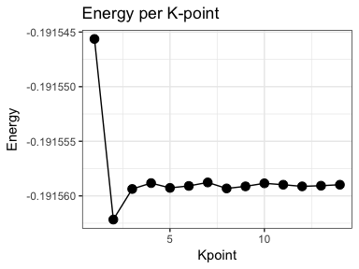

### SiO2 surface characterristics

The following surface characteristics will be determined

1. Cutting planes: I will focus on the planes (100,110,200) as indicated in the XRD results see (Figure 5)

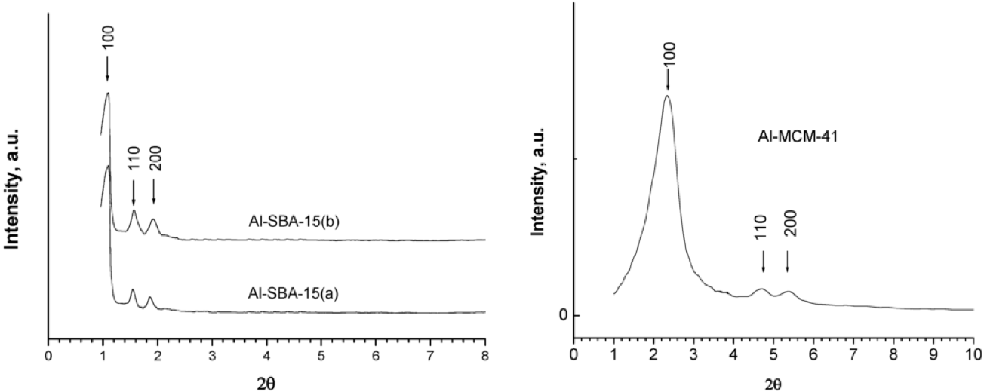

Figure 5: XRD Data

* For each plane the following characteristics will be determined
  + Slab Thickness
  + Vacuum Gap size
  + Surface thickness (The number of unrelaxed surface layers)

1. Create a amorphous surface layer from the ideal surface determined from characteristics obtained above.
2. Compare the amorphous surface reactivate with the crystalline surface

##### .

## References

##### 

##### 

# Abstract

Three -Quartz ,spacegroup 180, surfaces were modelled using crystallographic data from pearson…. obtained in the Medea package database. Surface planes with miller indexes 100, 110 and 200 were cut from the bulk structure. The different surfaces were compared to identify the ideal MCM-41 surface to be used as a catalyst support.

# Introduction

The utilisation of homogeneos catalysts in industry are limited, due to the fact that it is expensive to extract the catalyst from post-reaction mixtures (Balcar & Čejka, 2013), (Kotzé, 2015). Research especialy in the pharmaseutlical and petrochemistry industries took an intrest in the imobilisation or heteroganasion of a homgeneous catalyst as a posible solution to the mentiond problem.

Although the activity and selectivity of heterogeneous catalytic reactions are lower than homogeneous reactions, the advantage of separation, recovery and recycling outweigh these shortcomings. It is however important to ensure that the effectiveness of the immobilized homogeneous catalyst is not dramatically compromised (Kotzé, 2015), (Gryp *et al.*, 2010). Therefore the main objective in the successful immobilization of homogeneous catalyst systems is to combine the high activity and selectivity properties of homogeneous catalysts with the ease of recovery of a heterogeneous catalyst. To accomplish this the selection of an appropriate support material is very important (Kotzé, 2015).

Support materials can be divided into three categories e.g. insoluble organic, polymeric or inorganic supports. Immobilization by using insoluble organic supports involves ultrafiltration techniques as seen in the separation of the PUK-Grubbs 2 catalyst by using organic solvent nanofiltration (Gryp *et al.*, 2010). Van der Gryp et al. (Gryp *et al.*, 2010) performed this separation using organic membranes and discovered that the catalyst can be successfully separated, but its lifetime was dramatically decreased during the filtration process (Gryp *et al.*, 2010), (Kotzé, 2015). Polymer supports on the other hand provide easier filtration techniques, multiple coordination sites and the possibility to incorporate a molecular catalyst into the polymer structure. These are great advantages, but during the filtration process the thermal stability remains low (Kotzé, 2015). Inorganic supports have a high thermal stability, it provides for multiple coordination sites because it contains a large surface area (BET), big pores and narrow pore size distributions. Therefore inorganic supports are more effective in the immobilization of homogeneous catalysts systems than organic or polymeric support surfaces.(Balcar & Čejka, 2013)

There are three types of inorganic supports available, which is categorized by their pore sizes and physical compositions:

1. Inorganic microporous support materials have pore sizes < 2nm, e.g. Zeolites, Metal-Organic Frameworks (MOFs);
2. Inorganic mesoporous support materials have pore sizes in the range of 2-15 nm, e.g. MCM-41, SBA-15 and Aerogels; and
3. Inorganic macroporous support materials have pore sizes greater than 50 nm, e.g. glasses. (Balcar & Čejka, 2013), (Kotzé, 2015)

Although microporous and macroporious support materials have the ability to be used as heterogeneous support, it doesn’t have an industrial appeal yet (Balcar & Čejka, 2013),(Kotzé, 2015). Therefore the focus is on mesoporous support materials. Since the successful synthesis of mesoporous materials by Mobil in 1992, the research field in using and synthesizing mesoporious materials as support materials for heterogeneous catalytic reactions has grown significantly. The original synthesis of mesoporous support material was defined as the M41S family containing hexagonal MCM-41, cubic MCM-48 and lamellar MCM-50 structures. A more visual representation of the different structures can be seen in Figure 1

Figure 1: Different structures of the M41S family (Linares *et al.*, 2014)

Unfortunately M41S materials have a limitation in pore diameter, approximately 80 Å, which affects the separation of large molecules (Katiyar *et al.*, 2006). Zhao et al. (Zhao *et al.*, 1998) extended the family of inorganic mesoporous support materials by synthesizing Santa Barbara Amorphous (SBA) type materials, with a pore diameter ranging between 20 to 300 Å.

## Surface characterization

The surface of mesoporous support materials are amporphious and contain accessible hydroxyl groups. This makes immobilization of homogeneous complexes on the silica surface possible (Kotzé, 2015). The crusial factor for immobilization of a catalyst on the silica surface is the concentration, distribution and accessibility of the silanol groups on the silica surface (Balcar & Čejka, 2013). Ramírez et al. (A. Ramı’rez & Sierra*, 2003) showed that the types of silanols present on the silica surface are single, hydrogen bonded or germinal silanol groups as shown in Figure 2.

Figure 2: Different silanol groups on the surface of a silica support: (a) single, (b) hydrogen bonded and (c) geminal silanol groups [A. Ramı’rez & Sierra* (2003)]

Coordination of the metal complexes to the support can either take place by binding of the metal ions directly or via organic molecule linkers to the silanols. Sels and co-workers (Van Berlo *et al.*, 2008) observed that a weak physical interaction between a neutral Hoveyda-Grubbs- II type complex and the inorganic support was enough to seperate the complex from the mixture and altered surfaces using linkers was not nessesary. Cabrera et al. (Cabrera *et al.*, 2012) and Schachner et al. (Schachner *et al.*, 2011) also found that ruthenium-based metathesis catalysts containing a hemilabile pyridine-alkoxide ligand adsorb extremely well onto an unmodified silica support without compromising too much on the homogeneous catalytic effectiveness.

# Experimental

# Results and discussion

A. Ramı’rez, B. L. Lopez & Sierra*, L. 2003. Study of the acidic sites and their modifications in mesoporous silica synthesized in acidic medium under quiescent conditions. *Journal of Physical Chemistry*. (107):5.

Balcar, H. & Čejka, J. 2013. Mesoporous molecular sieves as advanced supports for olefin metathesis catalysts. *Coordination Chemistry Reviews*. 257(21-22):3107–3124.

Cabrera, J., Padilla, R., Bru, M., Lindner, R., Kageyama, T., Wilckens, K., Balof, S.L., Schanz, H.J., Dehn, R., Teles, J.H., Deuerlein, S., Muller, K., Rominger, F., & Limbach, M. 2012. Linker-free, silica-bound olefin-metathesis catalysts: Applications in heterogeneous catalysis. *Chemistry*. 18(46):14717–24.

Group, T.S. 2014. Overview of silica polymorphs.

Gryp, P. van der, Barnard, A., Cronje, J.-P., Vlieger, D. de, Marx, S., & Vosloo, H.C.M. 2010. Separation of different metathesis grubbs-type catalysts using organic solvent nanofiltration. *Journal of Membrane Science*. 353(1-2):70–77.

Izumi, S., Hara, S., Kumagai, T., & Sakai, S. 2004. Classification of amorphous-silicon microstructures by structural parameters: Molecular dynamics study. *Computational Materials Science*. 31(3-4):258–268.

Jordaan, M. 2007. Experimental and theoretical investigation of new grubbs-mae catalysts for the metathesis of alkenes (Journal Article). North West University South Africa.

Katiyar, A., Yadav, S., Smirniotis, P.G., & Pinto, N.G. 2006. Synthesis of ordered large pore sba-15 spherical particles for adsorption of biomolecules. *J Chromatogr A*. 1122(1-2):13–20.

Kotzé, H. de V. 2015. Immobilized ru(II) catalysts for transfer hydrogenation and oxidative alkene cleavage reactions (Journal Article). Stellenbosh University South Africa.

Linares, N., Silvestre-Albero, A.M., Serrano, E., Silvestre-Albero, J., & Garcia-Martinez, J. 2014. Mesoporous materials for clean energy technologies. *Chem Soc Rev*. 43(22):7681–717.

Schachner, J.A., Cabrera, J., Padilla, R., Fischer, C., Schaaf, P.A. van der, Pretot, R., Rominger, F., & Limbach, M. 2011. A set of olefin metathesis catalysts with extraordinary stickiness to silica. *ACS Catalysis*. 1(8):872–876.

Thielemann, J.P., Girgsdies, F., Schlogl, R., & Hess, C. 2011. Pore structure and surface area of silica sba-15: Influence of washing and scale-up. *Beilstein J Nanotechnol*. 2:110–8.

Ugliengo, P., Sodupe, M., Musso, F., Bush, I.J., Orlando, R., & Dovesi, R. 2008. Realistic models of hydroxylated amorphous silica surfaces and mcm-41 mesoporous material simulated by large-scale periodic b3lyp calculations. *Advanced Materials*. 20(23):4579–4583.

Van Berlo, B., Houthoofd, K., Sels, B., & Jacobs, P. 2008. Silica immobilized second generation hoveyda-grubbs: A convenient, recyclable and storageable heterogeneous solid catalyst. *Advanced Synthesis & Catalysis*. 350(13):1949–1953.

Zhao, D., Feng, J., Huo, Q., Melosh, N., Fredrickson, G.H., Chmelka, B.F., & Stucky, G.D. 1998. Triblock copolymer syntheses of mesoporous silica with periodic 50 to 300 angstrom pores. *SCIENCE*. 279(548).