BillMe Restaurant Management System
C4 Model & Sequence Diagrams

C4 Model Architecture

Level 1: System Context
The Restaurant Management System serves as a central platform connecting multiple actors with distinct roles and responsibilities.
Context Diagram: Restaurant Management System
External Actors:
- Super Admin - Manages system configuration, entities, subscriptions
- Entity Owner - Manages business profile, branches, staff, menu
- Manager - Oversees daily operations, employees, orders
- Employee/Waiter - Creates and processes orders
- Kitchen Staff - Prepares orders
- Customer - Places and pays for orders
External Systems:
- Payment Gateway - Processes digital payments
- Email/SMS Service - Sends notifications
- Analytics Service - Tracks metrics and reports

Level 2: Container Diagram
The system is composed of the following main containers:
Container | Responsibilities
Web Application (Frontend)  React/Vue.js | - User interface for all actors  - Real-time order management  - Dashboard and reporting views
Mobile Application  React Native/Flutter | - Customer ordering interface  - Waiter order management  - Real-time notifications
API Gateway  REST/GraphQL | - Routes requests to services  - Authentication & authorization  - Rate limiting & throttling
Order Service  Java/Spring Boot | - Order creation & modification  - Order status management  - Kitchen workflow integration
Payment Service  Java/Spring Boot | - Process payments (cash & digital)  - Tip management  - Payment reconciliation
User & Auth Service  Java/Spring Boot | - User registration & management  - Role-based access control  - JWT token management
Notification Service  Node.js | - Real-time notifications (WebSocket)  - Email/SMS delivery  - Push notifications
Reporting Service  Python/Analytics | - Generate sales reports  - Business analytics  - Export functionality
Database  PostgreSQL | - Entity & user data  - Order & transaction records  - Audit logs
Message Queue  RabbitMQ/Kafka | - Asynchronous processing  - Event streaming  - Service decoupling

Level 3: Component Diagram
Key components within Order Service (sample):
Component | Responsibilities
Order Controller | HTTP request handling, API endpoint exposure
Order Service | Business logic for order creation, modification, status updates
Order Repository | Data persistence layer, database queries
Kitchen Integration | Communicate with kitchen through message queue
Notification Publisher | Publish order events to message queue

Sequence Diagrams by Use Case
The following table presents sequence diagrams for all critical use cases, showing the flow of interactions between actors and system components.

Super Admin & Entity Owner Use Cases

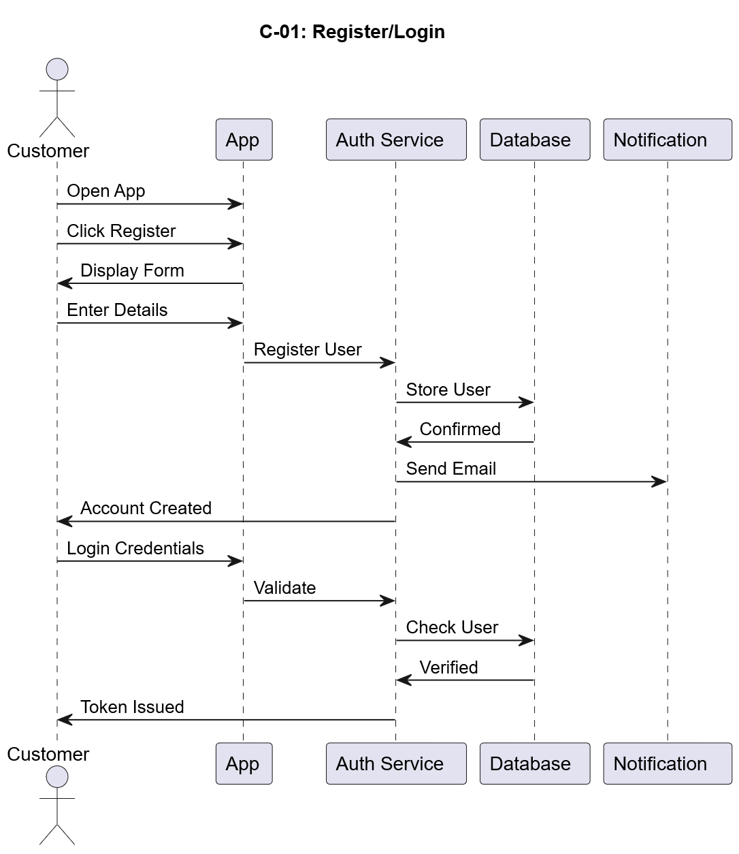
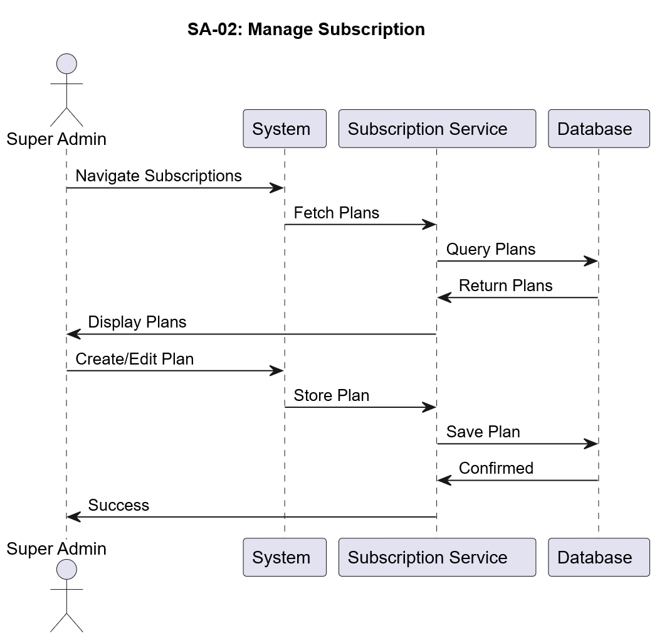

Manager & Employee Use Cases

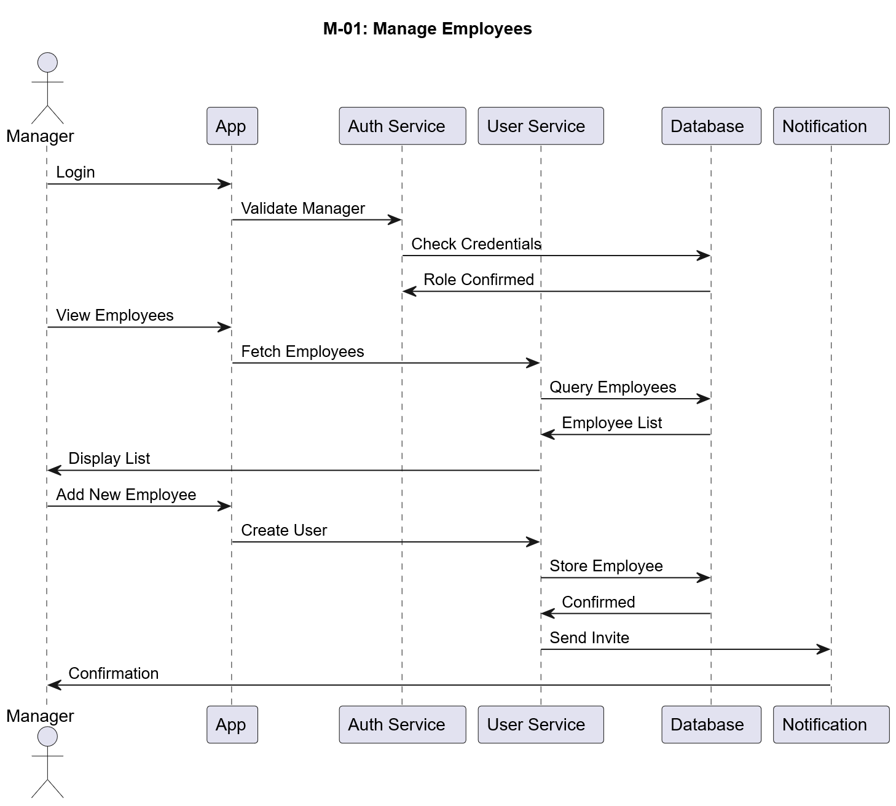
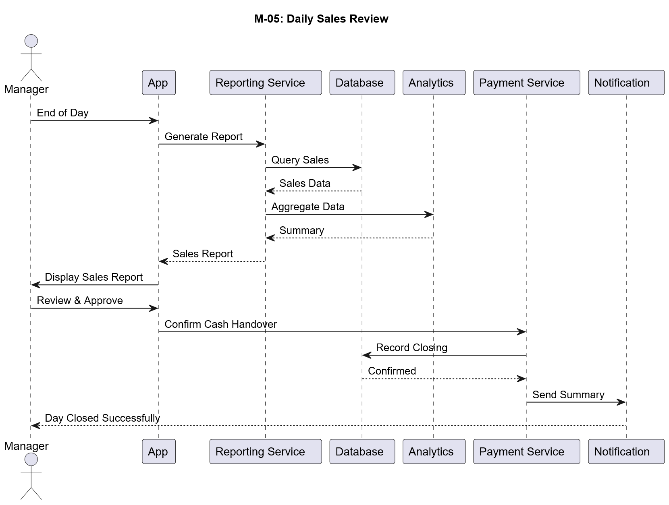

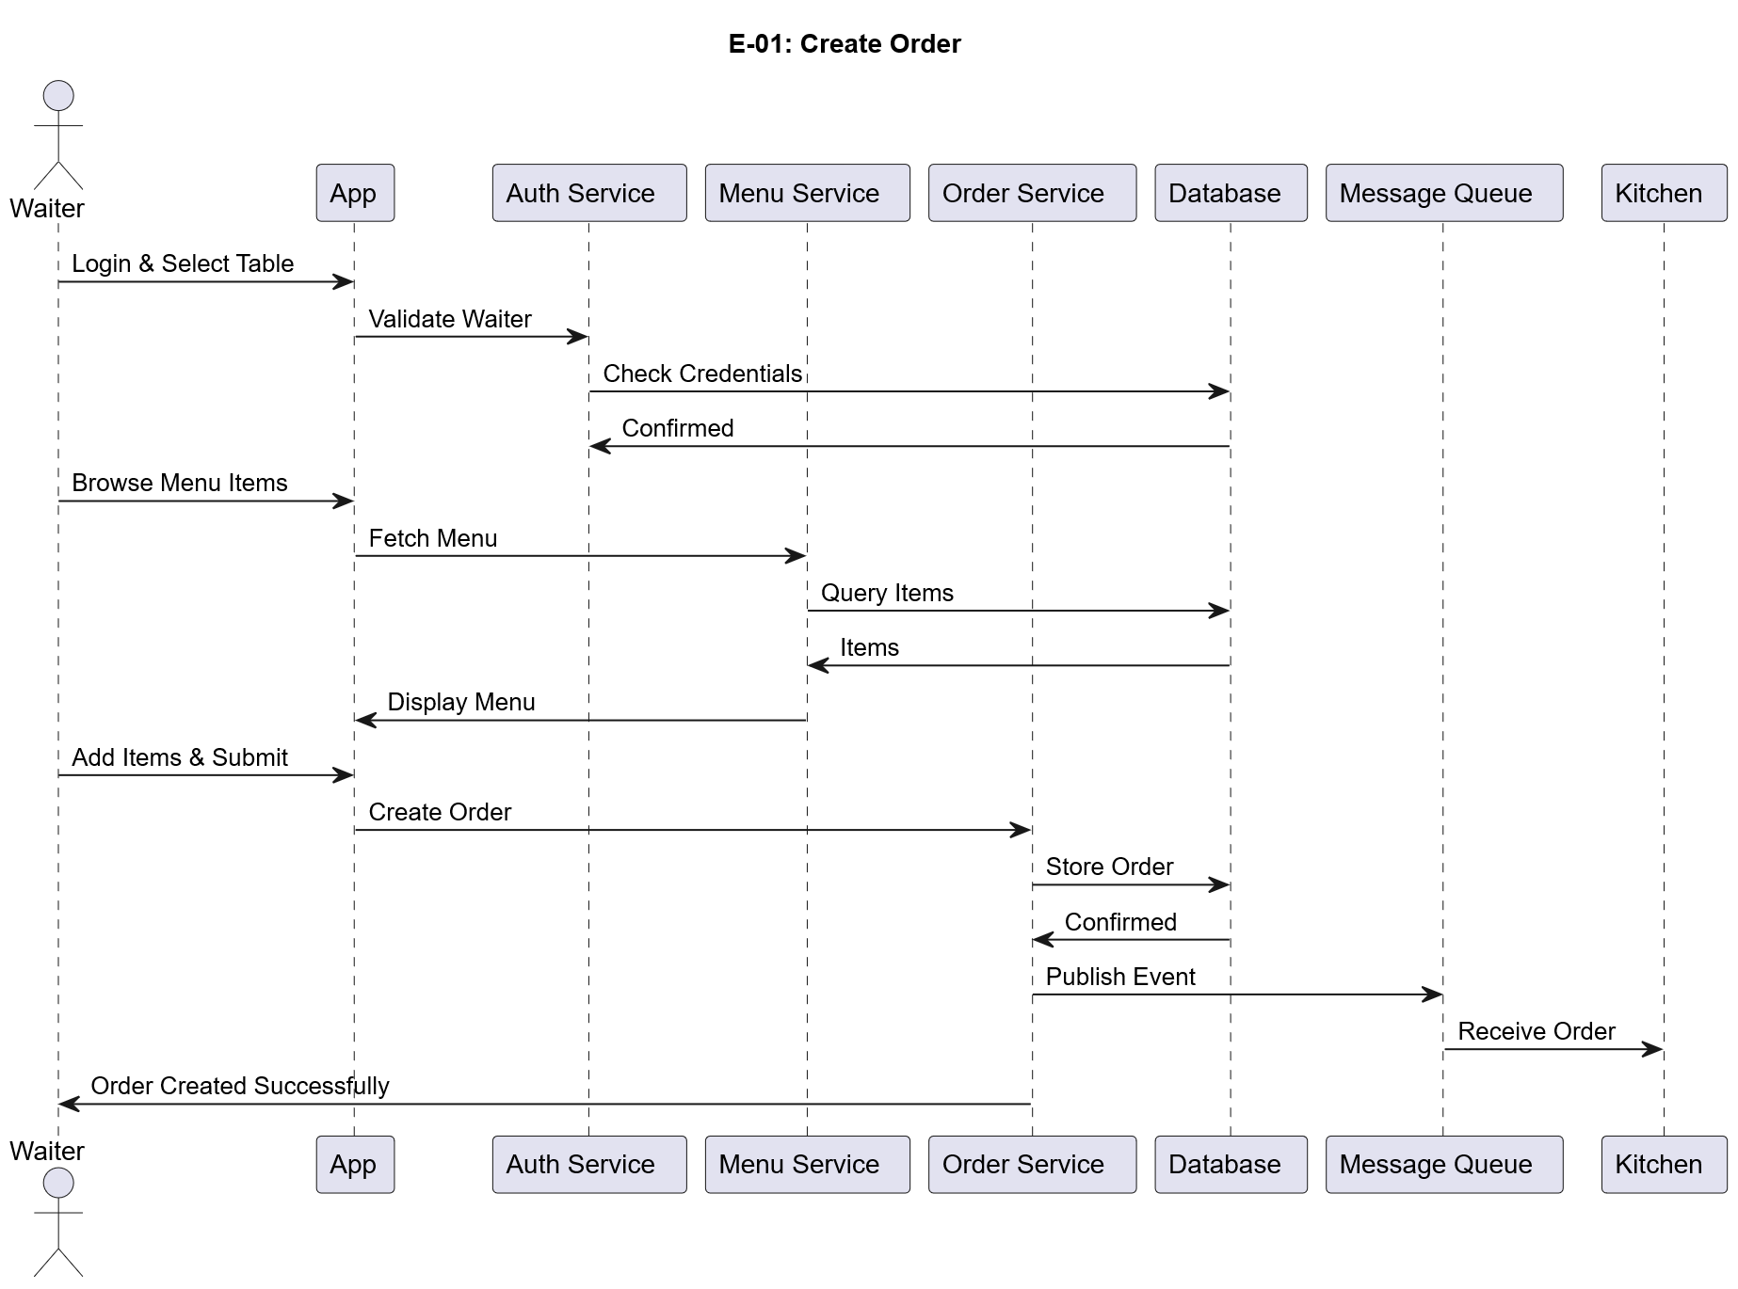
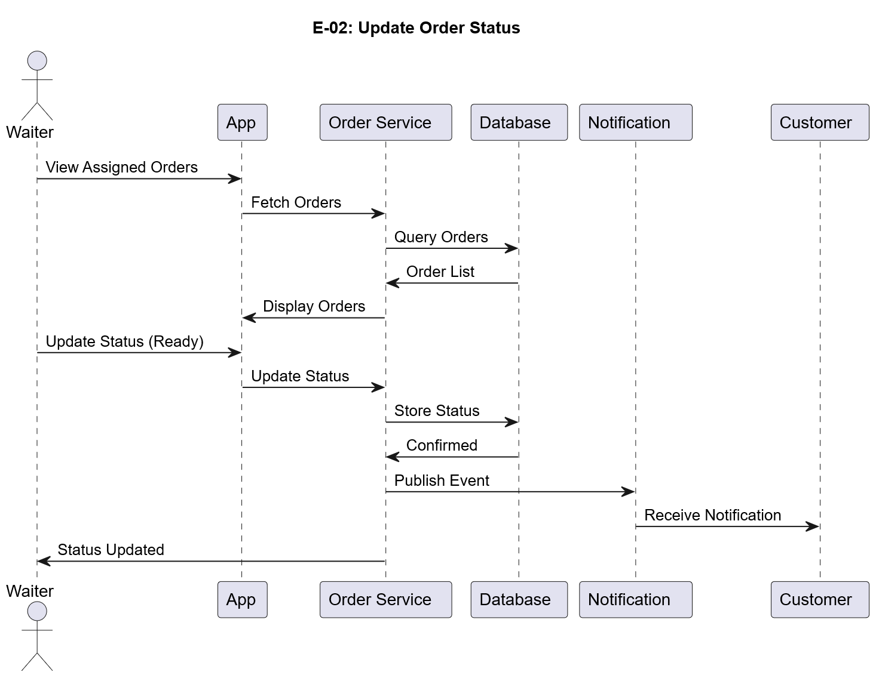

Customer & Payment Use Cases



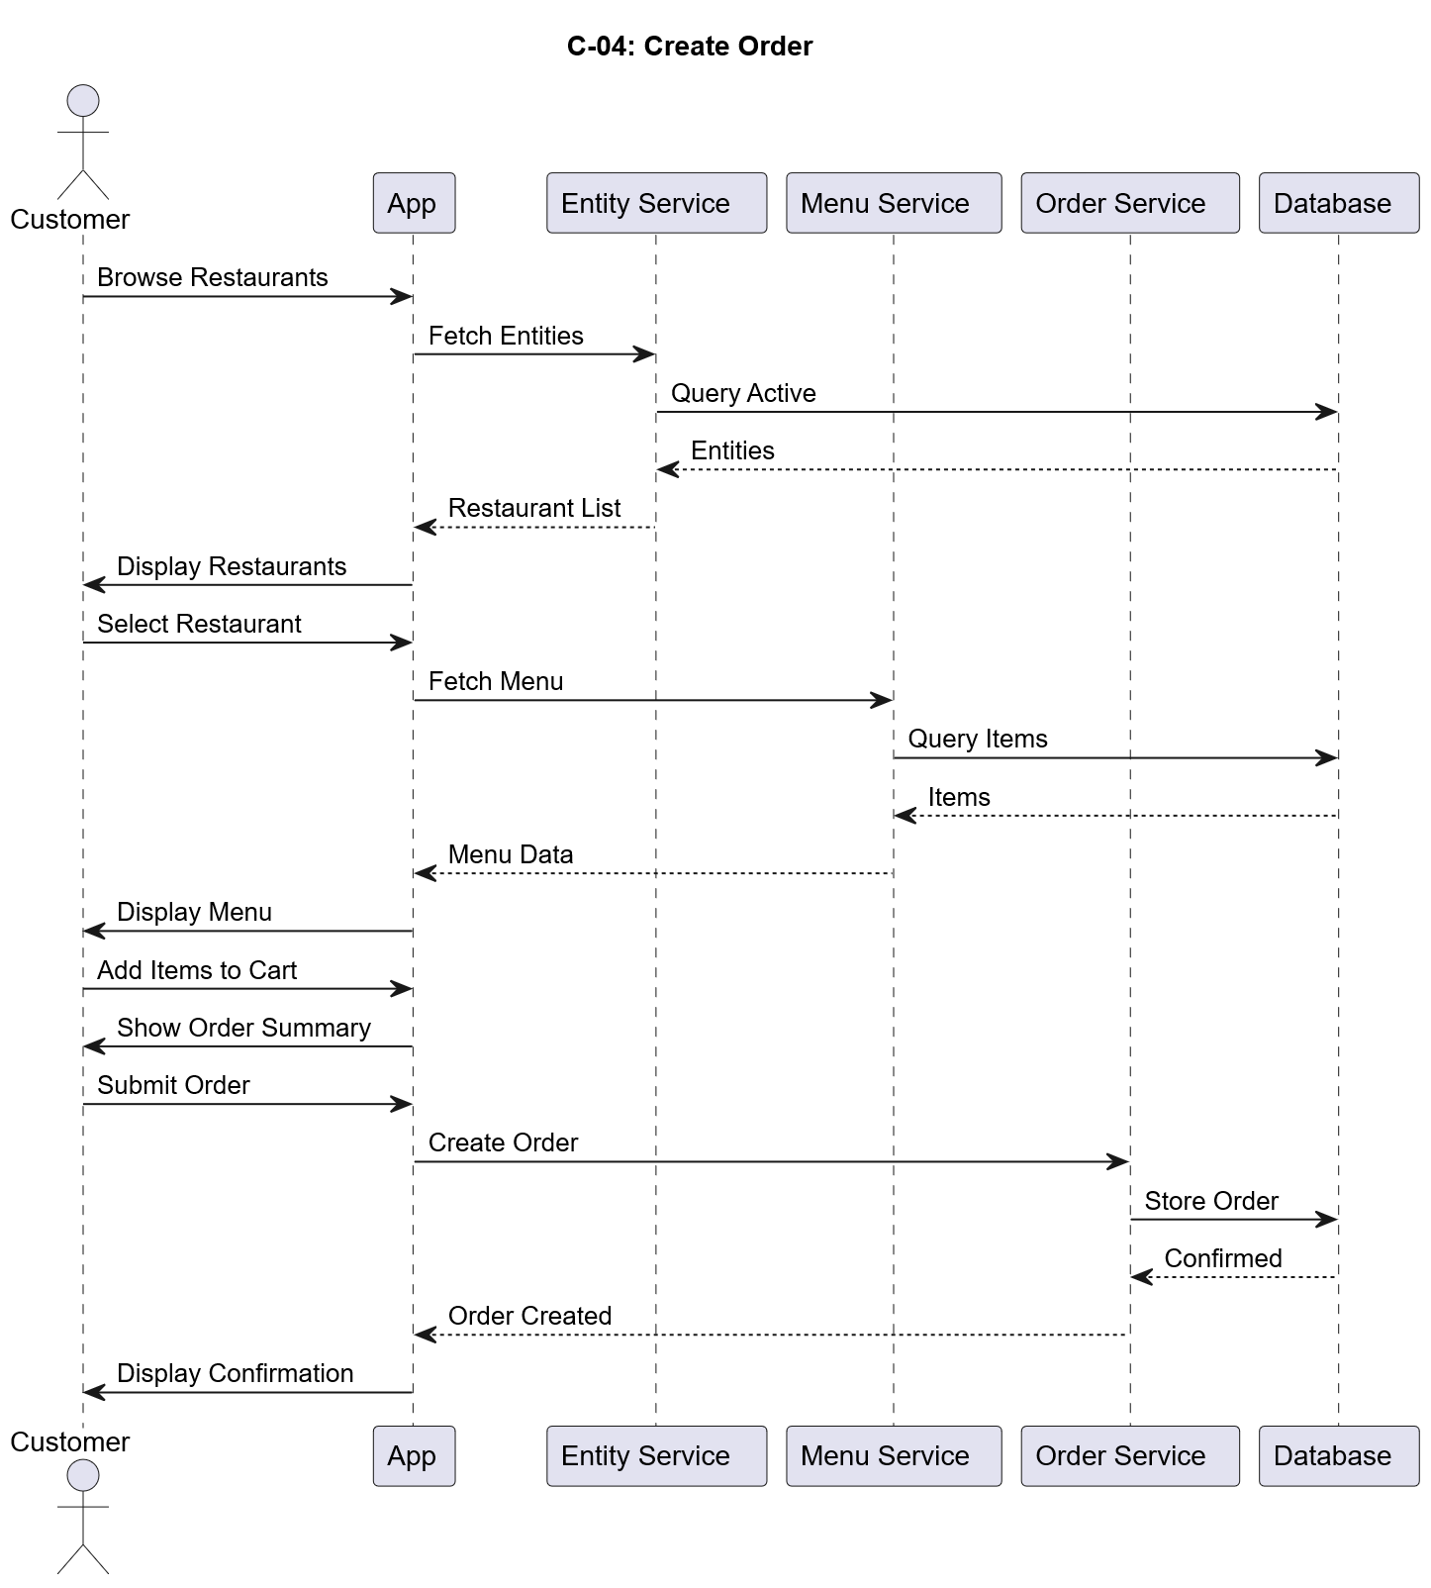
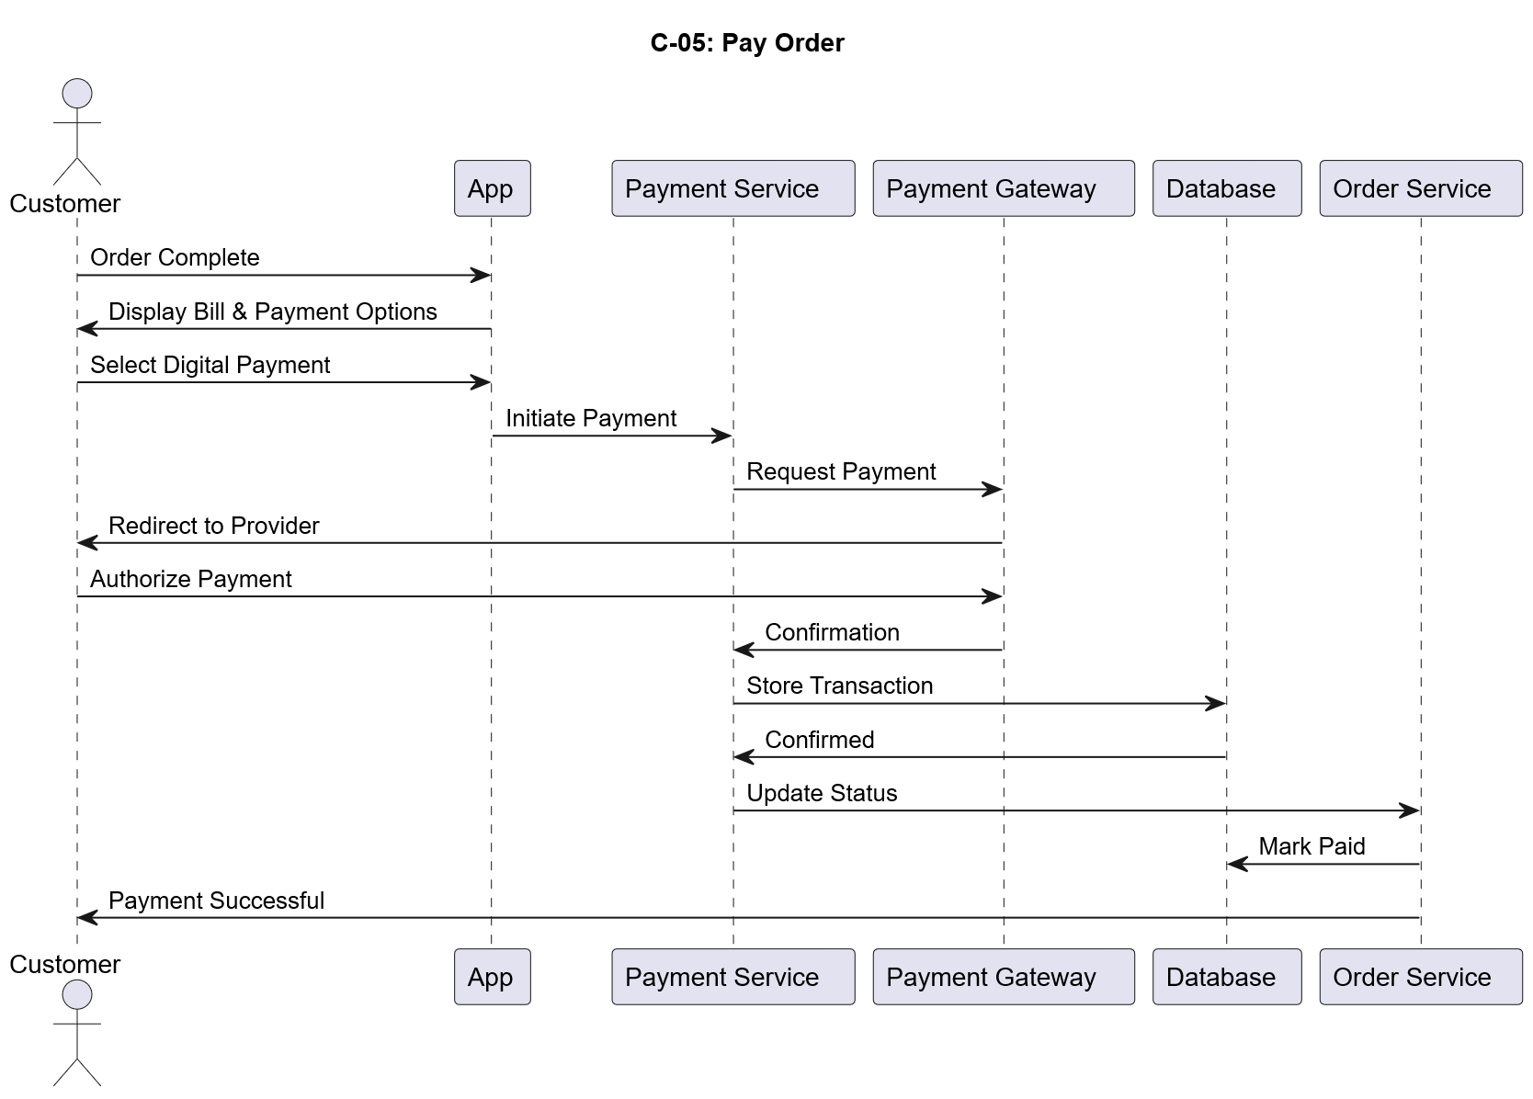
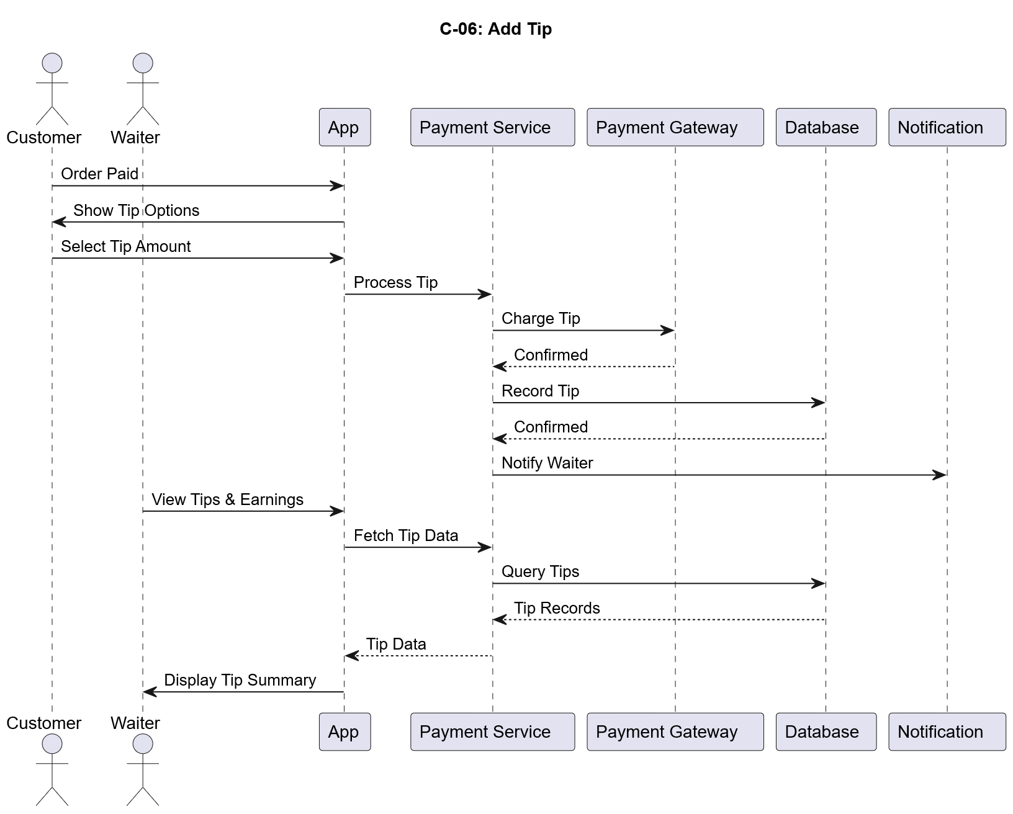

Kitchen & Advanced Use Cases

