Mini Project 4 - Data Visualization Write Up & Reflection

Wilson Tang & Jee Hyun Kim
Software Design Section 2

Project Overview
We took medical data:Inpatient Prospective Payment System (IPPS) Provider Summary for Top 100 Diagnosis-Related Group from a government site, data.CMS.gov and created an interactive map with various tools which display the data.

Result
We created a class called GMap that creates a google map plot of some version of the medical data file we got from the government site. The GMap will take in a title for the plot, data structure, and range for the axes. The create method will create the google maps plot with the providers as a point on the map.
The map has pan wheel zoom, box select, and hovering interactive tools. These tools allow the user to move around, zoom in, select only part of the data, and will display cost, total discharges and zip code of the specific provider when the mouse hover over the point.
We also attempted to add user-filtering in the stock_app_gmap.py file but we were unable to work with the way the applets and widgets works and convert our code.
Zoomed Out View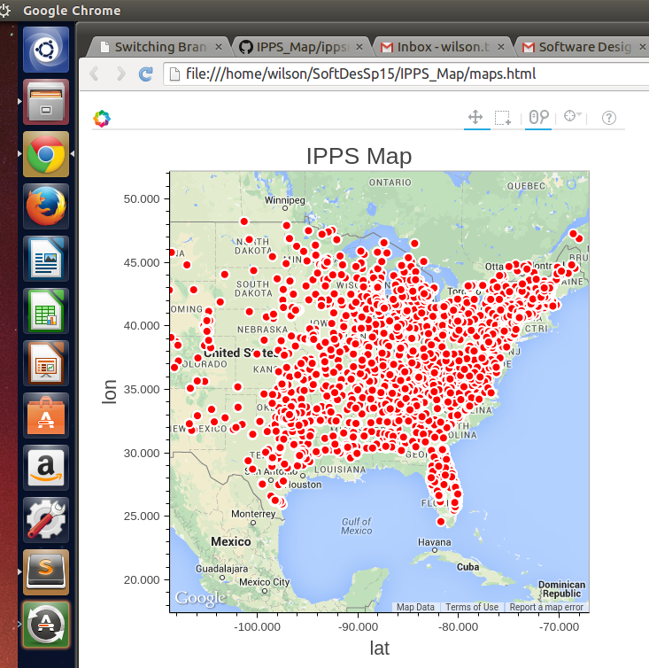

Example of Hovering Displaying Data at a Specific Location
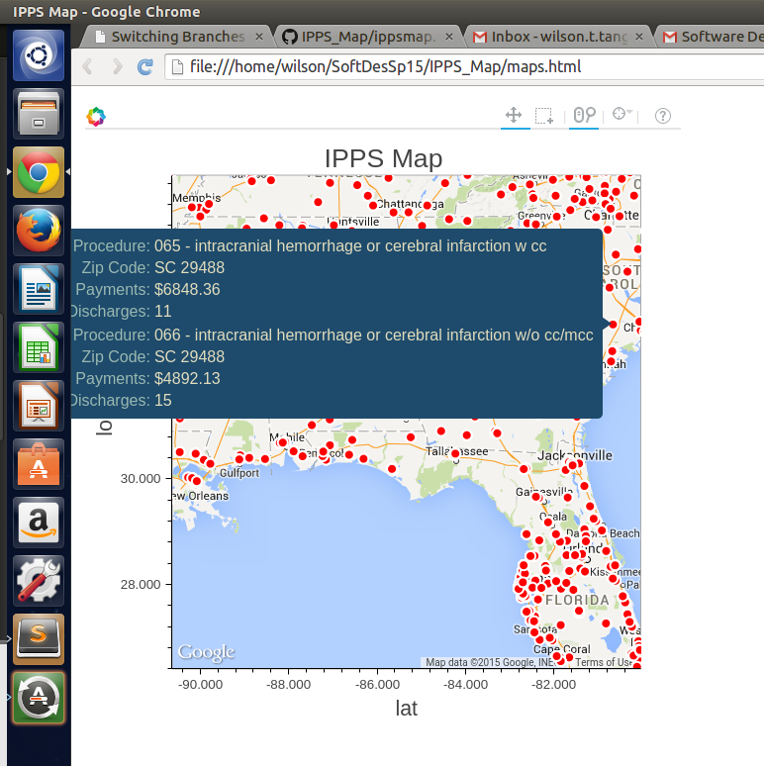

Implementation
System Architecture
We split the code into three sections: loading and formatting data, a GMap class, and creating a gmap plot using the class.

Formatting Data
We first had to run our csv data through code using gmap and address to generate and add Latitude and Longitude to the data.
We tried formatting data in many different ways - creating list of list, importing as panda.dataframe (for applet). For the final iteration of our code, we decided to create a dictionary with the header of the csv as the key and data aslist of the values in order. This made it convenient to call the data as we could do dictionary[‘specific header’] where the header could be latitude or longitude.

GMap Class
The class takes in title, data in a dictionary form, and the range for the axes. It has 4 main methods after initialization, set_tools and set_plot_options are called in make_plot which creates the plot object and stores it. The create method will creates the plot and stores it in a document within the class.

Creating GMap Plot
We create a GMap object with our desired parameters, saved it and opened the html file in a new browser window.

Design Decision
We choose to display the dots in red color with white border because the color is associated to hospitals. We resized the dots so that the dots were visible yet not too crowded when viewed zoomed out.
When deciding which data to display when a mouse hover the points, we narrowed it down to 4 datas (procedures, zip code, number of discharges, total payment) which we thought were the most relevant to people.
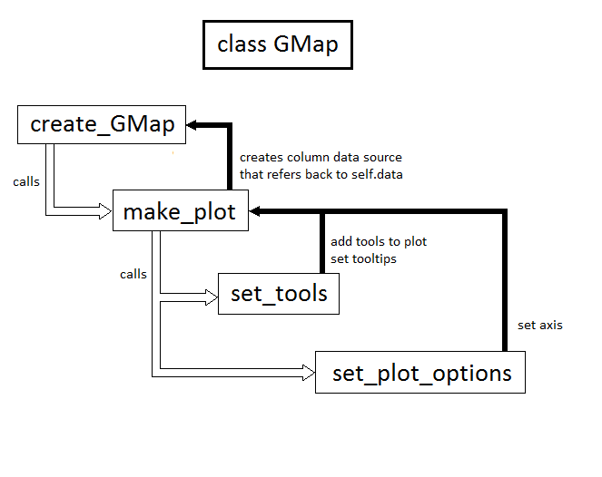
Reflection
Our project went well initially with trying out the bokeh library, we went through example code and tried to understand how they work and how we could use them. We were able to relatively quickly create a static Google Map with all our data by referring to the example. After adding the tools, we tried to adapt it to an applet format to add widgets but after many hours and many ninjas were unable to do so. We definitely could’ve improved on interpreting the applet example, if we had been able to understand sooner we might have been able to add the widgets
Our project was decently scoped: we had three levels of what we wanted to do. Our minimum was a static map displaying data as points, our reach goal was having interactive tools, and our stretch goal was having selective filtering. We wish that we knew bokeh was not as well documented as we had hoped and lacked resources needed to make the applet work. We worked well as a team though sometimes we were not on the same page and were not as productive. Next time, we could communicate more with each other as we program. We always worked together (both coding in parallel and pair programming) so we did not have to worry about merge conflict and we knew our own share of work.

