Project Overview

Books were harvested from Project Gutenberg and saved into folder in txt format. Using natural language processing capabilities from pattern, average sentiments for each chapter of the book was computed and graphed to show how the sentiments of the story changed throughout the book.

Implementation

First, the text file was converted to a string, eliminating unwanted notations. It was then split by chapter, and then by sentences. At first, the book was analyzed on sentence basis (instead of chapter) but there were too much noise in the results. Hence, the code was changed to create list (of sentences) in a list (of chapters).

The sentiment level of each element in the list was passed on as a list and the average for each chapter was computed. Using the average for each chapter, a graph of average sentiment level against chapter was plotted. It was designed to ensure that the list will only run through once for each function to minimize the time taken.

Results

Jane Eyre Emma
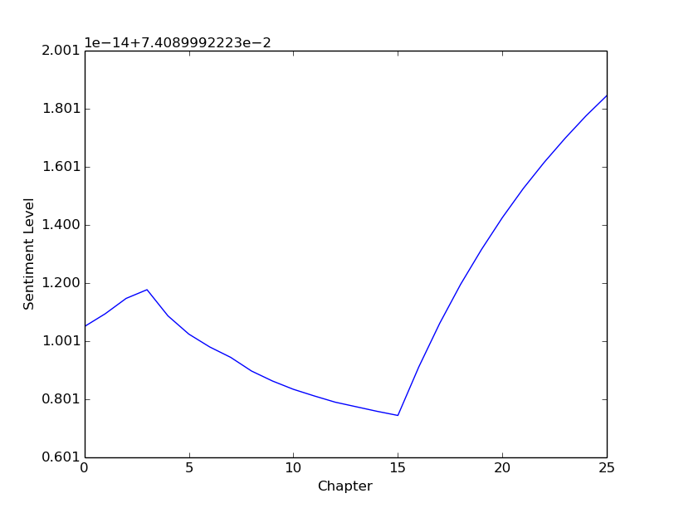
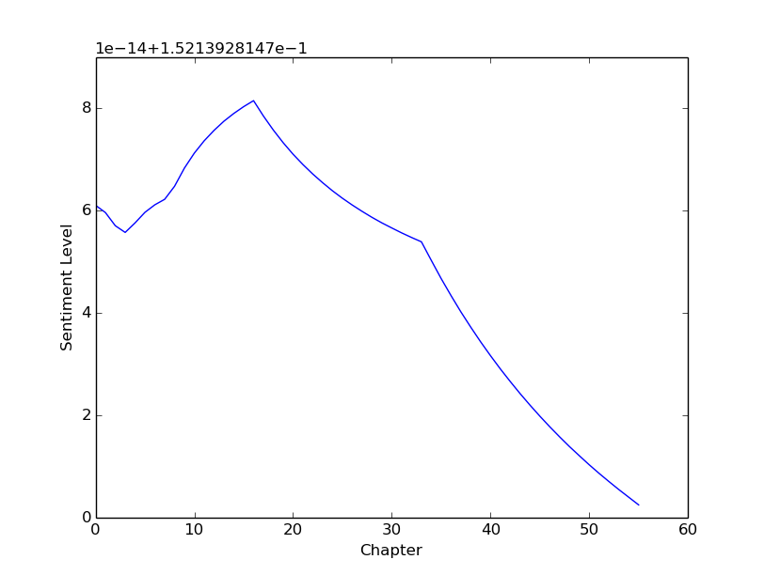
The average sentiment books never went below 0, and stabilized to between 0-2 for all the four books that I've tested.

Reflection
Possible extensions of the project includes importing many books of different genre and generating 'average' sentiments graph for different genre. By comparing and calculating standard deviation of the graph generated from a book with the 'average' graph, it will be possible to determine the book's genre.
Another extension is that we can create a book recommendation search. Like pandora, when the user type a book that they've enjoyed reading. The program can run through lists of books to search whose graph looks the most similar (sentimentals, histogram, similarity) and recommend it to the user.

