Laboratorio monitoreo Daniel A Montoya H cientifiqus@gmail.com

- Instalacion prometheus-server
https://codewizardly.com/prometheus-on-aws-ec2-part1/
- Instalacion prometheus-node-exporter
https://codewizardly.com/prometheus-on-aws-ec2-part2
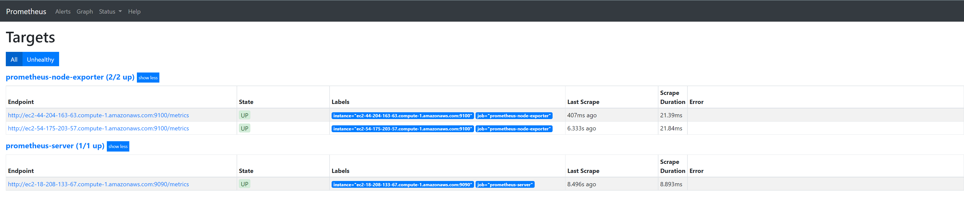
- URL servidor prometheus
http://ec2-18-208-133-67.compute-1.amazonaws.com:9090/graph
- Instalar grafana
https://www.muvi.com/blogs/install-grafana-on-ec2-and-start-with-an-autostart-for-monitoring.html
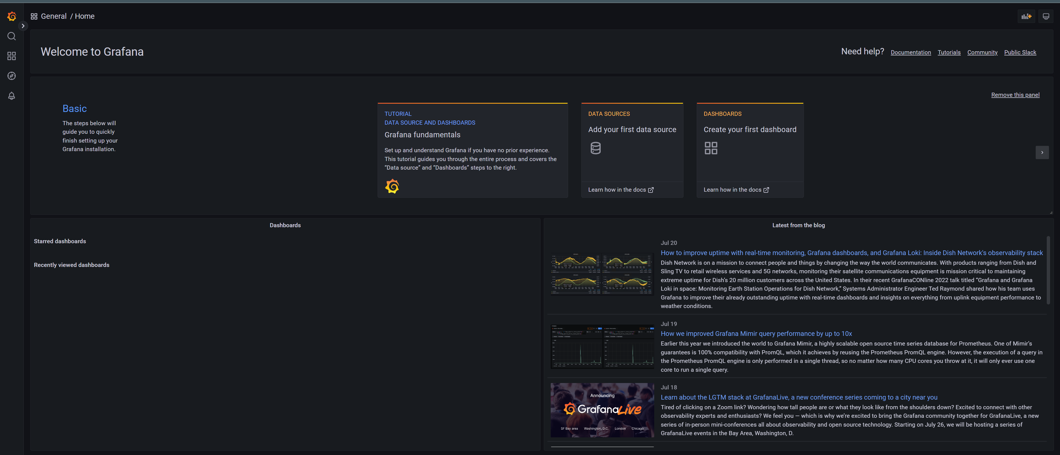
- URL
http://ec2-18-208-133-67.compute-1.amazonaws.com:3000/
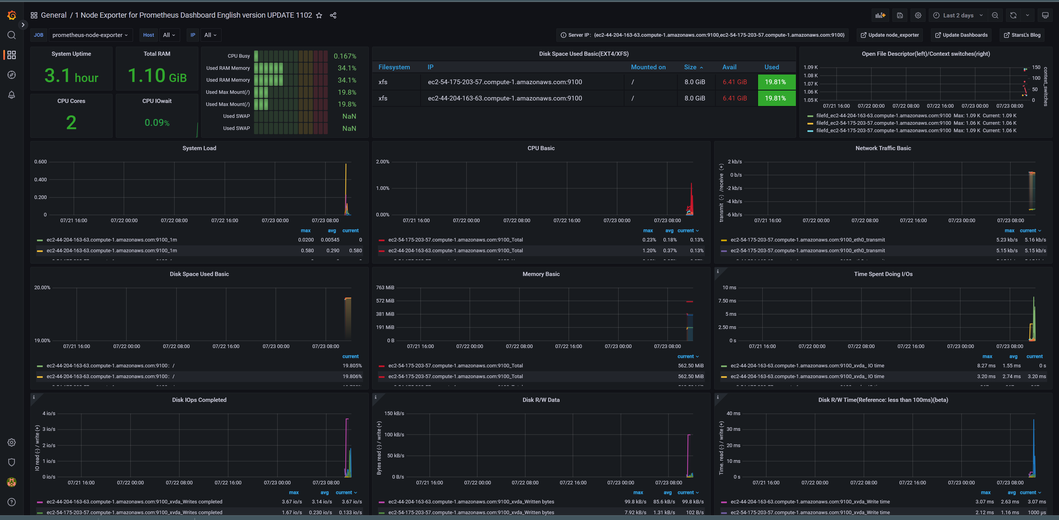
- Dashboard de prometheus para grafana, estado inicial
https://grafana.com/grafana/dashboards/11074-node-exporter-for-prometheus-dashboard-en-v20201010/
- Prueba de estres cpu+ram
https://www.cyberciti.biz/faq/stress-test-linux-unix-server-with-stress-ng/
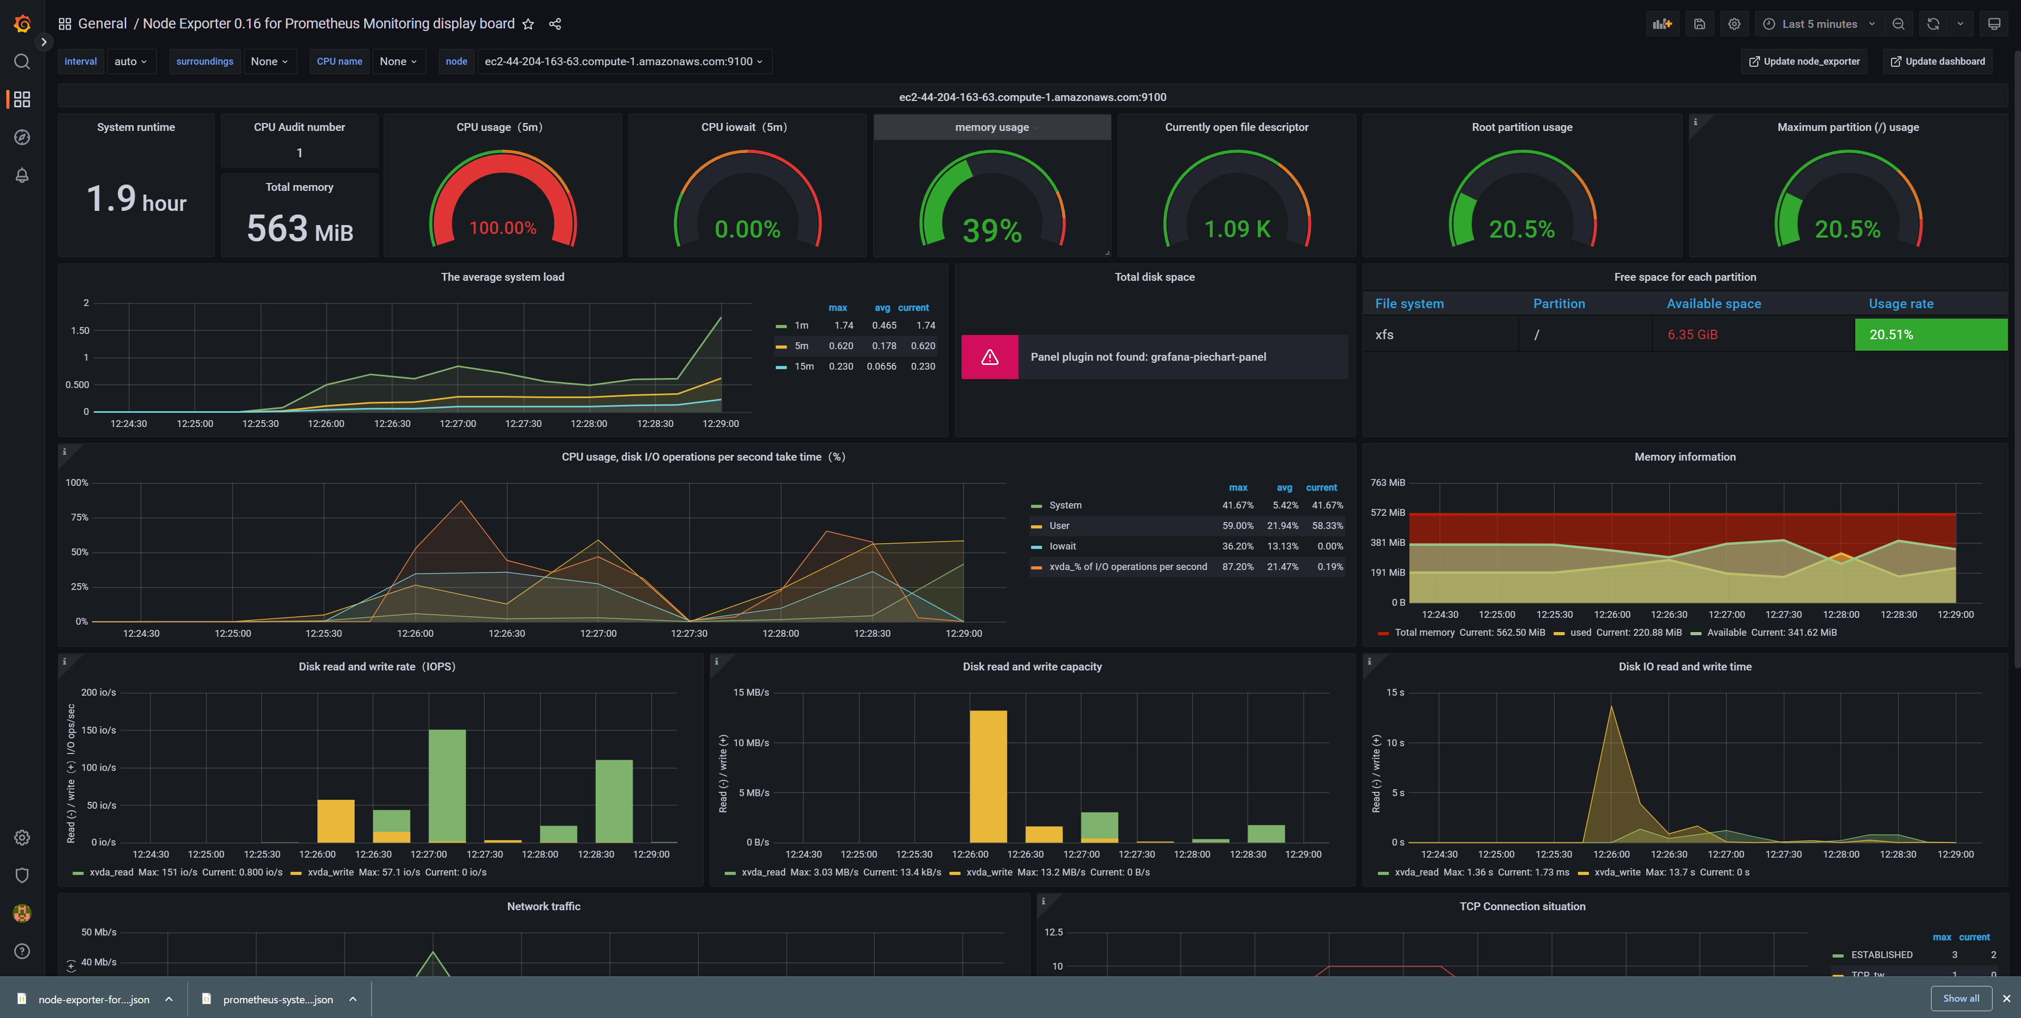
- CPU uso al 100%, ram 39% nodo1
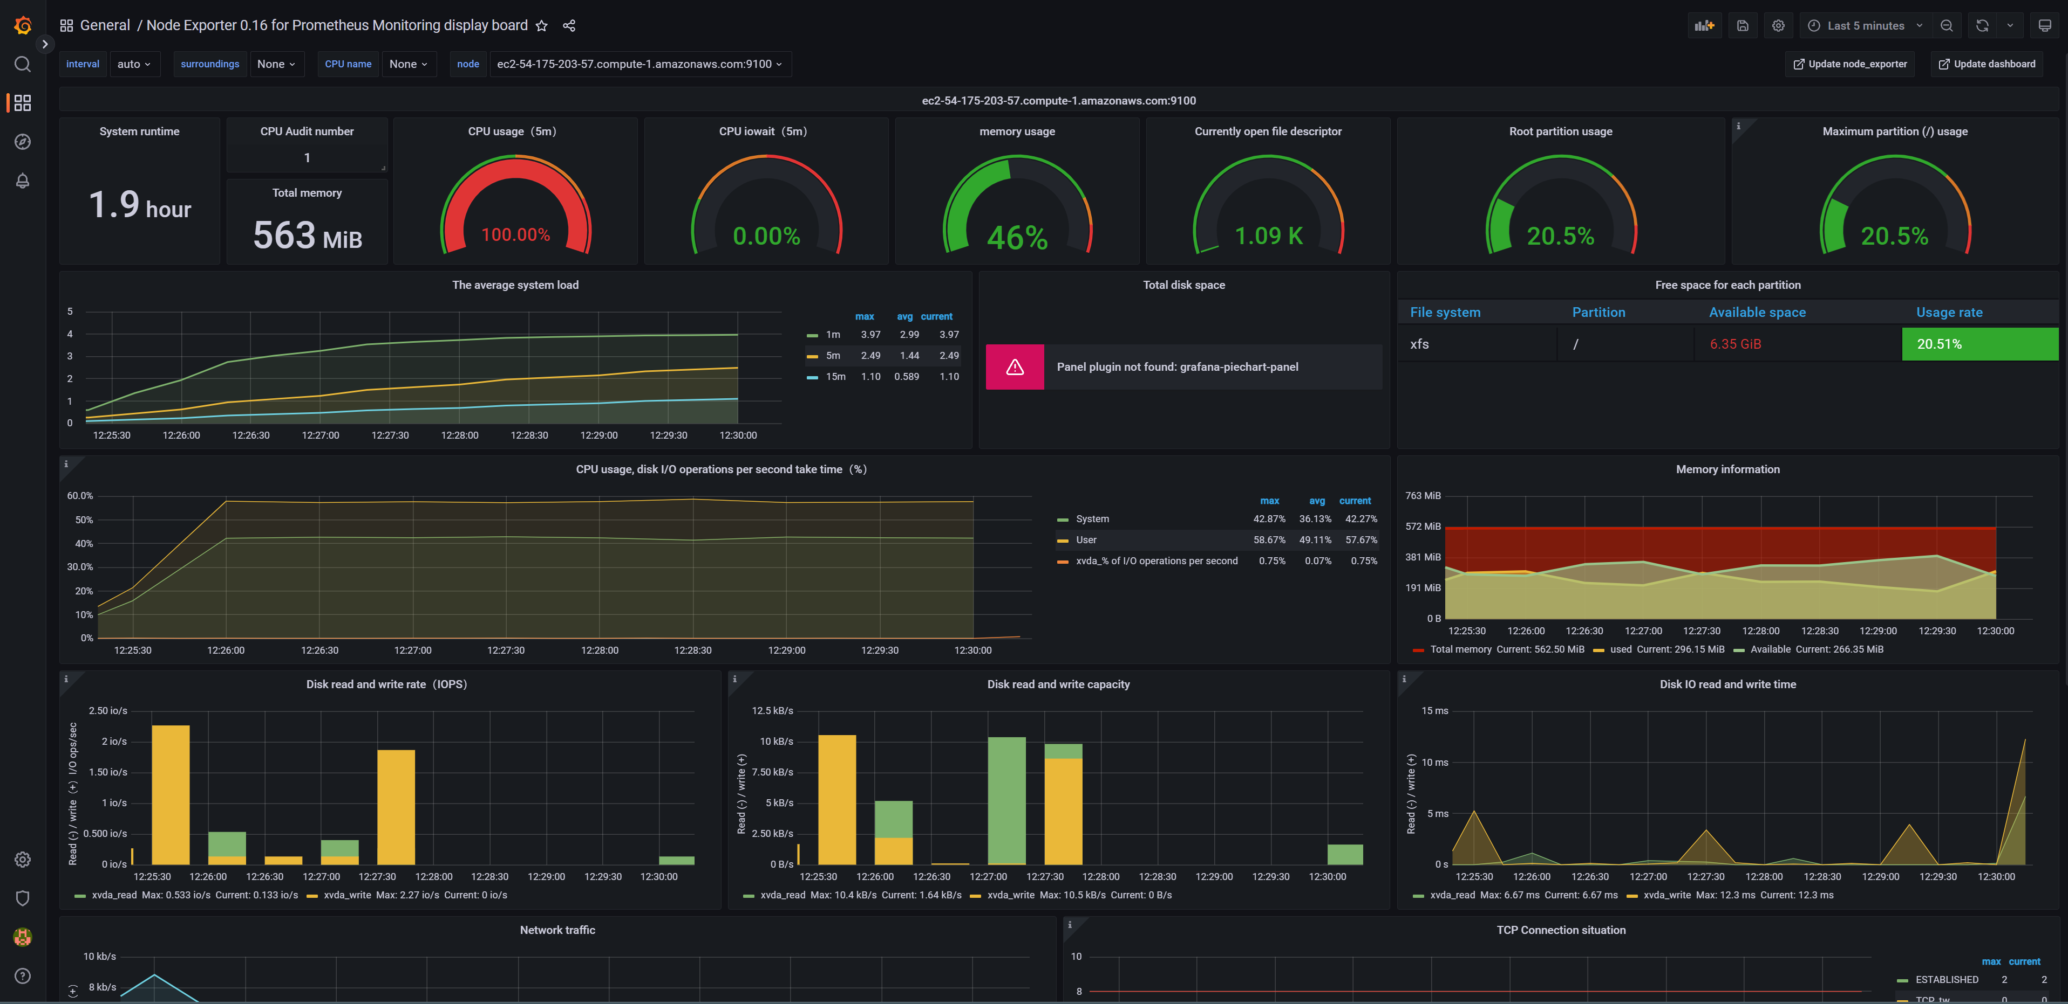
- CPU uso al 100% ,ram 46% nodo2
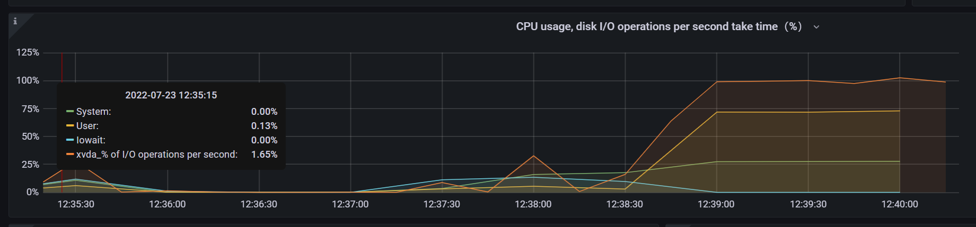
- I/O usage, cpu usage
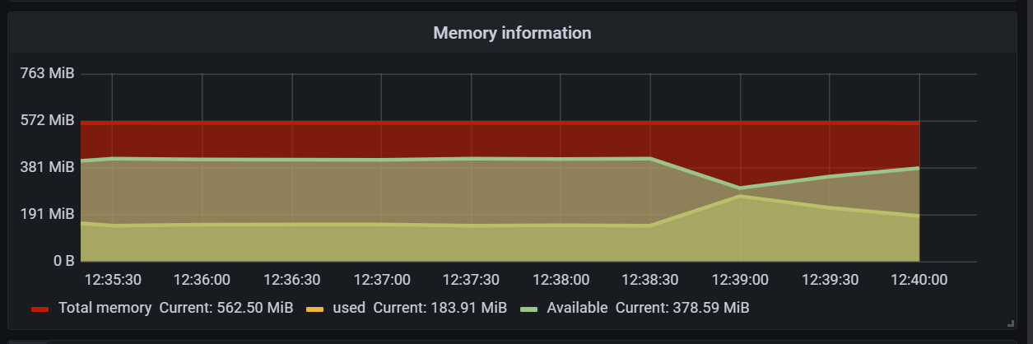
- Memory usage
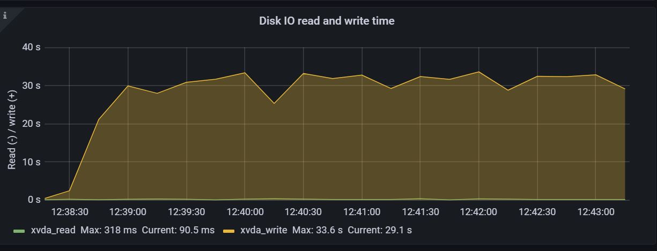
- Disk I/O usage
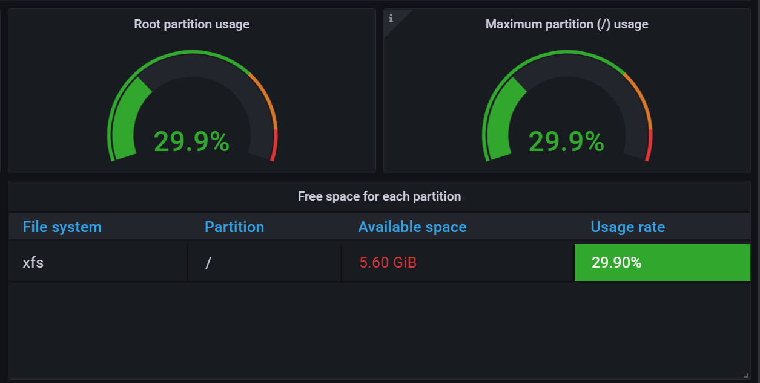
- Disk Space usage
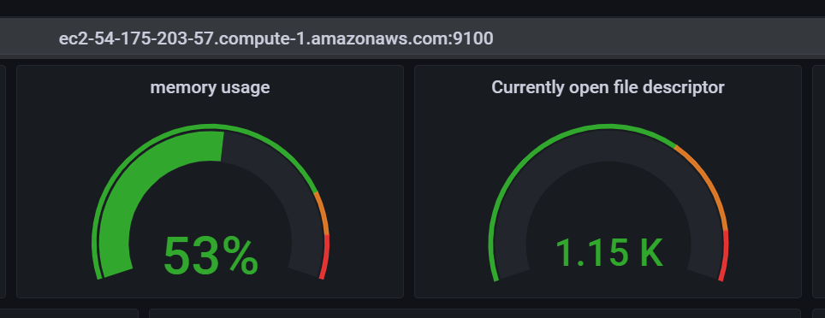
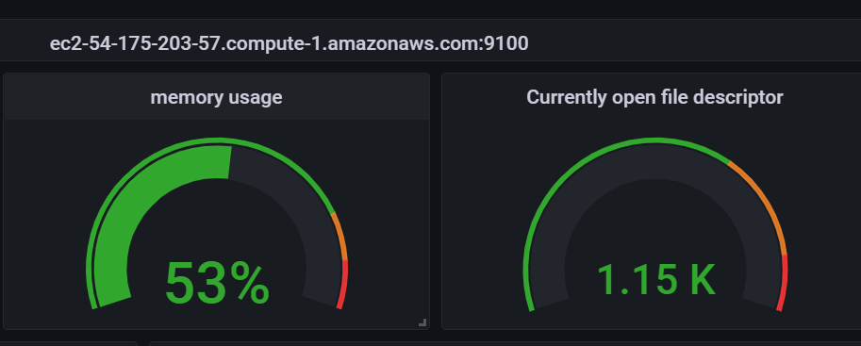
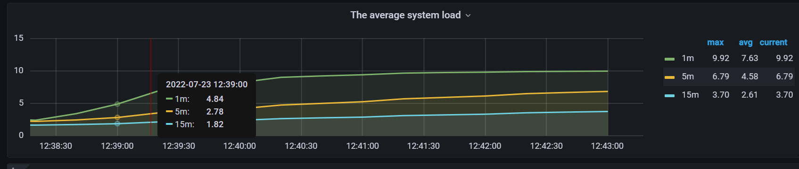
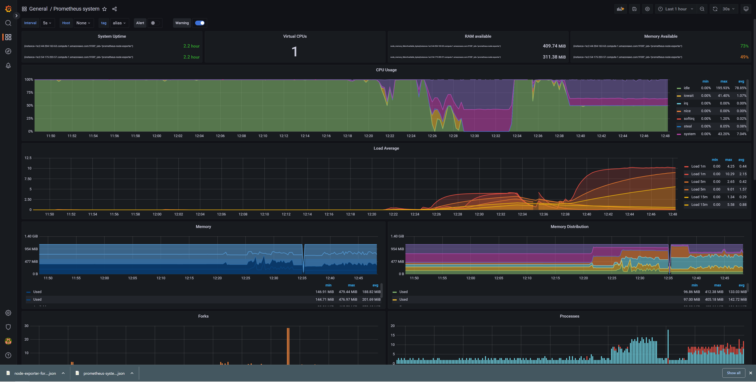
- System load and up time
- Prometheus configuracion /etc/prometheus/prometheus.yml
global:
scrape_interval: 15s
evaluation_interval: 15s
external_labels:
monitor: 'prometheus'

scrape_configs:

- job_name: 'prometheus-server'
static_configs:
- targets: ['ec2-18-208-133-67.compute-1.amazonaws.com:9090']

- job_name: 'prometheus-node-exporter'
static_configs:
- targets: ['ec2-54-175-203-57.compute-1.amazonaws.com:9100','ec2-44-204-163-63.compute-1.amazonaws.com:9100']
