Crystal Tutorial Notes

ECOOP 2009

Ciera Jaspan
Kevin Bierhoff
Jonathan Aldrich

Institute for Software Research
Carnegie Mellon University

Table of Contents
Register and Run a Crystal Analysis 3
Install Crystal 3
Register a new analysis 4
Run an analysis using the child Eclipse 7
Use an AST visitor to report errors 8
Create a dataflow analysis 10
Create the required classes 10
Use the flow analysis in the AST visitor 12
Add transfer functions 14
Advanced features 15

Register and Run a Crystal Analysis
Crystal is a plugin to Eclipse, and analyses in Crystal are also written by making an Eclipse plugin. We’ll install Crystal, register a very simple Crystal analysis, and show how to run an Eclipse plugin.

Install Crystal
We have provided you with a version of Eclipse with Crystal pre-installed. Please download it, along with the folders containing the sample analyses and the folder containing test code.

Start up Eclipse, go to the workbench, and you should see a Crystal menu which looks like this:

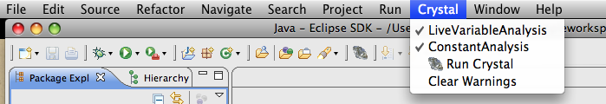

Installation is normally done through the Crystal update site, please see the wiki for more information. To implement an analysis in Crystal, you will need:
- Java 5 or greater
- Eclipse 3.5
- Java Development Tools (JDT plugin)
- Plugin Development Environment (PDE plugin)
These are already installed in the version of Eclipse we have provided for you.

Register a new analysis

Step 1: Create a plugin project.
- In the menu, go to File | New | Project...
- Under "Plug-in Development", select "Plugin Project".
- Click "Next"
- Give the project the name “NullPointerChecker”
- Click "Next"
- De-select "Generate an activator..."
- Click "Finish”

This will have created a new Java project which can contribute to Eclipse. A wizard will now be open in the main editor. This wizard sets up the configuration of your plugin.

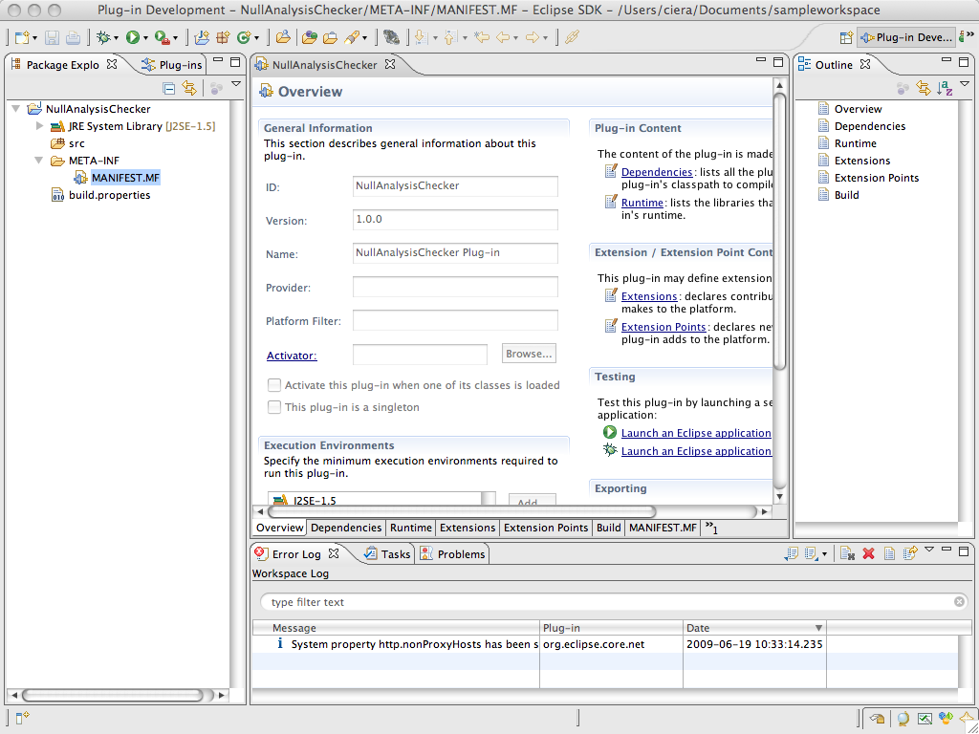

Step 2: Set up the dependencies
- In the configuration, go to "Dependencies" (the second tab)
- Under "Required Plugins", click "Add...".
- Select "edu.cmu.cs.crystal" and click "Ok". This will give you the ability to extend Crystal with your new analysis.
- Click "Add..."
- Select "org.eclipse.jdt.core" and click "Ok". This will give you the ability to use Eclipse's Java AST.
- Save

Step 3: Create an ICrystalAnalysis
- In the src directory, create a new Java class called “nullchecker.NullPointerAnalysis”.
- Have NullPointerAnalysis extend AbstractCrystalMethodAnalysis (which in turn implements the ICrystalAnalysisInterface)
- analyzeMethod(MethodDeclaration) will be called every time Crystal finds a new method to analyze.
- Implement analyzeMethod(MethodDeclaration) to just print out the name of the method to analyze. (See below)
- Override getName() to return a user-friendly name for the analysis, like “Check for NPEs”

package nullchecker;

import org.eclipse.jdt.core.dom.MethodDeclaration;
import edu.cmu.cs.crystal.AbstractCrystalMethodAnalysis;

public class NullPointerAnalysis extends AbstractCrystalMethodAnalysis {

@Override
public void analyzeMethod(MethodDeclaration d) {
String methodName = d.getName().getIdentifier();
getReporter().debugOut().println(methodName);
}

@Override
public String getName() {
return "Check for NPEs";
}
}

Step 4: Register the analysis with Crystal
- Open the plugin configuration wizard (plugin.xml or MANIFEST.MF or build.properties)
- Go to the "Extensions" tab. (fourth tab)
- Find the extension "edu.cmu.cs.crystal.CrystalAnalysis" and click "Finish"
- The extensions list will now show "edu.cmu.cs.crystal.CrystalAnalysis". Drill into it, and you should see something with a name like "MyAnalysisPlugin.CrystalAnalysis (analysis)". Select that; this is your extension point.
- The right side of the screen will now shown two properties for your analysis, "class" and "name".
- Under "class", put the fully qualified name to your analysis (“nullchecker.NullPointerAnalysis”).
- Save. Your analysis is now registered with Crystal.

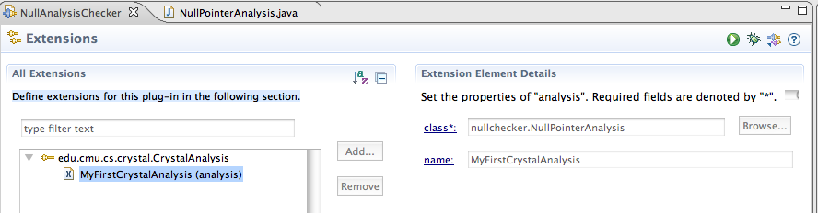

Run an analysis using the child Eclipse
Your analysis is a plugin to Crystal, which is a plugin to Eclipse. Therefore, to run your analysis, you will need to run Eclipse!

Child Eclipse: The Eclipse instance that we are testing in.
Parent Eclipse: The Eclipse instance that we are developing in.

Step 1: Start the child Eclipse
- Go to Run | Run Configurations...
- Select "Eclipse Application" and hit the icon for a "new" configuration near the top of the dialog to create a new run configuration.
- You should be able to just use the default settings, so simply give your run configuration a name, such as MyAnalysisEclipse, and hit the "Run" button.
- This has saved this run configuration, and from now on you can simply run it by selecting it from Run | Run Configurations... or from Run History.
- To debug instead, simply select the same configuration from Run |Debug Configuration...
- Go to the Crystal menu. Make sure your analysis is there.

Step 2: Create a test project
- Start the child Eclipse
- Create a new Java project
- Import the code from the sample test code we have provided for you
- This workspace will be saved and will reappear even if you close and restart the child Eclipse

Step 3: Run your analysis
- Open the Crystal console, so we can see the debug output. You can do so with Windows | Show View | Other... | Crystal | Crystal Console.
- Go to the Crystal Menu
- Make sure your analysis is checked, and the others are unchecked
- Run Crystal
- The debug output will be in Crystal Console.

Use an AST visitor to report errors
We first want to create a visitor which will walk the AST and find the “bad” nodes. This visitor will simply report an error every time it encounters a bad node.

Step 1: Create the ASTVisitor
In your analysis class, create an inner class that extends ASTVisitor.

package nullchecker;

import org.eclipse.jdt.core.dom.ASTVisitor;
import org.eclipse.jdt.core.dom.MethodDeclaration;
import edu.cmu.cs.crystal.AbstractCrystalMethodAnalysis;

public class NullPointerAnalysis extends AbstractCrystalMethodAnalysis {
private class NullPointerVisitor extends ASTVisitor {

}
…
}

This class is provided by Eclipse and has many methods you can override. Do not be alarmed. Here’s how to override methods the easy way in Eclipse:
- Right-click inside of NullPointerVisitor
- Go to Source | Override/Implement Methods
- Select the endVisit() methods which have the parameters you’re interested in visiting. For null, we’re interested in ArrayAccess, FieldAccess, and MethodInvocation

Step 2: Report errors to the user
- In each method, report an error to the user, as shown below with reporterUserProblem().
- You may optionally add the severity parameter (the default is INFO, other options are WARNING and ERROR)
- Remember to check if there is anything on the left side of the ‘.’ for MethodInvocation and FieldAccess.

@Override
public void endVisit(MethodInvocation node) {
if (node.getExpression() != null)
getReporter().reportUserProblem("The value of " +
node.getExpression() + " may be null.", node, getName());
}

Step 3: Call to the visitor
In NullPointerAnalysis.analyzeMethod(), create an instance of the visitor and start visiting on the MethodDeclaration.

@Override
public void analyzeMethod(MethodDeclaration d) {
d.accept(new NullPointerVisitor());
}

Step 4: Try it out!
When you run your analysis now, it will give an “info” message on every array access and every method call or field access where a dereference occurs.

Create a dataflow analysis
Now we will create a dataflow analysis and set up our visitor to use it. A UML class diagram of creating a flow analysis can be found at the end of this handout.

Create the required classes

Step 1: Create a lattice element class
Create a class to represent the lattice elements. This will likely be an enum. You can either create this yourself, or copy it from the samples directory.

public enum NullLatticeElement {
BOTTOM, NULL, NOT_NULL, MAYBE_NULL;
}

Step 2: Create the lattice operations class
Extend SimpleLatticeOperations and templatize by your lattice type (as shown below). Again, you can copy this class from the samples directory.

package nullchecker;
import edu.cmu.cs.crystal.simple.SimpleLatticeOperations;

public class NullLatticeOperations extends
SimpleLatticeOperations<NullLatticeElement> {
@Override
public boolean atLeastAsPrecise(NullLatticeElement left,
NullLatticeElement right) {
if (left == right)
return true;
else if (left == NullLatticeElement.BOTTOM)
return true;
else if (right == NullLatticeElement.MAYBE_NULL)
return true;
else
return false;
}

@Override
public NullLatticeElement bottom() {
return NullLatticeElement.BOTTOM;
}

@Override
public NullLatticeElement copy(NullLatticeElement original) {
return original;
}

@Override
public NullLatticeElement join(NullLatticeElement left,
NullLatticeElement right) {
if (left == right)
return left;
else if (left == NullLatticeElement.BOTTOM)
return right;
else if (right == NullLatticeElement.BOTTOM)
return left;
else
return NullLatticeElement.MAYBE_NULL;
}
}

Step 3: Create the transfer functions class
- Extend the class AbstractingTransferFunction and templatize by the lattice (or TupleLatticeElement, if that is desired).
  - TupleLatticeElement maps a key to another lattice element. In this case, we map all Variables to a NullLatticeElement.

public class NPESimpleTransferFunction extends AbstractingTransferFunction<TupleLatticeElement<Variable, NullLatticeElement>> {
...
}

- Create a field for the lattice operations
  - If TupleLatticeOperations is being used, pass in an instance of the sub-lattice operations and the default value
- Return the field from getLatticeOperations()

private TupleLatticeOperations<Variable, NullLatticeElement> ops =
new TupleLatticeOperations<Variable, NullLatticeElement>(
new NullLatticeOperations(), NullLatticeElement.MAYBE_NULL);

public ILatticeOperations<TupleLatticeElement<Variable, NullLatticeElement>>
getLatticeOperations(MethodDeclaration method) {
return ops;
}

- Implement createEntryValue() by returning a starting lattice element for a method. Notice that the interface IAnalysisContext provides many useful utilities.

public TupleLatticeElement<Variable, NullLatticeElement> createEntryValue(MethodDeclaration method) {
TupleLatticeElement<Variable, NullLatticeElement> def = ops.getDefault();

Variable thisVar = getAnalysisContext().getThisVariable();
def.put(thisVar, NullLatticeElement.NOT_NULL);

return def;
}

Use the flow analysis in the AST visitor

Step 1: Create a flow analysis
- In NullPointerAnalysis, create a field with the type SimpleTACFlowAnalysis. Templatize it by the lattice element.
- In analyze method, instantiate the transfer functions, and then instantiate the field and pass in the transfer functions.

private SimpleTACFlowAnalysis<
TupleLatticeElement<Variable, NullLatticeElement>> flowAnalysis;

@Override
public void analyzeMethod(MethodDeclaration d) {
NPESimpleTransferFunction tf = new NPESimpleTransferFunction();
flowAnalysis = new SimpleTACFlowAnalysis<
TupleLatticeElement<Variable, NullLatticeElement>>(tf, getInput());

d.accept(new NPEFlowVisitor());
}

Step 2: Call to the flow analysis from the visitor
- In the endVisit() method, get the flow results before/after a given ASTNode
- Get the desired variable using the flow analysis
- Query the tuple lattice for the value of the desired variable
- Report any errors found.

@Override
public void endVisit(MethodInvocation node) {
Expression exp = node.getExpression();
if (exp == null)
return;

TupleLatticeElement<Variable, NullLatticeElement> beforeTuple =
flowAnalysis.getResultsBefore(node);
Variable varToCheck = flowAnalysis.getVariable(exp);
NullLatticeElement element = tuple.get(varToCheck);

if (element == NullLatticeElement.MAYBE_NULL)
getReporter().reportUserProblem("The expression " + exp +
" may be null.", node, getName(), SEVERITY.WARNING);
else if (element == NullLatticeElement.NULL)
getReporter().reportUserProblem("The expression " + exp +
" is null.", node, getName(), SEVERITY.ERROR);
}

Step 3: Try it out!
At this point, your analysis will work almost the same as with the visitor (it will be slightly better since the starting information makes this non-null.)

Add transfer functions
Just add transfer functions as desired! Below are some examples to get you started. As with the ASTVisitor, we suggest using Source | Override/Implement methods to get started. Any transfer functions not overridden will just return the input value.

@Override
public TupleLatticeElement<Variable, NullLatticeElement> transfer(
ArrayInitInstruction instr,
TupleLatticeElement<Variable, NullLatticeElement> value) {
value.put(instr.getTarget(), NullLatticeElement.NOT_NULL);
return value;
}

@Override
public TupleLatticeElement<Variable, NullLatticeElement> transfer(
CopyInstruction instr,
TupleLatticeElement<Variable, NullLatticeElement> value) {
value.put(instr.getTarget(), value.get(instr.getOperand());
return value;
}

@Override
public TupleLatticeElement<Variable, NullLatticeElement> transfer(
LoadLiteralInstruction instr,
TupleLatticeElement<Variable, NullLatticeElement> value) {
if (instr.isNull())
value.put(instr.getTarget(), NullLatticeElement.NULL);
else
value.put(instr.getTarget(), NullLatticeElement.NOT_NULL);
return value;
}

Congratulations! You’ve made a simple flow analysis. Just continue to work on your transfer functions and test your analysis until you’re satisfied with them. Or, you can try to use some more sophisticated features to make the analysis more precise.

Advanced features
Crystal contains several advanced features, including:
- Easy access to annotations
- Branch-sensitive analyses
- Automated testing
- Ability to change join based on ASTNode (for widening)

We have provided more complex versions of the NPEAnalysis in the samples folder. To try them out, take the following steps:
- Go to File | Import…
- Drill into General -> Existing Projects into Workspace
- Click “Next”
- Set the root directory to the samples folder
- Import the desired projects. They can be run in the same manner as your analysis.

Class Diagram
