**Prueba final Weka**

Curso: Algoritmos de Big Data para ingenieros.

**Estudiante: Juan Pablo Delzo Melendez**

**PRIMER EJERCICIO:**

1. J48

=== Run information ===

Scheme: weka.classifiers.trees.J48 -C 0.25 -M 2

Relation: segment

Instances: 1500

Attributes: 20

region-centroid-col

region-centroid-row

region-pixel-count

short-line-density-5

short-line-density-2

vedge-mean

vegde-sd

hedge-mean

hedge-sd

intensity-mean

rawred-mean

rawblue-mean

rawgreen-mean

exred-mean

exblue-mean

exgreen-mean

value-mean

saturation-mean

hue-mean

class

Test mode: 10-fold cross-validation

=== Classifier model (full training set) ===

J48 pruned tree

------------------

region-centroid-row <= 155

| value-mean <= 91.4444

| | rawred-mean <= 24.6667

| | | hue-mean <= -1.89048

| | | | hue-mean <= -2.22266

| | | | | region-centroid-row <= 146: foliage (102.0/1.0)

| | | | | region-centroid-row > 146: cement (3.0)

| | | | hue-mean > -2.22266

| | | | | rawred-mean <= 2.55556

| | | | | | hue-mean <= -2.09121

| | | | | | | region-centroid-row <= 129: foliage (50.0)

| | | | | | | region-centroid-row > 129

| | | | | | | | region-centroid-col <= 128

| | | | | | | | | rawred-mean <= 0.666667: foliage (30.0/4.0)

| | | | | | | | | rawred-mean > 0.666667: window (5.0)

| | | | | | | | region-centroid-col > 128

| | | | | | | | | vedge-mean <= 0.333333: window (11.0)

| | | | | | | | | vedge-mean > 0.333333

| | | | | | | | | | region-centroid-col <= 216: window (3.0)

| | | | | | | | | | region-centroid-col > 216: foliage (2.0)

| | | | | | hue-mean > -2.09121: window (38.0/1.0)

| | | | | rawred-mean > 2.55556

| | | | | | region-centroid-row <= 121

| | | | | | | exgreen-mean <= -15.4444: brickface (2.0/1.0)

| | | | | | | exgreen-mean > -15.4444

| | | | | | | | vedge-mean <= 2.94444: window (75.0)

| | | | | | | | vedge-mean > 2.94444

| | | | | | | | | region-centroid-col <= 134: cement (2.0)

| | | | | | | | | region-centroid-col > 134: window (8.0)

| | | | | | region-centroid-row > 121

| | | | | | | rawred-mean <= 7.88889

| | | | | | | | region-centroid-col <= 43: brickface (2.0)

| | | | | | | | region-centroid-col > 43: window (13.0/2.0)

| | | | | | | rawred-mean > 7.88889

| | | | | | | | saturation-mean <= 0.492526: cement (15.0)

| | | | | | | | saturation-mean > 0.492526

| | | | | | | | | region-centroid-col <= 82: foliage (2.0)

| | | | | | | | | region-centroid-col > 82: cement (4.0/1.0)

| | | hue-mean > -1.89048

| | | | exgreen-mean <= -4.77778

| | | | | vedge-mean <= 2.77778: brickface (198.0/2.0)

| | | | | vedge-mean > 2.77778

| | | | | | region-centroid-row <= 115: brickface (4.0)

| | | | | | region-centroid-row > 115: foliage (3.0/1.0)

| | | | exgreen-mean > -4.77778

| | | | | hedge-mean <= 0.833336

| | | | | | region-centroid-col <= 115: foliage (4.0)

| | | | | | region-centroid-col > 115: window (42.0)

| | | | | hedge-mean > 0.833336: grass (2.0)

| | rawred-mean > 24.6667

| | | hue-mean <= -2.17742

| | | | vedge-mean <= 5: window (4.0/1.0)

| | | | vedge-mean > 5: foliage (18.0)

| | | hue-mean > -2.17742

| | | | rawgreen-mean <= 24.4444: brickface (3.0/1.0)

| | | | rawgreen-mean > 24.4444: cement (180.0)

| value-mean > 91.4444: sky (220.0)

region-centroid-row > 155

| exgreen-mean <= -2

| | saturation-mean <= 0.385555

| | | region-centroid-row <= 159

| | | | region-centroid-col <= 208: cement (3.0)

| | | | region-centroid-col > 208: path (2.0)

| | | region-centroid-row > 159: path (234.0)

| | saturation-mean > 0.385555: cement (11.0)

| exgreen-mean > -2: grass (205.0)

Number of Leaves : 34

Size of the tree : 67

Time taken to build model: 0.05 seconds

=== Stratified cross-validation ===

=== Summary ===

Correctly Classified Instances 1436 95.7333 %

Incorrectly Classified Instances 64 4.2667 %

Kappa statistic 0.9502

Mean absolute error 0.0138

Root mean squared error 0.1057

Relative absolute error 5.6471 %

Root relative squared error 30.2115 %

Total Number of Instances 1500

=== Detailed Accuracy By Class ===

TP Rate FP Rate Precision Recall F-Measure MCC ROC Area PRC Area Class

0,956 0,004 0,975 0,956 0,966 0,960 0,981 0,954 brickface

1,000 0,001 0,995 1,000 0,998 0,997 1,000 0,995 sky

0,942 0,018 0,895 0,942 0,918 0,905 0,975 0,889 foliage

0,941 0,009 0,945 0,941 0,943 0,933 0,978 0,946 cement

0,877 0,017 0,891 0,877 0,884 0,866 0,961 0,881 window

0,987 0,001 0,996 0,987 0,991 0,990 0,997 0,992 path

0,990 0,000 1,000 0,990 0,995 0,994 1,000 1,000 grass

Weighted Avg. 0,957 0,007 0,958 0,957 0,957 0,951 0,985 0,952

=== Confusion Matrix ===

a b c d e f g <-- classified as

196 0 3 1 5 0 0 | a = brickface

0 220 0 0 0 0 0 | b = sky

0 1 196 2 9 0 0 | c = foliage

2 0 4 207 6 1 0 | d = cement

3 0 16 6 179 0 0 | e = window

0 0 0 3 0 233 0 | f = path

0 0 0 0 2 0 205 | g = grass

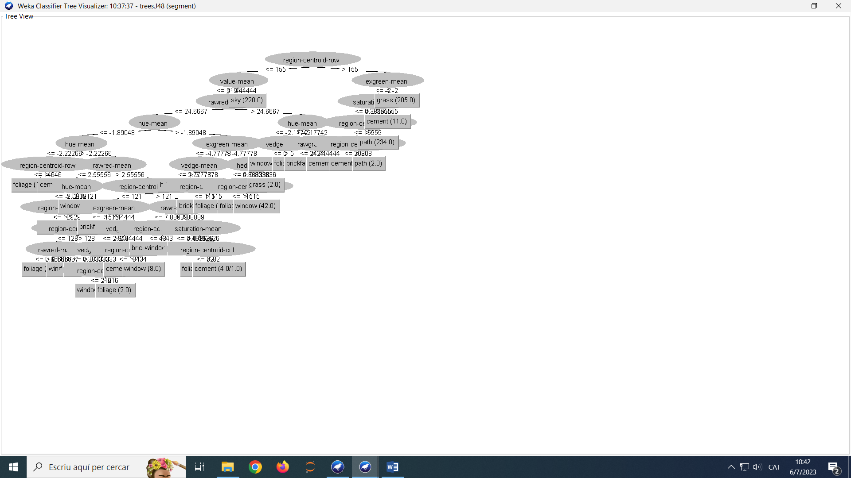

1. Random Forest

=== Run information ===

Scheme: weka.classifiers.trees.RandomForest -P 100 -I 100 -num-slots 1 -K 0 -M 1.0 -V 0.001 -S 1

Relation: segment

Instances: 1500

Attributes: 20

region-centroid-col

region-centroid-row

region-pixel-count

short-line-density-5

short-line-density-2

vedge-mean

vegde-sd

hedge-mean

hedge-sd

intensity-mean

rawred-mean

rawblue-mean

rawgreen-mean

exred-mean

exblue-mean

exgreen-mean

value-mean

saturation-mean

hue-mean

class

Test mode: 10-fold cross-validation

=== Classifier model (full training set) ===

RandomForest

Bagging with 100 iterations and base learner

weka.classifiers.trees.RandomTree -K 0 -M 1.0 -V 0.001 -S 1 -do-not-check-capabilities

Time taken to build model: 0.27 seconds

=== Stratified cross-validation ===

=== Summary ===

Correctly Classified Instances 1468 97.8667 %

Incorrectly Classified Instances 32 2.1333 %

Kappa statistic 0.9751

Mean absolute error 0.02

Root mean squared error 0.0786

Relative absolute error 8.1639 %

Root relative squared error 22.4623 %

Total Number of Instances 1500

=== Detailed Accuracy By Class ===

TP Rate FP Rate Precision Recall F-Measure MCC ROC Area PRC Area Class

0,990 0,001 0,995 0,990 0,993 0,992 1,000 1,000 brickface

1,000 0,001 0,995 1,000 0,998 0,997 1,000 1,000 sky

0,966 0,009 0,948 0,966 0,957 0,950 0,998 0,988 foliage

0,968 0,006 0,964 0,968 0,966 0,960 0,998 0,993 cement

0,926 0,008 0,950 0,926 0,938 0,928 0,997 0,983 window

0,996 0,001 0,996 0,996 0,996 0,995 1,000 1,000 path

1,000 0,000 1,000 1,000 1,000 1,000 1,000 1,000 grass

Weighted Avg. 0,979 0,003 0,979 0,979 0,979 0,975 0,999 0,995

=== Confusion Matrix ===

a b c d e f g <-- classified as

203 0 0 0 2 0 0 | a = brickface

0 220 0 0 0 0 0 | b = sky

0 1 201 2 4 0 0 | c = foliage

0 0 2 213 4 1 0 | d = cement

1 0 9 5 189 0 0 | e = window

0 0 0 1 0 235 0 | f = path

0 0 0 0 0 0 207 | g = grass

1. IBK (KNN)

=== Run information ===

Scheme: weka.classifiers.lazy.IBk -K 1 -W 0 -A "weka.core.neighboursearch.LinearNNSearch -A \"weka.core.EuclideanDistance -R first-last\""

Relation: segment

Instances: 1500

Attributes: 20

region-centroid-col

region-centroid-row

region-pixel-count

short-line-density-5

short-line-density-2

vedge-mean

vegde-sd

hedge-mean

hedge-sd

intensity-mean

rawred-mean

rawblue-mean

rawgreen-mean

exred-mean

exblue-mean

exgreen-mean

value-mean

saturation-mean

hue-mean

class

Test mode: 10-fold cross-validation

=== Classifier model (full training set) ===

IB1 instance-based classifier

using 1 nearest neighbour(s) for classification

Time taken to build model: 0 seconds

=== Stratified cross-validation ===

=== Summary ===

Correctly Classified Instances 1443 96.2 %

Incorrectly Classified Instances 57 3.8 %

Kappa statistic 0.9556

Mean absolute error 0.012

Root mean squared error 0.1039

Relative absolute error 4.9184 %

Root relative squared error 29.7112 %

Total Number of Instances 1500

=== Detailed Accuracy By Class ===

TP Rate FP Rate Precision Recall F-Measure MCC ROC Area PRC Area Class

0,995 0,003 0,981 0,995 0,988 0,986 0,996 0,978 brickface

1,000 0,000 1,000 1,000 1,000 1,000 1,000 1,000 sky

0,942 0,013 0,920 0,942 0,931 0,920 0,964 0,877 foliage

0,914 0,006 0,962 0,914 0,937 0,927 0,956 0,892 cement

0,877 0,019 0,882 0,877 0,880 0,861 0,932 0,790 window

1,000 0,003 0,983 1,000 0,992 0,990 0,998 0,984 path

1,000 0,000 1,000 1,000 1,000 1,000 1,000 1,000 grass

Weighted Avg. 0,962 0,006 0,962 0,962 0,962 0,956 0,978 0,933

=== Confusion Matrix ===

a b c d e f g <-- classified as

204 0 0 0 1 0 0 | a = brickface

0 220 0 0 0 0 0 | b = sky

0 0 196 0 12 0 0 | c = foliage

2 0 2 201 11 4 0 | d = cement

2 0 15 8 179 0 0 | e = window

0 0 0 0 0 236 0 | f = path

0 0 0 0 0 0 207 | g = grass

1. Conclusión:

El mejor método es Random Forest (97% de precisión), seguido de KNN (96%) y por último de J48(Decision Tree con 96%).