Productpage OK

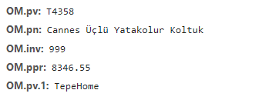

Category OK



Search OK



AddToCart – RemoveFromCart – BasketPage OK

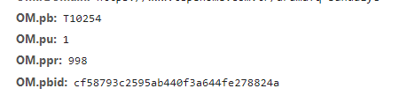

Register OK



Login OK



Purchase OK

