ProductPage ok

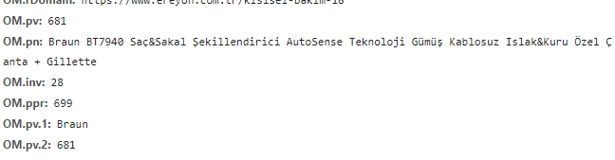

Basket ok

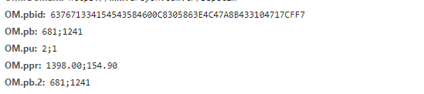

Purchase ok

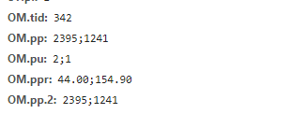

Category ok



SearchPage ok



SignUp ok

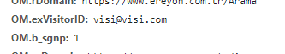

Login ok

