Flight Departure Delay Analysis & Prediction
Zurich Airport (ZRH) · October – December 2025
CIP Group 111 · Master of Science in Data Science · HSLU FS2026
Hanieh Jebeli · Elif Gürçınar · Silan Cihaner
Total Flights | Avg Delay | On-Time Rate | Airlines | Routes
29,896 | 5.44 min | 55.6% | 209 | 445

1 Introduction
Commercial airlines operate on exceptionally tight schedules, where even a minor departure delay can cascade into widespread operational disruptions and significant financial losses. This project develops a complete Python-based data science pipeline to analyze and predict flight departure delays at Zurich Airport (ZRH) over a three-month observation window spanning October 1 to December 31, 2025. The central objective is to identify the specific operational and meteorological factors that drive these delays, and to determine whether it is possible to predict the exact delay time in minutes using only information available prior to the scheduled departure.

*Over the course of the project we decided to add meteorological data to enrich our data set, thus we had to change the last research question after handing in the feasibility study.

Three core research questions structure the analysis:

1. How accurately can departure delays be predicted using operational flight information at Zurich Airport?
2. Does the inclusion of route-level historical delay benchmarks and real-time environmental data improve prediction accuracy compared to a baseline model?
3. Which operational and meteorological variables most strongly influence departure delays?

The project covers every stage of a complete data science workflow: API-based data acquisition, data cleaning and feature engineering, exploratory data analysis, predictive modelling, and the deployment of an interactive Streamlit dashboard as a decision-support tool.

2 Methods

2.1 Data Acquisition
Flight operations data for ZRH were sourced from the AeroDataBox API, queried in 12-hour intervals using Python's requests library to respect RapidAPI rate limits. Automated try-except blocks captured HTTP 429 errors and ensured complete extraction of all flight records, including cancelled and codeshared flights. To avoid redundant API calls during iterative development, a local SQLite caching mechanism using requests-cache was integrated into the pipeline. Hourly meteorological data, temperature (°C), precipitation (mm), and wind speed (km/h), were retrieved from the Open-Meteo API and joined to the flight records by timestamp.

2.2 Data Cleaning & Feature Engineering
Raw API data was ingested and processed using pandas. Nested JSON columns, including departure timestamps, arrival airport codes, airline identifiers, and aircraft information, were parsed to extract structured fields. The target variable, delay_min, was computed as the difference in minutes between the scheduled and revised departure times. Outliers were flagged using an IQR-based methodology and excluded from modelling. A secondary filter restricted the analysis to flights with delays in the range of -60 to +300 minutes to remove likely data errors such as timestamps belonging to the following day's flight. After cleaning, the dataset contained 29,896 flights.
Key engineered features included: departure hour (dep_hour), day of week (dep_dow), month (dep_month), a binary weekend flag (is_weekend), and route_avg_delay, the historical mean delay for each origin-destination pair across the observation period. Weather variables were appended by matching each flight to its scheduled departure hour.

2.3 Modelling Approach
Two modelling scripts were developed iteratively. The first (analysis_v01.py) established a baseline using only operational features, progressively adding route_avg_delay to assess its contribution. The second (analysis_v02_with_weather.py) extended the feature set with the three weather variables and compared all four model combinations on a consistent 80/20 train-test split with a fixed random seed (42). The models evaluated were Linear Regression (LR) and Random Forest Regressor (RF). Performance was assessed using Mean Absolute Error (MAE), Root Mean Squared Error (RMSE), and the coefficient of determination (R²). Feature importances were extracted from the best-performing Random Forest configuration.

2.4 Dashboard
The project outputs were deployed as an interactive Streamlit dashboard (dashboard.py), accessible at https://zrh-flight-delay.streamlit.app. The dashboard comprises four tabs: a Delay Explorer with filterable delay distribution, temporal patterns by hour and day of week, airline and aircraft breakdowns, and a delay heatmap by hour and day; a Weather Analysis tab with correlation charts; a Predictive Models tab displaying comparative model metrics; and a Live Predictor tab enabling users to input flight-specific parameters and receive an instant delay prediction from the trained model.

3 Results & Discussion

3.1 Dataset Overview & Delay Distribution
The cleaned dataset covers 29,896 commercial departures across 445 unique routes served by 209 airlines. The average departure delay across the full period is 5.44 minutes. The distribution is strongly right-skewed: 55.6% of flights depart on time or early, 32.2% experience minor delays of 1–15 minutes, 12.2% experience moderate to severe delays exceeding 15 minutes, and fewer than 1% fall into the severe category. This distribution is consistent with hub airport dynamics at ZRH, where network reactionary delays affect a minority of flights disproportionately.
Temporal patterns visible in the dashboard reveal that average delays increase noticeably in the morning peak around 08:00–09:00 UTC (reaching approximately 8 minutes), then taper during midday and rise again in the late afternoon. Friday shows the highest average delay by day of week at 6.7 minutes, while Tuesday is the lowest at 3.8 minutes. Wide-body aircraft record the highest average delay by aircraft family (7.5 minutes), likely reflecting the longer turnaround and coordination requirements of long-haul operations. Among airlines with at least 50 flights, Lufthansa (n = 519) records an average delay of approximately 8 minutes, while Sun Express and KM Malta also exceed 8 minutes.

3.2 Weather Correlation Analysis
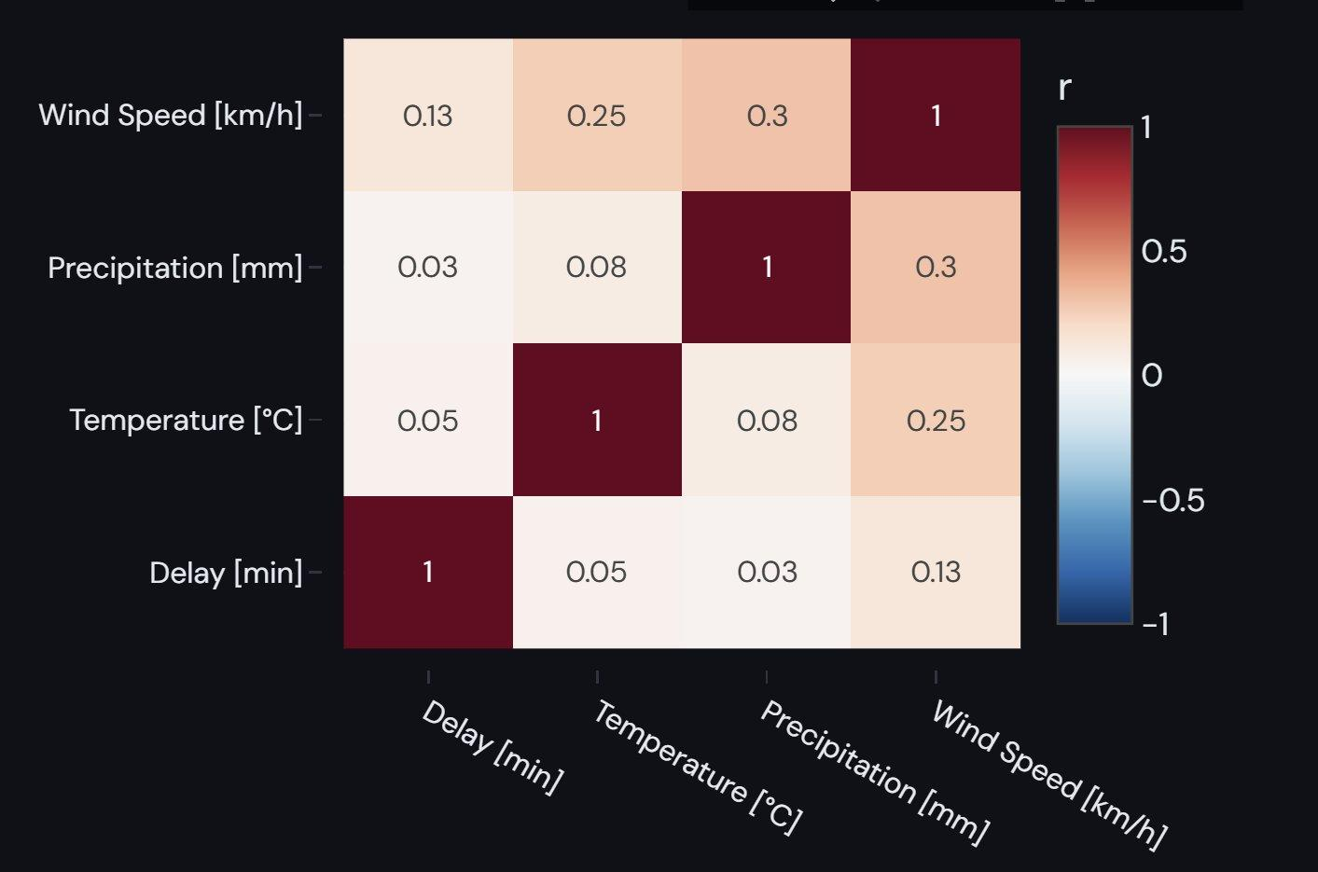
Figure 1 – Pearson correlation matrix: weather variables vs. departure delay (ZRH, Oct–Dec 2025). Axes read bottom-to-top: Delay [min], Temperature [°C], Precipitation [mm], Wind Speed [km/h].
Figure 1 shows the Pearson correlation coefficients between departure delay and the three weather variables, as rendered in the interactive dashboard. The matrix is displayed with Delay [min] on the bottom row and Wind Speed [km/h] on the top row. Wind speed exhibits the strongest correlation with delay (r = 0.13), followed by temperature (r = 0.05) and precipitation (r = 0.03). All three correlations are weak but in the expected direction: higher wind speeds and colder temperatures are associated with marginally longer delays, while precipitation shows almost no linear relationship with delay in isolation.
These results are consistent with expectations of ZRH. Zurich Airport operates procedures which substantially reduce weather sensitivity compared to smaller regional airports. The correlation matrix also confirms that the three weather predictors are not strongly collinear with one another, which means they can be added to the model without introducing multicollinearity issues that would inflate coefficient estimates.
Bar chart analyses (Figures 2–4 in the analysis script) corroborate these findings. The 30+ km/h wind group shows an above-average mean delay, and the sub-zero temperature bin (-5 to 0°C) also sits slightly above the overall mean, indicating that extreme meteorological conditions do affect operations at the margins. However, sample sizes in these extreme bins are small relative to the full dataset, so these differences must be interpreted cautiously.

3.3 Predictive Model Comparison
Table 1 summarises the performance of all models evaluated across both analysis scripts.

Model | MAE (min) | RMSE (min) | R²
LR – Baseline (v01) | 7.39 | 9.84 | 0.008
LR – Extended (v01) | 7.12 | 9.61 | 0.053
RF – Extended (v01) | 7.32 | 10.26 | -0.078
LR – Without Weather (v02) | 7.12 | 9.61 | 0.053
LR – With Weather (v02) | 7.07 | 9.54 | 0.066 | ✓ Best
RF – Without Weather (v02) | 7.32 | 10.26 | -0.078
RF – With Weather (v02) | 7.05 | 9.74 | 0.027
Table 1 – Model performance metrics on the 20% held-out test set
Across all models, MAE values cluster between 7.05 and 7.39 minutes, indicating that regardless of model architecture or feature set, average prediction error remains within a narrow band. The Linear Regression model with weather features achieves the lowest MAE (7.07 min) and the highest R² (0.066), making it the best-performing model overall. The Random Forest models perform surprisingly worse than their Linear Regression counterparts: the RF without weather features produces a negative R² (-0.078), meaning it performs worse than simply predicting the mean delay for every flight. Adding weather features brings the RF's R² to 0.027, a partial recovery, but still below the Linear Regression.
The negative R² for the baseline Random Forest is a meaningful finding. In the first analysis script (analysis_v01.py), it was noted in the code comments that route_avg_delay, while appearing important in the Random Forest's feature importance ranking, showed no meaningful trend in a scatter plot against actual delay. This suggests the model was exploiting the many available numeric split points in that continuous feature without capturing genuine predictive signal — a form of overfitting to training data structure rather than true relationships. Linear Regression, being constrained to linear combinations, is immune to this particular failure mode given this dataset.
The overall low R² values (best: 6.6%) are not unexpected. At hub airports such as ZRH, a substantial proportion of delays are reactionary, caused by inbound aircraft arriving late, crew rotation requirements, or network-level cascading effects that are by definition absent from pre-departure data. No pre-departure dataset can fully capture these dynamics, and the results confirm this fundamental ceiling on predictability given the available features.

3.4 Feature Importance

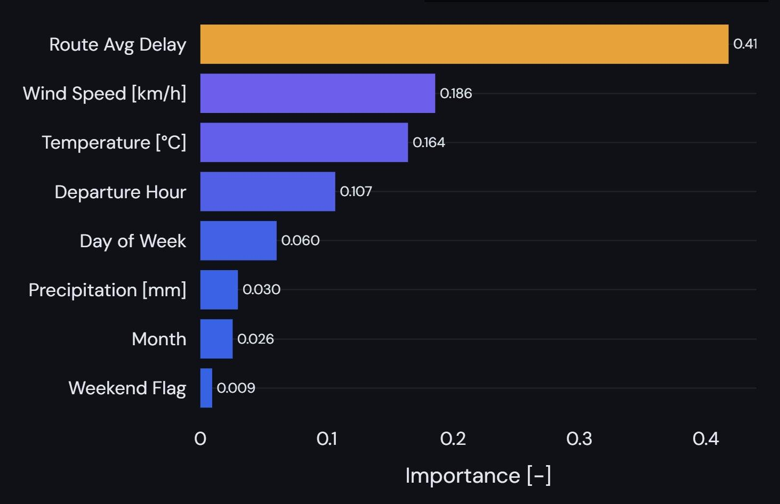
Figure 6 – Feature importance scores from the Random Forest Regressor (with weather features). Route Avg Delay (highlighted in orange) dominates at 0.41; all other features shown in blue in descending order.
Figure 6 displays the feature importance scores from the dashboard's interactive model tab, extracted from the Random Forest Regressor trained on the full weather-augmented feature set. Route average delay is highlighted in orange and dominates with an importance score of 0.41, accounting for over 40% of the model's split decisions. Wind speed (0.186) and temperature (0.164) rank second and third respectively, together contributing approximately 35% of the model's predictive weight. Departure hour (0.107) ranks fourth, followed by day of week (0.060), precipitation (0.030), month (0.026), and weekend flag (0.009), all shown in blue in descending order.
The prominence of route_avg_delay aligns with aviation domain knowledge: routes with structurally longer average delays, often longer international or connecting routes where reactionary delays are more common, tend to repeat this pattern systematically. However, as noted above, the Random Forest may be partly inflating this feature's apparent importance through its ability to exploit many numerical split points. The departure hour finding is also operationally intuitive: the morning peak brings accumulated overnight maintenance and ground handling constraints that compress available turnaround time.
Weather variables occupy the middle tier of importance. While their linear correlations with delay are weak (Figure 1), the Random Forest is able to capture non-linear threshold effects. For example, delays that spike only when wind speed exceeds a certain level, which explains why wind speed and temperature rank above strictly temporal features such as day of week and month. Precipitation's low importance score (0.030) is consistent with its near-zero linear correlation and further supports the conclusion that ZRH's infrastructure effectively absorbs moderate rainfall events.

4 Conclusion

4.1 Summary of Findings
This project delivered a complete end-to-end data science pipeline for flight delay analysis and prediction at Zurich Airport. The dataset of 29,896 flights revealed that the majority of departures are on time or only marginally delayed, with a mean delay of 5.44 minutes and a small but operationally significant tail of flights delayed beyond 15 minutes.
The three research questions can be answered as follows. First, departure delays can be predicted from pre-departure operational data, but accuracy is limited: the best model achieves an MAE of 7.07 minutes and explains only 6.6% of delay variance. Second, adding weather data does marginally improve prediction accuracy for Linear Regression (R² from 0.053 to 0.066, MAE from 7.12 to 7.07 min), but the improvement is modest. Third, route-level historical delay is the strongest single predictor, followed by wind speed and temperature among the weather variables, with the weekend flag and month contributing least.

4.2 Limitations
Several limitations constrain the current findings. The three-month observation window (October to December) captures only the autumn-winter period at ZRH, which may not generalise to spring and summer operating conditions. The most impactful drivers of real-world delay, inbound aircraft status, crew availability, gate conflicts, and network reactionary chains, are not present in the pre-departure data available through the AeroDataBox API, creating a structural ceiling on predictive performance. The Random Forest's tendency to overfit on high-cardinality continuous features such as route_avg_delay also warrants caution when interpreting feature importance rankings.

4.3 Future Work
Several directions could meaningfully extend this work. Expanding the time window to a full calendar year would allow seasonal effects to be modelled explicitly and improve the robustness of route-level delay benchmarks. Working on this project also proved to be a significant learning experience. Our primary challenge was identifying the right data source, a risk we mitigated by staying flexible, adjusting our approach as needed, and enriching the data with additional sources.

