# Lab: Sets and Maps Advanced

This document defines the lab for the ["Java Advanced" course @ Software University.](https://softuni.bg/trainings/4374/java-advanced-january-2024) Please submit your solutions (source code) to all below-described problems in [Judge](https://judge.softuni.org/Contests/1462/Sets-And-Maps-Advanced-Lab).

## Sets

### Parking Lot

Write a program that:

* Records **car numbers** for every car that enters the **parking lot.**
* Removes **car number** when the car is out.

When the parking lot is empty, print "**Parking Lot is Empty**".

#### Input

The input will be a string in the format "**{direction, carNumber}**".

The input ends with the string "**END**".

#### Output

Print the output with all car numbers which are in the parking lot.

#### Examples

|  |  |
| --- | --- |
| **Input** | **Output** |
| IN, CA2844AA  IN, CA1234TA  OUT, CA2844AA  IN, CA9999TT  IN, CA2866HI  OUT, CA1234TA  IN, CA2844AA  OUT, CA2866HI  IN, CA9876HH  IN, CA2822UU  END | CA9999TT  CA2844AA  CA9876HH  CA2822UU |
| IN, CA2844AA  IN, CA1234TA  OUT, CA2844AA  OUT, CA1234TA  END | Parking Lot is Empty |

#### Hints

* Car numbers are **unique.**
* Use the method **isEmpty().**

### SoftUni Party

There is a party in SoftUni. Many guests are invited, and they are two types: **VIP** and **regular**.   
When a guest comes, you have to check if he/she **exists** on any of the two reservation lists. All reservation numbers will be with **8 chars.** All **VIP** numbers start with a **digit.**

There will be 2 command lines:

* First is "PARTY" - the party is on, and guests are coming.
* The second is **"END"** - then the party is over, and no more guests will come.

The output shows all guests who didn't come to the party (**VIP** must be first).

#### Examples

|  |  |  |  |
| --- | --- | --- | --- |
| **Input** | **Output** | **Input** | **Output** |
| 7IK9Yo0h  9NoBUajQ  Ce8vwPmE  SVQXQCbc  tSzE5t0p  PARTY  9NoBUajQ  Ce8vwPmE  SVQXQCbc  END | 2  7IK9Yo0h  tSzE5t0p | m8rfQBvl  fc1oZCE0  UgffRkOn  7ugX7bm0  9CQBGUeJ  2FQZT3uC  dziNz78I  mdSGyQCJ  LjcVpmDL  fPXNHpm1  HTTbwRmM  B5yTkMQi  8N0FThqG  xys2FYzn  MDzcM9ZK  PARTY  2FQZT3uC  dziNz78I  mdSGyQCJ  LjcVpmDL  fPXNHpm1  HTTbwRmM  B5yTkMQi  8N0FThqG  m8rfQBvl  fc1oZCE0  UgffRkOn  7ugX7bm0  9CQBGUeJ  END | 2  MDzcM9ZK  xys2FYzn |

### "Voina" – Number Game

Write a program that:

* Reads 20 numbers for both players, separated with " " (single space).
* Every player can hold **unique** numbers.

Each Round, both players get the **top number** from their deck. The player with the bigger number gets both numbers and adds them to the **bottom** of his sequence.

The game ends after **50 rounds** or if any player **loses all** of his numbers.

#### Input

* Numbers – **Integer**

#### Output

* Output must be "**First player win!**", "**Second player win!**" or "**Draw!**".

#### Examples

|  |  |
| --- | --- |
| **Input** | **Output** |
| 26 58 16 92 44 65 65 77 57 23 71 57 7 52 85 44 32 70 38 23  43 95 33 51 62 93 57 55 0 31 32 95 68 34 30 51 37 32 11 97 | Second player win! |
| 74 78 82 42 19 39 29 69 20 42 31 77 57 36 76 26 4 9 83 42  15 43 80 71 22 88 78 35 28 30 46 41 76 51 76 18 14 52 47 38 | First player win! |

#### Hints

* Use Iterator<E> and **next()** for finding the top number in decks.
* Think where to check if any player is without cards.
* When you find the top number, be sure to remove it immediately.

#### Solution

You might help yourself with the code below:

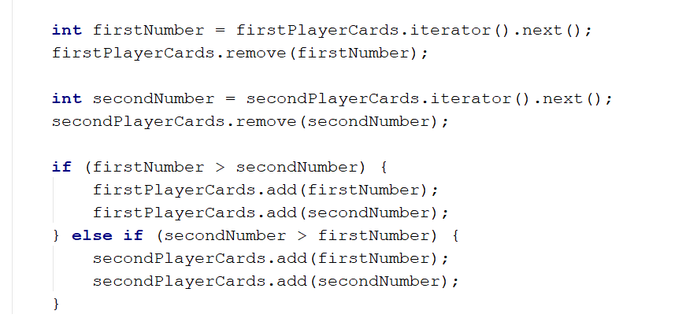

## Maps

### Count Real Numbers

Write a program that counts the occurrence of real **numbers**. The input is a single line with real numbers separated by a space. Print the numbers in the order of appearance. All **numbers** must be formatted to **one digit** after the decimal point.

#### Examples

|  |  |
| --- | --- |
| **Input** | **Output** |
| -2.5 4 3 -2.5 -5.5 4 3 3 -2.5 3 | -2.5 -> 3  4.0 -> 2  3.0 -> 4  -5.5 -> 1 |
| 2.3 4.5 4.5 5.5 5.5 2.3 3.0 3.0 4.5 4.5 3.0 3.0 4.0 3.0 5.5 3.0 2.3 5.5 4.5 3.0 | 2.3 -> 3  4.5 -> 5  5.5 -> 4  3.0 -> 7   * 1. -> 1 |

#### Solution

You might help yourself with the code below:

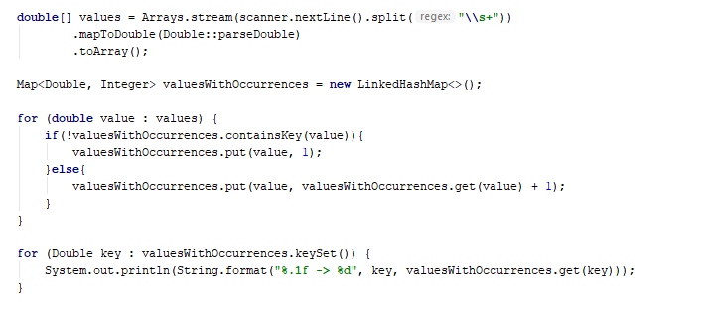

### Average Students Grades

Write a program, which reads the **name** of a student and their **grades** and **adds** them to the **student record**, then **prints** **grades** along with their **average grade – ordered the output by the students' names**.

#### Input

On the first line **N** – the number of students, then on the next, **N** lines student name with grade.

#### Examples

|  |  |
| --- | --- |
| **Input** | **Output** |
| 7  Stephan 5.20  Maria 5.50  Stephan 3.20  Maria 2.50  Alex 2.00  Maria 3.46  Alex 3.00 | Alex -> 2.00 3.00 (avg: 2.50)  Maria -> 5.50 2.50 3.46 (avg: 3.82)  Stephan -> 5.20 3.20 (avg: 4.20) |
| 4  Alex 4.50  Peter 3.00  Alex 5.00  Peter 3.66 | Alex -> 4.50 5.00 (avg: 4.75) Peter -> 3.00 3.66 (avg: 3.33) |
| 5  George 6.00  George 5.50  George 6.00  Alex 4.40  Peter 3.30  Peter 4.50 | Alex -> 4.40 (avg: 4.40)  George -> 6.00 5.50 6.00 (avg: 5.83)  Peter -> 3.30 (avg: 3.30) |

#### Hints

* Use a **TreeMap** (String -> ArrayList<Double>).
* Check if the name **exists** before adding the grade. If it doesn't, add it to the map.
* Pass through all **key-value pairs** in the map and print the results.
* Think of a way to get the average grades for each student.
* You can do that with an ordinary loop or with **Stream API.**

### Product Shop

Write a program that prints information about food shops in Sofia and the products they store. Until the "Revision" command you will receive an input in the format: "{shop}, {product}, {price}".

Keep in mind that if you get a store that already exists, you must gather product information.

Your output must be ordered by shop name and must be in the format:

"{shop}->

Product: {product}, Price: {price}"

The price should be formatted to one digit after the decimal point.

#### Examples

|  |  |
| --- | --- |
| **Input** | **Output** |
| lidl, peach, 1.20  lidl, juice, 2.30  fantastico, apple, 1.20  kaufland, banana, 1.10  fantastico, grape, 2.20  Revision | fantastico->  Product: apple, Price: 1.2  Product: grape, Price: 2.2  kaufland->  Product: banana, Price: 1.1  lidl->  Product: peach, Price: 1.2  Product: juice, Price: 2.3 |
| tmarket, peanuts, 2.20  GoGrill, meatballs, 3.30  GoGrill, HotDog, 1.40  tmarket, sweets, 2.20  Revision | GoGrill->  Product: meatballs, Price: 3.3  Product: HotDog, Price: 1.4  tmarket->  Product: peanuts, Price: 2.2  Product: sweets, Price: 2.2 |

### Cities by Continent and Country

Write a program to read **continents**, **countries,** and their **cities** put them on a **nested map,** and **print** them in the order of their first appearance.

#### Examples

|  |  |
| --- | --- |
| **Input** | **Output** |
| 9  Europe Bulgaria Sofia  Asia China Beijing  Asia Japan Tokyo  Europe Poland Warsaw  Europe Germany Berlin  Europe Poland Poznan  Europe Bulgaria Plovdiv  Africa Nigeria Abuja  Asia China Shanghai | Europe:  Bulgaria -> Sofia, Plovdiv  Poland -> Warsaw, Poznan  Germany -> Berlin  Asia:  China -> Beijing, Shanghai  Japan -> Tokyo  Africa:  Nigeria -> Abuja |
| 3  Europe Germany Berlin  Europe Bulgaria Varna  Africa Egypt Cairo | Europe:  Germany -> Berlin  Bulgaria -> Varna  Africa:  Egypt -> Cairo |
| 8  Africa Somalia Mogadishu  Asia India Mumbai  Asia India Delhi  Europe France Paris  Asia India Nagpur  Europe Germany Hamburg  Europe Poland Gdansk  Europe Germany Danzig | Africa:  Somalia -> Mogadishu  Asia:  India -> Mumbai, Delhi, Nagpur  Europe:  France -> Paris  Germany -> Hamburg, Danzig  Poland -> Gdansk |

#### Hints

* Use a **nested** **Map** (String **->** (Map -> ArrayList<String>)) .
* Check if the continent **exists** before adding the country. If it doesn't, **add** it to the dictionary.
* Check if the country **exists** before **adding** the city. If it doesn't, add it to the dictionary.

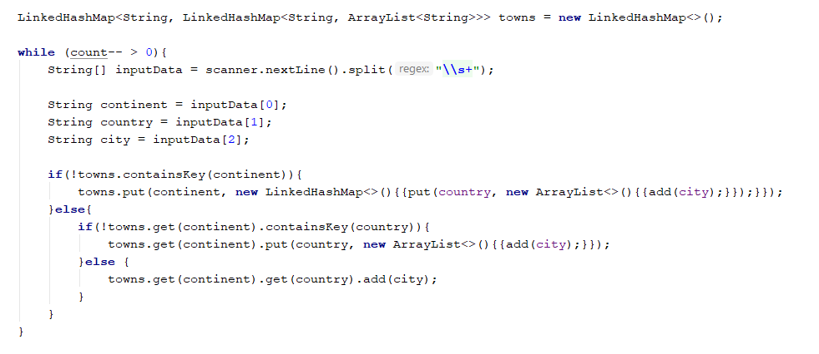

* Pass through all **key-value pairs** in the Map and the values' key-value pairs and print the results.

### Academy Graduation

Write a program that:

* Reads from console **number** of students for a track.
* Reads on **pair of rows**:
  + The first line is the **name** of the student.
  + The second line is his **score** for a different number of courses.
* Print on console "**{name} is graduated with {average scores)**".

#### Examples

|  |  |
| --- | --- |
| **Input** | **Output** |
| 3  George  3.75 5  Maria  4.25 6  Peter  6 4.5 | George is graduated with 4.375  Maria is graduated with 5.125  Peter is graduated with 5.25 |
| 5  George  4.36 5.50 3.30 5.63 2.57 5.75 2.81 4.89  Peter  3.10 5.35 3.30 3.35 5.64 4.99 2.75 4.68  Maria  3.45 3.23 3.03 5.42 5.46 4.15 2.26 5.95  Rosalia  2.08 3.48 3.36 2.73 2.96 4.54 3.70 3.85  John  4.75 4.92 3.78 4.79 4.82 4.75 2.81 2.13 | George is graduated with 4.351249999999999  John is graduated with 4.09375  Maria is graduated with 4.11875  Peter is graduated with 4.145  Rosalia is graduated with 3.3375 |

#### Hints

* Think about the **proper type** of map.
* **Value** can be an **array.**
* **A nested loop** and one more **variable** will be needed for the average score.

#### Solution

You might help yourself with the code below:

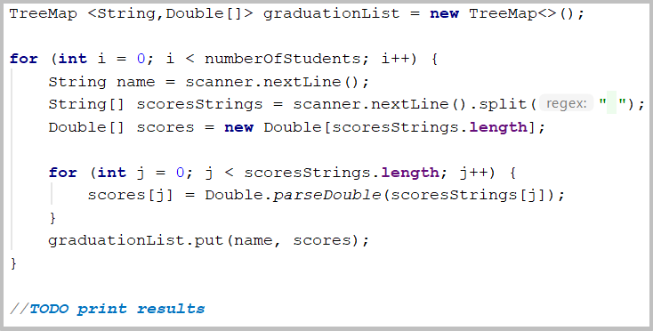

### Largest 3 Numbers

Read a **list of integers** and **print the largest 3 of them**. If there are **less** than 3, print **all** of them.

### Examples

|  |  |
| --- | --- |
| **Input** | **Output** |
| 10 30 15 20 50 5 | 50 30 20 |
| 20 30 | 30 20 |

### Hints

* Read a list of integers.
* Order the list using **Stream API.**

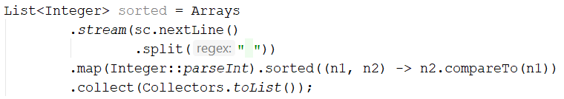

* Print the top 3 numbers with **for** loop.