# Workshop Custom Linked List

This document defines the lab for the ["Java Advanced" course @ Software University.](https://softuni.bg/trainings/4374/java-advanced-january-2024)

## Overview

In this workshop, we are going to create another custom data structure, which has similar functionalities as the **Java** LinkedList. Just like the structures from the previous workshop, our custom LinkedList will work only with integers. It will have the following functionalities:

* **void addFirst(int element)** – adds an element at the beginning of the collection
* void addLast(int element) – adds an element at the end of the collection
* int get(int index) - Returns the element at the specified position in this list
* **int removeFirst() –** removes the element at the beginning of the collection
* **int removeLast() –** removes the element at the end of the collection
* **void forEach() –** goes through the collection and executes a given action
* **int[] toArray() –** returns the collection as an array

Feel free to implement your functionality or to write the methods by yourself.

## Implement the Custom DoublyLinkedList Class

### Details about the Structure

The **Java** LinkedListuses a doubly-linked list, which provides a linear data structure that resembles a list but has different functionalities. Each element in it "knows" about the previous one, if it is such, and the next one, again, if there is such. This is possible because the **doubly linked list** has **nodes,** and each node has **two reference fields** pointing to other nodes and **a value field,** which contains some kind of data. By definition, the **doubly linked list** has a head (list start) and a tail (list end). The typical operations over a linked list **add**/**remove** an element at **both of the endings** and **traverse**. If you are interested, you can find more detailed information here: <https://en.wikipedia.org/wiki/Doubly_linked_list>. This figure shows how the structure looks:

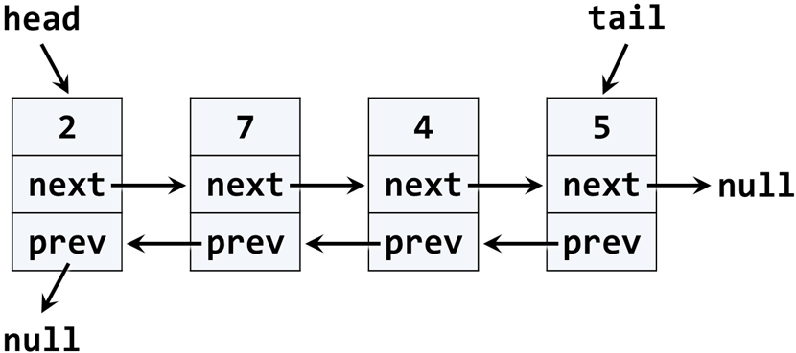

Now that we are somewhat familiar with the doubly linked list, we can proceed to the implementation of our custom doubly linked list. We will try to implement the main functionalities, but you are free to add others if interested.

### Implementation

The first step when implementing a linked / doubly linked list is to understand that we need **two classes**:

* ListNode – a class to hold a single list node (its value + next node + previous node)
* DoublyLinkedList – a class that holds the entire list (it's head + tail + operations)

Now, let's create the **ListNode** class. It should hold an item and a reference to its previous and next **node**. We can do that inside the **DoublyLinkedList** class because we will use it only internally inside it. Here is how the class should look:

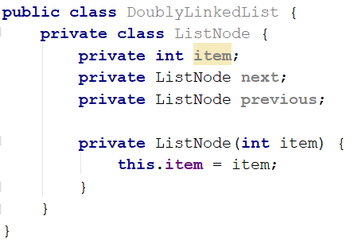

The class ListNode is called a **recursive data structure** because it references itself recursively. In this case, our nodes **item** field will be of type **int**. After the **Generics** lecture from this module, you can try to change that and make the structure generic, which means it will be able to work with any type.

### Implement Head, Tail, and Count

Now, let's define the head and tail of the doubly linked list. They will be of the type **ListNode**:

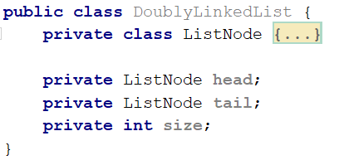

### Implement void addFirst(int element) Method

Adding an element at the beginning of the list (before its head) has **two scenarios** (considered in the above code):

* **Empty list** -> add the new element as head and tail at the same time.
* **Non-empty list** -> add the new element as a **new head** and redirect the **old head** as the second element, just after the new head.

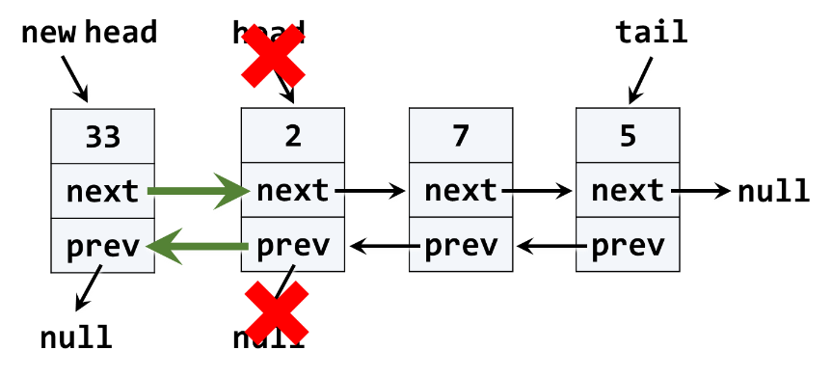

The above graphic visualizes the process of inserting a new node at the start (head) of the list. The **red** arrows denote the removed pointers from the old head. The **green** arrows denote the new pointers to the new head.

Next, implement the addFirst(int element) method:

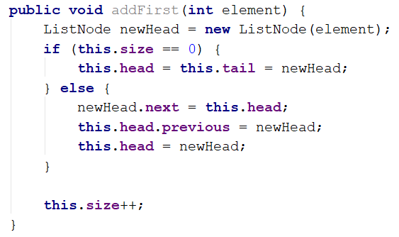

### Implement void addLast(int element) Method

Next, implement the addLast(int element) method for appending a new element as the list tail. It should be very similar to the addFirst(int element) method. The logic inside it is the same, but we append the new element at the tail instead of at the head:

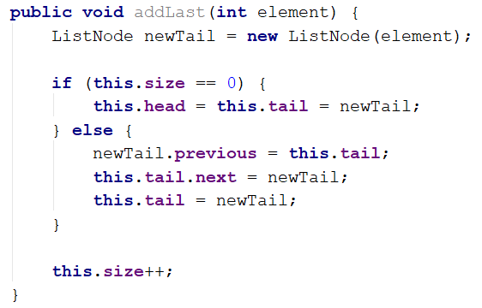

### Implement int get(int index) Method

Next, implement the get(int index) method for returning the element at the specified position in this list.

Here is how the method should work step by step.

* Check whether the given index is valid:

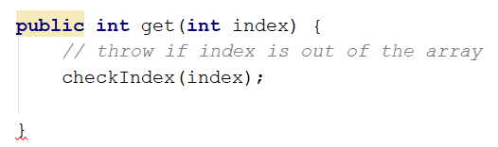

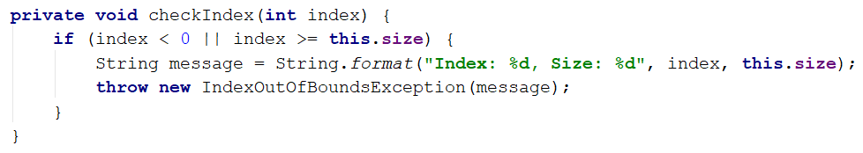

* We can optimize our iterating with the condition **if the index is less than** size / 2**,** iterate from **0** to **index** and return the **last iterated node item**. Else, iterate from size - 1 to index and again return the **last iterated node item**:

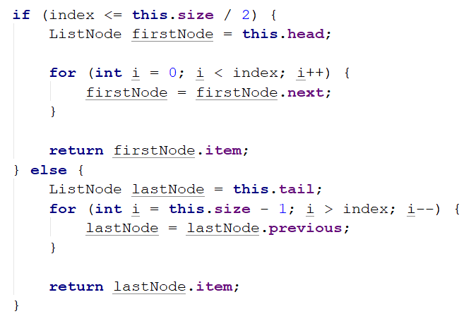

### Implement int removeFirst() Method

Next, let's implement the method removeFirst() 🡪 int. It should **remove the first element** from the list and move its head to point to the second element. The removed element should be returned as a result of the method. In case of an empty list, the method should throw an exception. We have to consider the following three cases:

* **Empty list** 🡪 throw an exception.
* **Single element in the list** 🡪 make the list empty (head == tail == null).
* **Multiple elements in the list** 🡪 remove the first element and redirect the head to point to the second element (head = head.NextNode).

A sample implementation of removeFirst() method is given below:

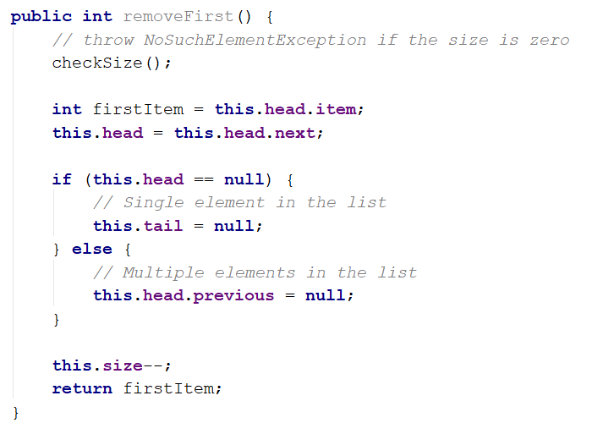

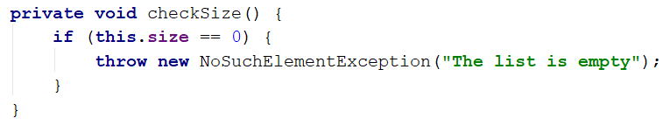

### Implement int removeLast() Method

Next, let's implement the method removeLast() -> int. It should **remove the last element** from the list and move its tail to point to the element before the last. It is very similar to the method removeFirst():

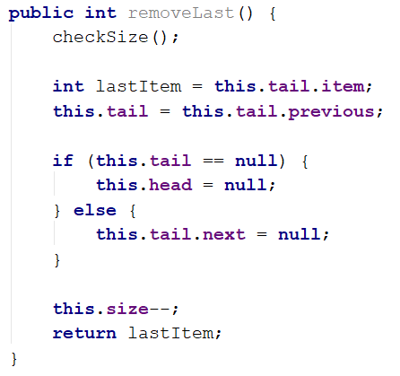

### Implement void forEach(Consumer<Integer> consumer) Method

We have a doubly-linked list. We can add elements to it. But we cannot see what is inside because the list still does not have a method to traverse its elements (pass through each one of them, one by one). Now let's define forEach(Consumer<Integer>) method. In programming, such a method is known as a ["**visitor**" pattern](https://en.wikipedia.org/wiki/Visitor_pattern). It takes as an argument a function (consumer) to be invoked for each of the elements in the list. The algorithm behind this method is simple: start from the head and pass to the next element until the last element is reached (its next element is null). A sample implementation is given below:

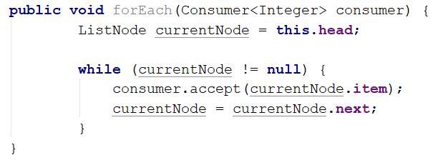

For example, if you want to print all of the items, you can use the following code:



Where **list** is **DoublyLinkedList** type object.

### Implement int[] toArray() Method

Now, implement the next method: toArray() -> int[]. It should copy all linked list elements to an array of the same size. You could use the following steps to implement this method:

* Allocate an array int[] of size this.size.
* Pass through all elements of the list and fill them to int[0], int[1], …, int[size - 1].
* Return the array as a result.

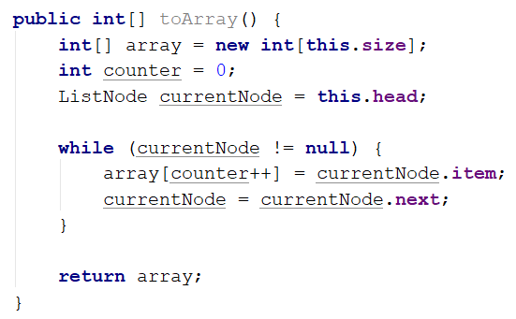

Congratulations! You have implemented your doubly linked list.

*"Somewhere, something incredible is waiting to be known."* – **Carl Sagan**