# Java Basic Web Project: Phonebook

Problems for exercises for the ["Programming Fundamentals" course @ SoftUni.](https://softuni.bg/trainings/4381/programming-fundamentals-with-java-january-2024)

## Problem

You have been tasked to create a simple **Phonebook** application. The application should hold **contacts**, which are the main app **entity**.

The functionality of the application should support:

* **Listing contacts**

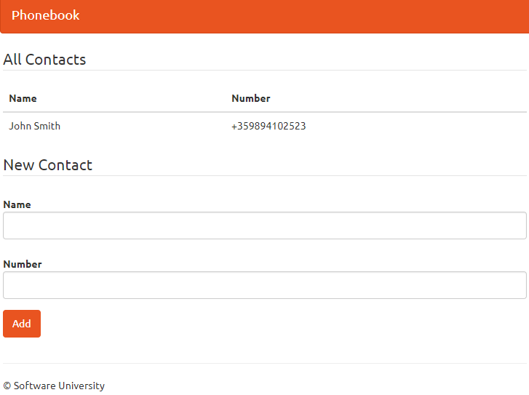

* **Add Contact**

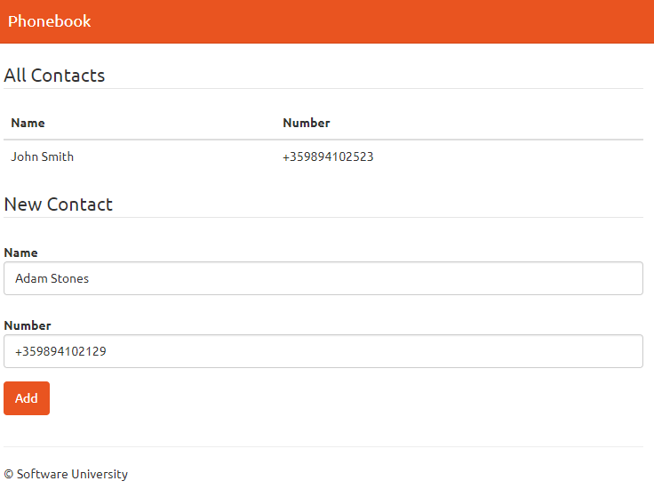

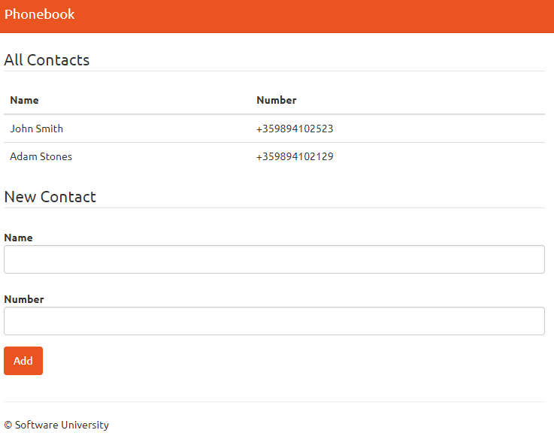

## Overview

### Requirements

* **Spring** framework (**Spring MVC** + **Spring Boot** + **Spring Data**)
* **Thymeleaf** view engine

### Data Model

The Contact entity holds **2 properties**:

* name – non-empty text
* number – non-empty text

### Project Skeletons

You will be given the applications' skeletons, which hold about **90%** of the logic. You'll be given some **files**. The files will have **partially implemented logic**, so you'll need to write some code for the application to **function properly**.

The application's views will be given to you fully implemented. You only need to include them in your business logic.

Everything that has been given to you inside the skeleton is **correctly implemented,** and if you write your code **correctly**, the application should work just fine. You are free to change anything in the Skeleton on your account.

## Setting Up IntelliJ Idea Configuration

Start **IntelliJ** and **import** the skeleton.

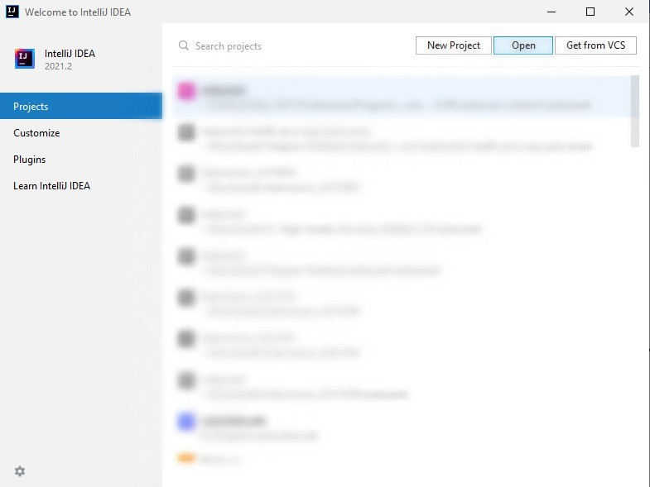

Now we need to **set up** our **project. Choose** the directory you've downloaded your skeleton and **click OK.**

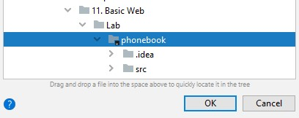

You can start working on your code!

## Contact Entity

It's time to create our first entity. In the src/main/java/phonebook **package,** you can see a few packages that **define our project**. A **package** is a **folder** **containing** **Java** files. The one we are interested in is the "entity" package. Inside, create a **new** **java class** called "Contact":

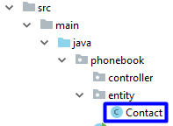

The file should look like this:

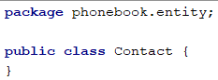

We need to define our contact entity. Create the following private fields:

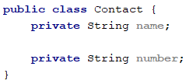

Let's create [getters and setters](http://java.about.com/od/workingwithobjects/a/accessormutator.htm) for our fields. You should already be familiar with them. If you are curious why we are doing that, you can read more [here](https://www.tutorialspoint.com/java/java_encapsulation.htm). There is a **simple way to create them** in **IntelliJ Idea**. If you press   
"Alt + Insert", you should see that context menu:

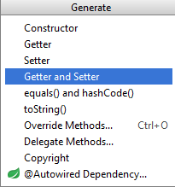

Choosing the "**Getter and Setter**" option will **open a new window**. You should select **all private fields** from there:

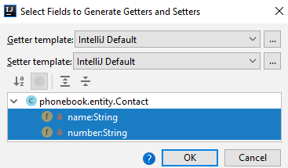

When you **click** "**OK**", you should **receive this code**:

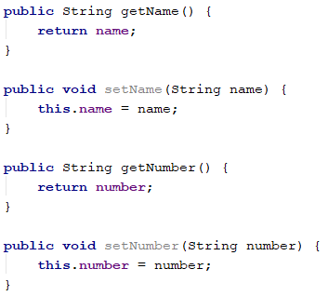

It's time to **create our constructor**:

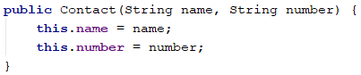

We will **use** **this** **constructor** to **create tasks** easily. However, we need to create another **empty** **constructor** for **Spring**:



And this is pretty much everything. Our Contact entity is ready.

## Contact Controller

We have reached the point at which we can create our **controller**. In the "controller" package create a new class called "ConctactController":

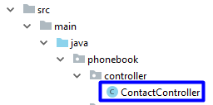

Add the following annotation:

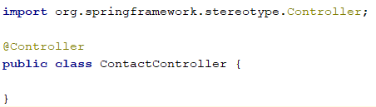

This class will **list** and **save** contacts. That means that it will use **routes**. To let **Spring** know that this class will be a controller, we need to use the "@Controller" annotation. This annotation also gives us **access** to **requests** and gives us the ability to respond to them. Now, we need to store contacts somewhere. We will use a **list**. Later in the course, we will learn how to store information in the **database**.

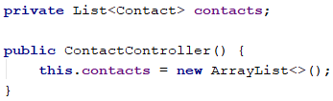

We need to **initialize** our list, so we will do it through the **constructor**.

### Listing All Tasks

First, we need to list all articles to the given route. Go to the ContactControllerand create the method index.

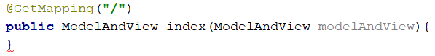

The "@GetMapping" annotation tells **Spring** that this method **cannot be called** if the user wants to **submit data**. It should only be **used** for **viewing data**. ModelAndView allows us to pass all the information required by **Spring MVC** in one return:

We have only one **view** which we will use in our application, called "index". If you look at the view, you will find:

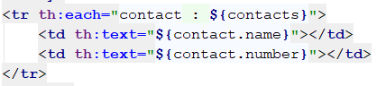

This means that our view expects a collection called "contacts", so we have to add contactsto the modelAndViewand return it as a result:

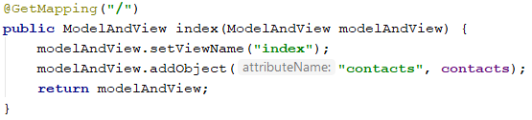

We are ready to list all contacts.

### Adding Contact

As we have mentioned, we have only one view. If you go back to the view and take a look once again, you will find a **form**:

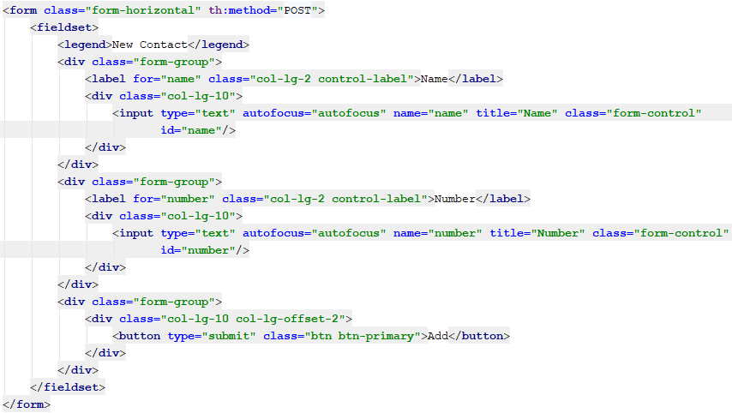  
Thanks to the form, we can process post requests.

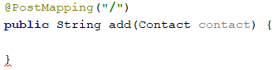

**Spring** will automatically map the data into a contact object if we've created it correctly.

With the "@PostMapping" annotation, we told **Spring** that **this method expects data** that it needs to **autofill in the** contact **object**. The annotation handles "POST" **requests** that are usually what the **HTML forms** are using as a "method" of the **request**. In summary, **this method** will be called **when users submit the data**.

Finally, we need to **add the contact to our list** and give a **response** to the user.

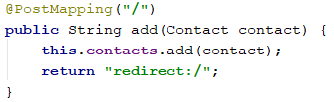

We redirect the user back to the index page as a response.

With that, we finished our **Java Phonebook**. Feel free to **build on your project even further**.