# Lab: Lists

Problems with exercises and homework for the ["Programming Fundamentals" course @ SoftUni.](https://softuni.bg/trainings/4381/programming-fundamentals-with-java-january-2024)

You can check your solutions in [Judge.](https://judge.softuni.org/Contests/1295)

## List Manipulation Basics

Write a program that reads a list of integers. Then until you receive **"end"**, you will be given different **commands:**

* **Add {number}** –add a number to the end of the list
* **Remove {number}** – remove a number from the list
* **RemoveAt {index}** – remove a number at a given index
* **Insert {number} {index}** – insert a number at a given index

**Note: All the indices will be valid!**

When you receive the **"end"** command, print the **final state** of the list (**separated by spaces**).

### Examples

|  |  |
| --- | --- |
| **Input** | **Output** |
| 4 19 2 53 6 43  Add 3  Remove 2  RemoveAt 1  Insert 8 3  end | 4 53 6 8 43 3 |
| 12 34 100 1 45 2 8  Add 30  Remove 12  Remove 3  RemoveAt 3  Insert 2 3  end | 34 100 1 2 2 8 30 |

### Solution

First, let us read the list from the console.

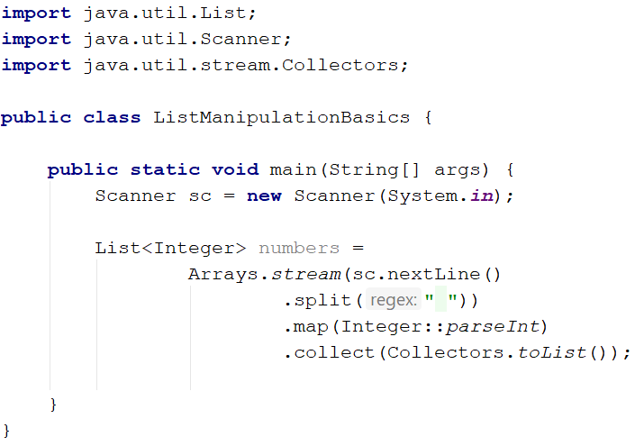

Next, we make the while loop for the commands and make a switch statement for the commands.

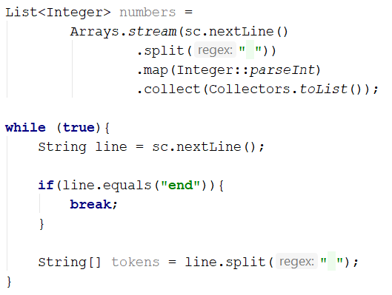

We break if the line is "**end**", otherwise, we split it into tokens and process the command.

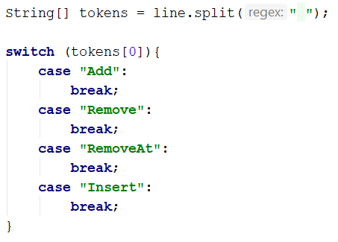

Now let's implement each command.

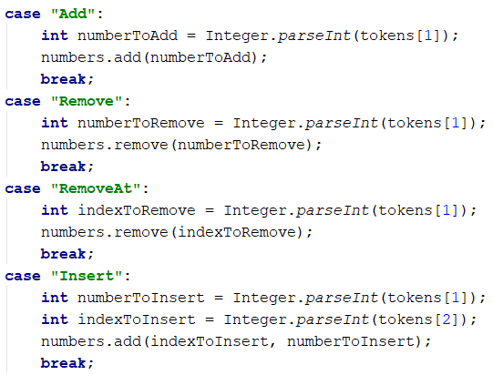

For all commands **except** the **"Insert",** **tokens[1]** is the **number/index**. For the **"Insert"** command, we receive a **number and an index** (**tokens[1], tokens[2]**).

Finally, we **print** the numbers, joined by **a single space:**

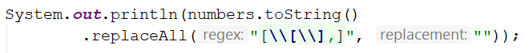

## Gauss' Trick

Write a program that **sum** all **numbers in a list** in the following order:

first **+** last, first + 1 **+** last - 1,first + 2 **+** last **-** 2**,** … first + n, last - n.

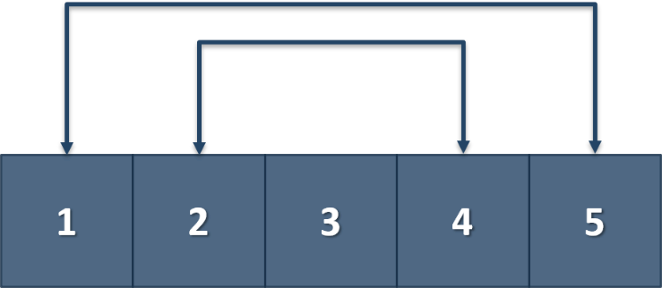

### Example

|  |  |
| --- | --- |
| **Input** | **Output** |
| 1 2 3 4 5 | 6 6 3 |
| 1 2 3 4 | 5 5 |

## Merging Lists

You are going to receive two lists with numbers. Create a result list that contains the numbers from both of the lists. The first element should be from the first list, the second from the second list, and so on. If the length of the two lists is not equal, just add the remaining elements at the end of the list.

### Examples

|  |  |
| --- | --- |
| **Input** | **Output** |
| 3 5 2 43 12 3 54 10 23  76 5 34 2 4 12 | 3 76 5 5 2 34 43 2 12 4 3 12 54 10 23 |
| 76 5 34 2 4 12  3 5 2 43 12 3 54 10 23 | 76 3 5 5 34 2 2 43 4 12 12 3 54 10 23 |

### Hint

* Read the two lists.
* Create a result list.
* Start looping through them until you reach the end of the smallest one.
* Finally, add the remaining elements (if any) to the end of the list.

## List Manipulation Advanced

Now we will implement more complicated list commands. Again, read a list, and until you receive **"end"** read commands:

* **Contains {number}** – check if the list contains the number. If **yes,** print **"Yes**", **otherwise,** print **"No such number"**
* **Print even** – print **all the numbers** that are **even** **separated by a space**
* **Print odd** – print **all the numbers** that are **oddly separated by a space**
* **Get sum** – print the **sum of all the numbers**
* **Filter {condition} {number}** – print all the numbers that **fulfill that condition**. The condition will be either **'<'**, **'>', ">=", "<="**

### Examples

|  |  |
| --- | --- |
| **Input** | **Output** |
| 2 13 43 876 342 23 543  Contains 100  Contains 543  Print even  Print odd  Get sum  Filter >= 43  Filter < 100  end | No such number  Yes  2 876 342  13 43 23 543  1842  43 876 342 543  2 13 43 23 |
| 12 3 123 546 222 45 7  Contains 3  Contains 121  Print even  Print odd  Get sum  Filter >= 100  Filter < 45  end | Yes  No such number  12 546 222  3 123 45 7  958  123 546 222  12 3 7 |

## List of Products

Read a number **n** and **n lines of products**. Print a **numbered list** of all the products **ordered by name**.

### Examples

|  |  |
| --- | --- |
| **Input** | **Output** |
| 4  Potatoes  Tomatoes  Onions  Apples | 1.Apples  2.Onions  3.Potatoes  4.Tomatoes |
| 3  Orange  Grape  Strawberry | 1.Grape  2.Orange  3.Strawberry |

### Solution

First, we need to read the number **n** from the console.

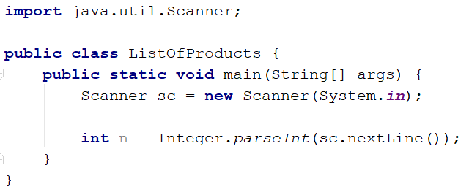

Then we need to create our **list of strings** because the **products are strings.**

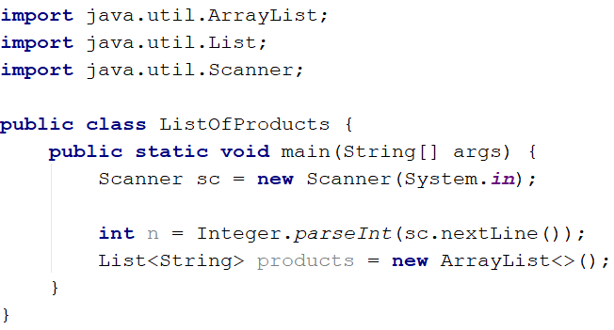

Then we need to iterate **n times** and **read products**.

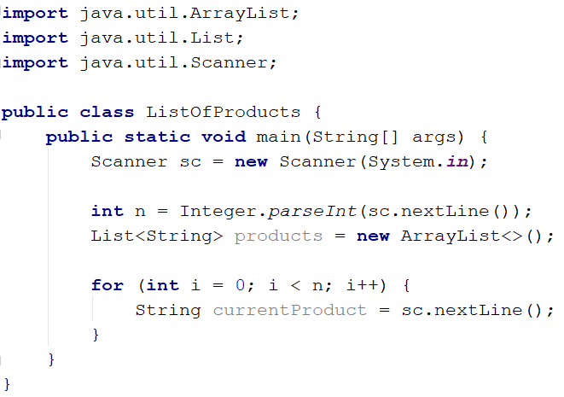

The next step is to add the current product to the list.

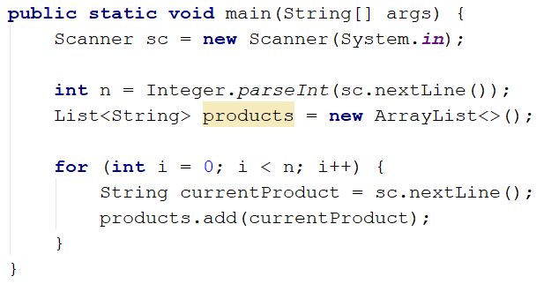

After we finish reading the products, we **sort our list alphabetically.**

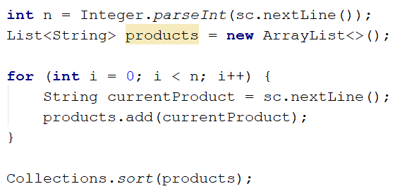

The **sort method** sorts the list in ascending order.

Finally, we have to **print our sorted** list. To do that we **loop through the list**.

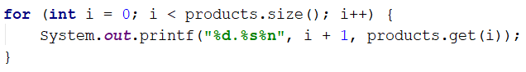

We use **i + 1** because we want to **start counting from 1**.

## Remove Negatives and Reverse

Read a **list of integers**, **remove all negative numbers** from it and print the remaining elements in **reversed order**. In case of no elements left in the list, print "empty".

### Examples

|  |  |
| --- | --- |
| **Input** | **Output** |
| 10 -5 7 9 -33 50 | 50 9 7 10 |
| 7 -2 -10 1 | 1 7 |
| -1 -2 -3 | empty |

### Solution

Read a list of integers.

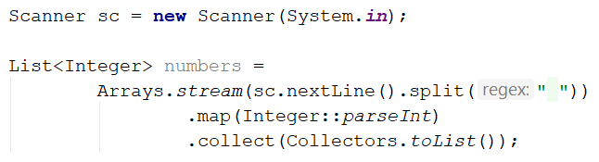

Remove all negative numbers and reverse the collection.



If the list is empty, print "**empty**", otherwise, print all numbers joined by space.

