作業1 : 練習使用一個民生物聯網 API，例如空氣、地震等感測站所回傳的紀錄資料。

           參考資料網址： [**https://ci.taiwan.gov.tw/dsp/environmental.aspx**](https://ci.taiwan.gov.tw/dsp/environmental.aspx)

Ans：

以水利署API查詢雨量感測器資料，

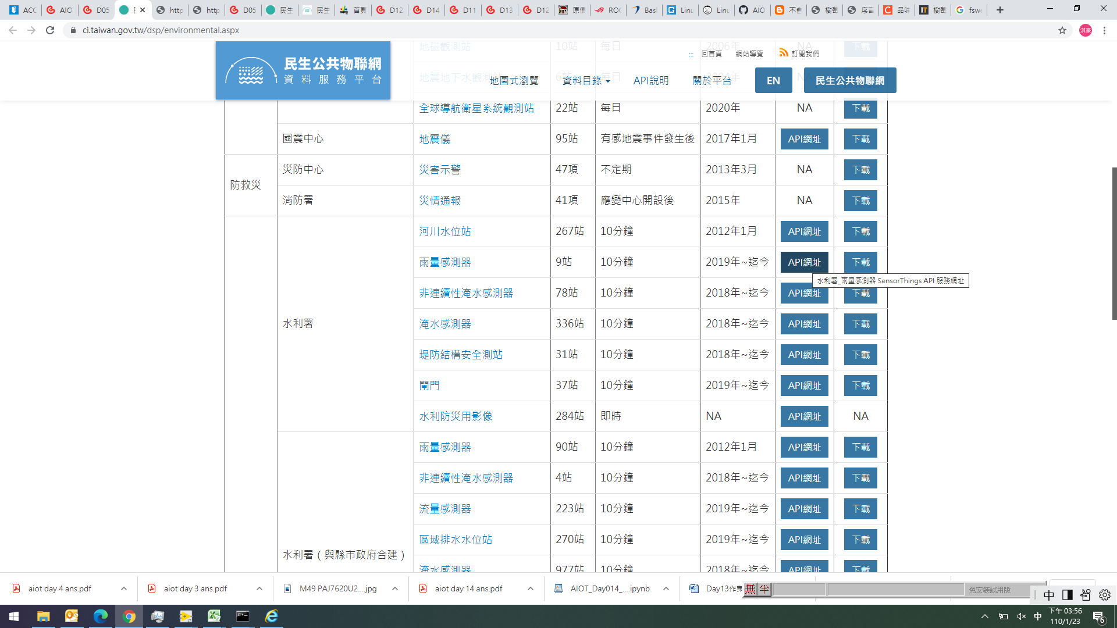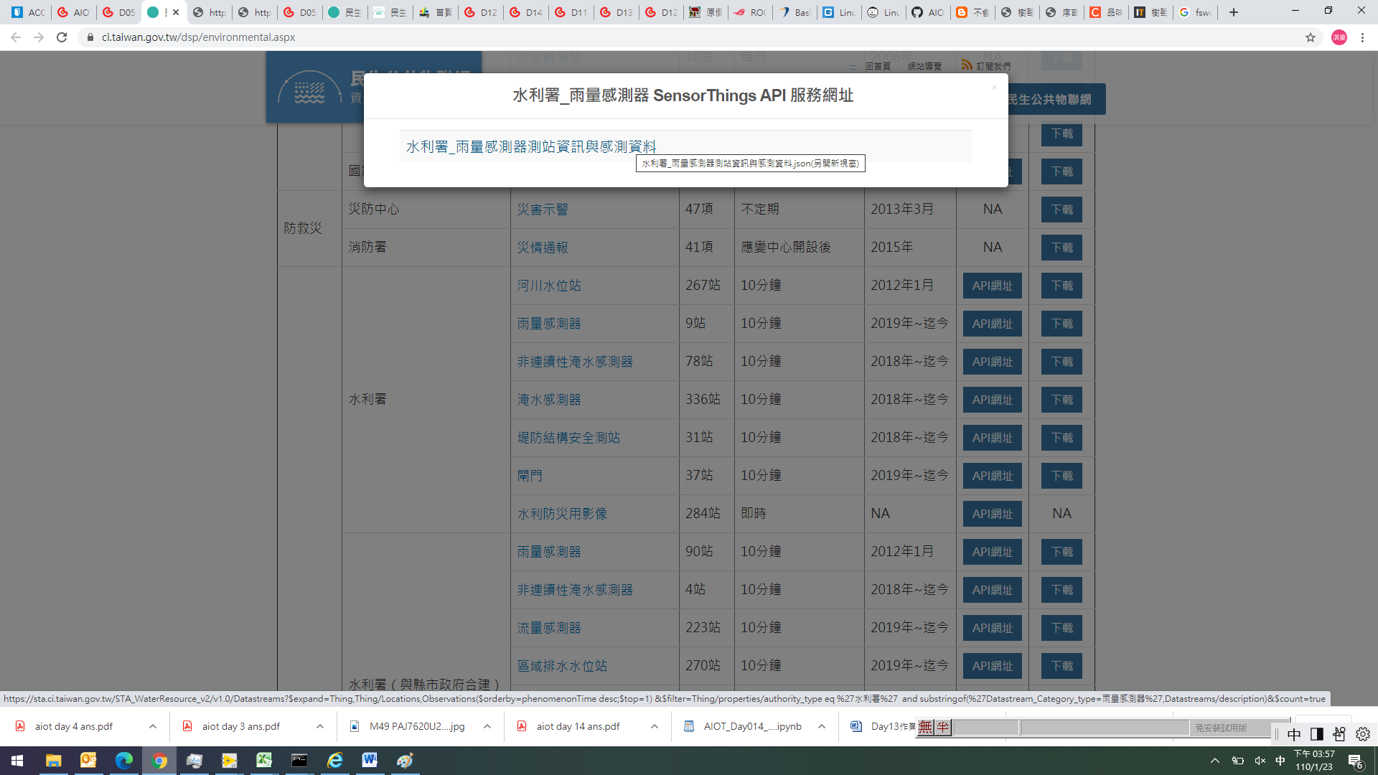

查詢頭前溪雨量水位感測器資料

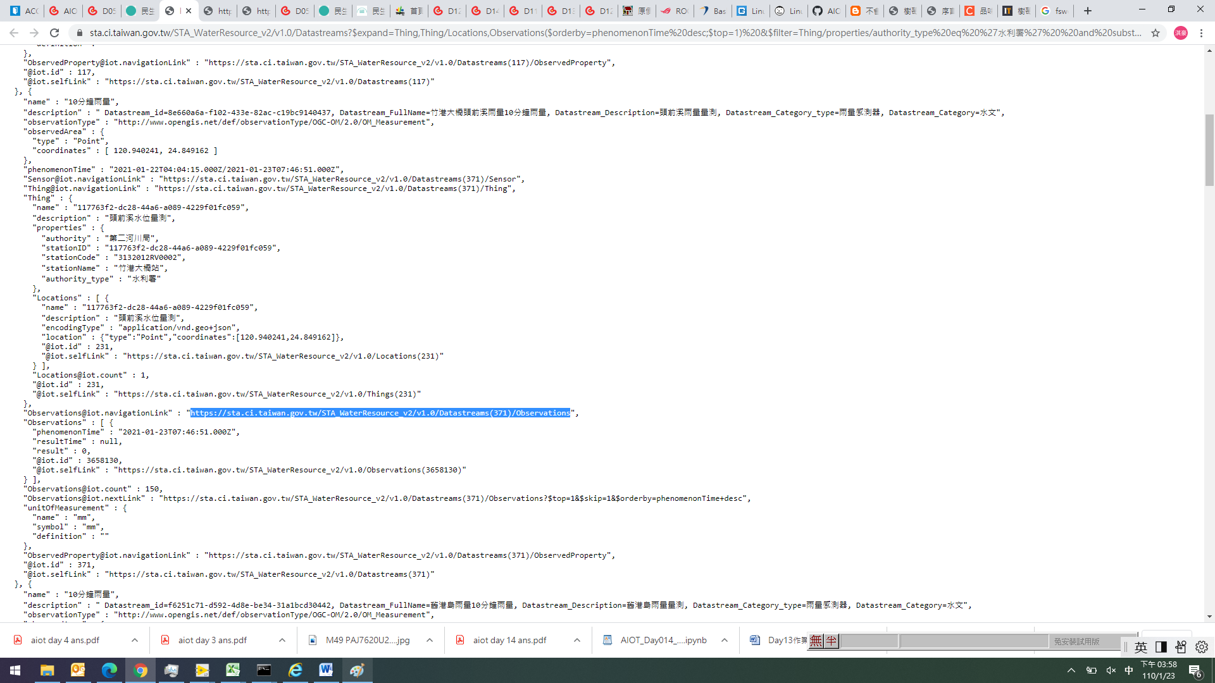

不同時間點的雨量水位感測器數值

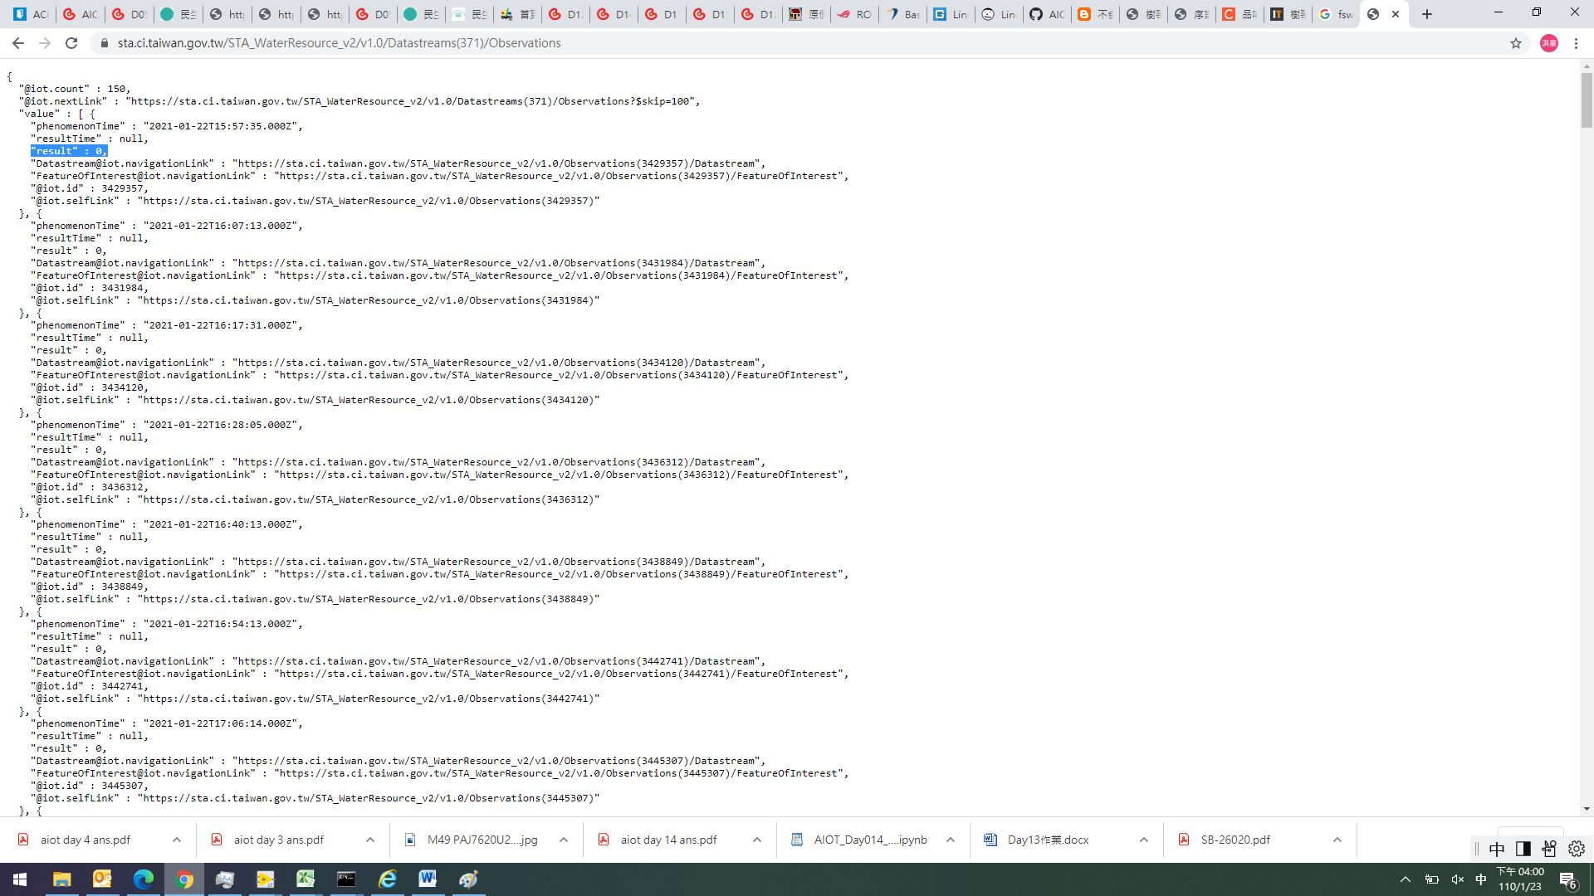

作業2 : 練習操作 OGC SensorThings API，將環保局測站位置的資料抓取下來，並且觀察下載資料的內容。

           參考網址：**[https://sta.ci.taiwan.gov.tw/STA\_AirQuality\_EPAIoT/v1.0/Things](https://sta.ci.taiwan.gov.tw/STA_AirQuality_EPAIoT/v1.0/Things" \t "_blank)**

**Ans：**

**進入環保局測站OGC SensorThings API URL後，會出現各個測站的資訊，框選”苗栗縣西山工業區”測站資訊如下**

{"description":"智慧城鄉空品微型感測器-9330689794","@iot.id":3,"name":"智慧城鄉空品微型感測器-9330689794","properties":{"city":"苗栗縣","areaType":"工業區","isMobile":"false","township":"苗栗市","authority":"行政院環境保護署","isDisplay":"true","isOutdoor":"true","stationID":"9330689794","locationId":"A0191","Description":"經昌/CE003","areaDescription":"西山工業區"},"@iot.selfLink":"https://sta.ci.taiwan.gov.tw/STA\_AirQuality\_EPAIoT/v1.0/Things(3)","Locations@iot.navigationLink":"**https://sta.ci.taiwan.gov.tw/STA\_AirQuality\_EPAIoT/v1.0/Things(3)/Locations**","Datastreams@iot.navigationLink":"https://sta.ci.taiwan.gov.tw/STA\_AirQuality\_EPAIoT/v1.0/Things(3)/Datastreams","TaskingCapabilities@iot.navigationLink":"https://sta.ci.taiwan.gov.tw/STA\_AirQuality\_EPAIoT/v1.0/Things(3)/TaskingCapabilities","HistoricalLocations@iot.navigationLink":"https://sta.ci.taiwan.gov.tw/STA\_AirQuality\_EPAIoT/v1.0/Things(3)/HistoricalLocations","MultiDatastreams@iot.navigationLink":"https://sta.ci.taiwan.gov.tw/STA\_AirQuality\_EPAIoT/v1.0/Things(3)/MultiDatastreams"}

**再進入該Location URL後，可得知此測站座標、名稱如下所示**

{"@iot.count":1,"value":[{"description":"智慧城鄉空品微型感測器-9330689794","encodingType":"application/vnd.geo+json","@iot.id":3,"location":{"type":"Point","**coordinates":[120.8083677,24.593241]},"name":"智慧城鄉空品微型感測器**-9330689794","@iot.selfLink":"https://sta.ci.taiwan.gov.tw/STA\_AirQuality\_EPAIoT/v1.0/Locations(3)","Things@iot.navigationLink":"https://sta.ci.taiwan.gov.tw/STA\_AirQuality\_EPAIoT/v1.0/Locations(3)/Things","HistoricalLocations@iot.navigationLink":"https://sta.ci.taiwan.gov.tw/STA\_AirQuality\_EPAIoT/v1.0/Locations(3)/HistoricalLocations"}]}

作業3 : 依據作業 2 所下載的各個環保局測站感測器的描述資料，進一步點選 Datastreams、Locations，以及 Datastreams 點選進入後，點選 Observations 的 URL，觀察所下載到的資料內容，其中 Observations 內部是否包含個別感測器紀錄的資料。

Ans：

Datastreams點選進入後，顯示如下，可以再進一步查詢細懸微粒、溫度、相對溼度：

{"@iot.count":3,"value":[{"description":"細懸浮微粒 PM2.5","@iot.id":7,"name":"PM2.5","observationType":"http://www.opengis.net/def/observationType/OGC-OM/2.0/OM\_Measurement","observedArea":{"type":"Point","coordinates":[120.8083677,24.593241]},"phenomenonTime":"2021-01-23T04:00:22.000Z/2021-01-23T08:26:26.000Z","resultTime":null,"@iot.selfLink":"https://sta.ci.taiwan.gov.tw/STA\_AirQuality\_EPAIoT/v1.0/Datastreams(7)","unitOfMeasurement":{"name":"microgram per cubic meter","symbol":"μg/m3","definition":"https://acronyms.thefreedictionary.com/ug%2Fm3"},"ObservedProperty@iot.navigationLink":"https://sta.ci.taiwan.gov.tw/STA\_AirQuality\_EPAIoT/v1.0/Datastreams(7)/ObservedProperty","**Observations@iot.navigationLink":"https://sta.ci.taiwan.gov.tw/STA\_AirQuality\_EPAIoT/v1.0/Datastreams(7)/Observations**","Sensor@iot.navigationLink":"https://sta.ci.taiwan.gov.tw/STA\_AirQuality\_EPAIoT/v1.0/Datastreams(7)/Sensor","Thing@iot.navigationLink":"https://sta.ci.taiwan.gov.tw/STA\_AirQuality\_EPAIoT/v1.0/Datastreams(7)/Thing"},{"description":"相對溼度","@iot.id":8,"name":"Relative humidity","observationType":"http://www.opengis.net/def/observationType/OGC-OM/2.0/OM\_Measurement","observedArea":{"type":"Point","coordinates":[120.8083677,24.593241]},"phenomenonTime":"2021-01-23T04:00:22.000Z/2021-01-23T08:26:26.000Z","resultTime":null,"@iot.selfLink":"https://sta.ci.taiwan.gov.tw/STA\_AirQuality\_EPAIoT/v1.0/Datastreams(8)","unitOfMeasurement":{"name":"percentage","symbol":"%","definition":"https://en.wikipedia.org/wiki/Percentage"},"ObservedProperty@iot.navigationLink":"https://sta.ci.taiwan.gov.tw/STA\_AirQuality\_EPAIoT/v1.0/Datastreams(8)/ObservedProperty","Observations@iot.navigationLink":"https://sta.ci.taiwan.gov.tw/STA\_AirQuality\_EPAIoT/v1.0/Datastreams(8)/Observations","Sensor@iot.navigationLink":"https://sta.ci.taiwan.gov.tw/STA\_AirQuality\_EPAIoT/v1.0/Datastreams(8)/Sensor","Thing@iot.navigationLink":"https://sta.ci.taiwan.gov.tw/STA\_AirQuality\_EPAIoT/v1.0/Datastreams(8)/Thing"},{"description":"溫度","@iot.id":9,"name":"Temperature","observationType":"http://www.opengis.net/def/observationType/OGC-OM/2.0/OM\_Measurement","observedArea":{"type":"Point","coordinates":[120.8083677,24.593241]},"phenomenonTime":"2021-01-23T04:00:22.000Z/2021-01-23T08:26:26.000Z","resultTime":null,"@iot.selfLink":"https://sta.ci.taiwan.gov.tw/STA\_AirQuality\_EPAIoT/v1.0/Datastreams(9)","unitOfMeasurement":{"name":"degree celsius","symbol":"°C","definition":"https://en.wikipedia.org/wiki/Celsius"},"ObservedProperty@iot.navigationLink":"https://sta.ci.taiwan.gov.tw/STA\_AirQuality\_EPAIoT/v1.0/Datastreams(9)/ObservedProperty","Observations@iot.navigationLink":"https://sta.ci.taiwan.gov.tw/STA\_AirQuality\_EPAIoT/v1.0/Datastreams(9)/Observations","Sensor@iot.navigationLink":"https://sta.ci.taiwan.gov.tw/STA\_AirQuality\_EPAIoT/v1.0/Datastreams(9)/Sensor","Thing@iot.navigationLink":"https://sta.ci.taiwan.gov.tw/STA\_AirQuality\_EPAIoT/v1.0/Datastreams(9)/Thing"}]}

**點選**”細懸微粒” **Observations 的 URL後，可查詢此感測器不同時間的數值**

{"@iot.count":222,"@iot.nextLink":"https://sta.ci.taiwan.gov.tw/STA\_AirQuality\_EPAIoT/v1.0/Datastreams(7)/Observations?$skip=100","value":[{"@iot.id":204326088,"phenomenonTime":"2021-01-23T04:02:23.000Z","result":20.713,"resultTime":null,"@iot.selfLink":"https://sta.ci.taiwan.gov.tw/STA\_AirQuality\_EPAIoT/v1.0/Observations(204326088)","Datastream@iot.navigationLink":"https://sta.ci.taiwan.gov.tw/STA\_AirQuality\_EPAIoT/v1.0/Observations(204326088)/Datastream","MultiDatastream@iot.navigationLink":"https://sta.ci.taiwan.gov.tw/STA\_AirQuality\_EPAIoT/v1.0/Observations(204326088)/MultiDatastream","FeatureOfInterest@iot.navigationLink":"https://sta.ci.taiwan.gov.tw/STA\_AirQuality\_EPAIoT/v1.0/Observations(204326088)/FeatureOfInterest"},{"@iot.id":206855355,"phenomenonTime":"2021-01-23T07:02:06.000Z","**result":13.859**,"resultTime":null,"@iot.selfLink":"https://sta.ci.taiwan.gov.tw/STA\_AirQuality\_EPAIoT/v1.0/Observations(206855355)","Datastream@iot.navigationLink":"https://sta.ci.taiwan.gov.tw/STA\_AirQuality\_EPAIoT/v1.0/Observations(206855355)/Datastream","MultiDatastream@iot.navigationLink":"https://sta.ci.taiwan.gov.tw/STA\_AirQuality\_EPAIoT/v1.0/Observations(206855355)/MultiDatastream","FeatureOfInterest@iot.navigationLink":"https://sta.ci.taiwan.gov.tw/STA\_AirQuality\_EPAIoT/v1.0/Observations(206855355)/FeatureOfInterest"}