Load (load_pyrobot_env)
source pyenv_pyrobot/bin/activate

source low_cost_ws/devl/setup.bash
source sis2021/environment.sh
roslaunch locobot_control main.launch use_arm:=true teleop:=true

[new terminal]
source pyenv_pyrobot/bin/activate
python ~/low_cost_ws/src/pyrobot/robots/LoCoBot/locobot_control/nodes/robot_teleop_server.py

[new terminal]
source pyenv_pyrobot/bin/activate
python ~/low_cost_ws/src/pyrobot/robots/LoCoBot/locobot_control/nodes/keyboard_teleop_client.py

rosrun rqt_graph rqt_graph

roslaunch locobot_control main.launch use_arm:=false teleop:=false

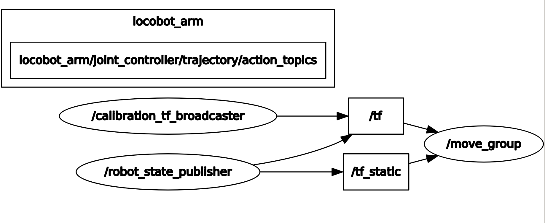
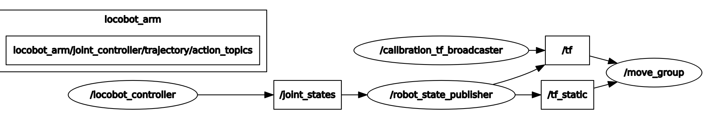
roslaunch locobot_control main.launch use_arm:=true teleop:=false
roslaunch locobot_control main.launch use_arm:=true teleop:=true
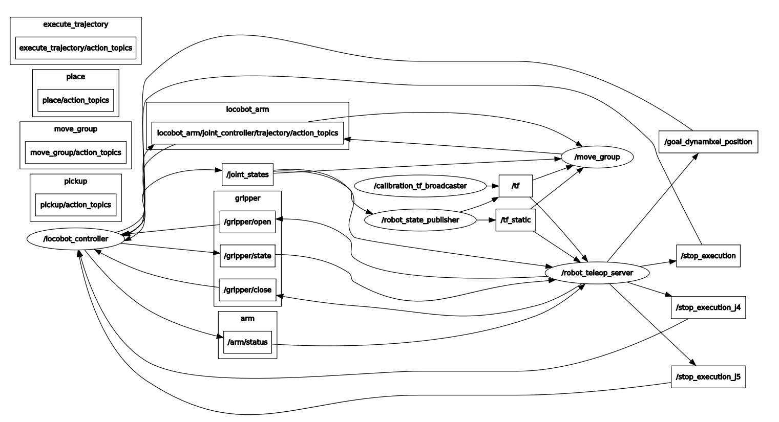
python ~/low_cost_ws/src/pyrobot/robots/LoCoBot/locobot_control/nodes/robot_teleop_server.py

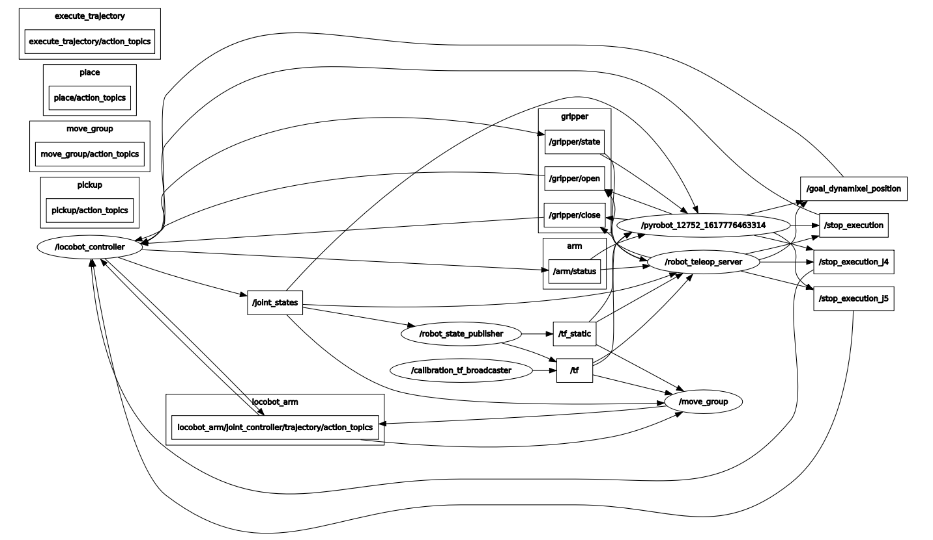

python ~/low_cost_ws/src/pyrobot/robots/LoCoBot/locobot_control/nodes/keyboard_teleop_client.py
