**Mini – Project on Embeddings of Graphs**

Directed by Prof. Michael Elkin.

**Table of contents**

1. Presenting the chosen paper
2. The Algorithm
3. The Implementation of The Algorithm
4. Research question
5. The Experiments
6. The Results of your experiments
7. The conclusion
8. Directions for future work.

**Section 1: The Paper**

The algorithm implemented in this project is from the paper by Elkin, M. 2011: “Streaming and fully dynamic centralized algorithms for constructing and maintaining sparse spanners”.

The paper devises a streaming algorithm for the construction of sparse spanners for unweighted undirected graphs.

Graph spanners are fundamental structures in algorithmic graph theory, used to approximate distances in large graphs with significantly fewer edges. The paper focuses on the problem of constructing 2t-1 spanners, that is for every edge (u,v) in the original graph, the distance between u and v in the spanner is at most (2t-1).

Prior to this paper, a known algorithm is the streaming algorithm of Feigenbaum et al. (2008) which had a processing time per edge of O(t2·log n·n1/(t-1)). Elkin's 2011 paper presents a new algorithm for constructing sparse spanners in the streaming model which, compared to the previous algorithm, constructs a spanner with a smaller number of edges and with a smaller number of bits of space used, using far less processing time per edge without any costs.

The paper provides a streaming algorithm for constructing (2t−1)-spanners with an optimal per-edge processing time of O(1), while also achieving strong guarantees on spanner size and stretch. The algorithm itself uses $O\left(t*{\left(\log{n}\right)}^{2-\frac{1}{t}}*n^{1+\frac{1}{t}}\right)$ bits of memory and with high probability the spanner contains $O\left(t*n^{1+\frac{1}{t}}*{\left(\log{n}\right)}^{1-\frac{1}{t}}\right)$ edges.

Furthermore, the paper introduces the first fully dynamic algorithm to offer non-trivial bounds on both insertion and deletion update times, filling a gap left by earlier spanner algorithms that were either static or only efficient in limited scenarios.

These results hold for unweighted graphs and can be extended to some weighted cases with slight modifications. The algorithm presented combines little time edge processing, support for streaming and dynamic models, and efficient space and update performance.

**Section 2: The Algorithm**

The algorithm implemented in this project is the streaming spanner construction algorithm. It constructs a spanner that approximates the distances of the original graph within a factor of (2t−1), using a simple label propagation technique and minimal state per vertex.

1. Label Structure

Each vertex v is assigned a label P(v), which encodes two values:  
- A base identifier (initially, the vertex’s own ID)  
- A level (initially 0)  
  
The label is stored as a single integer:  
P(v) = base + n * level  
Where n is the number of vertices.  
  
Labels are compared lexicographically: higher level wins; if equal, higher base ID wins.

1. Radius Sampling

Each vertex independently draws a random radius r(v) from a truncated geometric distribution, which controls how far its label will propagate:

$P\left(r=k\right)=p^{k} \left(1-p\right)$, for every $k∈\left[\left(t-2\right)\right]$, and $P\left(r=t-1\right)=p^{t-1}$

This radius determines how many levels the label of a vertex can 'spread' to neighbors.

1. Streaming Edge Processing & Label Propagation

Edges arrive one by one. For each edge (u, v), the algorithm does the following:

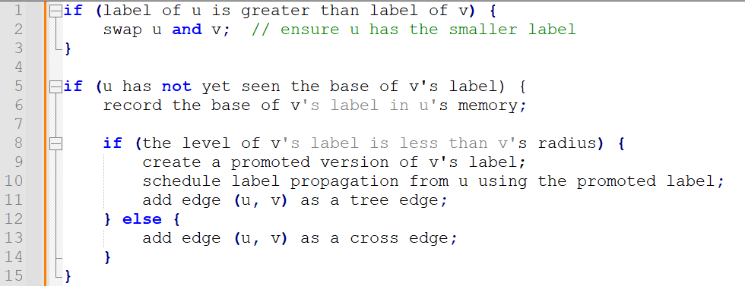

1. Tree vs. Cross Edges

Tree Edges T(v) are edges used to propagate labels from node to node.  
Cross Edges X(v) are added when propagation stops — they ensure the spanner remains connected and satisfies the stretch guarantee.  
  
The spanner output is:  
H = union over v in V of T(v) ∪ X(v)

1. Stretch Guarantee

The algorithm guarantees that for any edge (u, v) in the original graph, there exists a path in the spanner of length at most (2t - 1).

**Example:**

Consider a small graph of 5 vertices: A, B, C, D, E with edges arriving in order: (A,B), (B,C), (C,D), (D,E).  
  
Assume:  
- A gets a high-priority label with radius 2  
- Label from A propagates to B and then to C  
- (C,D) doesn’t satisfy the propagation condition → becomes a cross edge  
  
Then the spanner includes:  
- Tree edges: (A,B), (B,C)  
- Cross edge: (C,D)  
- Possibly (D,E), depending on the labels and radius  
  
This keeps the spanner sparse but ensures no shortest path is stretched by more than (2t - 1) hops.

**Section 3: The Implementation of The Algorithm**

This section describes how the algorithm from Elkin’s paper was implemented in Python.

The implementation is organized across multiple files, each with a clear responsibility:

* Main.py – Entry point of the program - initializes the graph, assigns radii and labels, processes edges, and constructs the spanner.
* Graph.py – Generates and stores the graph structure using the networkx library.
* Vertex.py – Represents a vertex in the graph, along with its label, radius, edge sets, and memory table.
* Edge.py – Represents an edge between two vertices.
* Label.py – Encodes label behavior, including label promotion and extraction of base and level.
* Spanner.py – Contains the main algorithm logic: radius sampling, label comparisons, and spanner construction using functions readEdge and generateRadiusValue.
* config.py / config.json – Configuration files that define parameters such as graph size, edge probability, and stretch factor.

**Running the project:**

Todo, include requirements n stuff

**Key Elements**

* **Vertices (Vertex.py)**  
  Each vertex object has a unique identifier labeled id, a label which is an instance of Label class, a radius value drawn from geometric distribution, two sets of edges – tree and cross, a table to track seen label bases (M(v) in the paper).
* **Labels (Label.py)**

The labels are stored as an integer where label = level*n + base. Include methods to promote a label (increment level) and to extract base and level from integer form and baseVertex that links the label to its origin.

* **Edges (Edge.py):**

Object storing the two vertices it connects: labeled first and second.

**Spanner Construction Flow**   
First, Graph.py uses networkx.erdos_renyi_graph() to randomly generate a connected unweighted graph and each graph node is wrapped with a Vertex object thus initializing the vertices.

Second, we assign radii using generateRadiusValue() (in Spanner.py) using a geometric distribution as defined before where each vertex independently samples a radius $r\left(v\right)∈[0, t-2]$.

Next we initialize labels where each vertex starts with a label includes a base that is the vertex id and a level of 0.

Lastly we process the edges and labels as implemented in readEdge() (Spanner.py). For each edge the vertices are compared by label, label promotion happens if the radius allows it and both the tree edges and cross edges (respectively T(v) and X(v)) are collected accordingly. The union of all tree and cross edges from all vertices is extracted to a new Graph object as the final spanner.

In implementing the algorithm, we decided to use network for the graphs as it provides efficient graph structures and algorithms which simplify generation, visualization and actions done on the graph. We used a hash set for M(v), which allowed constant-time checks and insertions for seen label bases, matching the paper’s goal of minimal state per vertex.

**Section 4: Research question**

The research question is:

**How does the behaviour of the constructed spanner change when the underlying graph structure varies?**

Specifically, this question examines how the distribution of edge stretches in the resulting spanner is affected by two key parameters:

* The **number of vertices (n)** in the graph
* The **probability (p)** of an edge being included in the Erdős–Rényi random graph model

The **stretch** of an edge refers to the ratio between the shortest path distance in the spanner and the original direct edge in the full graph. While the algorithm guarantees a worst-case stretch of (2t−1), this project explores how stretch behaves **on average** or **in distribution** when:

* The graph becomes **larger** (increased number of vertices)
* The graph becomes **denser or sparser** (by changing edge creation probability p)

The underlying goal is to better understand:

* How often edges in the spanner are **stretched** close to the worst-case bound
* Whether the **average stretch remains low** in practice
* How the **spanner size** and **structure** are influenced by graph density and size

By systematically modifying these parameters and measuring the resulting stretch distributions and spanner statistics, this research aims to uncover practical insights into the performance and scalability of the algorithm beyond its theoretical guarantees.

**Section 5: The Experiments**

This section presents a systematic evaluation of the streaming spanner algorithm’s empirical performance across a diverse range of graph configurations.

The goal is to understand how changes in the input graph's structure, such as size, density, and target stretch factor, impact the spanner’s quality and efficiency in practice.

**Experimental Parameters**

The experiments were conducted using the following controlled parameters:

* **Vertex Count (n):**  
  5, 20, 50, 100, 150, 200, 250, 300

Larger graphs beyond 300 vertices were excluded due to high computation time.

* **Edge Probability (p):**  
  0.05, 0.1, 0.15, 0.2, 0.25, 0.3, 0.4

This parameter governs the density of edges in graphs generated using the Erdős–Rényi model.

* **Stretch Factor (α):**  
  1, 3, 5, 7, 15, 25, 35, 49

A smaller α imposes a tighter bound on stretch, whereas larger values allow more relaxed distances but potentially lead to smaller spanners.

Each unique (n, p, α) configuration was executed multiple times to account for randomness. Results were aggregated to improve statistical reliability.

**Experimental Workflow**

For each run, the following steps were performed:

1. **Graph Generation**  
   A random unweighted graph was generated using the Erdős–Rényi model, with vertex count n and edge probability p.
2. **Spanner Construction**  
   The streaming spanner algorithm was applied with the specified α.
3. **Metric Collection**  
   The following metrics were computed:
   * **Stretch Distribution:** frequency of edge stretch values in the spanner.
   * **Compression Ratio:** |E′| / |E| — number of edges in spanner vs original.
   * **Statistical Summary:** average, median, mode, max, and standard deviation of stretch.
4. **Output Files**  
   Each run generated two outputs:
   * A **CSV** file summarizing the statistics.
   * A **PNG** image showing a histogram of stretch values (e.g., 1.0 = no stretch; 2.0 = path doubled in length).

**Example of a typical CSV output:**

Metric,Value

compression_ratio,12.085972850678733

average,1.63485

median,1.5

std_dev,0.69508

mode,1.0

max,4.0

alpha,15

vertex_count,200

edge_probability,0.4

graph_type,unweighted

graph_seed,316181

**Analysis Goals**

The experiments aim to explore:

* **Accuracy vs. Sparsity:**  
  How does increasing α impact compression ratio and average stretch?
* **Scalability:**  
  How do larger graphs affect stretch variability and construction time?
* **Density Effects:**  
  How does edge probability influence the distribution of stretch and the size of the spanner?
* **Stretch Distribution:**  
  Do most edges remain close to original distances, or are large stretches common?

**Next Steps**

Following the experiments, all CSV and image outputs were automatically collected and processed using a dedicated analysis script.

The goal is to uncover trends and trade-offs between structural graph parameters and the performance of the streaming spanner algorithm. The following relationships are being examined:

* **Compression vs. Stretch Tradeoffs**  
  Explore how the compression ratio relates to average, median, mode, standard deviation, and maximum stretch.
* **Impact of α (Stretch Bound)**  
  Investigate how varying the stretch factor affects spanner size and stretch distribution.
* **Scalability with Vertex Count**  
  Analyze how increasing the number of nodes impacts the compression ratio and stretch variability.
* **Effect of Graph Density**  
  Assess how changes in edge probability influence stretch characteristics and spanner compactness.
* **Multi-parameter Interactions**  
  Study heatmaps and 3D surfaces for combined effects, such as (α, n) → average stretch or (n, p) → max stretch.
* **Stretch Distribution Behavior**  
  Examine histograms for the frequency of each stretch factor.

These insights will inform when and how the streaming spanner algorithm is best applied in practice—highlighting the conditions under which it remains both efficient and accurate, as well as where compromises arise between sparsity and path fidelity.

**Section 6: The Results of your experiments**

This section presents a detailed examination of the empirical behavior of the streaming spanner algorithm across various graph configurations.

We begin by exploring foundational pairwise relationships, such as the effect of the stretch factor on average and maximum stretch, and the tradeoff between stretch and compression ratio.

From there, we progressively analyze how the structure of the input graph (e.g., size and density) influences these outcomes.

Finally, we examine more nuanced, multi-variable interactions using color-coded plots, highlighting how different parameters jointly affect the spanner’s efficiency and accuracy.

This structured approach, from simple to complex reveals both expected trends and subtle dynamics that inform when and how the algorithm performs best in practice.

Basic Pairwise Relationships

**Stretch Average vs. Stretch Factor (α)**

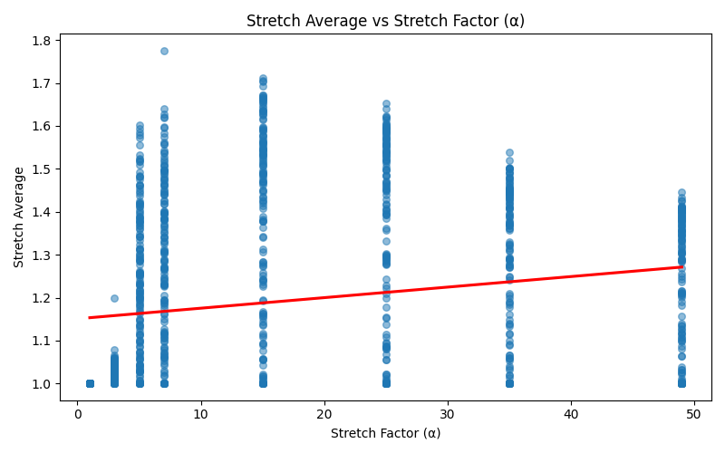

This plot examines how the average stretch of the spanner changes as the stretch factor α increases. As expected, we observe a modest upward trend: higher α values typically allow more relaxed path lengths, resulting in slightly increased average stretch. However, the slope is relatively shallow, indicating that beyond a certain point, increasing α yields diminishing returns in terms of average stretch. This suggests that the algorithm maintains reasonably efficient paths even when the allowed stretch factor is relaxed significantly.

It's worth noting that this result may be influenced by the relatively small size of the graphs used in our experiments; the asymptotic behavior on larger graphs could show a stronger or more distinct trend.

**Compression Ratio vs. Stretch Factor (α)**

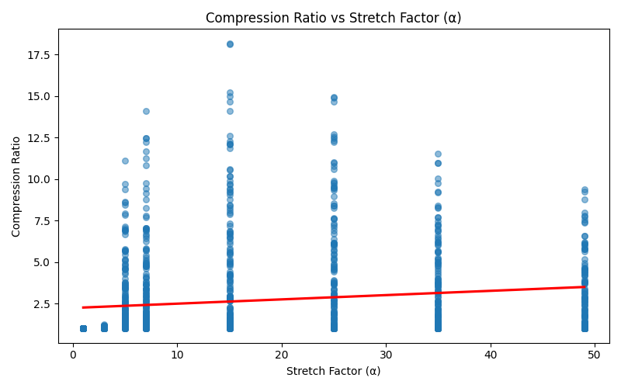

This plot shows a clear positive correlation between the allowed stretch factor α and the compression ratio of the resulting spanner. As expected, permitting greater stretch enables the algorithm to drop more edges while maintaining connectivity guarantees, leading to sparser spanners. The increasing trend is in line with theoretical expectations, though the rate of growth is modest. It's important to note that these results may be somewhat affected by the limited scale of our input graphs; larger graphs might exhibit a more pronounced asymptotic compression gain.

**Stretch Max vs. Stretch Factor (α)**

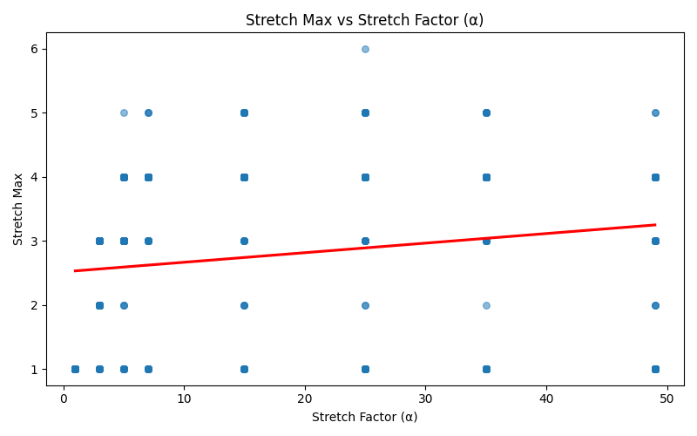

This plot explores how the maximum stretch across all edges varies with the allowed stretch factor α. As expected, the general trend shows a slight increase in maximum stretch as α increases. However, the data also reveals substantial variability, with outliers appearing even at lower α values. This indicates that while increasing α generally allows for longer detours in the spanner, high-stretch outliers can occur regardless of α. These results are consistent with theoretical behavior, but the relatively mild slope may again reflect the limited graph sizes used; larger graphs might amplify extreme stretch values more clearly.

**Stretch Average vs. Compression Ratio**

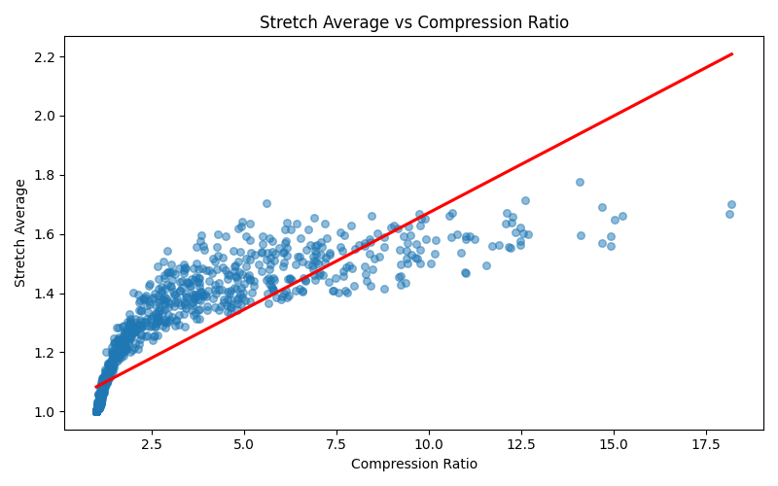

This graph illustrates the trade-off between spanner sparsity and path quality. As the compression ratio increases (indicating fewer edges retained), the average stretch also tends to rise. This is expected: sparser graphs naturally introduce longer detours. Interestingly, while the lower bound of stretch increases gradually, the average seems to saturate or plateau around certain values, even at high compression ratios. This suggests diminishing returns beyond a certain point, further edge removal doesn’t drastically worsen the average stretch. These results align with theoretical expectations and reflect a core design tension in spanner construction.

**Stretch Std. Dev. vs. Compression Ratio**

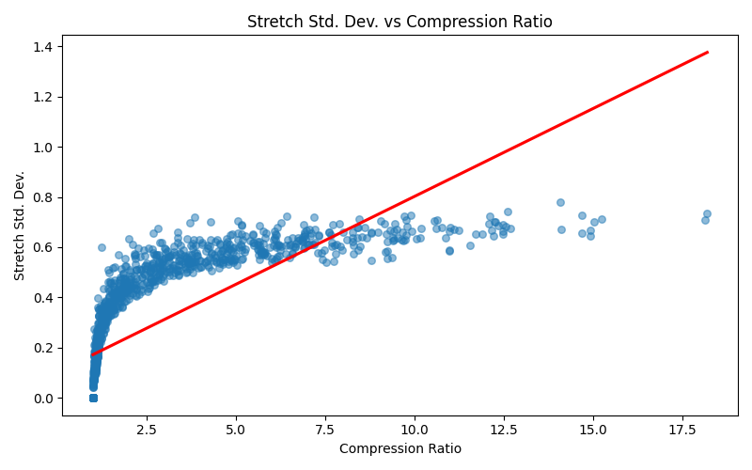

While the red trend line suggests a linear increase, a closer look at the scatter points reveals a plateauing effect: the standard deviation of stretch grows quickly at first but then stabilizes around 0.6–0.7 for higher compression ratios.

This indicates that beyond a certain level of sparsification, additional compression doesn't significantly increase variability in stretch. This behavior is insightful, it implies that after some threshold, further compression may not worsen worst-case consistency much, even if average or max stretch might still grow.

Structural Effects (Graph Size/Density Effects)

**Compression Ratio vs. Number of Vertices (n)**

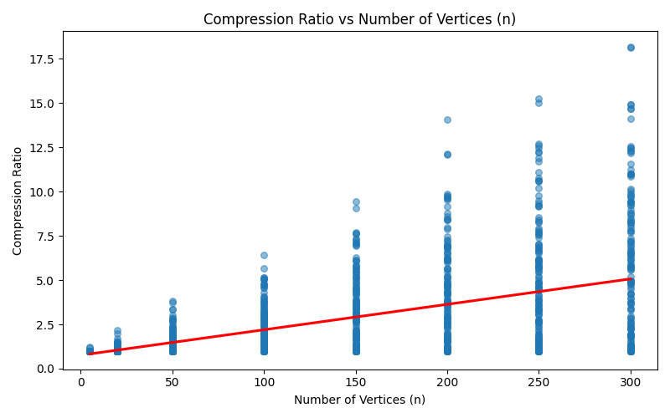

This plot shows that as the number of vertices increases, the compression ratio tends to rise as well, indicating that larger graphs offer more room for edge sparsification.

This trend is intuitive: in denser input graphs (which grow quadratically in edges with increasing n), the spanner can remove proportionally more edges while still maintaining the desired stretch guarantees.

The trend line supports this upward trajectory, and the variance also grows with n, suggesting that sparsifiability becomes more sensitive to other factors (like edge probability or stretch factor) as graph size increases.

**Compression Ratio vs. Edge Probability (p)**

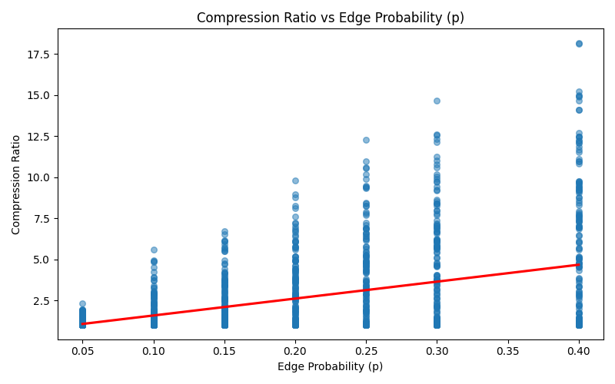

As expected, the graph reveals that higher edge probabilities (denser graphs) result in higher compression ratios.

This aligns with the intuition that in denser graphs, there are more redundant edges that can be safely removed by the spanner while maintaining the desired stretch.

The data points show a consistent upward trend, and the spread indicates a wide range of compressibility even at similar densities, likely due to the interplay with other parameters like n and α. This relationship confirms the algorithm's effectiveness in exploiting redundancy in dense graphs.

**Stretch Average vs. Edge Probability (p)**

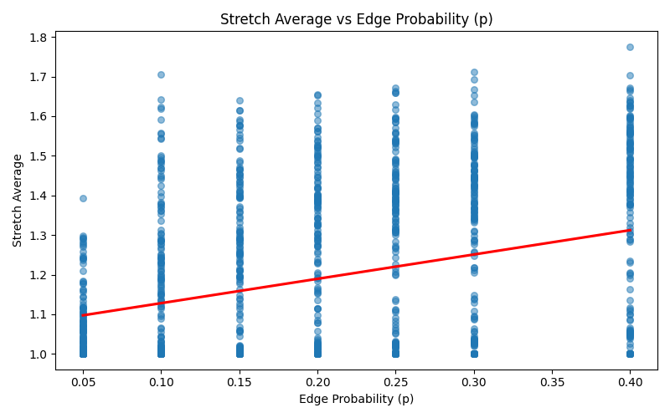

This graph shows a subtle yet noticeable upward trend in average stretch as edge probability increases.

At first glance, this might seem counterintuitive, denser graphs might be expected to allow for shorter paths, thus lowering stretch. However, the spanner aggressively prunes edges in denser graphs to maximize compression, which can lead to slightly increased path lengths.

This tradeoff is a key design feature of spanners, and the relatively modest increase in stretch confirms the algorithm maintains good path quality even when heavily compressing dense graphs.

**Stretch Average vs. Number of Vertices (n) by Stretch Factor (α)**

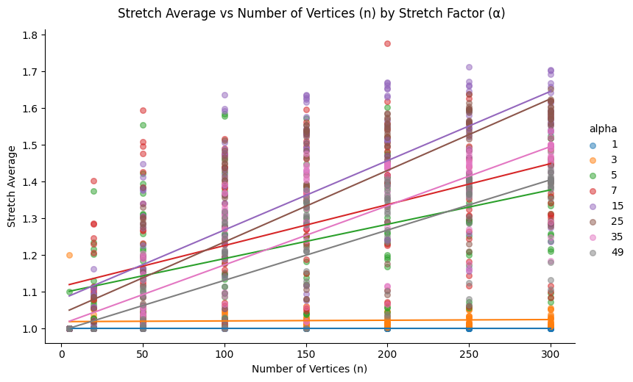  
**Compression Ratio vs. Edge Probability (p) by Stretch Factor (α)**

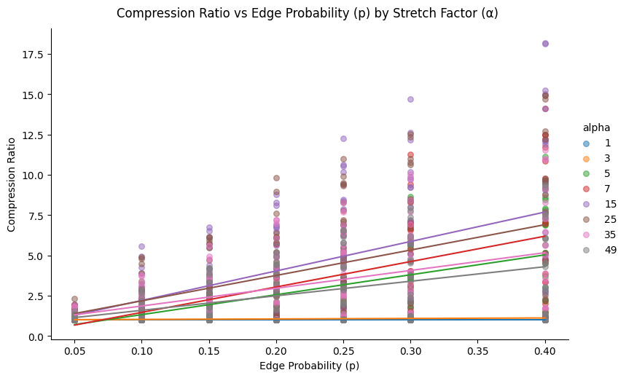

This pair of plots explores how compression ratio evolves with structural graph properties, namely, the number of vertices (n) and edge probability (p), while controlling for the stretch factor (α). Each line represents a fixed α value, making it easy to observe how different α levels modulate compression outcomes.

As expected, for small α values (e.g., 1 or 3), the compression ratio remains consistently low across all structural configurations, reflecting tight spanner constraints. As α increases, the compression ratio also grows, particularly between α = 5 and α = 15, where the spanner gains flexibility to discard more edges without violating the stretch bound.

However, a turning point appears beyond α ≈ 25, where the compression ratio no longer improves and, in some cases, begins to plateau or decline. This non-monotonic behaviour suggests that very high α values lead to sparser graphs that are no longer able to capture useful structural shortcuts, resulting in diminishing compression returns.

**Planned Follow-Up Experiment (i.e. Alpha Experiment)**  
To better understand this critical α region, we plan a focused experiment where the graph size (n) and edge probability (p) are held constant while α is varied. This will allow us to pinpoint the stretch factor that maximizes compression ratio, validating whether α ≈ 35 represents a consistent optimal trade-off across configurations.

**Stretch Average vs. α (Alpha Experiment)**

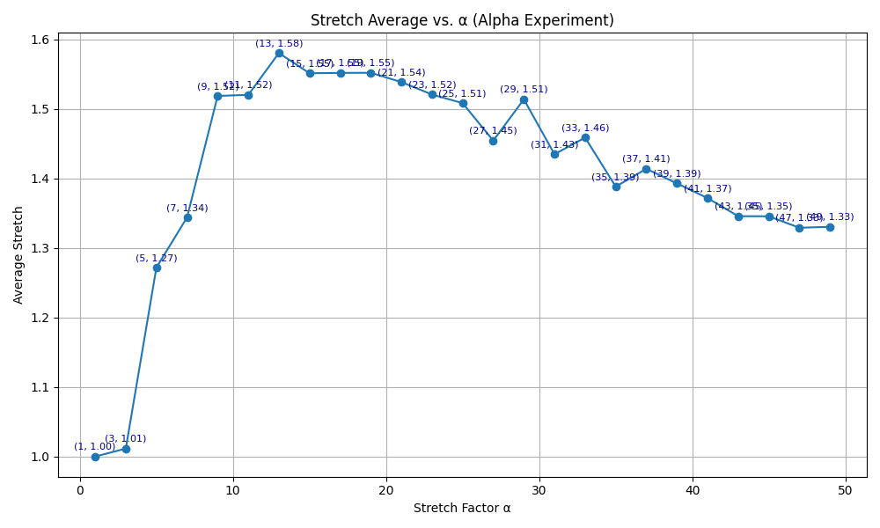

This plot explores how the average stretch evolves as the stretch factor α increases, using a fixed graph configuration with 200 vertices and an edge probability of 0.15. Each data point represents the average stretch over five randomized runs per α value, ensuring a robust signal across stochastic variability.

As expected, for small values of α (1 to 3), the stretch remains tightly constrained, with values near the theoretical minimum (just above 1.0). This reflects the strict path length preservation requirements at low α levels. As α increases beyond 5, the spanner is permitted to discard more edges, which naturally increases the stretch, the average stretch climbs sharply, peaking around α = 13 to 15 with an average stretch of ~1.58.

Interestingly, this growth is not unbounded. Beyond α ≈ 15, the curve begins to flatten and eventually decline. By the time α reaches 35 to 49, the average stretch falls back toward ~1.33. This non-monotonic behaviour suggests a structural transition: at very high α, the spanner becomes so sparse that only the shortest essential paths are retained. These minimal paths often overlap with the original shortest paths, leading to lower average stretch despite looser guarantees.

This finding confirms the hypothesis posed in earlier sections — that an optimal “stretch sweet spot” exists, beyond which the added flexibility of α no longer leads to longer paths. Instead, structural minimalism takes over, leading to unexpectedly shorter paths.

**Implications and Takeaways**

* **Non-Monotonic Behaviour**: The average stretch does not increase indefinitely with α. Instead, it peaks and then slowly drops, revealing complex interactions between graph structure and path optimization.
* **Practical α Tuning**: For applications balancing compression and performance, α ≈ 13–15 represents a critical threshold to examine, as it provides maximal stretch impact without overshooting into redundancy.
* **Robust Trends**: The low variance across runs (as seen in the small std_dev values) indicates strong consistency in behavior, supporting the reliability of this trend.

**Section 7: The conclusion**