Appendices for Ethics Application Testing the Effect of Distancing on Moral Dumbfounding (in different cultures)

Appendix A: Full list of participating researchers 2
Appendix B: Recruitment Materials for the Study 3
Appendix C: Participant Information Leaflet For the Study 4
Appendix D: Consent Form for the Study 7
Appendix E Debriefing Form 8
Appendix F: Moral Scenarios 10
Appendix G: Judgement and Confidence Questions 11
Appendix H: Counter Arguments 12
Appendix I: Critical Slide 13
Appendix J: Concluding Questions 14
Appendix K: Temporal Distance Manipulations (Study 1) 15
Appendix L: Mindset Induction (Study 2) 16
Appendix M: Morality and Value Question (Study 3) 19
Appendix N: Attention Checks 20
Appendix O: References 21

Appendix A: Full list of participating researchers

Name | Qualification or Role | Department / Affiliation | Signature
Cillian McHugh | Associate Professor | Department of Psychology, University of Limerick | 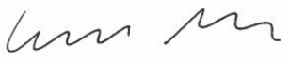
Dries Bostyn | Postdoctoral Researcher | Department of Developmental, Personality and Social Psychology, Ghent University | 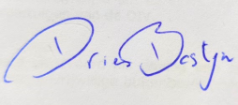
Kathryn B. Francis | Senior Research Fellow | Department of Psychiatry, University of Oxford & The Uehiro Oxford Institute, University of Oxford | 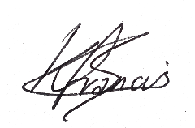
Ana Gantman | Associate Professor | Department of Psychology, Brooklyn College CUNY | 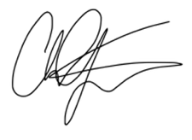
Eric R. Igou | Professor | Department of Psychology, University of Limerick | 
Elaine L. Kinsella | Associate Professor | Department of Psychology, University of Limerick | 
Marek McGann | Senior Lecturer | Department of Psychology, Mary Immaculate College | 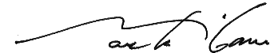
Bryan C.Y. Pang | PhD Student | Department of Psychology, University of Illinois Urbana-Champaign | 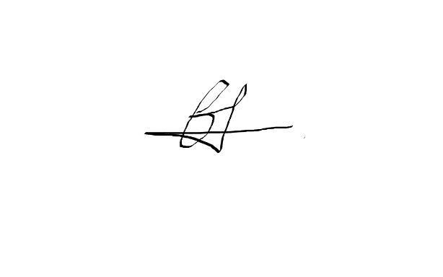
Mariola Paruzel-Czachura | Associate Professor | Department of Psychology, University of Silesia in Katowice & Perelman School of Medicine, ChatLab, University of Pennsylvania | 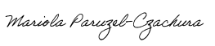
Cristián G. Rodríguez | Assistant Professor | Department of Psychology, Universidad de los Andes, Chile | 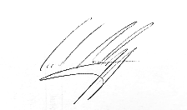
Jordan Wylie | Assistant Professor | Department of Psychology, Cornell University | 

Appendix B: Recruitment Materials



EHS REC Number:

The following text will be used for recruitment of participants across social media and email:

Subject: Invitation to complete a psychology study on moral judgements.

I am part of a team investigating different influences on people’s moral judgments. We are looking for participants to complete a short survey on moral judgments [Studies 1 & 2] / the role of morality in your life [Study 3]. We are asking if you might be interested in participating in an online survey, which will be completely anonymous! Completion of the survey will only take 15 minutes [Studies 1 & 2] / 2 minutes [Study 3].

To participate, you must be
- 18 years of age or older
- Be fluent in English (Dutch, Polish, Spanish, Cantonese)

If interested, please, click this link to access the survey:

Thank you for your time and consideration!

This research study has received Ethics approval from the Education and Health Sciences Research Ethics Committee EHS REC “-“
If you have any concerns about this study and wish to contact someone you may contact:
Chair Education and Health Sciences Research Ethics
Committee EHS Faculty Office
University of Limerick
Tel (061) 234101

Appendix C: Participant Information Sheet


EHSREC Number:

Project Title: Influences on Moral Judgements
You are invited to take part in a research study. Before you decide, it is important that you understand why the research is being done and what it will involve. This Participant Information Sheet tells you about the purpose, risks, and benefits of this research study. If you agree to take part, we will ask you to complete a Consent Form, declaring that you consent to take part. Please read this information sheet. You should only consent to participate in this research study when you feel you understand what is being asked of you, and you have had enough time to think about your decision. Thank you for reading this.
What is the purpose of the study?
This study aims to further our understanding of how people make moral judgments. Previous research has shown that people respond differently to different kinds of moral dilemmas. We are investigating some possible influences on how people respond to moral issues.
What does participation involve?
(Studies 1 & 2)
You are being asked to take part in an experimental study. You will be asked to complete an online survey. As part of this you will be asked to read four moral scenarios and respond to a series of questions relating to each. [You will also be asked to complete a thought exercise in relation to achieving goals (Study 2 only)]
(Study 3)
You will be asked to consider various aspects of life and rate their relative importance in your own life
(All Studies)
You will also be asked to provide basic demographic information (age, gender, nationality, etc.,).
What are the benefits?
Participation is an opportunity to broaden the understanding of how people think about moral issues and the role of morality in everyday life. The findings will help us understand how different factors can influence people’s moral judgements.
What are the risks?
There is risk of mild discomfort since the study deals with topics that could be sensitive or could potentially cause offense. Specifically, some of the scenarios you will be asked to respond to contain descriptions of behaviours that you may find morally wrong or morally offensive. The anticipated risk is comparable to that you could reasonably expect from an 18 rated movie or TV show.
Do I have to take part?
No, participation is voluntary.
What if want to withdraw?
Participation is voluntary so you do not have to take part in the study if you do not want to; there is no penalty for not participating. If you decide to take part and then change your mind you can withdraw from the study at any point without giving a reason. Please note that if you do choose to withdraw once you have begun the study, it will not be possible to remove any responses already provided. This is because the responses are fully anonymized on collection, and it will not be possible to isolate your responses from the remainder of the data collected. The primary analysis will require complete responses and therefore partially complete responses will be excluded from these analyses. However, partial responses will likely be included in some analysis when they include responses to measures of interest.
What happens at the end of the study?
At the end of the study the information will be used to present results, but the information will be completely anonymous.
What will happen to the data I provide for the study?
Raw anonymized data will be stored for the duration of this study. All data will be fully anonymized on collection and stored on GDPR compliant OneDrive accounts accessible only by the named researchers on this project. All cleaned and processed data will be stored indefinitely and made available to other researchers through the open science framework.
Who can I contact if I have any questions or want to find out more about the study?
If you have any further questions about the research, you can contact:
Principal Investigator:
Cillian McHugh
Department of Psychology, University of Limerick.
cillian.mchugh.ul.ie;
Other Investigators:
Dries Bostyn (Dries.Bostyn@UGent.be)
Department of Developmental, Personality and Social Psychology, Ghent University
Kathryn B. Francis (kathryn.francis@psych.ox.ac.uk)
Department of Psychiatry, University of Oxford & The Uehiro Oxford Institute, University of Oxford
Ana Gantman (ana.gantman@brooklyn.cuny.edu)
Department of Psychology, Brooklyn College CUNY
Eric R. Igou (eric.igou@ul.ie)
Department of Psychology, University of Limerick
Elaine L. Kinsella (elaine.kinsella@ul.ie)
Department of Psychology, University of Limerick
Marek McGann (marek.mcgann@mic.ul.ie)
Department of Psychology, Mary Immaculate College
Bryan C.Y. Pang (bryan.pang2506@gmail.com)
Department of Psychology, University of Illinois Urbana-Champaign
Mariola Paruzel-Czachura (mariola.paruzel-czachura@us.edu.pl)
Department of Psychology, University of Silesia in Katowice & Perelman School of Medicine, ChatLab, University of Pennsylvania
Cristián G. Rodríguez (crodriguez@uandes.cl)
Department of Psychology, Universidad de los Andes, Chile
Jordan Wylie (jordan.wylie@cornell.edu)
Department of Psychology Cornell University
This research study has received Ethics approval from the Education and Health Sciences Research Ethics Committee (“-“). If you have any concerns about this study and wish to contact someone independent you may contact:
Chair Education and Health Sciences Research Ethics Committee, EHS Faculty Office, University of Limerick, Tel (061) 234101

Appendix D: Consent Form


EHSREC Number:

I declare that I am willing to take part in research for the project entitled: Influences on Moral Judgements
I declare that I have been fully briefed on the nature of this study and my role in it and have been given the opportunity to ask questions before agreeing to participate.
- The nature of my participation has been explained to me, and I have full knowledge of how the information collected will be used.
- I am aware that such information may also be used in future academic presentations and publications about this study.
- I fully understand that I am not obliged to participate in this study.
- I understand that I can withdraw at any stage
- I understand that if I choose to withdraw, any responses already entered cannot be withdrawn
- I understand that what the researchers find out in this study may be shared with others but that my name will not be shared with anyone
- My anonymized data will be stored indefinitely and may be made available to other researchers in the field through the Open Science Framework

By agreeing to take part below I confirm that I am at present aged 18 or older, I have read and understood this form, and I consent to participate in this study.

Do you agree to take part?
☐ Yes
☐ No

Appendix E Debriefing Forms

EHSREC Number:

We thank you for you participation in this study.
Studies 1 & 2
In this project, we are investigating the phenomenon known as moral dumbfounding. This occurs when people defend a moral judgment even though they cannot provide a reason for it. We are interested in testing whether thinking about things differently can reduce moral dumbfounding and help people to be better at providing reasons for their moral judgments. You were presented with 4 scenarios that have previously been shown to lead to moral dumbfounding.
[Study 1] One way that might help people think of reasons is to think about things in the distant future. In this study, some people were asked to think about these scenarios in the distant future, and some people were asked to think about them in the near future, and some were not given explicit instructions. We want to see if thinking about things in the distant future helps people provide reasons for their moral judgements.
[Study 2] One way that might help people think of reasons is to adopt a more abstract mindset (compared to a more concrete mindset). In this study, there was mindset task before the moral judgement task that was designed to encourage either a more abstract or a more concrete mindset (by thinking about either “why” we do things, or “how” we can do things). Some people were encouraged to think more abstractly while others were encouraged to think more concretely. We want to see if a more abstract mindset can help people to provide reasons for their moral judgements.

We are also interested in how moral dumbfounding varies in different countries. We are conducting this study in Ireland, Poland, Chile, Belgium, USA, UK, and Hong Kong.

Study 3
In this project we are interested in how much people value morality in their lives, and if this varies across different countries. We are asking this question to participants in Ireland, Poland, Chile, Belgium, USA, UK, and Hong Kong.

Thanks again for your participation.
If you have any questions about this research, please contact:
Principal Investigator:
Cillian McHugh (cillian.mchugh@ul.ie)
Department of Psychology, University of Limerick.
Other Investigators:
Dries Bostyn (Dries.Bostyn@UGent.be)
Department of Developmental, Personality and Social Psychology, Ghent University
Kathryn B. Francis (kathryn.francis@psych.ox.ac.uk)
Department of Psychiatry, University of Oxford & The Uehiro Oxford Institute, University of Oxford
Ana Gantman (ana.gantman@brooklyn.cuny.edu)
Department of Psychology, Brooklyn College CUNY
Eric R. Igou (eric.igou@ul.ie)
Department of Psychology, University of Limerick
Elaine L. Kinsella (elaine.kinsella@ul.ie)
Department of Psychology, University of Limerick
Marek McGann (marek.mcgann@mic.ul.ie)
Department of Psychology, Mary Immaculate College
Bryan C.Y. Pang (bryan.pang2506@gmail.com)
Department of Psychology, University of Illinois Urbana-Champaign
Mariola Paruzel-Czachura (mariola.paruzel-czachura@us.edu.pl)
Department of Psychology, University of Silesia in Katowice & Perelman School of Medicine, ChatLab, University of Pennsylvania
Cristián G. Rodríguez (crodriguez@uandes.cl)
Department of Psychology, Universidad de los Andes, Chile
Jordan Wylie (jordan.wylie@cornell.edu)
Department of Psychology Cornell University
This research study has received Ethics approval from the Education and Health Sciences Research Ethics Committee (“-“). If you have any concerns about this study and wish to contact someone independent you may contact:
Chair Education and Health Sciences Research Ethics Committee, EHS Faculty Office, University of Limerick, Tel (061) 234101

Appendix F: Moral Scenarios

Heinz
(Ambiguous/high trade-off salience)
Imagine that in Europe, a woman is near death from a very bad disease, a special kind of cancer. There is one drug that the doctors think might save her. It is a form of radium for which a druggist is charging ten times what the drug cost him to make. The sick woman's husband, Heinz, has approached everyone he knows to borrow the money, but he has only been able to get together about half of what it cost. He has told the druggist that his wife was dying, and asked him to sell it cheaper or let him pay later. But the druggist said, "No, I discovered the drug and I'm going to make money from it." So, Heinz gets desperate and brakes into the man's store to steal the drug for his wife. The druggist has Heinz arrested and charged.

Trolley
(Ambiguous/high trade-off salience)
Imagine that a Trolley is hurtling down a track towards five people. It will kill them all on impact. Paul is on a bridge under which it will pass. He can stop it by putting something very heavy in front of it. As it happens, there is a very large man next to him – Paul's only way to stop the trolley is to push him over the bridge and onto the track, killing him to save five. Paul decides to push the man.

Jennifer
(Unambiguous/low trade-off salience)
Imagine a person called Jennifer. She works in a medical school pathology lab as a research assistant. The lab prepares human cadavers that are used to teach medical students about anatomy. The cadavers come from people who had donated their body for the general use of the researchers in the lab. The bodies are normally cremated, however, severed cuts may be disposed of at the discretion of lab researchers, One night Jennifer is leaving the lab when she sees a body that is going to be discarded the next day. Jennifer was a vegetarian, for moral reasons. She thought it was wrong to kill animals for food. But then, when she saw a body about to be cremated, she thought it was irrational to waste perfectly edible meat. So she cut off a piece of flesh, and took it home and cooked it. The person had died recently of a heart attack, and she cooked the meat thoroughly, so there was no risk of disease

Julie and Mark
(Unambiguous/low trade-off salience)
Imagine Julie and Mark, who are brother and sister, are travelling together in France. They are both on summer vacation from college. One night they are staying alone in a cabin near the beach. They decide that it would be interesting and fun if they tried making love. At very least it would be a new experience for each of them. Julie was already taking birth control pills, but Mark uses a condom too, just to be safe. They both enjoy it, but they decide not to do it again. They keep that night as a special secret between them, which makes them feel even closer to each other.

Appendix G: Judgement and Confidence Questions

How would you rate the behavior described?
1 2 3 4 5 6 7
Morally wrong Neutral Morally right
________
How conﬁdent are you in your judgment?
1 2 3 4 5 6 7
Not at all conﬁdent Extremely conﬁdent

Appendix H: Counter Arguments

Heinz

Do you agree that the druggist has to make a living?

And do you accept that Heinz broke into the druggist's store?

And do you accept that he stole from him?

Trolley

Do you accept that five people would have died if Paul didn't push the man?

And this man is the only way available to stop the trolley? (Paul does not weigh enough)

Do you agree that in stopping the trolley Paul saved the lives of five people?

Jennifer

The body had been donated for research, it was to be discarded the next day. You must agree then that it had obviously fulfilled its purpose?

Do you accept that the body was already dead?

And do you accept that there was no risk of disease?

Julie and Mark

Do you not agree that any concerns regarding reproductive complications are eased by their using of two forms of contraception?

And do you accept that they are both consenting adults, and that they both consented and enjoyed it?

And do you concede that nobody else was affected by their actions?

Appendix I: Critical Slide

Heinz

The druggist was only protecting his livelihood.

How can that be wrong?

Jennifer

Jennifer's actions did not harm anyone, or negatively affect anyone.

How can there be anything wrong with what she did?

Julie and Mark

Julie and Mark's actions did not harm anyone, or negatively affect anyone.

How can there be anything wrong with what they did

Trolley

Paul's actions saved the lives of five people!

How can saving lives be wrong?

Response options (randomised order)

There is nothing wrong.

It's wrong but I can't think of a reason.

It's wrong and I can provide a valid reason.

Appendix J: Concluding Questions

How confused were you?
1 2 3 4 5 6 7
Not at all Extremely confused
________
How irritated were you?
1 2 3 4 5 6 7
Not at all Extremely irritated
________
How much was your judgement based on reason?
1 2 3 4 5 6 7
Not at all Extremely
________
How much was your judgement based on “gut” feeling?
1 2 3 4 5 6 7
Not at all Extremely

Appendix K: Temporal Distance Manipulations (Study 1)

Control

In the following you will read several situations of people making decisions. After you read each scenario you will be asked a series of questions, including making a judgment.
Read carefully and answer the questions below each description.

Increased Temporal Distance

Instructions before scenarios

In the next couple of minutes try to think about a day a year from now: how it will look like, what will happen, what you will do/feel...
In the following you will read several situations of people making decisions. After you read each scenario you will be asked a series of questions, including making a judgment.

Try to imagine each scenario is going to happen a year from now. Read carefully and answer the questions below each description.

Final sentence appended to each scenario:

Imagine this event is going to happen in a year from now.

Decreased Temporal Distance

Instructions before scenarios

In the next couple of minutes try to think about tomorrow: how it will look like, what will happen, what you will do/feel...
In the following you will read several situations of people making decisions. After you read each scenario you will be asked a series of questions, including making a judgment.
Try to imagine each scenario is going to tomorrow. Read carefully and answer the questions below each description.

Final sentence appended to each scenario:

Imagine this event is going to happen tomorrow.

Manipulation Check Question:

How far into the future did you imagine this event?
1 2 3 4 5 6 7
Very close/very soon Very Far/Very distant

Appendix L: Mindset Induction (Study 2)

How Task (Concrete)
For everything we do, there always is a process of how we do it. Moreover, we often can follow our broad life-goals down to our very specific behaviors. For example, like most people, you probably hope to find happiness in life. How can you do this? Perhaps finding a good job, or being educated, can help. How can you do these things? Perhaps by earning a college degree. How do you earn a college degree? By satisfying course requirements. How do you satisfy course requirements? In some cases, such as today, you participate in a psychology experiment. Research suggests that engaging in thought exercise like that above, in which one thinks about how one's ultimate life goals can be expressed through specific actions, can improve people's life satisfaction. In this experiment, we are testing such a technique. This thought exercise is intended to focus your attention on how you do the things you do.
For this thought exercise, please consider the following activity: "improving and maintaining one's physical health."
________
Please list three ways in which you can improve your health:
________
How much will engaging in this activity improve and maintain your health?
1 2 3 4 5
A little Very, very much
________
Starting with the goal outlined in the top box, please identify how you might achieve this and enter your answer into the second box. Next, think about the response you just provided and identify how you might achieve this; enter your answer in the box. Work your way through the boxes until you have entered a response into all boxes. Your first response should identify how you might improve and maintain your health
You entered _______. How would you _______?
You entered _______. How would you _______?
You entered _______. How would you _______?

Why Task (Abstract)
For every thing we do, there always is a reason why we do it. Moreover, we often can trace the causes of our behavior back to broad life-goals that we have. For example, you currently are participating in a psychology experiment. Why are you doing this? Perhaps to satisfy a course requirement. Why are you satisfying the course requirement? Perhaps to pass a psychology course. Why pass the course? Perhaps because you want to earn a college degree. Why earn a college degree? Maybe because you want to find a good job, or because you want to educate yourself. And perhaps you wish to educate yourself or find a good job because you feel that doing so can bring you happiness in life. Research suggests that engaging in thought exercises like that above, in which one thinks about how one's actions relate to one's ultimate life goals, can improve people's life satisfaction. In this experiment, we are testing such a technique. This thought exercise is intended to focus your attention on why you do the things you do.

For this thought exercise, please consider the following activity: "improving and maintaining one's physical health."
________
Please list three ways in which improving and maintaining your physical health could help you meet important life goals
________
How much will improving and maintaining your health help you meet this important goal?
1 2 3 4 5
A little Very, very much
Starting with the goal outlined in the bottom box, please identify why you might want to achieve this and enter your answer into the second box. Next, think about the response you just provided and identify why you might want achieve this; enter your answer in the next box. Work your way through the boxes until you have entered a response into all boxes. Your first response should identify why you might want to improve and maintain your health
You entered _______. Why do you want to _______?
You entered _______. Why do you want to _______?
You entered _______. Why do you want to _______?

Figure 1.
Direct manipulation of Construal level
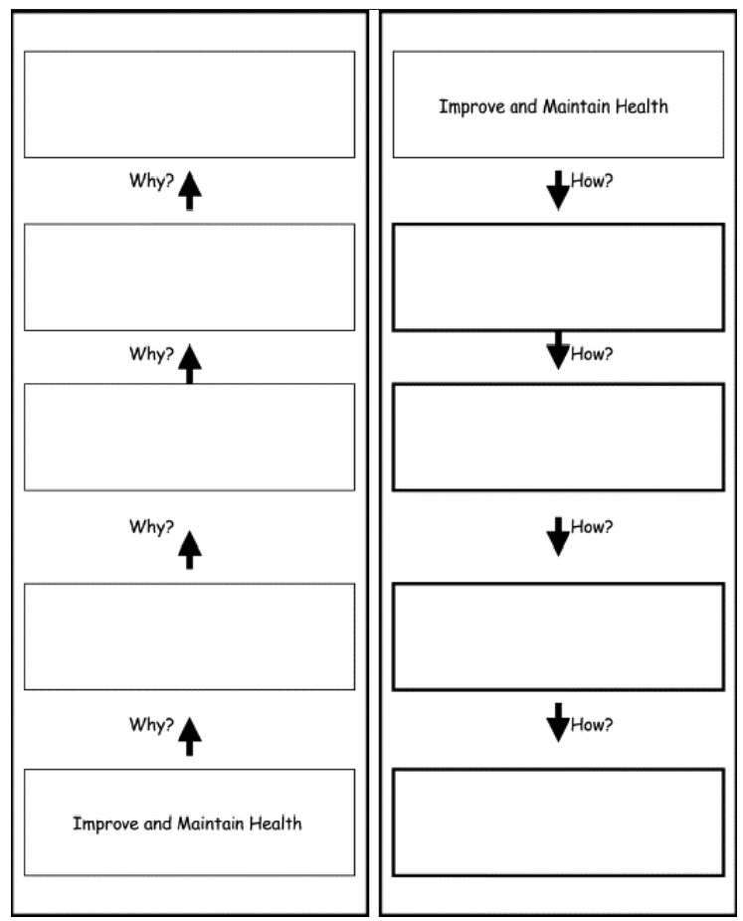

Appendix M: Morality and Value Question (Study 3)
Imagine a circle representing all the time in your life. Your task is to decide how much of that time you would ideally want to spend on different pursuits.
These pursuits include:
- Aesthetic & Intellectual Expression
Pursuing and passing on knowledge, making and seeing art, seeking truth, playing or listening to music, perfecting a sport
- Civic Life
Pursuing political action, participating in collective decision-making, managing shared resources, engaging with your political community
- Morality
Pursuing justice, promoting fairness, protecting others from risks and threats, participating in religious or spiritual practices
- Play & Leisure
Pursuing enjoyment for its own sake, engaging in play, having hobbies and recreational activities, taking time for leisure
- Relationships
Pursuing connection and interaction with other people and animals, feeling close to others, maintaining ties with friends and family
Once you begin entering values, a pie chart will appear. Adjust the amounts for each pursuit so the chart reflects your ideal way of dividing your life across these pursuits. Your task is to adjust the pursuits you are shown to match YOUR ideal.

Appendix N: Attention Checks

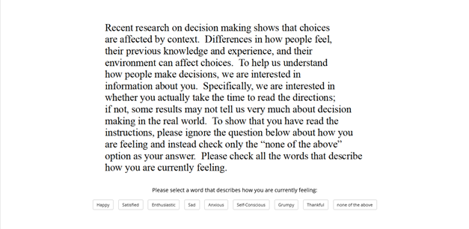

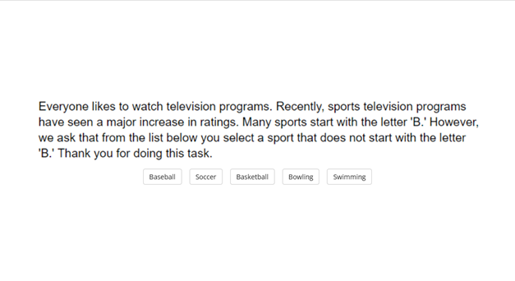

Appendix O: References
Freitas, A. L., Gollwitzer, P., & Trope, Y. (2004). The influence of abstract and concrete mindsets on anticipating and guiding others’ self-regulatory efforts. Journal of Experimental Social Psychology, 40(6), 739–752. https://doi.org/10.1016/j.jesp.2004.04.003
Fujita, K., Trope, Y., Liberman, N., & Levin-Sagi, M. (2006). Construal Levels and Self-Control. Journal of Personality and Social Psychology, 90(3), 351–367. https://doi.org/10.1037/0022-3514.90.3.351
McHugh, C., McGann, M., Igou, E. R., & Kinsella, E. L. (2017). Searching for Moral Dumbfounding: Identifying Measurable Indicators of Moral Dumbfounding. Collabra: Psychology, 3(1), 1–24. https://doi.org/10.1525/collabra.79
McHugh, C., McGann, M., Igou, E. R., & Kinsella, E. L. (2023). Cognitive Load Can Reduce Reason-Giving in a Moral Dumbfounding Task. Collabra: Psychology, 9(1), 73818. https://doi.org/10.1525/collabra.73818
McHugh, C., Zhang, R., Karnatak, T., Lamba, N., & Khokhlova, O. (2023). Just wrong? Or just WEIRD? Investigating the prevalence of moral dumbfounding in non-Western samples. Memory & Cognition, 51(5), 1043–1060. https://doi.org/10.3758/s13421-022-01386-z

