1.
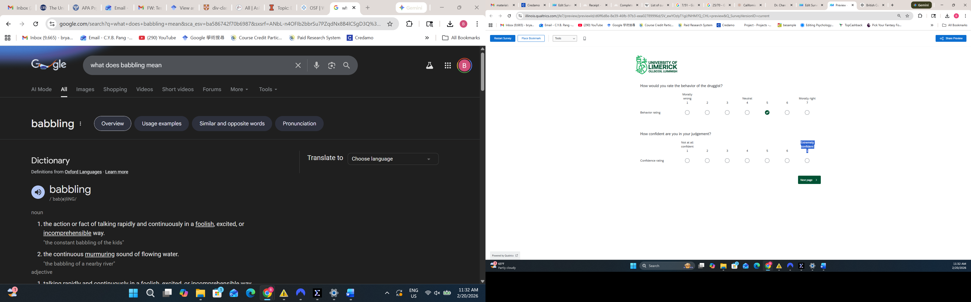
Oh! Good catch! Thanks for that!
2.
A ? missing on the following
Thanks again
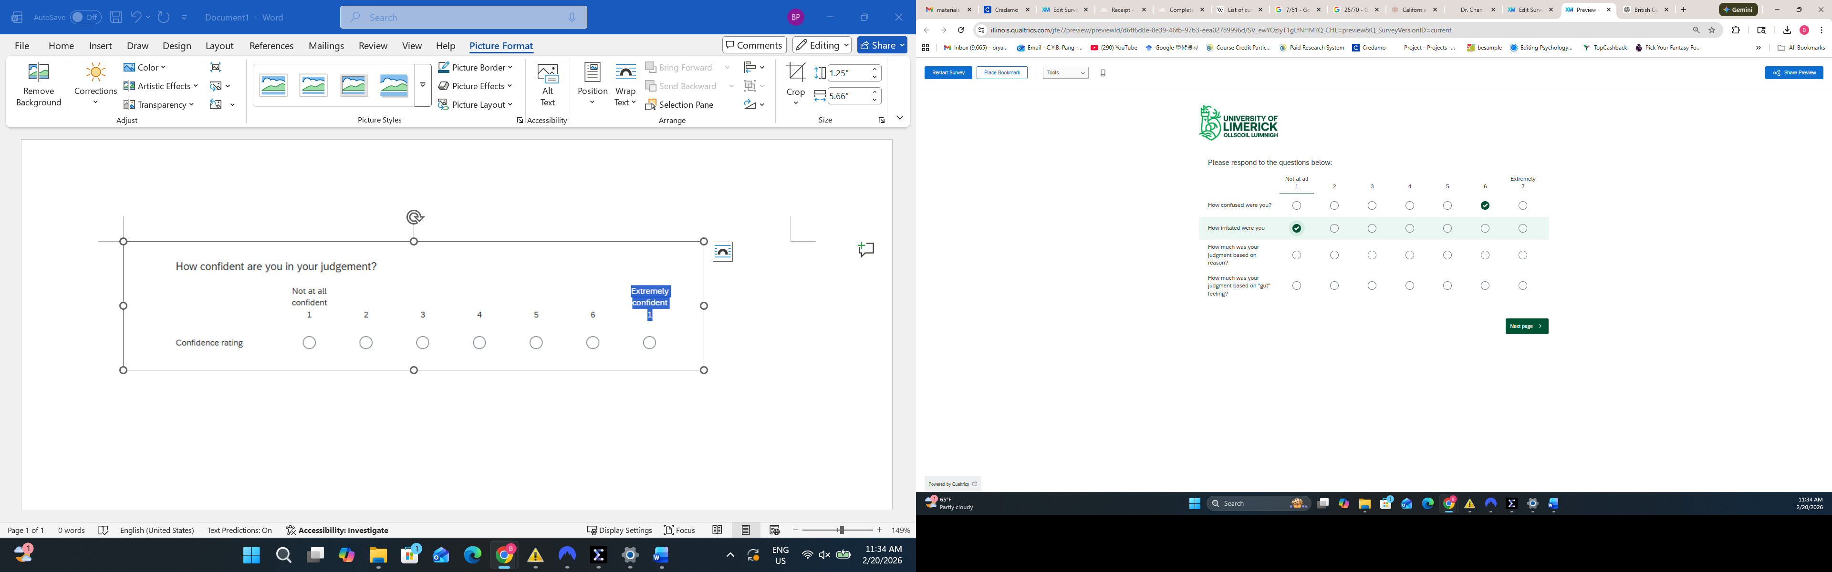
3.
Is the last sentence redundant on the following?
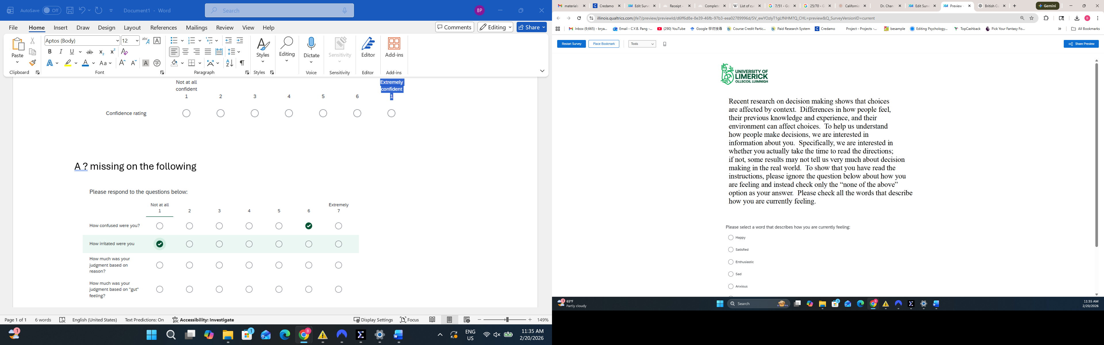
Fair. I’ve deleted the repeated question from qualtrics

4.
Generally, when asking questions about the scenario, I’m thinking if you want to display the scenario on the same page as well. When I am making judgments, I find that I have forgotten details of the scenario itself.
My Advisor Dov would tell me to display the scenario in grey when it is displayed for the second time. To signal to people that this is repeating information and just there for your reference.
I’ll leave it to you to decide whether to do this or not.
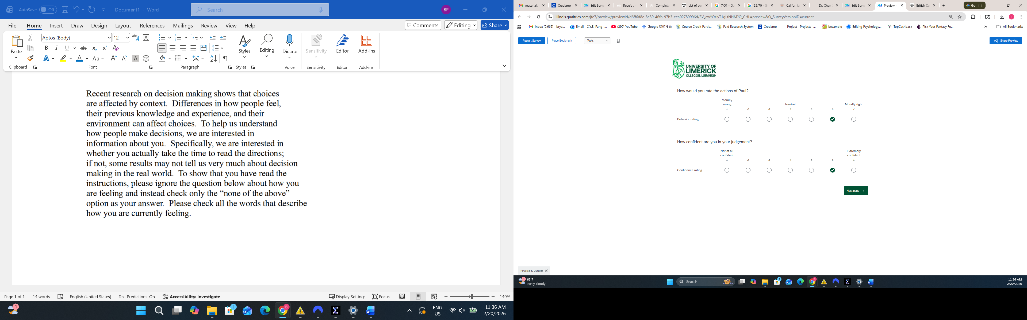
Fair point. We have gotten into the practice of only showing the dumbfounding scenarios at the start. This is a legacy “we’ve always done it this way” answer, but there’s a bit of a rationale, that if they can go back and reference the text they could find something there they could potentially use as a justification. It seems to work fine without repeating the scenario.
5.
When I was asked things like
Do you accept that they are consenting adults and they have both enjoyed it?
I answered yes
Then next page I was asked
Do you think it is wrong?
I am unsure if the “it” refers to “that they enjoyed the sex”, of if it means the original scenario itself.
I think this generally goes for all the cases where you ask if I accept a premise, and then ask me if it is wrong. I’m not sure if you mean the premise is wrong, or of the original scenario is wrong. (From my reading of your previous papers, it should be the latter meaning, right..?)
Should we change it to “Do you think the behaviour is wrong?”

6.
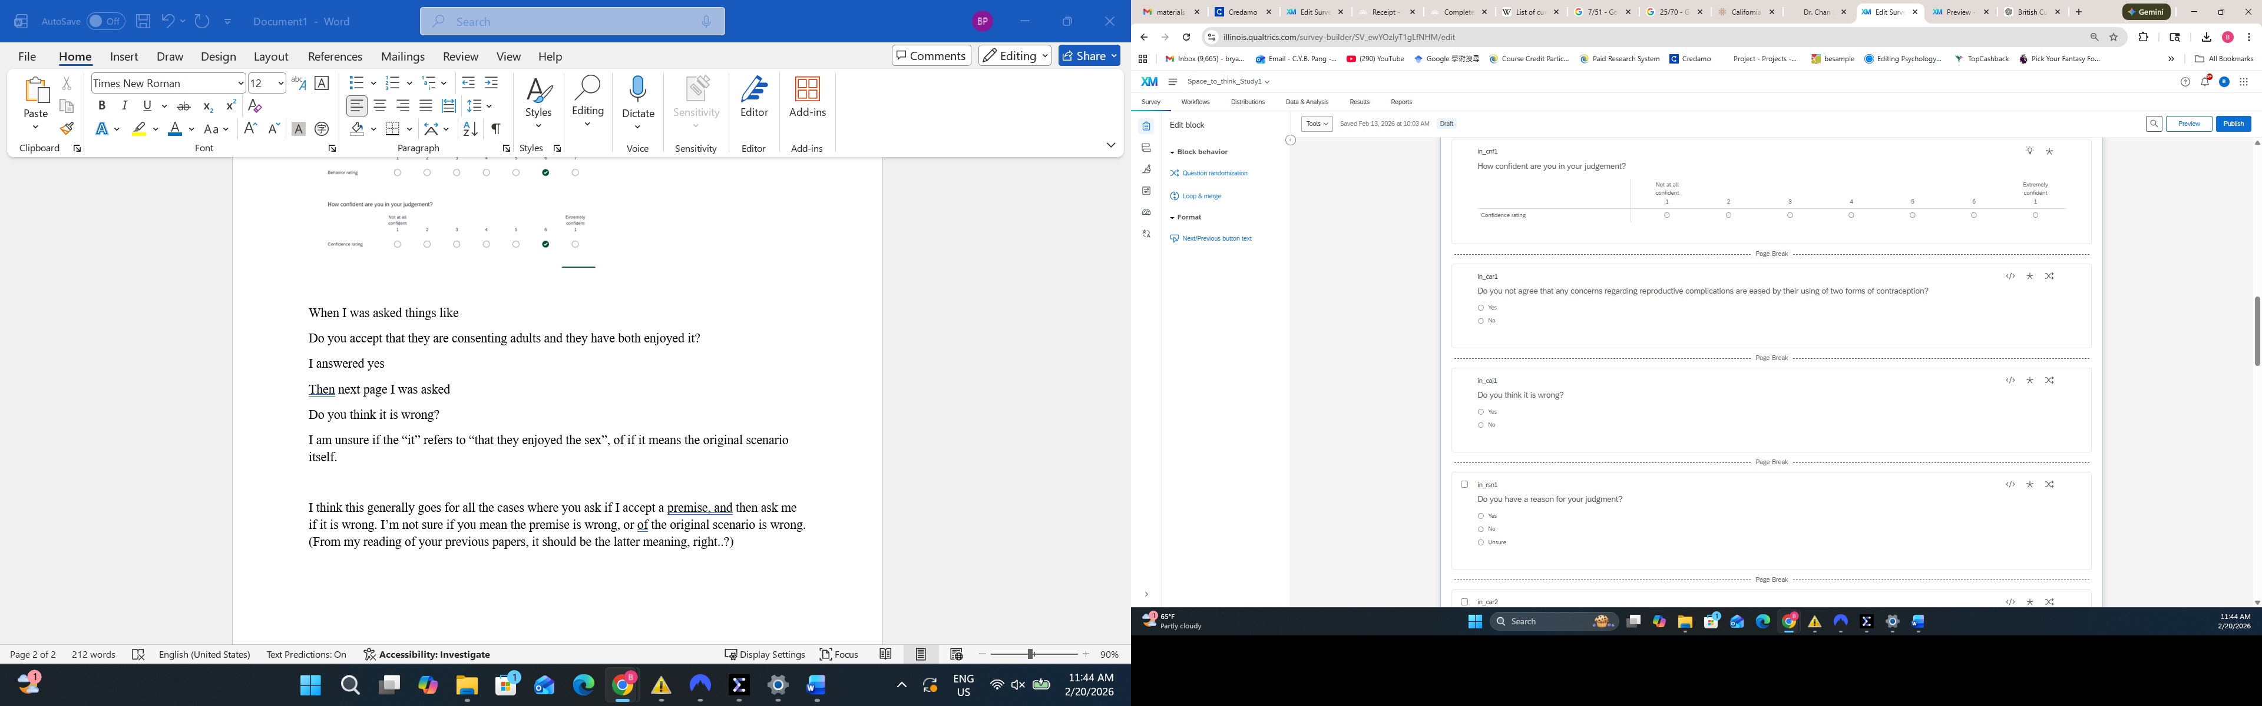
This question has a double negative. Would it be better to just say “Do you agree that …..?”

Responding to both 5 and 6 together. The responses to these questions are not important. The idea is that they get participants thinking about the possible invalidity of reasons for judging the behaviour as wrong. They could be potentially more precise, but they’ve worked so far. If you want to make them less confusing in your translation, that’s fine.

