Thanks a million for your careful reading of this. I really appreciate it. I’ve tried to balance addressing your concerns with the constraints of (1) using existing / established method/materials; and (2) having the methods and materials already approved following peer review. I’m quite reluctant to deviate from the approved methods for fear that this would impact our in-principle acceptance.
1.
In the “How” instructions:
For example, like most people, you probably hope to find happiness in life. How can you do this? Perhaps finding a good job, or being educated, can help. How can you do these things? Perhaps by earning a college degree. How do you earn a college degree? By satisfying course requirements. How do you satisfy course requirements? In some cases, such as today, you participate in a psychology experiment.

In the “Why Instructions”:
For example, you currently are participating in a psychology experiment. Why are you doing this? Perhaps to satisfy a course requirement. Why are you satisfying the course requirement? Perhaps to pass a psychology course. Why pass the course? Perhaps because you want to earn a college degree. Why earn a college degree? Maybe because you want to find a good job, or because you want to educate yourself.

These instructions are tailored to university students. Is the key here to lead people to think about:
1. How their overall life goals lead them to doing this experiment today, and
2. How participating in this experiment today trace back to their overall life goals?
In that case, I would need to come up with a causal chain that works for general participants, correct?
Good catch. I took this wording directly from Freitas et al. (2004). My understanding is that the experiment is not particularly important, it is just used as an example to illustrate thinking about causal chains in general. It does read as more tailored to college students, but I think the use of “perhaps” in both is (hopefully) sufficient to allow non-students to see that “ok this specific causal chain doesn’t describe my experience, but if asked I could come up with an alternative chain that does, that is similar to the one described”.
So while not necessarily ideal for a non-student sample, the manipulation should still be effective if participants are able to see past the specific content of the preamble and focus on the relevant thought processes.
But I think that manipulations can be really fickle.. I am imagining my friend who is currently a nurse reading this instruction and be like “well, I’m not a college student”. Or, imagine some blue collar worker without a college education reading this. They may feel “oh, these people designed the experiment for college students, not for someone like me”. People feeling they’re excluded can break the experiment..
Was the exact wordings included in the submitted methods? If not, here’s a way to modify it:

For example, like most people, you probably hope to find happiness in life. How can you do this? Perhaps staying informed about current trends, and connecting with others, can help. How can you do these things? Perhaps by connecting with others via social media. How do you connect with others via social media? By texting your friends, or reading shared social media posts. In some cases, such as today, that led you to participate in a psychology experiment.

For example, you currently are participating in a psychology experiment. Why are you doing this? Perhaps a friend texted you the link to this experiment, or you read it from a shared social media post. Why are you texting your friend or reading social media posts? Perhaps to connect to others via social media. Why connect with others via social media? Perhaps to maintain connection with others and current trends in general. Why do that? Perhaps staying informed and connected is key to a good life.

That depends on whether the wordings in the registered report allows us to make this change. (My apologies but I’m not sure if I have the full text of the final version of the manuscript that was accepted) But I think there should be flexibility for adapting to unforeseen problems, right..? It’s impossible to forsee all problems at the time of submitting the report. (Or, can we write to the editor to ask about the degrees of modifications allowed?)
I added:
“Please note, in describing the thought experiment we use the example of a college student. This is simply an example to illustrate the idea. We encourage you to think about how similar ideas could apply to you and your life.”
2. In the How Instructions:
This thought exercise is intended to focus your attention on how you do the things you do.
This sentence is a bit vague; I think we want people to think about how they achieve their goals, right? (e.g. how to gain happiness, how to maintain one’s physical health). Maintain one’s physical health seems not to be “a thing people do”.
I agree, but, as above, I’m reluctant to make a change. I think participants should be able to figure out what we're getting at.
Same comment as above..
Also, the vagueness gets compounded when it’s translated. Staying true to the original meaning when translating is hard enough. Staying true to the original vagueness is even harder. I tried translating this to Cantonese and it just reads like babbling..
If in the end we’re not making changes, I hope you’ll allow me to change the content so that the meaning is clearer in Cantonese. If the issue is to not deviate from the pre-reg, it’s not like any reviewer will challenge us on how the stuff is translated into Cantonese.
As above, I added:
“Please note, in describing the thought experiment we use the example of a college student. This is simply an example to illustrate the idea. We encourage you to think about how similar ideas could apply to you and your life.”
Feel free to make it make more sense in your translations.

3. For both the “How” and “Why” procedures, I was asked to list three ways to improve physical health or three reasons why I want to improve physical health. But on the next page, I am immediately asked to restate one of the ways/reasons. This made me confused because I was like “didn’t they just ask me that? Why are they asking me again? Did I read the previous instructions wrong, or am I reading the current instructions wrong?”
What is the reason for asking participants to list the three reasons on the first page? Why not immediately jump into the going upwards/downwards boxes?
Agreed, I thought it was a bit overkill while I was setting it up, but this is again taken from the original study. I’ve added an introduction to the task (this also addresses your point 7 below) that tells participants that first they’ll be asked to come up with three ways and second they’ll be asked to think of in more detail about 1 specific way/a particular goal
Okay. That should ease the confusion.
4. For going upward/downward boxes, my suggestion is: why not only show people the current box they need to fill in, instead of showing them all the boxes? For example, we could program it to make it look like the below: (I use the “why” condition as example)
I’ve done a hybrid of what you suggested and what was already there, and I think this is actually closer to the original (paper based) method.
OK. I look forward to seeing the new version
Page 1
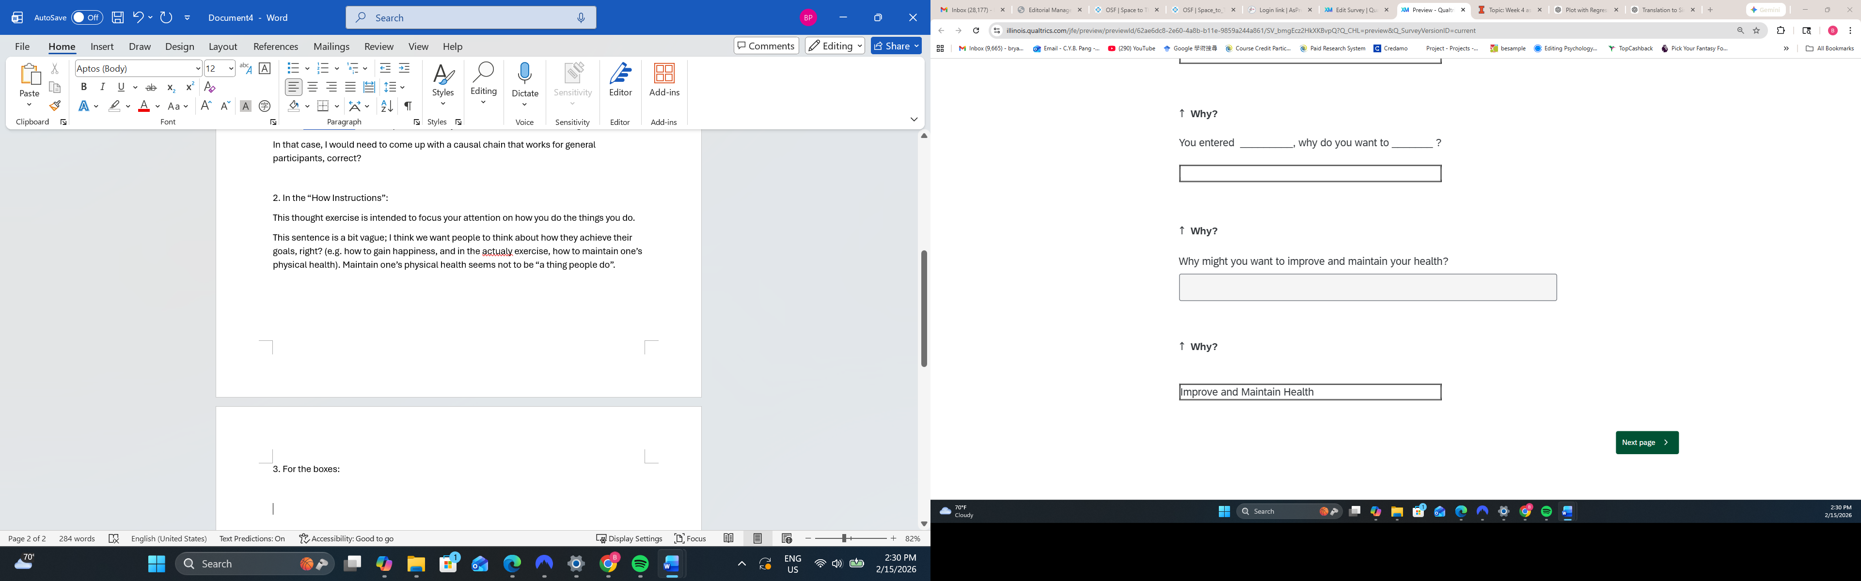
Page 2
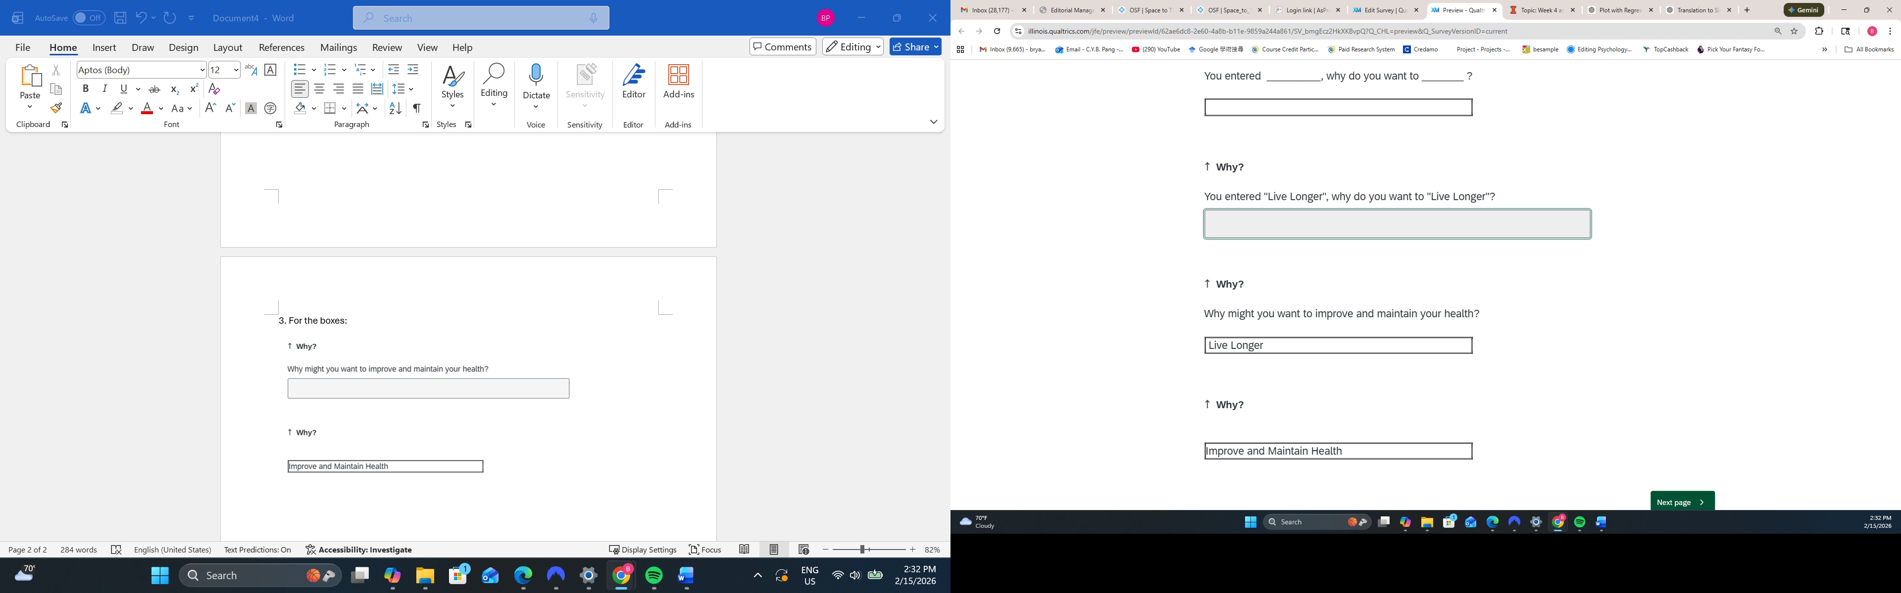

Page 3
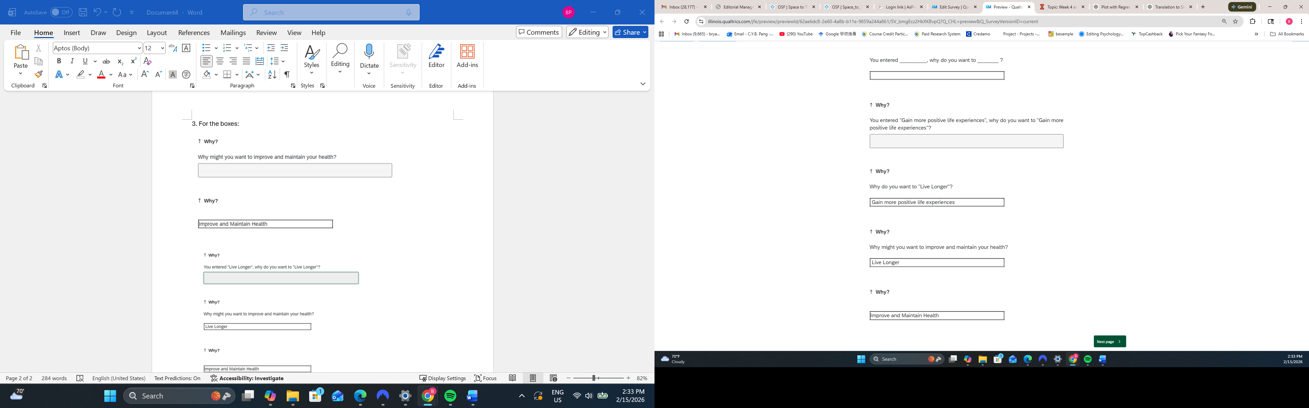
Page 4
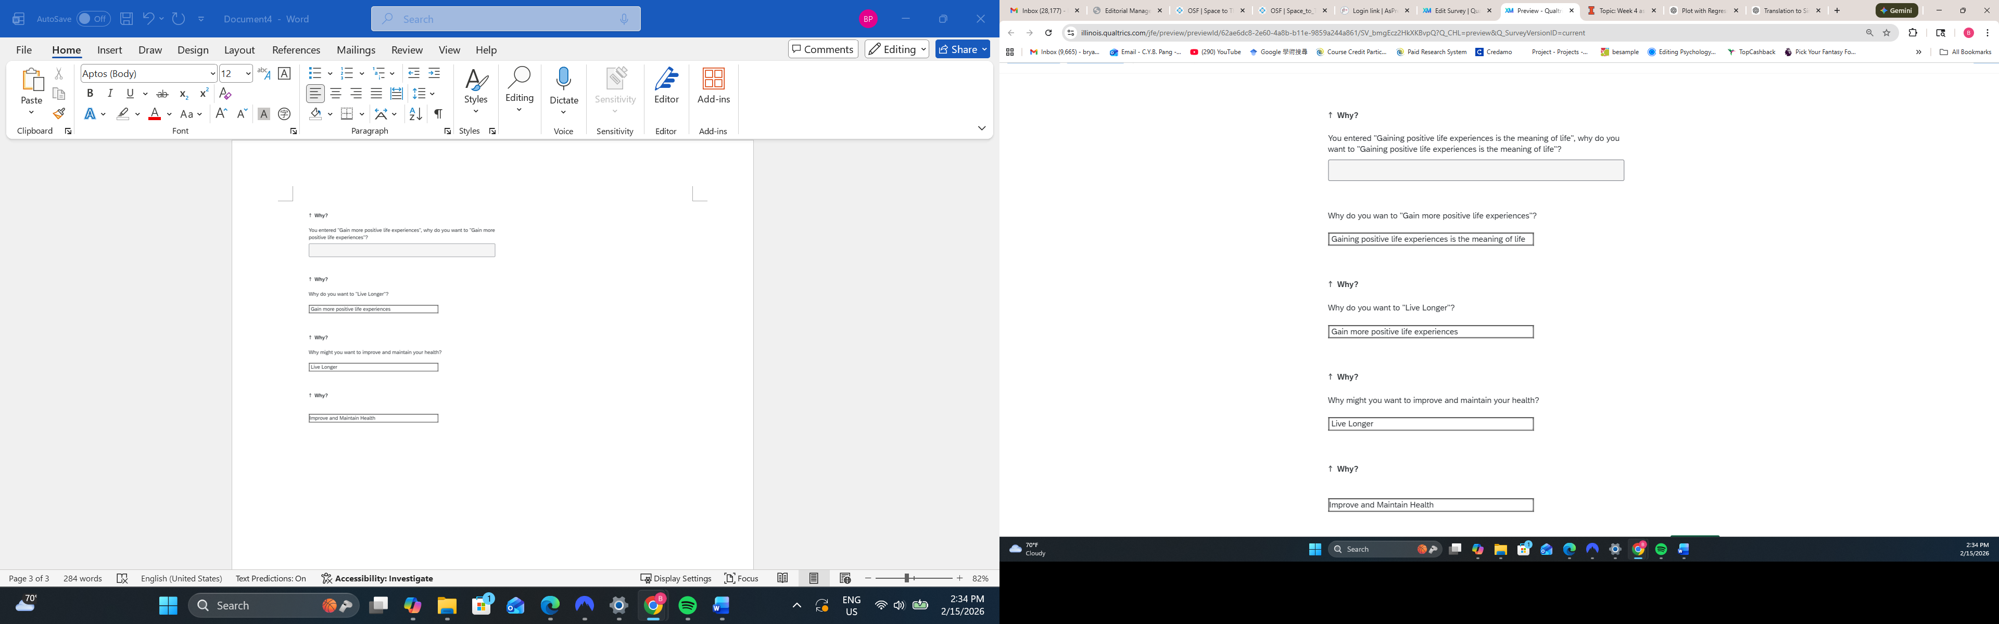
That might reduce participant confusion.

5. For the “Why” boxes, since the question asked is “Why do you want to XXX”, it is possible that people will key in something that is not an action. In which case, the next question won’t make sense.
For example, answering “Why do you want to gain more positive experiences”, I said “Gaining positive experiences is the meaning of life”. The next question, why do you want to gaining positive experiences is the meaning of life, doesn’t make sense.
It is also possible that to the first question,
Why might you want to improve and maintain your health?
One could answer: A healthy body is a key to happiness.
In that case, the chain is broken in the first step.

Maybe, you could add a “to _________” or “so that I could__________” in front of the box?
Why might you want to improve and maintain your health?
to ______________________
or
so that I could __________________________
In that case, people must enter an action. I have the java script to add words in front of text boxes; I can send over if you need them.
I found this also but I’m not sure how to address it. I hope that after the first “failed” answer participants will figure out a way to make it make sense. E.g., on your example “a healthy body is a key to happiness” they could infer this to be “happiness”. I’ve tweaked the wording of the prompt to read “you entered _______. Why do you want to achieve this?” I’ll note this as a deviation from the pre-reg in the revised submission, I think it’s sufficiently minor that nobody will object.

I think that’s an improvement, but “you entered a healthy body is a key to happiness. Why do you want to achieve this?” still doesn’t make much sense.
What do you think about my suggestion of making the textbox
So that I could __________________________?
I liked it, but we should probably have included in the submission. Very reluctant to deviate from the submitted methods wherever possible. I’m presuming that even with some possible responses not making sense, participants will still end up thinking more abstractly when they are pushed to respond to a series of “why” questions, and we have a manipulation check (manually coding the responses) to check this.

6. There is a bug in the “how” boxes:
Fixed (I hope)

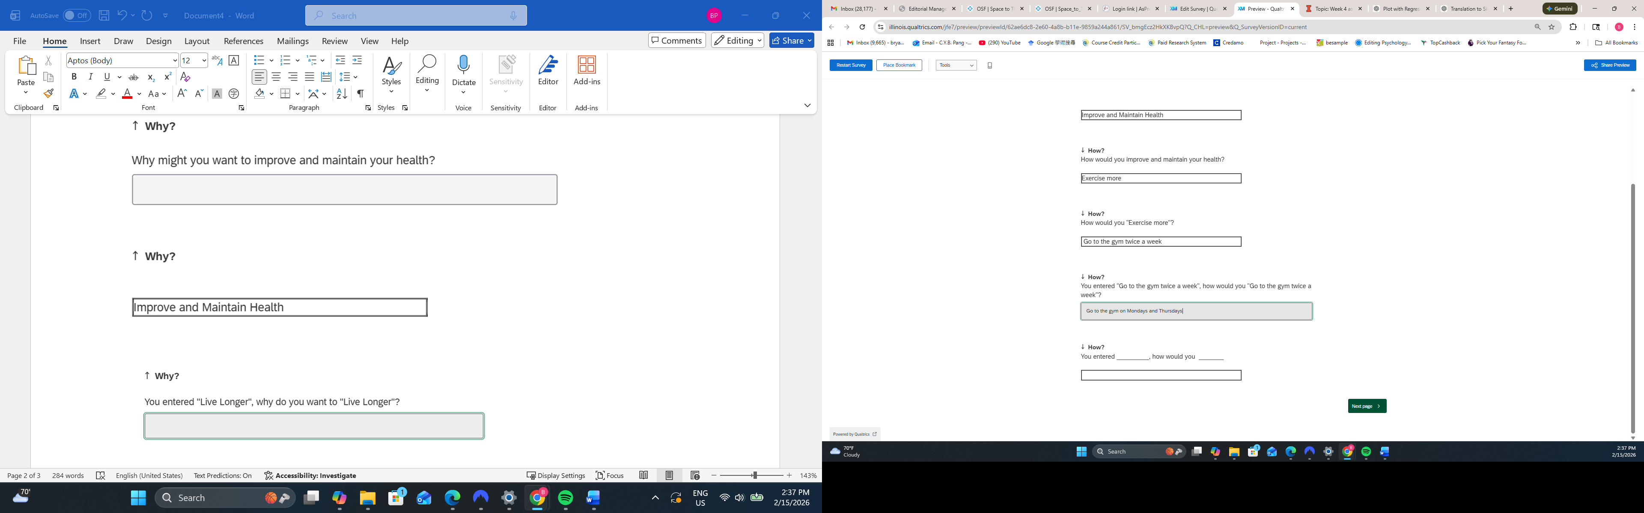
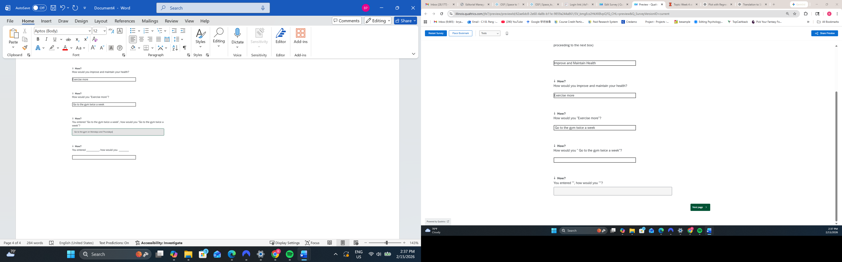
The last box doesn’t work (the thing I entered did not go on to the next page).
7. I found it a bit weird that in the consent form, I was told that this is a study on moral judgments. But the first part of the study is this unrelated exercise. And in the middle it jumped to moral judgments without transitions.
Maybe we need a cover story on why there are two seemingly unrelated parts to the study? Maybe in the consent form, say that we have two parts: one part about a thought exercise that improves well-being, and the second part about moral judgments?
Good call. I’ve added an “instructions” block for each task that notes “before you complete the moral judgment task….”
Nice!

