Introduction

Table of Contents

Cillian McHugh1, Marek McGann2, Eric R. Igou1, & Elaine L Kinsella1

1 University of Limerick

2 Mary Immaculate College University of Limerick

Author note

All procedures performed in studies involving human participants were approved by institutional research ethics committee and conducted in accordance with the Code of Professional Ethics of the Psychological Society of Ireland, and with the 1964 Helsinki declaration and its later amendments or comparable ethical standards. Informed consent was obtained from all individual participants included in the study. The authors declare that there are no potential conflicts of interest with respect to the research, authorship, and/or publication of this article. All authors consented to the submission of this manuscript.

Correspondence concerning this article should be addressed to Cillian McHugh, Mary Immaculate College, South Circular road, Limerick, Ireland. E-mail: [cillian.mchugh@ul.ie](mailto:cillian.mchugh@ul.ie)

Abstract

Moral dumbfounding occurs when people defend a moral judgment even though they cannot provide a reason in support of this judgment. It manifests as an admission of not having reasons, or the use of unsupported declarations () or tautological reasons () as justifications for a judgment. We test a dual-processes explanation of moral dumbfounding, where moral dumbfounding is an example of conflict between a habitual response (making a judgment) and a response that results from deliberation (providing a reason for the judgment). The dumbfounding paradigm involves three possible responses: (a) providing reasons for a judgment (deliberative/controlled process); (b) accepting the counter-arguments and rating the behaviour as (habitual/automatic process); (c) a dumbfounded response (habitual/automatic process). Cognitive load manipulations have been shown to inhibit deliberative responding. We present 6 studies in which dumbfounded responding was investigated under cognitive load manipulations. We hypothesized that rates of providing reasons would be reduced under cognitive load. The identification of reasons was inhibited in Studies 1, 2, 3, and 6, but not in Studies 4 or 5. The results provide some evidence for a dual-process explanation of moral dumbfounding. We found some evidence that dumbfounded responding may be linked with Need for Cognition.

*Keywords:* keywords

*Word count:* TBC

Introduction

Moral dumbfounding occurs Moral dumbfounding occurs when people defend a moral judgment even though they cannot provide a reason in support of this judgment (Haidt, 2001; Haidt et al., 2000; see also McHugh, et al., 2017, 2020). It has traditionally been seen as evidence for intuitionist and dual-process theories of moral judgment (e.g., Crockett, 2013; Cushman, 2013; Cushman, Young, & Greene, 2010; Greene, 2008; Haidt, 2001; Prinz, 2005; though this narrative has been contested, e.g., Guglielmo, 2018; Royzman, Kim, & Leeman, 2015). Despite the influence of moral dumbfounding on the morality literature, the phenomenon is not well understood. We test two predictions of a conflict in dual-processes explanation of moral dumbfounding across six studies. Using three different cognitive load manipulations we show that dumbfounded responses are more likely when participants are engaged in a secondary task (Studies 1, 2, 3, and 6; though this effect was not observed for Studies 4 and 5), and that this effect is not limited to a single scenario (Study 6). We also found that individual differences in need for cognition (Cacioppo & Petty, 1982; Petty, Cacioppo, & Kao, 1984; Forsterlee & Ho, 1999; Petty et al., 1996) weakly predict responses in the dumbfounding paradigm, with aggregate analysis (Studies 1-5) showing that participants who score higher in need for cognition more likely to provide reasons and less likely to present as dumbfounded.

# Moral Dumbfounding: A Dual-Process Perspective

Drawing on dual-process theories of moral judgment (Bago & De Neys, 2019; Brand, 2016; Cushman, 2013; e.g., Greene, 2008), we hypothesize that moral dumbfounding occurs as a result of a conflict in dual-processes (Bonner & Newell, 2010; De Neys, 2012; De Neys & Glumicic, 2008; Evans, 2007; see also De Neys & Pennycook, 2019). Dual-Process conflict occurs when a habitual/intuitive response is different from a response that results from deliberation. Examples of such conflicts include, base rate neglect problems (Bonner & Newell, 2010; De Neys, 2012; De Neys & Glumicic, 2008; Evans, 2007), the conjunction fallacy (De Neys, 2012; Tversky & Kahneman, 1983), and perhaps most relevant to the current discussion, a seemingly irrational but persistent unwillingness to contact various symbolically “contaminated” objects, despite assurances these items are sanitary Lerner & Goldberg (1999). This final example closely resembles the non-moral tasks described in the original unpublished dumbfounding manuscript (Haidt et al., 2000).

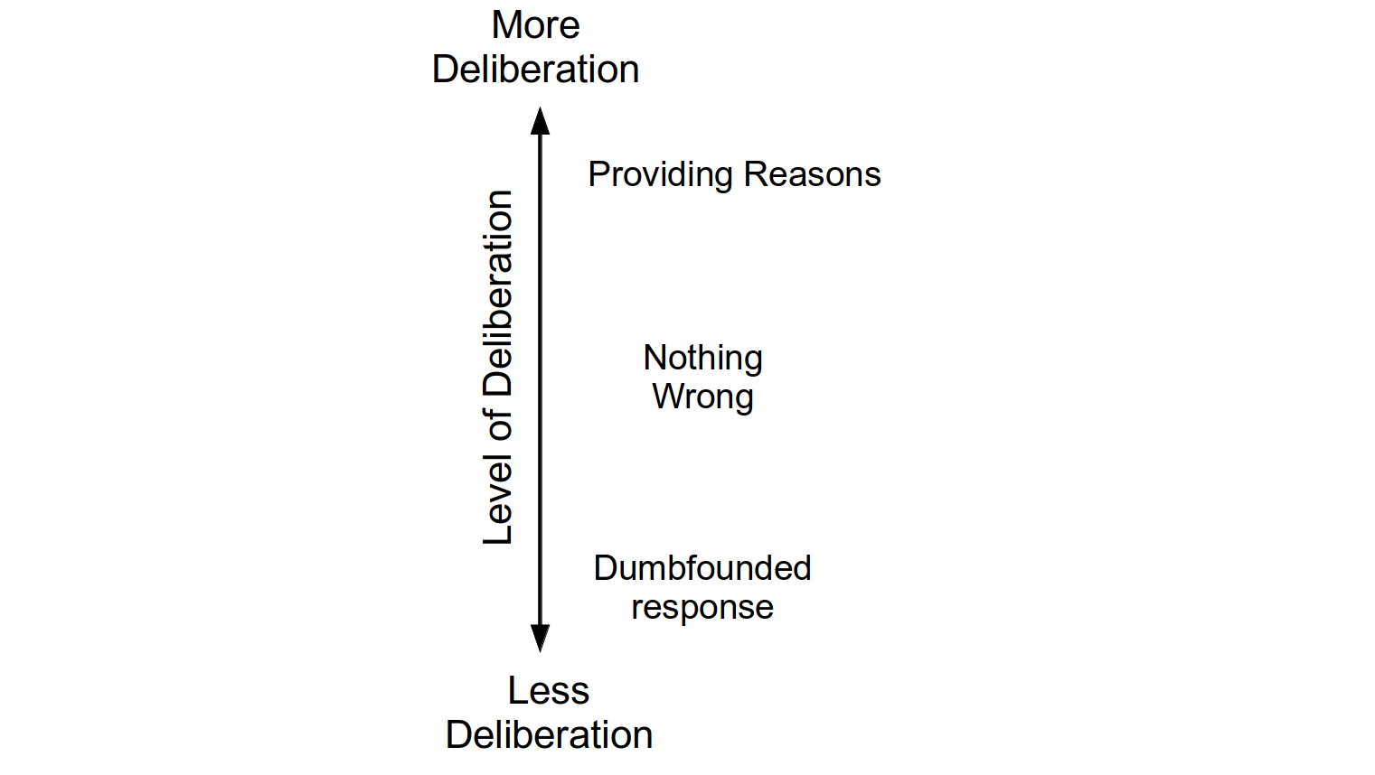

*hypothesized* *relationship* between responses in the dumbfounding paradigm and level of deliberation

To understand moral dumbfounding as a conflict in dual-processes, we classified the responses in the dumbfounding paradigm as involving more or less deliberation. There are typically three responses in the dumbfounding paradigm: (1) the providing of reasons (reason); (2) accepting the counter-arguments and rating the behavior as “not wrong” (nothing wrong); or (3) a dumbfounded response (dumbfounding). Drawing on existing theorizing (e.g., Cushman, 2013; Haidt, 2001; McHugh et al., 2021) we hypothesize that making a judgment involves an intuitive/habitual response, involving relatively little deliberation, while providing reasons for judgment requires more deliberation (a deliberative response). We propose that dumbfounding occurs when the habitual response (the judgment) is in conflict with the deliberative response (providing reasons for the judgment). The dumbfounding paradigm additionally involves a third response, where participants may accept the counter-arguments and change their judgment, we hypothesize that this response involves more deliberation than a dumbfounded response but less deliberation than providing reasons. The hypothesized relative amounts of deliberation for each response are outlined in Figure 1.

# Influences on Moral Dumbfounding

One prediction of explaining dumbfounding as conflict in dual-processes is that under specific manipulations, responses in the moral dumbfounding paradigm should vary in predictable ways. In addition to external manipulation, a second prediction of this conflict in dual-processes explanation is that responses in the moral dumbfounding paradigm may display variability that can be linked to specific individual difference variables. The studies described here aim to investigate both of these possibilities.

Cognitive load has been shown to inhibit deliberative responding (e.g., De Neys, 2006; Evans & Curtis-Holmes, 2005; Evans & Stanovich, 2013; Schmidt, 2016). Above, we identified providing reasons as involving more deliberation than alternative responses in the dumbfounding paradigm. This implies that cognitive load should inhibit the identification of reasons for a judgment, leading to an increase in dumbfounded responding or an increase in accepting the counter-arguments and revising the judgment made.

A second prediction is that responses in the dumbfounding paradigm will vary depending on individual differences. One individual difference variable linked to dual-process approaches to cognition, therefore may be related to susceptibility to dumbfounding is Need for Cognition (Cacioppo & Petty, 1982; Forsterlee & Ho, 1999; Petty, Cacioppo, & Kao, 1984; Petty, Feinstein, Blair, & Jarvis, 1996). The Need for Cognition Scale (NFC) is a measure of an individual’s tendency “to engage in and enjoy effortful analytic activity” (Forsterlee & Ho, 1999, p. 471; see also Cacioppo & Petty, 1982), or a tendency to engage in deliberation (Evans & Stanovich, 2013). We hypothesize that people who score high in NFC will be more likely to provide reasons for their judgment. Related to this, people who score low on the NFC are likely to fail to identify reasons for their judgment (or provide a dumbfounded response).

# The Current Studies

The studies described here aim to investigate test two predictions of a conflict in dual-process explanation of moral dumbfounding. To test the first prediction we experimentally manipulated cognitive load. We predict that a cognitive load manipulation will inhibit people’s ability to provide reasons for their judgment, leading to greater habitual responses (either nothing wrong or dumbfounding or both) The second prediction is that a person’s tendency to provide reasons will be related to their score on the Need for Cognition scale (Cacioppo & Petty, 1982; Petty, Cacioppo, & Kao, 1984). We hypothesize that as NFC increases people will be less likely to present as dumbfounded. We conducted six studies to assess these predictions.[1],[2]

Bago, B., & De Neys, W. (2019). The intuitive greater good: Testing the corrective dual process model of moral cognition. *Journal of Experimental Psychology: General*, *148*(10), 1782–1801. <https://doi.org/10.1037/xge0000533>

Bonner, C., & Newell, B. R. (2010). In conflict with ourselves? An investigation of heuristic and analytic processes in decision making. *Memory & Cognition*, *38*(2), 186–196. <https://doi.org/10.3758/MC.38.2.186>

Brand, C. (2016). *Dual-Process Theories in Moral Psychology: Interdisciplinary Approaches to Theoretical, Empirical and Practical Considerations*. Springer. Retrieved from <http://books.google.com?id=nQ3NCwAAQBAJ>

Cacioppo, J. T., & Petty, R. E. (1982). The need for cognition. *Journal of Personality and Social Psychology*, *42*(1), 116–131. <https://doi.org/10.1037/0022-3514.42.1.116>

Crockett, M. J. (2013). Models of morality. *Trends in Cognitive Sciences*, *17*(8), 363–366. <https://doi.org/10.1016/j.tics.2013.06.005>

Cushman, F. A. (2013). Action, Outcome, and Value A Dual-System Framework for Morality. *Personality and Social Psychology Review*, *17*(3), 273–292. <https://doi.org/10.1177/1088868313495594>

Cushman, F. A., Young, L., & Greene, J. D. (2010). Multi-system Moral Psychology. In J. M. Doris (Ed.), *The Moral Psychology Handbook* (pp. 47–71). Oxford; New York: Oxford University Press.

De Neys, W. (2006). Dual Processing in Reasoning: Two Systems but One Reasoner. *Psychological Science*, *17*(5), 428–433. <https://doi.org/10.1111/j.1467-9280.2006.01723.x>

De Neys, W. (2012). Bias and Conflict: A Case for Logical Intuitions. *Perspectives on Psychological Science*, *7*(1), 28–38. <https://doi.org/10.1177/1745691611429354>

De Neys, W., & Glumicic, T. (2008). Conflict monitoring in dual process theories of thinking. *Cognition*, *106*(3), 1248–1299. <https://doi.org/10.1016/j.cognition.2007.06.002>

De Neys, W., & Pennycook, G. (2019). Logic, Fast and Slow: Advances in Dual-Process Theorizing. *Current Directions in Psychological Science*, *28*(5), 503–509. <https://doi.org/10.1177/0963721419855658>

Evans, J. St. B. T. (2007). On the resolution of conflict in dual process theories of reasoning. *Thinking & Reasoning*, *13*(4), 321–339. <https://doi.org/10.1080/13546780601008825>

Evans, J. St. B. T., & Curtis-Holmes, J. (2005). Rapid responding increases belief bias: Evidence for the dual-process theory of reasoning. *Thinking & Reasoning*, *11*(4), 382–389. <https://doi.org/10.1080/13546780542000005>

Evans, J. St. B. T., & Stanovich, K. E. (2013). Dual-Process Theories of Higher Cognition: Advancing the Debate. *Perspectives on Psychological Science*, *8*(3), 223–241. <https://doi.org/10.1177/1745691612460685>

Forsterlee, R., & Ho, R. (1999). An Examination of the Short form of the Need for Cognition Scale Applied in an Australian Sample. *Educational and Psychological Measurement*, *59*(3), 471–480. <https://doi.org/10.1177/00131649921969983>

Greene, J. D. (2008). The Secret Joke of Kant’s Soul. In W. Sinnott-Armstrong, *Moral Psychology Volume 3: The neurosciences of morality: Emotion, brain disorders, and development* (pp. 35–79). Cambridge (Mass.): the MIT press.

Guglielmo, S. (2018). Unfounded dumbfounding: How harm and purity undermine evidence for moral dumbfounding. *Cognition*, *170*, 334–337. <https://doi.org/10.1016/j.cognition.2017.08.002>

Haidt, J. (2001). The emotional dog and its rational tail: A social intuitionist approach to moral judgment. *Psychological Review*, *108*(4), 814–834. <https://doi.org/10.1037/0033-295X.108.4.814>

Haidt, J., Björklund, F., & Murphy, S. (2000). Moral dumbfounding: When intuition finds no reason. *Unpublished Manuscript, University of Virginia*.

Lerner, M. J., & Goldberg, J. H. (1999). When Do Decent People Blame Victims? The Differing Effects of the Explicit/Rational and Implicit/Experiential Cognitive Systems. In S. Chaiken & Y. Trope (Eds.), *Dual-process Theories in Social Psychology* (pp. 627–640). Guilford Press. Retrieved from <http://books.google.com?id=5X_auIBx99EC>

McHugh, C., McGann, M., Igou, E. R., & Kinsella, E. L. (2017). Searching for Moral Dumbfounding: Identifying Measurable Indicators of Moral Dumbfounding. *Collabra: Psychology*, *3*(1), 1–24. <https://doi.org/10.1525/collabra.79>

McHugh, C., McGann, M., Igou, E. R., & Kinsella, E. L. (2020). Reasons or rationalizations: The role of principles in the moral dumbfounding paradigm. *Journal of Behavioral Decision Making*, *33*(3), 376–392. <https://doi.org/10.1002/bdm.2167>

McHugh, C., McGann, M., Igou, E. R., & Kinsella, E. L. (2021). Moral Judgment as Categorization (MJAC). *Perspectives on Psychological Science*. <https://doi.org/10.1177/1745691621990636>

Petty, R. E., Cacioppo, J. T., & Kao, C. F. (1984). The efficient assessment of need for cognition. *Journal of Personality Assessment*, *48*(3), 306–307.

Petty, R. E., Feinstein, J. A., Blair, W., & Jarvis, G. (1996). Dispositional differences in cognitive motivation: The life and times of individuals varying in need for cognition. *Psych. Bull*, 197–253.

Prinz, J. J. (2005). Passionate Thoughts: The Emotional Embodiment of Moral Concepts. In D. Pecher & R. A. Zwaan (Eds.), *Grounding Cognition: The Role of Perception and Action in Memory, Language, and Thinking* (pp. 93–114). Cambridge University Press.

Royzman, E. B., Kim, K., & Leeman, R. F. (2015). The curious tale of Julie and Mark: Unraveling the moral dumbfounding effect. *Judgment and Decision Making*, *10*(4), 296–313.

Rozin, P., Markwith, M., & McCauley, C. (1994). Sensitivity to indirect contacts with other persons: AIDS aversion as a composite of aversion to strangers, infection, moral taint, and misfortune. *Journal of Abnormal Psychology*, *103*(3), 495–504. <https://doi.org/10.1037/0021-843X.103.3.495>

Schmidt, D. (2016). The Effects of Cognitive Load and Stereotyped Groups on Punitiveness. *CMC Senior Theses*.

Tversky, A., & Kahneman, D. (1983). Extensional versus intuitive reasoning: The conjunction fallacy in probability judgment. *Psychological Review*, *90*(4), 293–315. <https://doi.org/10.1037/0033-295X.90.4.293>

1. A priori power analysis indicated that, for the primary research question (the influence of cognitive load on dumbfounded responding), in order to detect a large effect size (*V* = .35) with 80% power, a sample of *N* = 79 participants was required; in order to detect a medium effect size (*V* = .21) with 80% power a sample of *N* = 218 participants was required; in order to detect a small effect size (*V* = .07) with 80% power a sample of *N* = 1966 was required. This means that studies 1-5 are likely under-powered. To account for this we conducted pre-registered sixth study with a large sample size, and additionally we conducted mini meta-analyses, along with a combined analysis of all studies.
2. A priori power analysis indicated that, for the secondary research question (the relationship between dumbfounded responding and Need for Cognition), in order to detect a large effect size (*OR* = 9) with 80% power, a sample of *N* = 11 participants was required; in order to detect a medium effect size (*OR* = 3.45) with 80% power a sample of *N* = 32 participants was required; in order to detect a small effect size (*OR* = 1.49) with 80% power a sample of *N* = 309 was required. Again, the studies described here are likely under-powered and we conclude with a combined analysis of all studies.