Study 4

Table of Contents

Blinded1, Blinded2, Blinded1, & Blinded1

1 Blinded

2 Blinded

Author note

All procedures performed in studies involving human participants were approved by institutional research ethics committee and conducted in accordance with the Code of Professional Ethics of the Psychological Society of Ireland, and with the 1964 Helsinki declaration and its later amendments or comparable ethical standards. Informed consent was obtained from all individual participants included in the study. The authors declare that there are no potential conflicts of interest with respect to the research, authorship, and/or publication of this article. All authors consented to the submission of this manuscript.

Correspondence concerning this article should be addressed to Blinded, Blinded. E-mail: Blinded

Abstract

Six studies etc.

*Keywords:* keywords

*Word count:* TBC

Study 4

# Study 4 - Online Replication 3

Study 3 found a significant relationship between cognitive load and response to the critical slide and a significant relationship between Need for Cognition and response to the critical slide. The aim of Study 4 was to replicate these findings. In addition Study 4 included a manipulation check to assess the effectiveness of the cognitive load manipulation employed.

## Study 4: Method

### Study 4: Participants and Design.

Study 4 was a between subjects design. The dependent variable was response to the critical slide. The independent variable was cognitive load with two levels: present and absent. Need for Cognition (Cacioppo & Petty, 1982; Petty, Cacioppo, & Kao, 1984) was included as a potential correlate and moderator variable.

Following the elimination of 29 participants who scored less than 7 on the memory task we were left with a final sample of 127 participants (84 female, 43 male; *M*age = 41.19, min = 21, max = 74, *SD* = 13.91). Participants in this sample were recruited through MTurk (under the same conditions as Studies 2 and 3).

### Study 4: Procedure and Materials.

Study 4 was the same as Study 3 with one change, the inclusion of a manipulation check. A prose paragraph was included after participants made their revised judgements. Participants were then asked three comprehension questions relating to the prose paragraph. It was expected that participants in the control group would perform better at this task than participants under cognitive load (Just & Carpenter, 1992).

## Study 4: Results

Ninety eight participants (77.17%) rated the behavior of Julie and Mark as wrong initially, and ninety two participants (72.44%) rated the behavior as wrong at the end of the task. Initial ratings (*M* = 2.09, *SD* = 1.62) were significantly more severe than revised ratings (*M* = 2.31, *SD* = 1.79), *t*(126) = -3.14, *p* = .002; *d* = 0.28. Inspection of the binned judgments revealed that thirteen participants changed the valence of their judgments, and all but two of these involved one judgment that was neutral (see Supplementary materials Table XX).

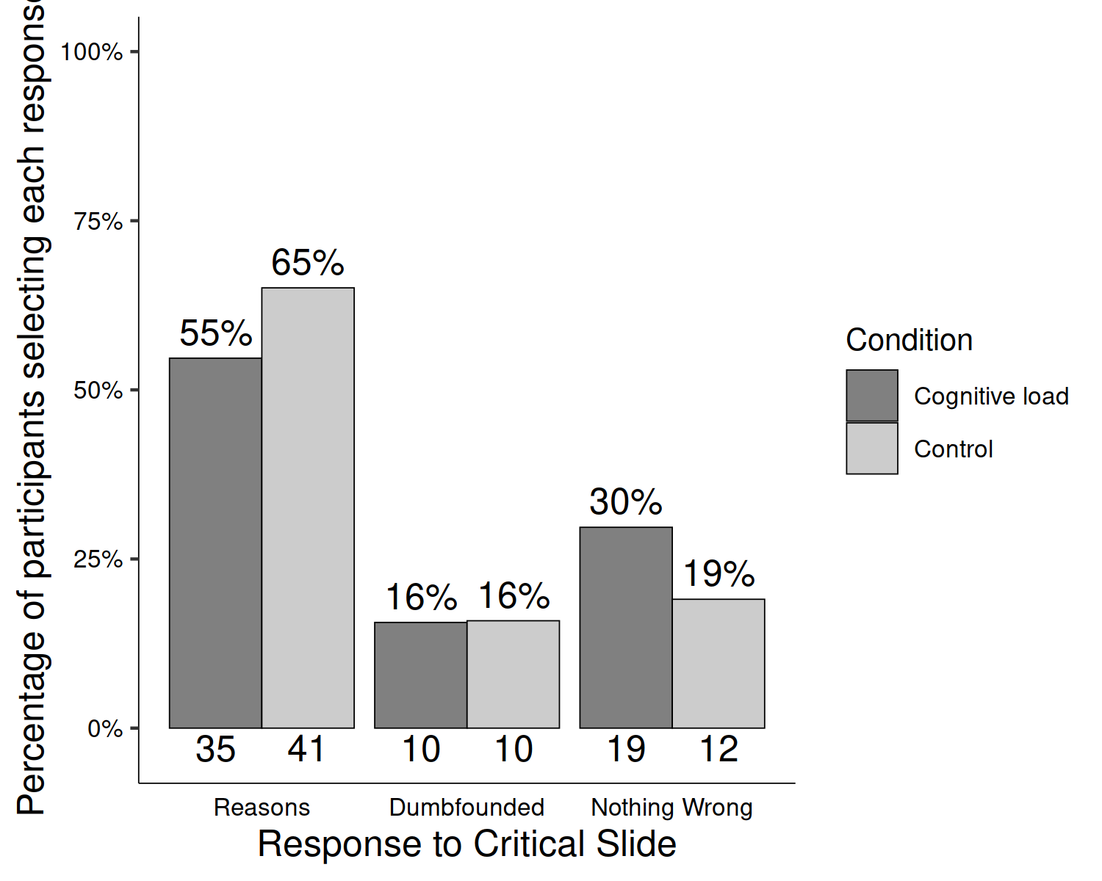

*Figure* *1.*  Study 4: Responses to critical slide for the cognitive load group (*N* = 64) and the control group (*N* = 61)

Investigation of the responses to the manipulation check questions revealed no difference in the number of correct answers to these questions between the cognitive load group and the control group *t*(123.91) = 0.57, *p* = .569; *d* = 0.10. There was also no difference in time taken to read the vignette between the groups *t*(63.40) = 1.62, *p* = .111; *d* = 0.28.

On the critical slide, twenty participants (15.75%) selected “It’s wrong but I can’t think of a reason.” Seventy six participants (59.84%) selected “It’s wrong and I can provide a valid reason”; and thirty one participants (24.41%) selected “There is nothing wrong.”

Table 1:

*Study 4 – Observed counts, expected counts, and standardised residuals for each response to the critical slide depending on cognitive load*

|  |  |  |  |
| --- | --- | --- | --- |
|  |  | Cognitive Load | Control |
| Observed count | Reasons | 35.00 | 41.00 |
|  | Dumbfounded | 10.00 | 10.00 |
|  | Nothing Wrong | 19.00 | 12.00 |
| Expected count | Reasons | 38.30 | 37.70 |
|  | Dumbfounded | 10.08 | 9.92 |
|  | Nothing Wrong | 15.62 | 15.38 |
| Standardised residuals | Reasons | -1.19 | 1.19 |
|  | Dumbfounded | -0.04 | 0.04 |
|  | Nothing Wrong | 1.40 | -1.40 |

*Note.* * = sig. at < .05; ** = sig. at < .001

A chi-squared test for independence revealed no significant association between experimental condition and response to the critical slide, 2(2, *N* = 127) = 2.05, *p* = .359, *V* = 0.13, the observed power was 0.23. The responses to the critical slide for the experimental group (*N* = 64) and the control group (*N* = 63) are displayed in Figure 1. The observed counts, expected counts and standardised residuals are displayed in Table 1.

A multinomial logistic regression revealed no statistically significant association between Need for Cognition and response to the critical slide, 2(2, *N* = 127) = 1.5, *p* = .472, the observed power was 0.18 (see Supplamentary Figure XX for relative probabilities of selecting each response depending on Need for Cognition).

Cacioppo, J. T., & Petty, R. E. (1982). The need for cognition. *Journal of Personality and Social Psychology*, *42*(1), 116–131. <https://doi.org/10.1037/0022-3514.42.1.116>

Just, M. A., & Carpenter, P. A. (1992). A capacity theory of comprehension: Individual differences in working memory. *Psychological Review*, *99*(1), 122–149. <https://doi.org/10.1037/0033-295X.99.1.122>

Petty, R. E., Cacioppo, J. T., & Kao, C. F. (1984). The efficient assessment of need for cognition. *Journal of Personality Assessment*, *48*(3), 306–307.