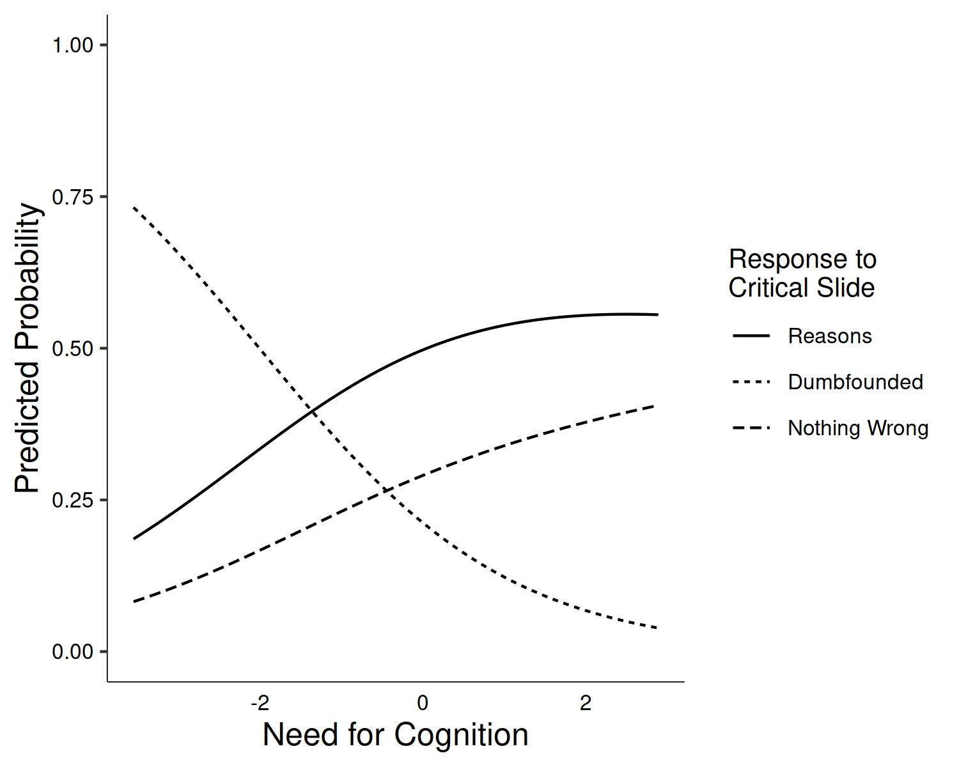

*Figure* *1.*  Study 1: Probability of selecting each response to the critical slide depending on Need for Cognition

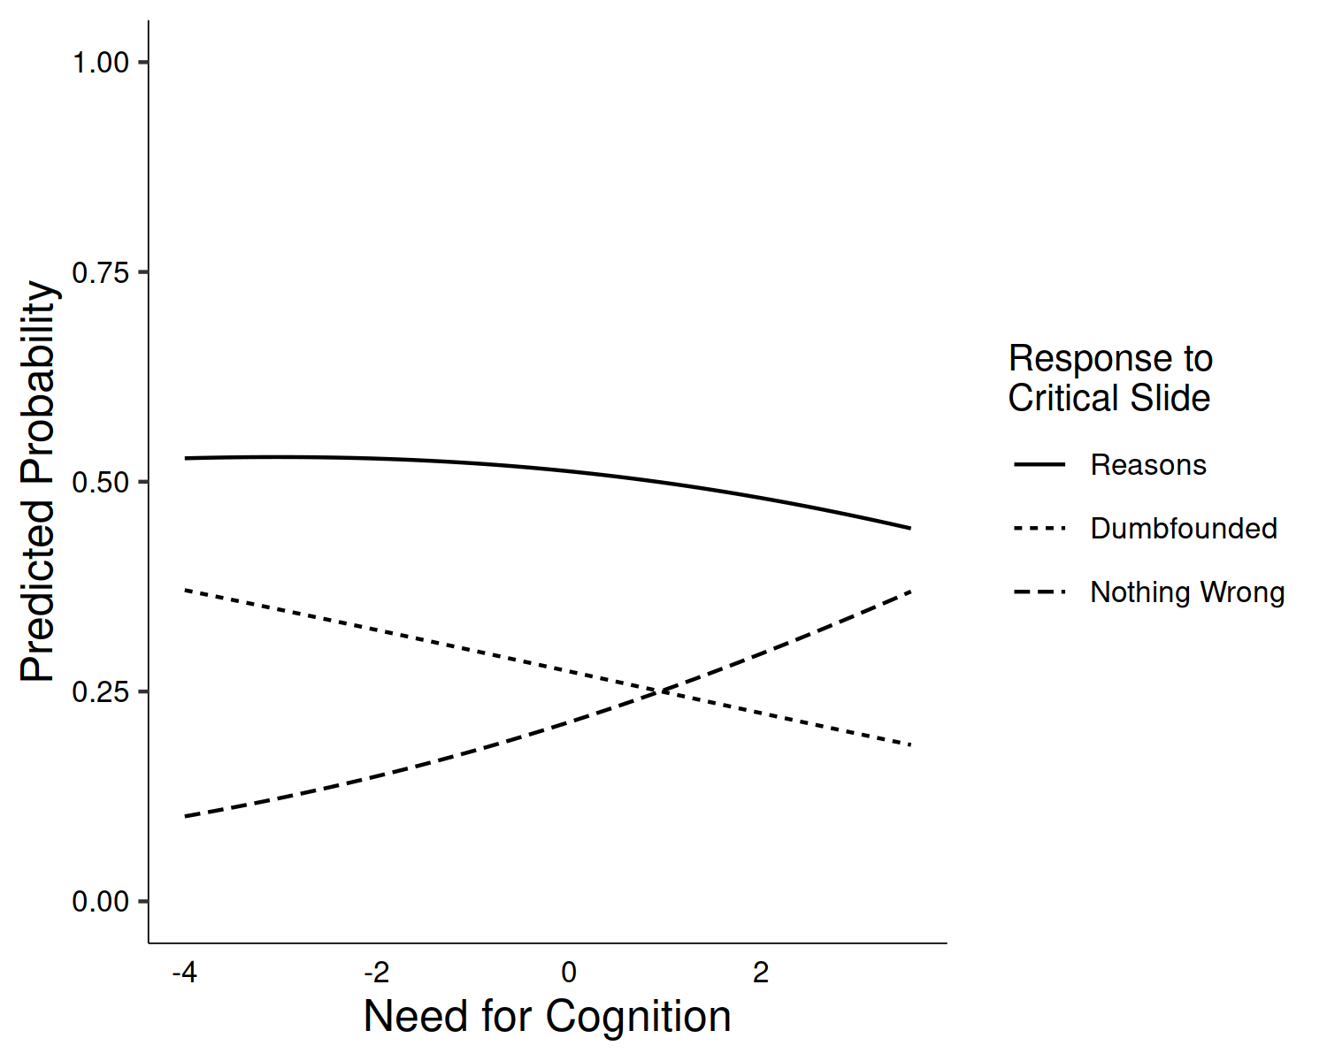

*Figure* *2.*  Study 2: Probability of selecting each response to the critical slide depending on Need for Cognition

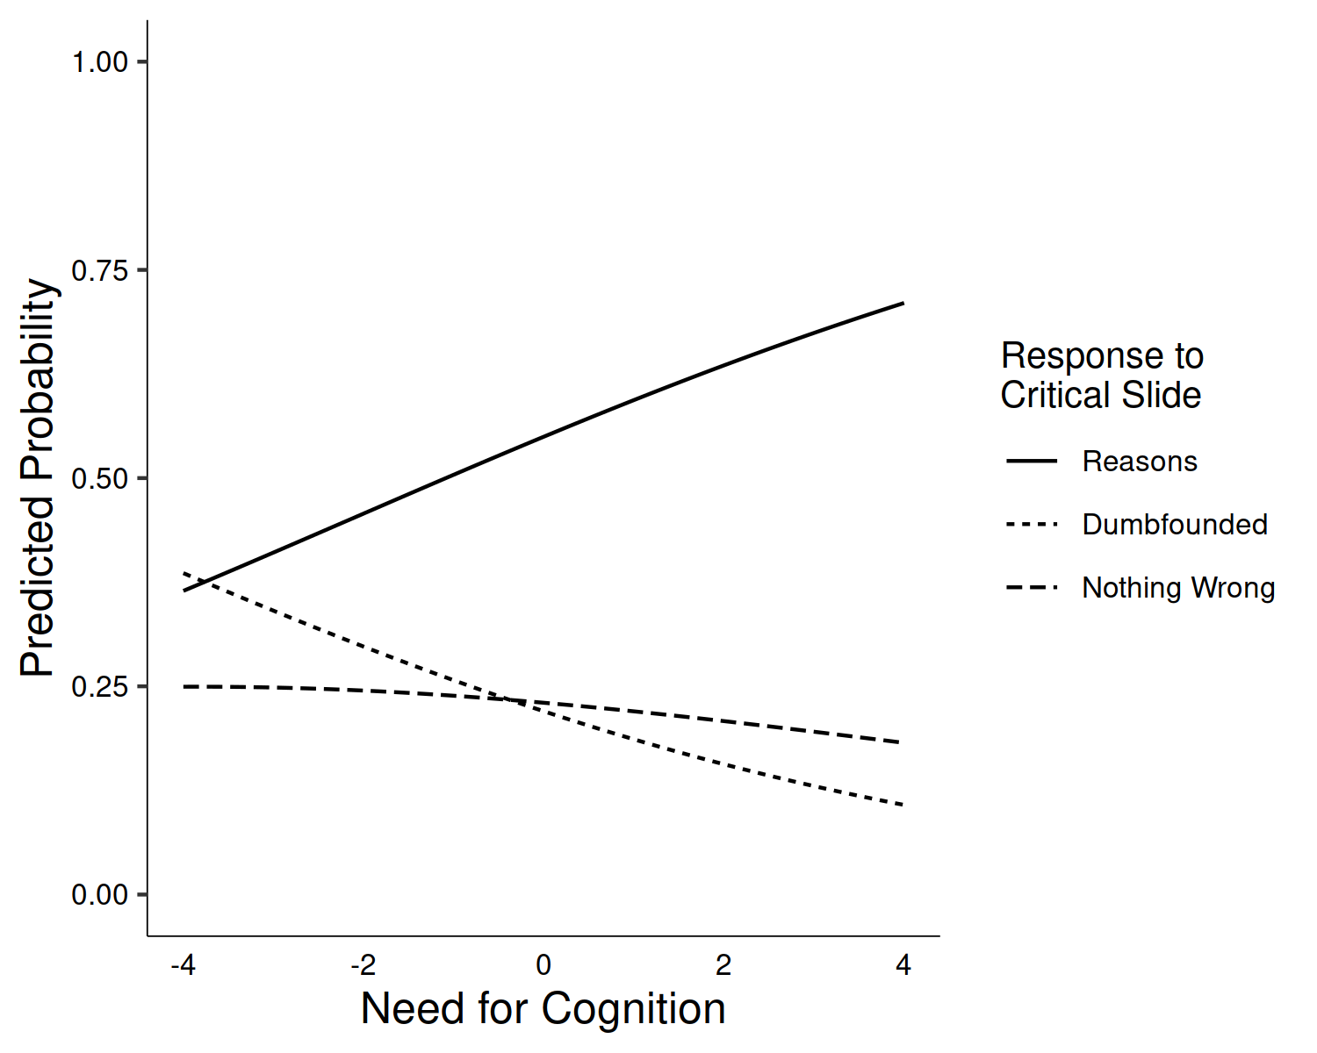

*Figure* *3.*  Study 3: Probability of selecting each response to the critical slide depending on Need for Cognition

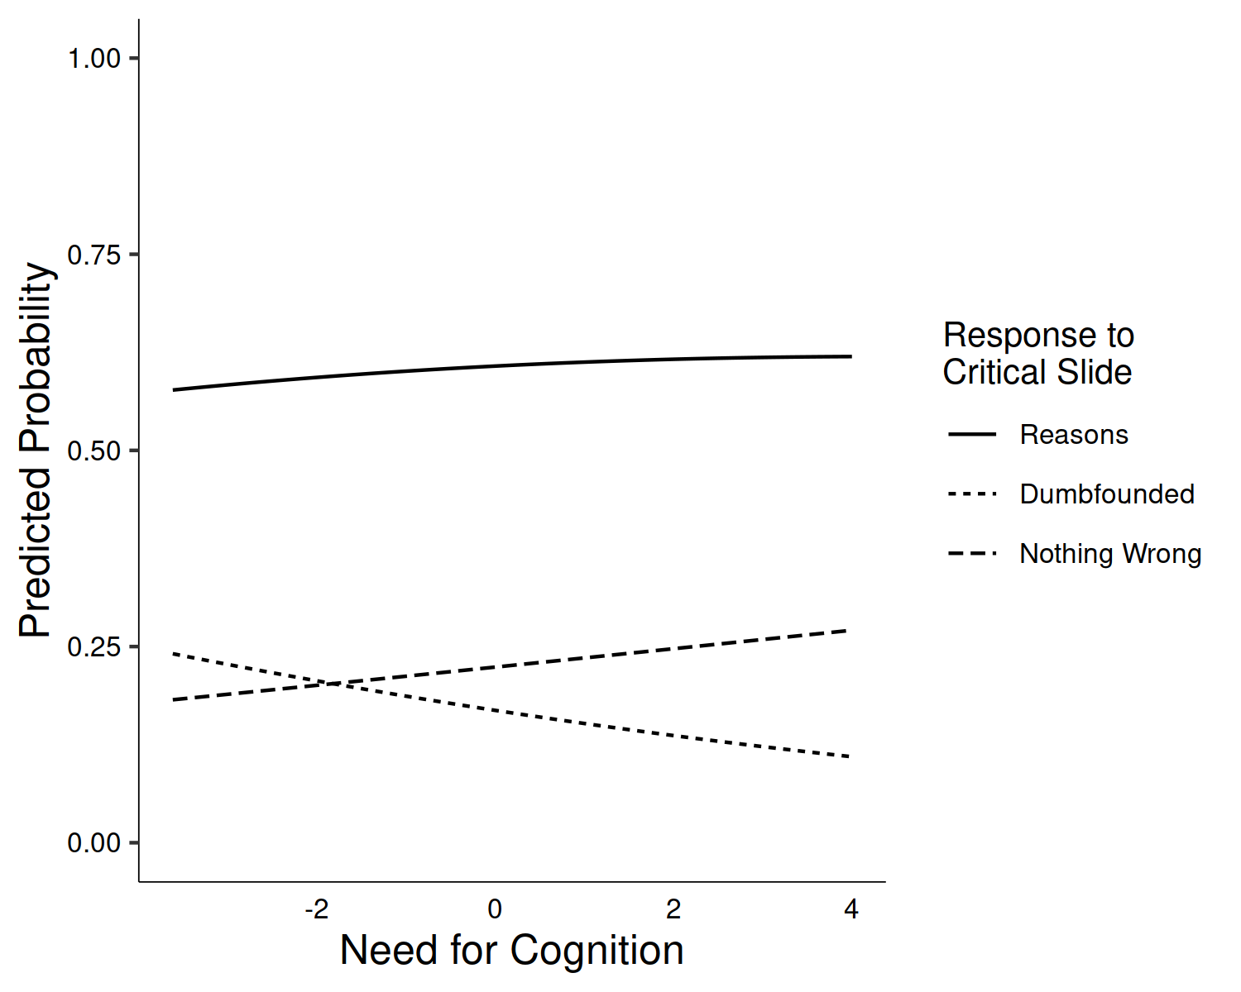

*Figure* *4.*  Study 4: Probability of selecting each response to the critical slide depending on Need for Cognition

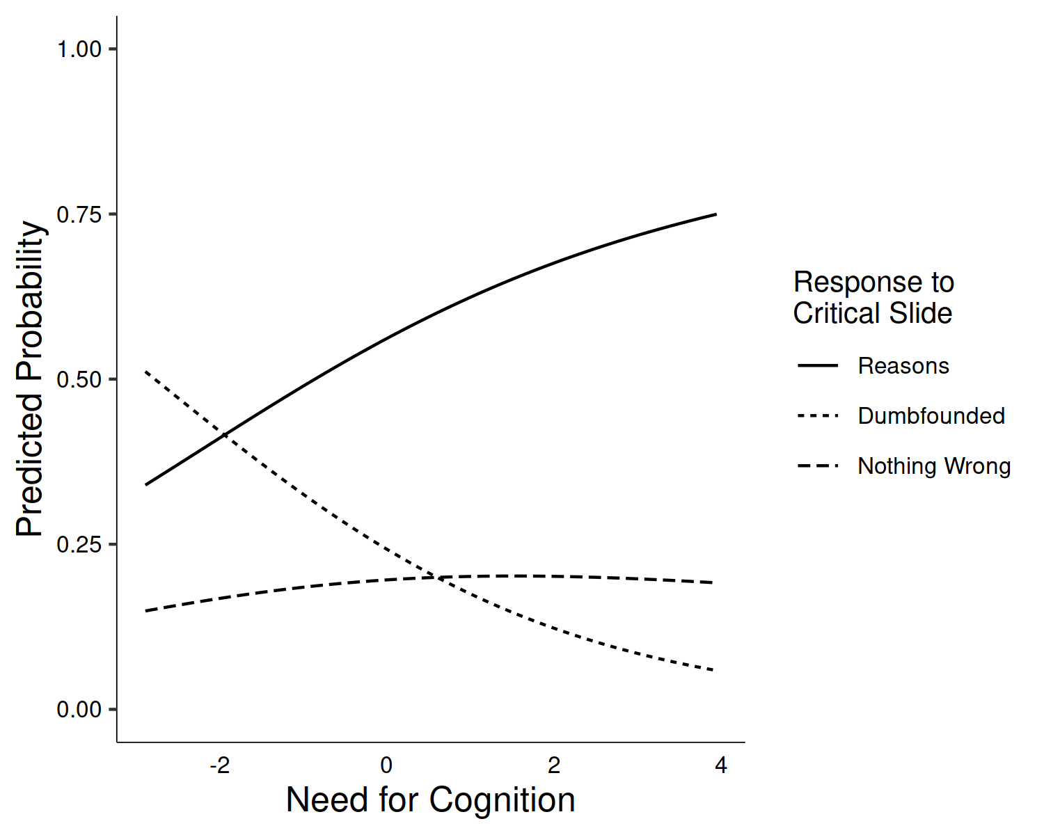

*Figure* *5.*  Study 5: Probability of selecting each response to the critical slide depending on Need for Cognition

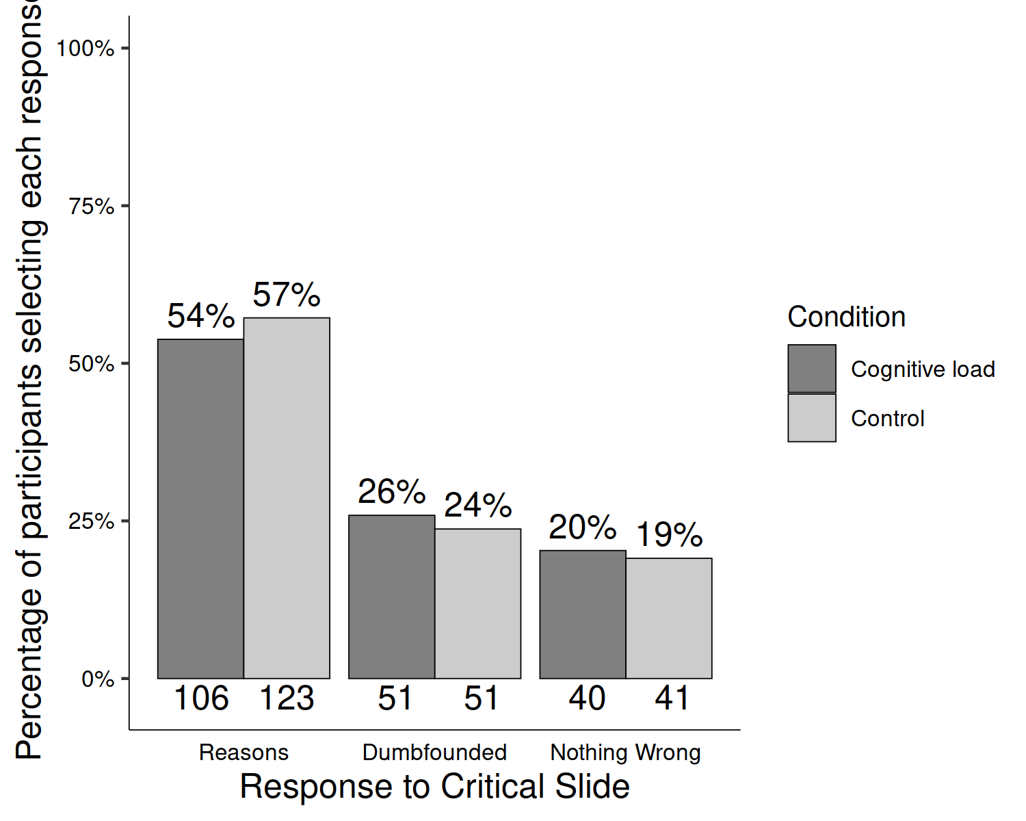

*Figure* *6.*  Study 6: Responses to critical slide depending on cognitive load (Julie and Mark)

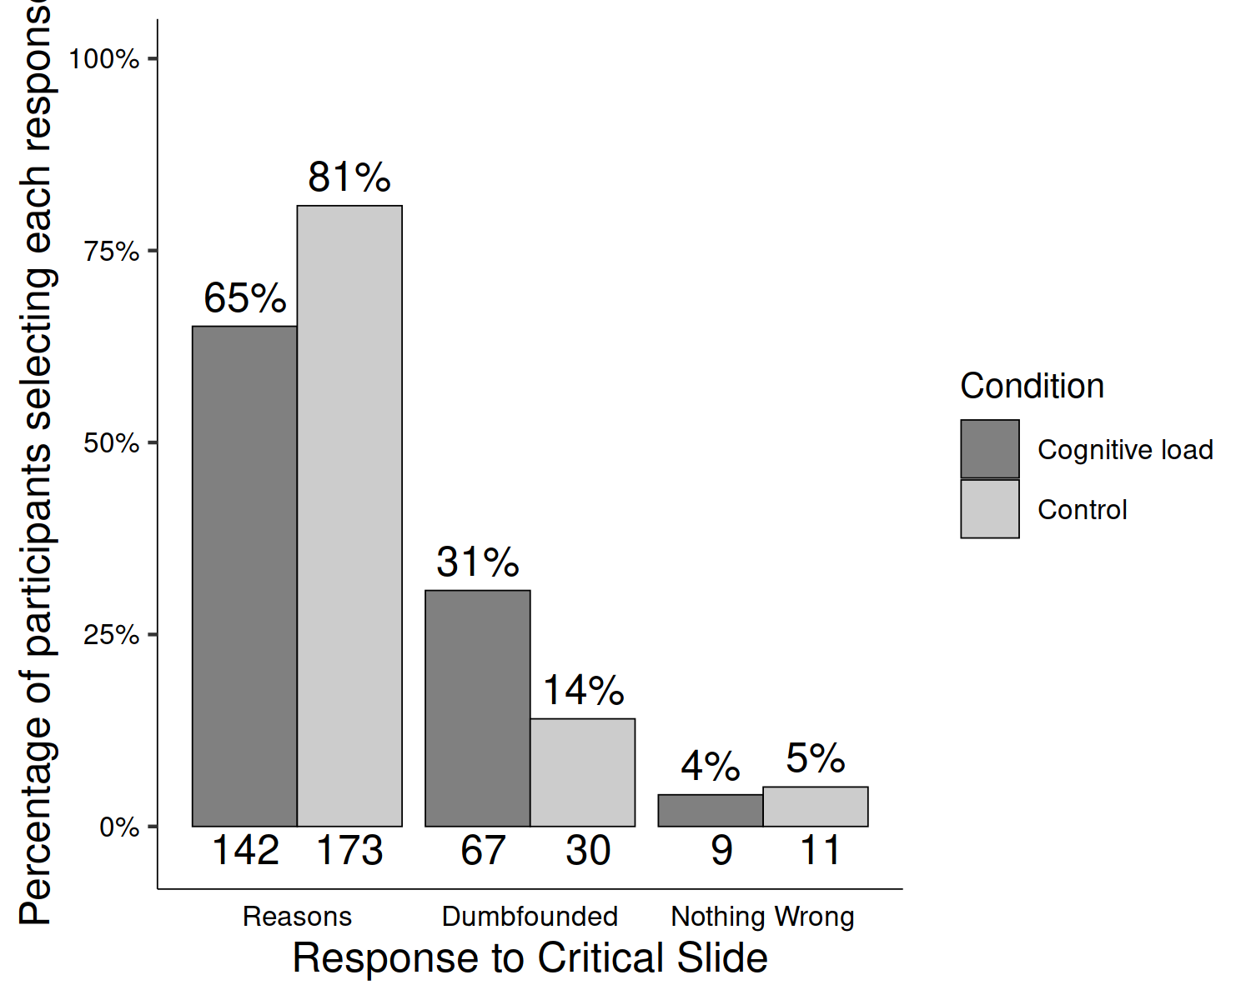

*Figure* *7.*  Study 6: Responses to critical slide depending on cognitive load (Jennifer)

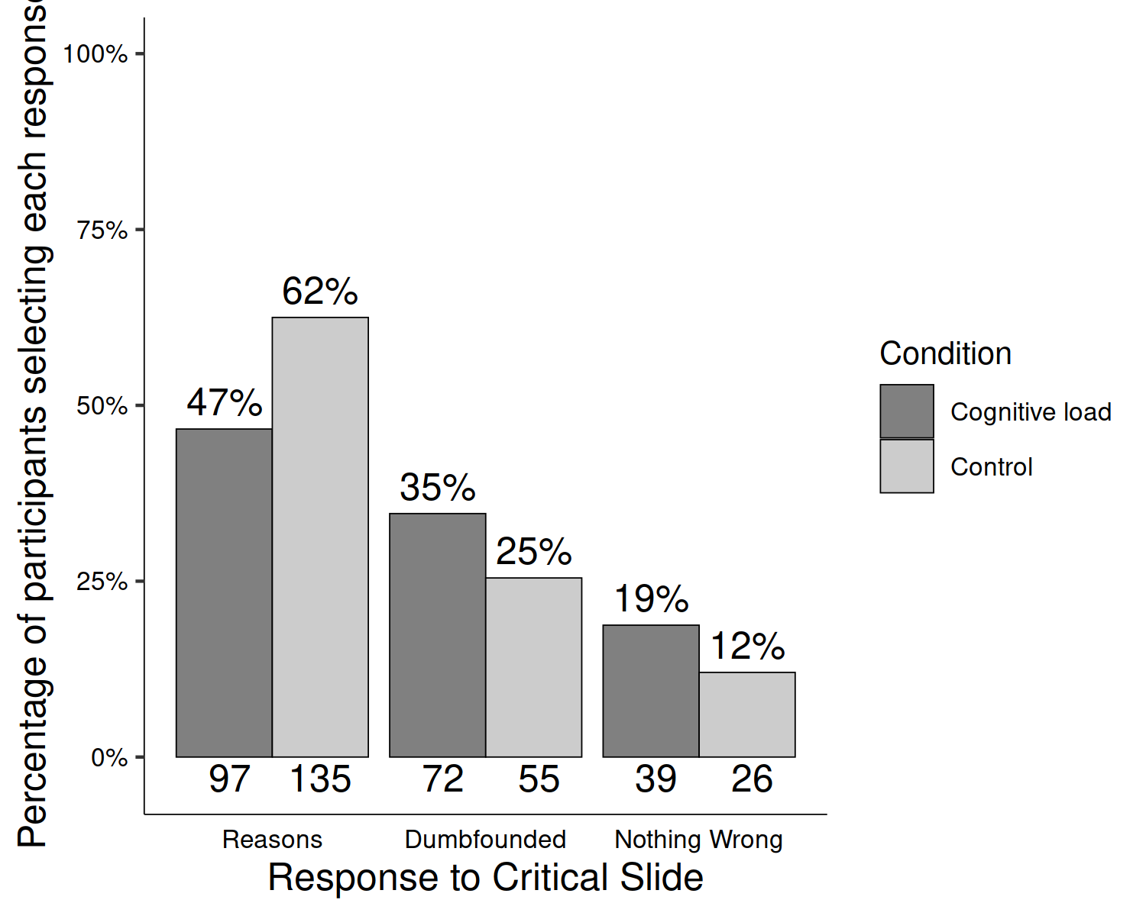

*Figure* *8.*  Study 6: Responses to critical slide depending on cognitive load (Trolley)

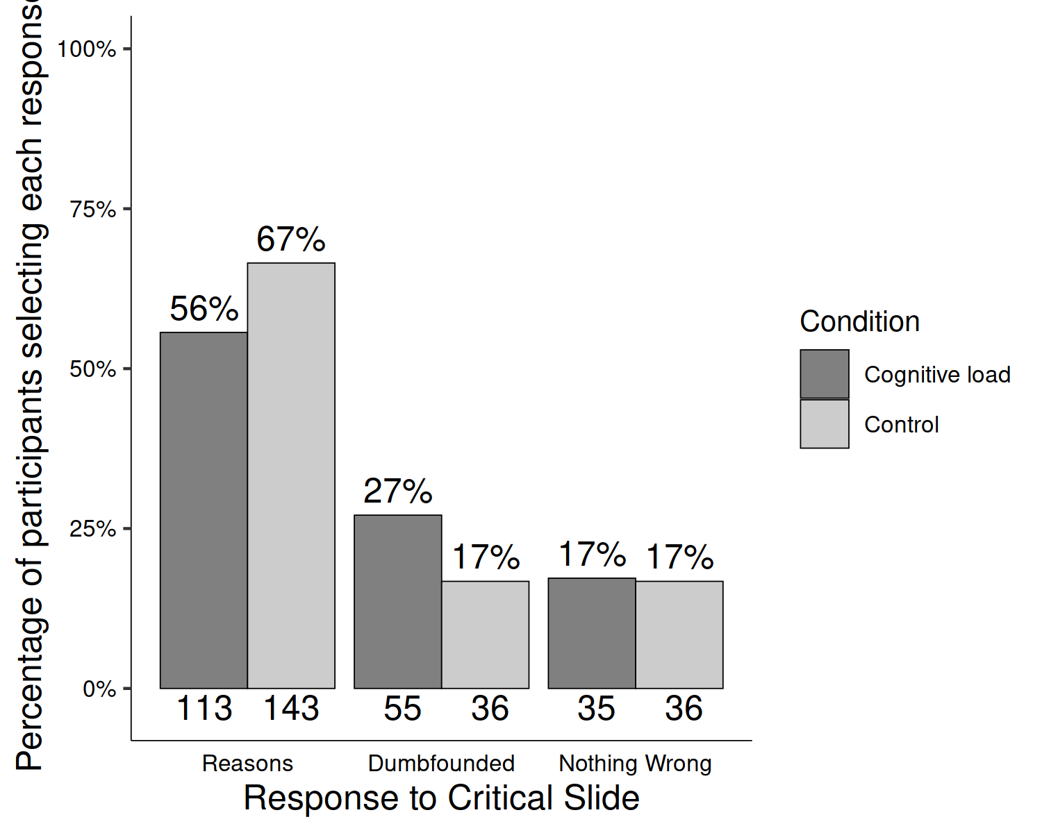

*Figure* *9.*  Study 6: Responses to critical slide depending on cognitive load (Heinz)