Horizontal Spin Scroller

# Overview

Horizontal Spin Scroller is your way to integrate fortune Scroller, spin Scroller and daily reward spin Scroller like features in your game. Most of the games today has some similar features that helps developer in retaining their users by giving them some sort of reward. With the help of this plugin, this is very simple and easy to do. User will be shown spin Scroller screen as daily reward or they can buy Fortune Scroller’s spin to get your game’s goods in reward. There are 8 chunks of our spin Scroller just like a pizza, but it’s not limited to that, as you get all the code and can easily make spin Scroller of as much chunks as you want.

Features List:

This asset includes following features.

1. Complete source code.
2. A spin Scroller with animations and sounds
3. Editor support to configure your spin Scroller
4. Simple and easy to understand script to get you started
5. Custom theme
6. 5 in built themes to use in your games.
7. Reward placeholder
8. Plug and play in your game
9. Select Free or Paid Turns
10. 24/7 hours Support from author.

Getting Started:

To test the scene. Just open demo scene present in HorizontalSpinScroller Directory and hit play. To configure your spin Scroller, select GameObject called Configurations and from where you can customize theme, duration, spin cost of spin Scroller and Settings for configuring rewards will open up for you. You can also customize the Spin Scroller Type here as well. There are total of 5 skins available that you can plugin into your game.

There are three Types of Spin Scrollers:

**Paid Scrollers:** In this type, User need to spend coins to have a turn. It’ll cost user money

**Free Only:** This mode is for freely spinning your Scroller. User can spin as many times as they want with no money involve.

**Both Paid & Free:** In this mode, user can get free spin turns time to time. You can customize free turn during in SpinTurnTimer Script by changing nextFreeTurn Variable value. User will be given free turn after each the specified period.

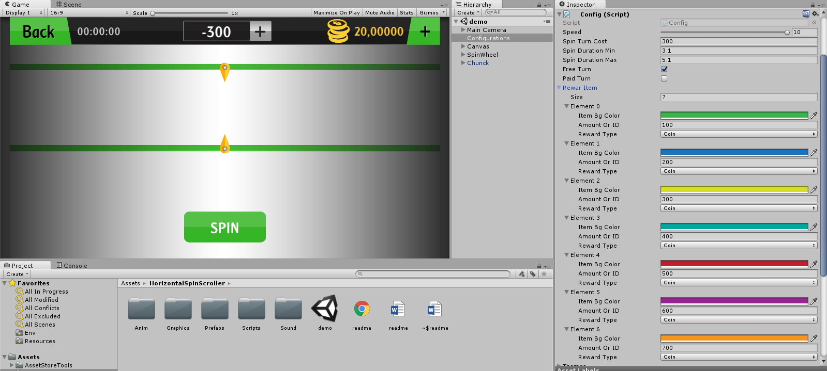

# Scripting Reference

**Namespace**

The namespace of this Project is GameBench.

**Classes**

Following are the important classes in this asset.

SpinScroller:

This is the main script which handles everything. This script is responsible for spin, animations and rewarding player. This is a singleton class, hence you can call it from any of your scripts.

RewardPlayer method is there to so you can reward your player directly from the script. You can also get SelectedReward after spin completes to know what reward user have won and can then add goods to user’s bucket/profile.

ChunkSlice:

This script is to keep track of dots on chunk/slice of spin Scroller. It’s necessary because it lights up the currently active chunk/slice and also it controls animation of points/dots. It stores info of the reward taken from the FortuneScrollerSetup editor values.

PointCollider:

This script is attached to point on chunk/slice of spin Scroller. It’s there to light up the point/slice simply and also helps to play sound when the spin arrow hits it.

ChangeSortingOrder:

This script is used to change sorting order of MeshRenderer of 3D Text used to show quantity of items.

# Help and Support

Email: [info.gamebench@gmail.com](mailto:info.gamebench@gmail.com)

Facebook: <https://www.facebook.com/Game-Bench-240598019929708/>

Unity Connect: <https://connect.unity.com/u/5b56f21603b00200199bb25a>