**Archer Shooter**

# How to play

1. Before running the game, add the"loading" "charSelect" "game" scenes in the folder scene to the "scenes in build" column of the "build settings" interface.
2. select the " charSelect " scenario and start the game.

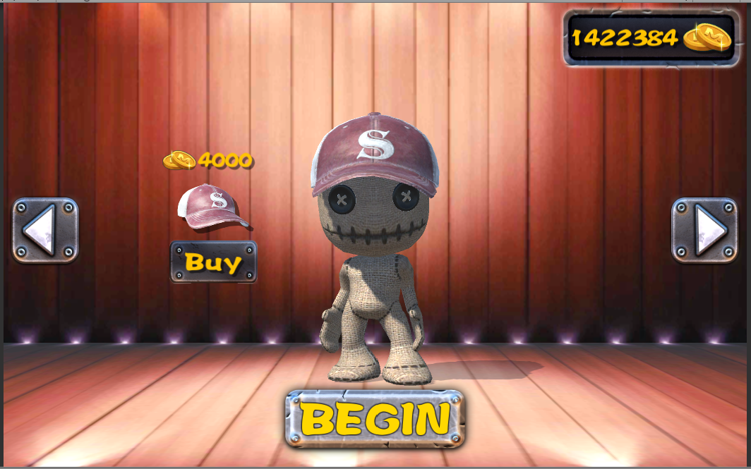

1. 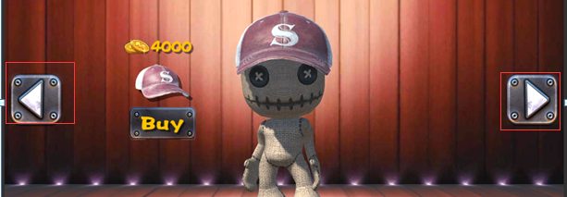 Choose appearance props
2. 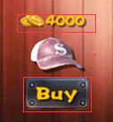 Each appearance props correspond to the price and purchase button.
3. 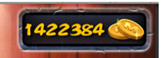 The amount of gold coins currently owned
4. 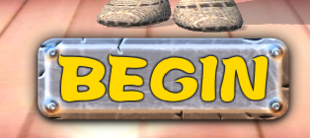 Click the "BEGIN" button to start the game.
5. start the game

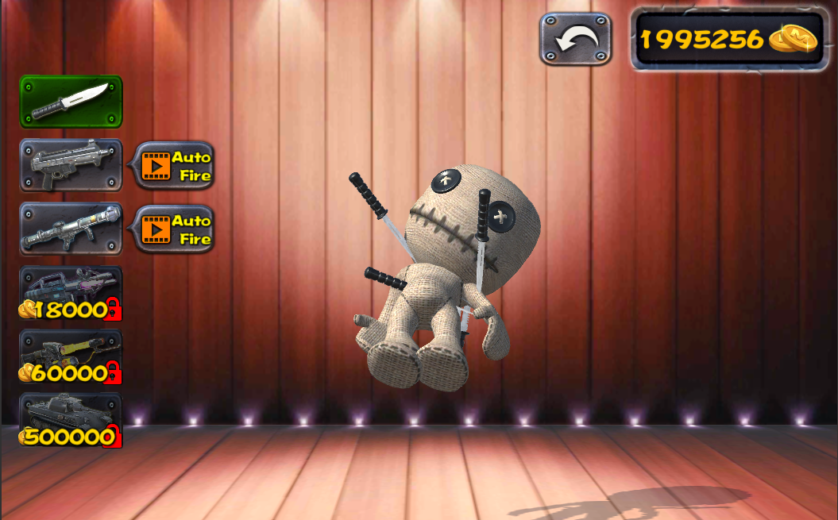

1. 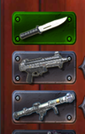 By buying the unlocking weapon button.
2. 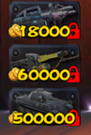 Unlocked weapon button
3.  Automatic fire button
4. 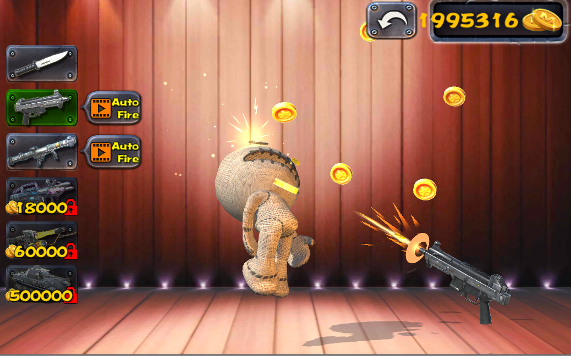 After selecting the weapon button, click the game screen and use the weapon to attack the puppet.
5.  Return to appearance props selection interface

# Advanced Scripts

1. atkTank.cs : Tank weapon attack mobile control

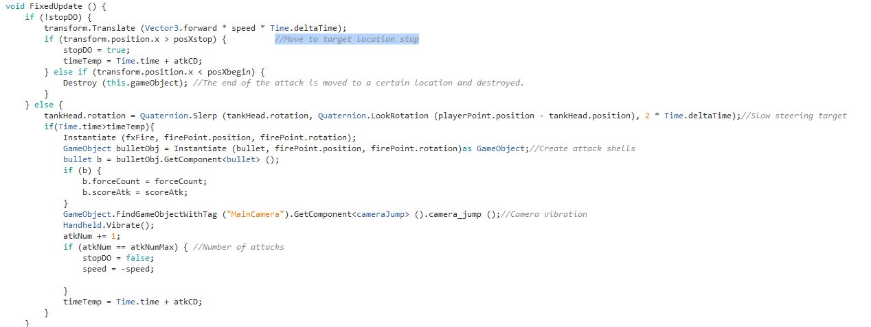

Control tanks from creation, movement to target location, fire, exit and destruction.

1. atkTankGun.cs : When there are no tanks in the scene, new tanks can be created.
2. autoFireCD.cs : Automatic attack time setting
3. btncontrol.cs : Weapon buttons, automatic fire and weapon unlocking control

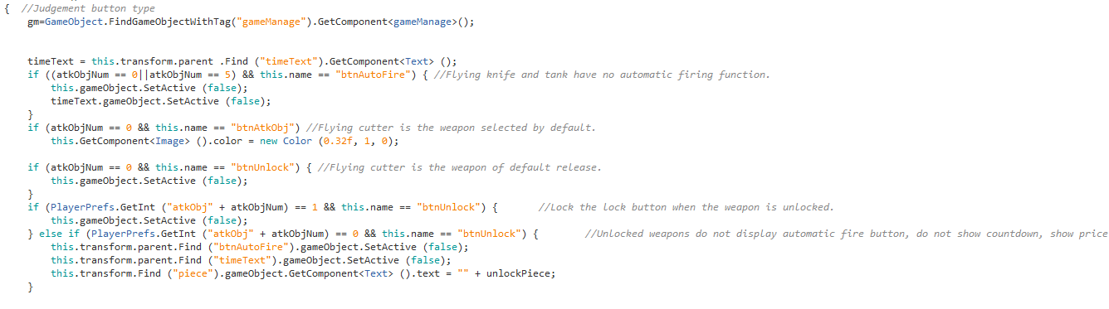

By naming the button function

1. bullet.cs : Bullet hit judgement
2. bullet_fire.cs : Fire weapon hit judgement
3. bullet_light.cs : Hit judgement of laser weapon
4. cameraJump.cs : Camera vibration
5. coinMove.cs : Gold flying animation
6. control.cs : Basic game operation
7. existTime.cs : Special effects are broadcast and destroyed.
8. gameManage.cs : Basic functions of game

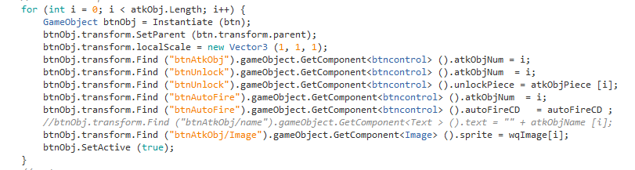

Automatically create weapon buttons and give corresponding settings.

1. gameManage_charSelect.cs : Role switching function
2. gun.cs : Weapon orientation and firing
3. knife.cs : Hit control of flying knife attack
4. LoadingScene.cs : Loading end jump scene
5. soundResources.cs : Voice playback control

# Create Ragdoll

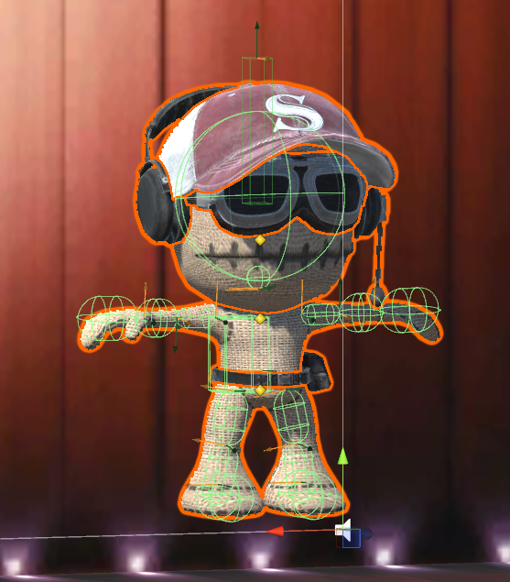

1. in order to achieve the real physical effect of the role being hit, we need to use Create Ragdoll.

The implementation process can refer to the following links

http://www.ceeger.com/Components/wizard-RagdollWizard.html

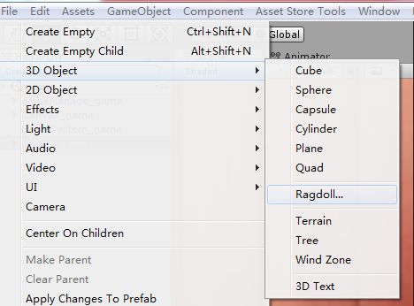 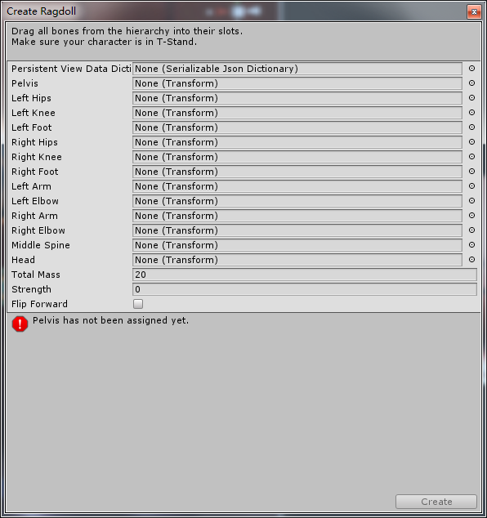

1. 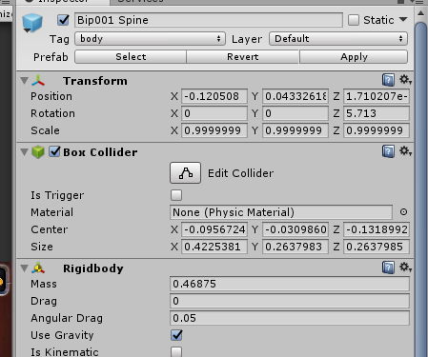 You need to add BoxCollider to the hit part of the character and change the tag to "body".
2. hang the role on cube.

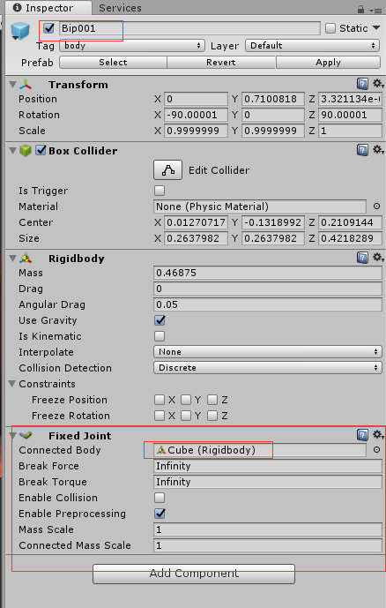

# Make your own game

## Basic function control of charSelect

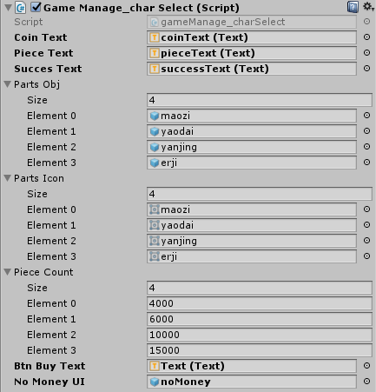

1. 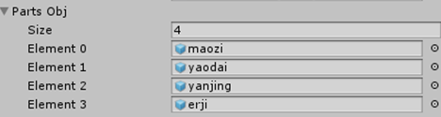 Appearance props resources
2. 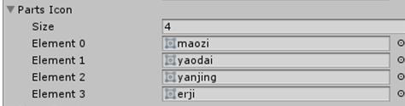 Appearance props Icon
3. 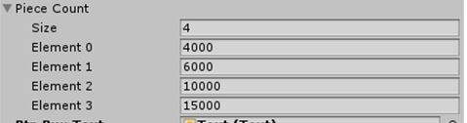 Appearance props price

## Basic function control of game

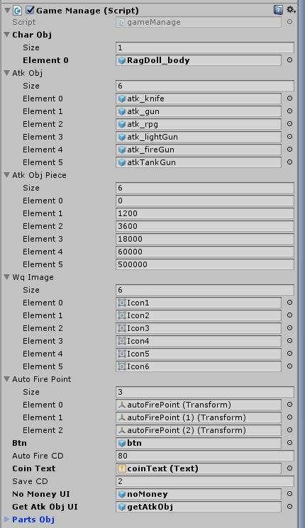

1. 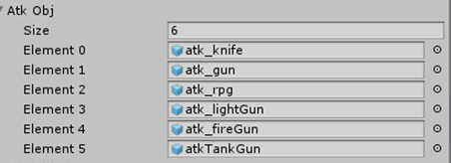 Weapons resources
2. 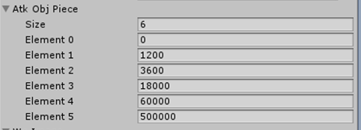 Weapon price
3. 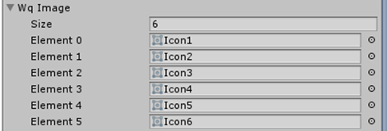 Weapon icons
4. 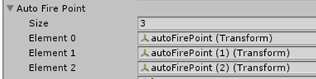 Automatic firing position
5.  Automatic fire duration

# **How to get support**

Contact to us ：soyskyapple@outlook.com

Remember attach your invoice otherwise there would not be my reply.

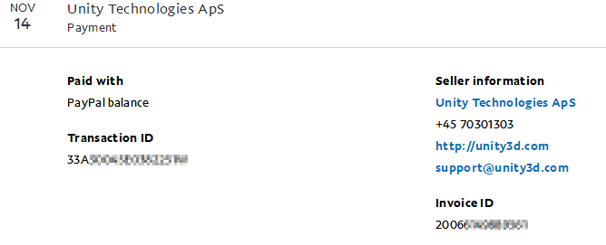

The invoice you can get from your paypal account records.

If you do not have a invoice. Grab some screenshot to confirm your buy successful flow is also ok.