Game documentation and HowTo guide.
Sky Flight Game

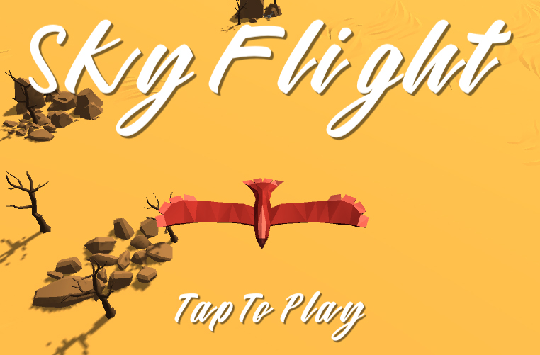

This document contains:

Package Description and features 1
Try the Demo 2
Update history 2
Credits 2
Overview of the game's library contents 2
Customization Guide 3
Getting started 3
The Game Controller 3
Player Controls 4
Ring 5
Times of Day 6
UnityAds Integration 7

Package Description and features
Sky Flight Game is a full Unity template that gives you a quick and easy way to create an endless runner type of game where you must pass through the rings while avoiding obstacles.

How to Play?

Move with the mouse or keyboard (gamepad and touch/tilt controls also supported on mobile) and pass through the rings while avoiding obstacles!

Try the Demo

Features:
- Game ready for release straight out of the box, just build and play!
- Works on all platforms, PC, Mac, iOS, Android, etc
- Supports multiple resolutions and aspect ratios, automatically.
- Supports Mouse, Keyboard, Gamepad, and Touch controls.
- Easily customizable with lots of options to control game difficulty.
- Great learning resource with commented scripts and documentation.
- All assets included: graphics, sounds, and code.

Current version 1.10

Update history

1.10 (03.06.2018)
- You can set a number of lives, you lose a life when hitting an obstacle or when you miss a ring.
- You can select a different player character in the main menu.

1.05 (18.04.2018)
- Improved mobile controls, and removed tilt controls.

1.0 (15.03.2018)
- Initial version

Credits
The main font used is Mattilda by Barri Lubis
The sounds are courtesy of the free sound project.
Music is Outro by boringXtreme ( Public Domain )
Please rate my file, I’d appreciate it

Overview of the game's library contents
Let's take a look inside the game files. Open the main SFGAssets folder using Unity3D 5.5.0 or newer. Take a look at the project library, usually placed on the right or bottom side of the screen. Here are the various folders inside:

- Animations: Holds the animation clips made with Unity’s built-in animation system.
- FLA: Holds the object graphics made with Flash CS3. These are vector graphics than can be easily scaled without loss of quality and then exported as PNG to be used in Unity.
- Fonts: Holds the font used in the game.
- Prefabs: Holds all the prefabs used in the game. These are distributed to various folders for easier access, Buttons, Enemies, Objects, etc. It also holds all the canvases in the game which are used to hold buttons and other UI elements.
- Scenes: The first scene that runs in the game is Menu. From this scene you can get to the Game scene.
- Scripts: Holds all the scripts used in the game. Each prefab contains one or more of these scripts.
- Sounds: Holds all the sounds used in the game. Ring, Miss, etc
- Textures: Holds all the textures used in the game which are used for materials and as sprites in Unity.

Customization Guide

Getting started
Sky Flight Game (SFG) is considered a complete project, and as such is supposed to work as the starting point of your planned game, rather than an addition to an existing project. That said, you may of course pick and choose some of the scripts/models to import into your existing project, but SFG works best as a starter kit which you can customize any part of to your liking.

The Game Controller
The Game Controller is the main prefab that controls all the progress of the game from start to finish. It controls the UI of the game, keeps track of passing/missing rings and triggers the game over function.
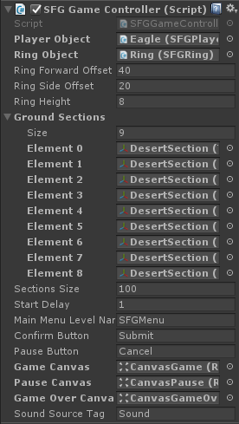
Player Object – The player object that moves in the scene.
Ring Object – The ring that the player must pass through.
Ring Forward Offset – The forward distance we push the ring after the player passes through it.
Ring Side Offset – The random side distance we set the ring after the player passes through it.
Ring Height – The random height we set the ring after the player must pass through.
Ground Sections – A list of sections that will keep appearing as the player moves forward.
Start Delay – How long to wait before starting gameplay.
Main Menu Level Name – The level of the main menu that can be loaded after the game ends.
Confirm Button – The keyboard/gamepad button that will restart the game after game over.
Pause Button – The keyboard/gamepad button that pauses the game.
User Interface – Various canvases for the UI, assign them from the scene.

Player Controls
The player controls script contains is attached to the player objects, allowing it to move using the mouse, keyboard, gamepad, or touch and tilt controls on mobile.
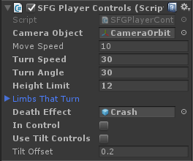
Camera Object – The camera object that follows the player object.
Move Speed – The forward movement speed of the player object.
Turn Speed – The turning speed of the player object.
Turn Angle – The maximum angle the player object can turn to.
Height Limit – The maximum height the player can rise to.
Limbs That Turn – A list of player limbs that will bend based on the turning direction.
Death Effect – The effect that appears when the player dies.
In Control – Is the player controlling the player object?
Use Tilt Controls – When using tilt controls, the player can control movement by tilting the mobile device.
Tilt Offset – The vertical offset for the default device tilt (at what angle we are holding the device).

Ring
The ring is the object that the player must pass through. If the player misses this object we lose the game.
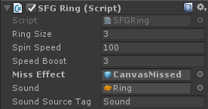
Ring Size – The size of the ring we must pass through.
Spin Speed – The rotation speed of the ring object.
Speed Boost – The speed increase the player gets when it passes through the ring.
Miss Effect – The miss effect that appears when the player passes near a ring, but not through it.
Target Position – The target position of the ring. When we pass through the ring, it changes position and moves away from the player.
Limbs That Turn – A list of player limbs that will bend based on the turning direction.
Sound – The sound to play when passing through the ring.
Sound Source Tag – The sound to play when passing through the ring.

Times of Day
The Time of Day component changes the lighting, sky box, and fog in the scene to give a different feel, for example daylight or nighttime.
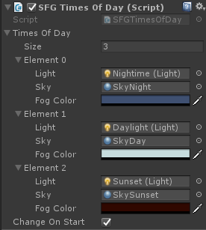
Light – The light object that will be activated. The scene only has one light object at a time.
Sky – The skybox material that will be activated.
Fog Color – The color of the fog in the scene, if it's activated.
Change On Start – Change to the next time of day when the scene starts.

UnityAds Integration
Since Unity 5.2 UnityAds integration has been simplified, here’s how you can have full screen video ads in your game.
This video shows a quick process of integrating UnityAds into your project. In the example we used one of my templates, but it works on all my other templates too.
https://www.youtube.com/watch?v=EQNTgfV35DU
Here is what we did in the process:
- Sign in to your Unity account in order to allow Unity Services such as UnityAds to be activated.
- Open Build Settings and switch the platform to one of the supported ones (iOS, Android).
- Download Puppeteer's UnityAds package from: http://puppeteerinteractive.com/freebies/PUPUnityAds.unitypackage
- Drag the downloaded package into your Unity project, and import it. This UnityAds prefab can be used to display ads every several minutes.
- Drag the prefab into any scene where you want ads to be shown. Make sure to save changes.
- The time check is shared between all prefabs in all scenes, so you will never show too many ads.
- The final step is to activate UnityAds services and get your unique project ID.
- Open the services window and choose your organization, then click create.
- Choose UnityAds from the list and turn it On.
- Choose age group for your project ( Will affect the nature of ads shown ), and save changes.
- While working on your project keep Test Mode activated. But when you are ready to release the final project, switch Test Mode off.
- That's it! Now when you start the game, an ad will be shown after 3 minutes. The ad will never appear during gameplay or post-game screen. Instead, it will wait until the next level load ( restart, main menu, etc ) and then show the ad.

Before releasing a game, make sure you uncheck Enable Test Mode.
For more info about integrating UnityAds read this:
http://unityads.unity3d.com/help/monetization/integration-guide-unity

