Average Window Smoothing for an Indonesian Language Online Speaker Identification System
Cil Hardianto Satriawan, Dessi Puji Lestari

School of Electrical Engineering and Informatics,
Institut Teknologi Bandung

Abstract: Online speaker diarization and identification is the process of determining ‘who spoke when’ given an ongoing conversation or audio stream, in contrast to the offline scenario where the conversation has concluded and the entire file is available. Online identification is required when speaker identities need to be determined during or directly after speech, for instance in the automatic transcription of live broadcasts and of some meetings. The process of constructing an Indonesian language online speaker identification system is explored, from design, corpus development, to experimentation. The system conducts speaker identification directly on low-energy separated segments and employs a rolling window of time-weighted average likelihoods to improve accuracy, resulting in a system with a latency of one speaker segment for predictions. Experimentation against a standard baseline offline system resulted in speaker error rates (SER) of 25.5% and 18.5% for the proposed online and baseline offline systems, respectively. The latency of the proposed system is 0.21 times the length of input segments, compared to 1.10 for the baseline system.
Keywords: Speaker identification, Indonesian, online, average window

1 Background
Speaker diarization and identification is the process of determining ‘who spoke when’, for instance in a conference or interview setting. Speaker diarization usually refers to the task of taking audio containing speech from one or more speakers and determining which parts are spoken by which speakers, after which speaker identification can be performed to determine identity. In online speaker identification, there is the additional constraint of producing these identities in a timely manner, be it at regular time intervals or at certain speech boundaries. Online speaker diarization differs from offline speaker diarization mainly in the amount of information available for analysis; online diarization makes use of all data available up to the current time, whereas for offline diarization data at all time points is available.
Offline speaker diarization is well-established, with systems assessed on evaluation challenges such as the National Institute of Standards and Technology (NIST) Rich Transcription evaluation. Most approaches in speaker diarization are centred around the process of converging towards an optimum number of clusters corresponding to speakers, either from very few clusters (top-down) or from a large number derived from speaker segments (bottom-up). In the more common bottom-up approach, the diarization process is typically broken down into a number of steps:
- Speaker segmentation, alternatively speaker change detection or speaker turn detection, splits the audio at points where speaker changes occur. Hence each resulting segment contains speech from a single speaker. In this approach, distance-based metrics are calculated between adjacent audio blocks to determine whether the blocks originate from a single speaker. Commonly used metrics include the Bayesian information criterion (BIC), generalized likelihood ratio (GLR), and Kullback- Leibler (KL or KL2) divergence.
- Speaker clustering, where segments belonging to the same speaker are grouped together. The label of the resulting clusters corresponds to a speaker, though the identity is undetermined at this point. In an offline setting, hierarchical clustering is usually performed.
- Post-processing methods are used to improve predictions; non-speech segments can be classified and excluded from clustering, Viterbi decoding can be used to estimate the most likely sequence of clusters, and so on.
This process is illustrated in Fig. 1: As seen in the lower picture, the incoming signal is split into 5 voiced segments and 1 unvoiced segment, and is subsequently clustered to obtain the speaker labels for each segment. In the case of speaker identification, the process is performed on the clusters to obtain the actual speaker identities.
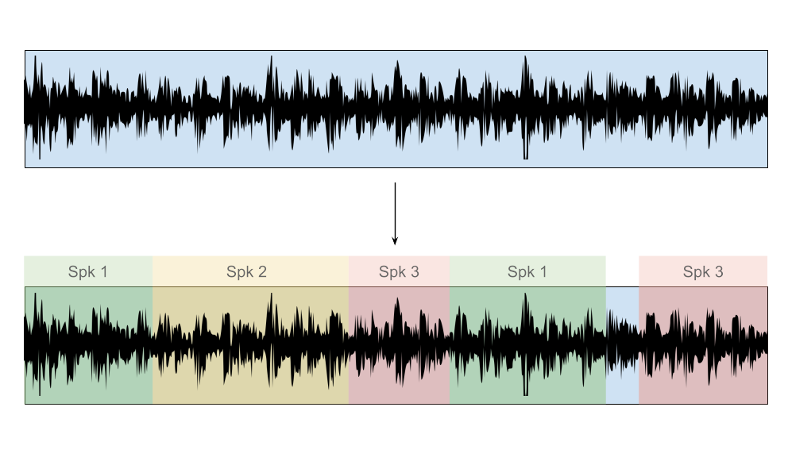
Figure 1: Illustration of diarization process
The standard approach to speaker identification is similar to that in speaker verification; a Gaussian Mixtures Model (GMM) representing the vocal characteristics of the average person is first trained from a large number of speakers, and is dubbed the universal background model (UBM). For each user to be identified, the training vectors derived from the user’s speech are adapted to the UBM’s parameters by performing maximum a posteriori (MAP) adaptation. This process is described in greater detail in Reynolds, Quatieri, and Dunn (2000).
Newer systems have adopted the usage of total variability statistics originally developed for the speaker verification domain to achieve results comparable to the aforementioned approaches while discarding the need for complicated back end post-processing N. Dehak et al. (2011). In this approach, the most salient features in the low-dimensional i-vector space are extracted and exploited to allow for more accurate clusterings.
Online speaker diarization is important when real time or close to real time information regarding speaker identities is required. Paired with online speech recognition, for example, it becomes possible to generate a transcription of an ongoing conference, meeting, live broadcast, or audio stream in general. The clustering step is useful in obtaining speaker clusters, which can boost speech recognition when speaker adaptation is performed. Other uses include the addition of real time or close to real time machine translation and summarization.
Unfortunately, many approaches that are standard in offline diarization cannot be used in an online setting, or require some modification. For instance, the hierarchical clustering used in offline diarization requires full knowledge of the data to be clustered beforehand. In addition, some of the speaker segmentation methods depend on smoothing the resulting metrics first, as in Delacourt and Wellekens (1999) or depend on the analysis of large audio buffers which may not be feasible due to latency constraints.
In addition, most existing research is developed and built upon existing evaluation challenges, such as the aforementioned NIST Rich Transcription evaluation, in which blind diarization is assumed, where the number and identities of speakers are unknown a priori. However, for the purpose of meeting diarization it is generally assumed that there is a closed set of participants, with a priori knowledge available. The assumptions are therefore more closely aligned with speaker verification.
This research describes the process of constructing an online speaker diarization and identification system for meeting transcription. The system has a priori knowledge of the speakers to be identified, and must give speaker predictions in a timely manner to server as a visual guide for meetings. The remainder of this study is organized as follows: Section 2 discusses related research and the design of the system to be built, in particular with regards to online speaker segmentation and identification post-processing. Section 3 describes the process of building the speaker corpus, including data collection and annotation, and Section 4 discusses the experimental setup and results, comparing between the proposed system and a baseline offline system.

2 Online Diarization System

2.1 Related research
Several different approaches have been explored in online speaker diarization. In a series of papers, Liu et al. explored the adaptation of the standard diarization pipeline for online and real time usage. Fast speaker change detection is achieved with a phone-class decode followed by Bayesian information criterion (BIC) calculation with additional penalty factor in Li and Kubala (1999). As hierarchical clustering requires knowledge beforehand of all clusters, it is implausible to implement in an online setting. Instead, a modification of k-means clustering is employed to achieve online clustering in Li and Kubala (2003). In this approach, new clusters (speakers) are formed whenever a segment is found to be sufficiently distant from any existing cluster means, whereas existing cluster means are continuously updated with incoming data. Online speaker adaptation and identification are discussed in Li et al. (2005), where Maximum Likelihood Linear Regression (MLLR) is used to adapt existing clusters and to accumulate statistics for the identification of subsequent segments. In this approach, no prior knowledge regarding the number of speakers of speaker characteristics is necessary.
With the capabilities of modern graphic processing units (GPU), it is possible to approach the diarization problem in a brute-force manner, by offloading most computationally expensive tasks to the GPU. In Friedland (2012), all of the standard offline steps are reproduced for each incoming block of data, but as the GPU is able to process at thousands of times the rate of real time, it is essentially real time.

2.2 Design and Analysis
One of the larger difficulties with speaker diarization, specifically the clustering step, is the assumption of previously unknown speakers and an unknown number of speakers. Hence, in this research, given the domain of meeting transcription and known prior speakers, we attempt to eschew the clustering step in favor of direct identification on speaker segments. This allows for much less complexity at the cost of reduced accuracy.
In addition, the identification system should be easily integrated into existing workflows. Specifically, the system should act as middleware to a real time signal processing pipeline. In this way, the low-level specifics of signal input/output and communication are handled by the pipeline framework. This also allows for greater extensibility of the system to related functionality, such as speech recognition, machine translation, or automatic summarization. An example of the finished system is shown in Fig. 2.
The Perisalah system, an Indonesian language speech recognition system, was chosen as the starting point for its functional online component, developed from the Kaldi GStreamer Server by Alumäe (2014). The Transcriber application in Adianto, Satriawan, and Lestari (2017), developed from the Kaldi Offline Transcriber, although similar in functionality, lacks an online diarization component. The system developed for this research essentially extends the aforementioned systems to allow for functional online identification.
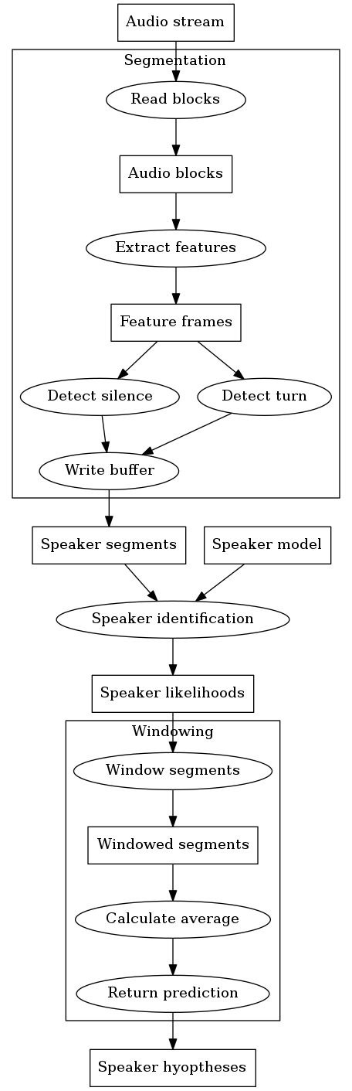

Figure 2: Block diagram for online identification system

2.3 Online speaker segmentation
In practice, speaker segmentation mostly succeeds in guaranteeing individual segments contain at most one speaker, but fails to ensure consecutive segments belong to different speakers.
For online diarization, a custom GStreamer plugin is developed for speaker segmentation, separating the input audio stream at low energy points in the signal. In this method, features are extracted from audio blocks and the log energy portion of the resulting frames are analyzed. If the average energy is below a specified threshold, the block is considered silent. After a specified number of blocks of silence have passed, the audio blocks buffered up to that point are segmented.
The energy threshold portion of the algorithm depends on the signal-to-noise ratio (SNR) of the acoustic environment which is relatively static, and can be set according to the conditions of the environment beforehand. The silence length threshold (denoting the number of consecutive silent blocks to tolerate), on the other hand, is easily disrupted in cases where speakers interrupt each other regularly in conversations. Hence, a number of different methods for speaker segmentation were also tested, namely Kullback-Liebler (KL or KL2) as discussed in Siegler et al. (1997) and penalized Generalized Likelihood Ration (GLR) thresholding as used in Delacourt and Wellekens (1999), which are not solely influenced by energy.
Segments obtained this way are then run through the LIUM speaker identification program and the most likely speaker predicted. Provided the segmentation is reasonably accurate, directly running speaker identification on speaker segments while forgoing the clustering step leads to time performance gains at a low cost to identification accuracy.

2.4 Windowed average predictions
There are a number of shortcomings to direct speaker identification on speaker segments, stemming primarily from the low amount of audio data available for analysis at any given segment. By considering only the current segment, we are also discarding information from the prediction of previous segments. This often results in noisy predictions, with correctly identified longer segments interspersed with misidentified short segments.
A simple post-processing method is devised to partially alleviate this problem, which involves calculating the most likely speaker within a rolling window of segments. The process is illustrated in greater detail in Fig. 3. The window to be considered consists of the segment at the current time t and the n - 1 segments preceding it. The speaker likelihoods S for each segment in the window are weighted against the length l of the segment. These time-weighted scores are then summed across the segments of the window for each speaker; the speaker with the highest score is the prediction for the current segment.
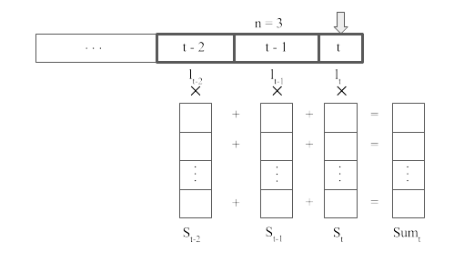
Figure 3: Time-weighted average rolling window
It is important to discard speaker likelihoods beyond a specified number of segments, as global time-weighted average scores are necessarily biased towards speakers who have spoken more overall. The size of the rolling window is therefore an important heuristic, signifying the amount of local context to consider; too large a value misses short speaker turns, while too small a value negates the benefits of applying a window in the first place. The window size should ideally be set according to the median amount of segments spoken per speaker. Unfortunately, this cannot be known a priori. Empirically, a window of size three lead to a sizeable increase in accuracy for the tested corpus.
Although this method provides an easy boost to accuracy at low computational cost, more sophisticated methods such as batched k-means clustering or newer methods such as time-delay neural networks (TDNN) and long short-term memory (LSTM) networks are likely to produce better results, as they have the advantage of considering all previous data instead of the data within a small window. A hybrid diarization/identification system is also plausible, with an existing speaker model used as cluster initializations for a Dirichlet Process Gaussian Mixture Model (DPGMM) of speakers.

3 Corpus Development

3.1 Corpus Background
A speaker identification corpus was built for the purpose of this research, with data taken from audio recordings of the meetings of the Indonesian Regional Representation Council (Dewan Perwakilan Daerah Republik Indonesia) throughout 2014 and 2015. These recordings were provided by PT Inti, an Indonesian telecommunication state company, with whom we have jointly developed portions of the Perisalah speech recognition system ref. A total of 57 separate meetings were recorded during this time period, 30 of which were chosen for this research.
These meetings, which are open to the public, are held by members of the Regional Representation Council (DPD) to discuss various national concerns related to regional representation in the passing of new laws. The committee primarily serves a legislative function, including monitoring and budgeting, specifically in relation to regional aspirations. In addition to their primary function, the council is also occasionally called upon to resolve conflicts between regional stakeholders and the government. The subject matter and structure of the meetings can generally be classified into one of the following topics:
- Expert consultation sessions. Experts in relevant fields are called upon to assess the current status of the issue being discussed and are asked to present their topic of expertise. These meetings will typically consist of one or more experts presenting their topics uninterrupted, before concluding with a question and answering session.
- Discussing recommendations. These meetings are typically heavily moderated discussion sessions, whereby the moderator goes through the prepared document in sections and calls upon the relevant teams for clarification, before opening discussion to the floor for that section. Although still relatively structured due to the moderation, these meetings can at times produce portions of overlapping speech.
- Summons. Government officers are summoned to discuss issues related to their performance or regarding matters of importance.
- Conflict resolution. This involves a hearing between two sides in a conflict usually regarding settlements related to land rights. The two sides are called upon to make statements regarding the issue before the council, after which the council will discuss the issue.
- Internal sessions. These are usually meetings to discuss internal matters, for instance with regards to scheduling future meetings, deadlines, diplomatic visits to various regions, et cetera.
An overview of the meetings is presented in Tbl. 1.

Meeting ID | Topic | Type
2,3 | Mother and child healthcare | Consultation
4,10,32,46 | Scheduling | Internal
5 | Tax ministry | Summon
6,34,48 | Tax law revisions | Discussion
7 | Bank Indonesia governor | Summon
8 | National auditing report | Discussion
9,18 | Budget office | Consultation
11,12,13 | Budget office | Discussion
21,29,30,49,50 | Koperasi | Consultation
38 | Koperasi | Discussion
33,40 | Budget recommendations | Discussion
44 | Land dispute | Conflict
45,127 | Agriculture ministry | Summon
53,57 | National planning | Discussion
Table 1: Meetings information

3.2 Pre-processing
The meetings were recorded using the Perisalah system, which combines the audio from numerous microphones into a single channel and stores them for further processing. These recordings were first converted to 16 kHz 16-bit WAV audio for ease of storage and access. In the process, the audio was high pass filtered at 100 Hz to reduce low frequency noises such as rumbling and pops. In addition, loudness leveling was applied across recordings to ensure equal average loudness between meetings and to prevent clipping of the signal. In particular, loudness leveling is important if signal level/energy is an audio feature. The audio recordings were then analyzed to determine the total duration of speech they contained, as meetings were often preceded, succeeded, and occasionally punctured by long stretches of silence.

3.3 Annotation
The annotation of training data was conducted in a semi-supervised and iterative manner. This was due mainly to the difficulty of identifying speakers across meetings, and also to reduce the time-costly manual labeling of speaker segment boundaries. The LIUM speaker diarization toolkit, discussed in Rouvier et al. (2013) and Meignier and Merlin (2010) was utilized for most of the training, specifically for speaker modeling and identification and the initial speaker clustering and labeling. Various Python scripts were also utilized for feature extraction, as seen in Torfi (2017), annotation and data analysis.
A single speaker clustering run was conducted on the pre-processed audio to obtain the initial predictions for speaker segment boundaries and speaker labels. Each segment in each meeting was then labeled manually to obtain speaker labels and genders. For the purposes of this research, speaker segment boundaries were not altered. Instead, segments with overlapping speakers were marked and omitted from training and testing, and hence do not contribute to the final error rate. As such, it is assumed that the segment boundaries derived from the speaker segmentations process was accurate.
In the first labeling iteration, speaker labels were attached to each segment by listening through the recordings and manually assigning a label. Due to human limitations, it was difficult to ensure speaker labels were consistent across files/meetings. Instead, an iterative approach was taken where:
- Each meeting is labeled locally, with speaker labels that apply only for the given file.
- Each (local) speaker label is assumed to belong to a unique speaker across all meetings and is automatically assigned a unique label.
- A speaker model is trained from a given amount of speech from each unique speaker.
- The speaker model is cross-verified and a prediction produced.
- Manually cross-check reference for incorrect speaker hypotheses; for reference speaker labels with multiple hypothesized speaker labels, check if the multiple hypothesized labels actually belong to the same speaker.
- Manually assign a unique speaker label for such speakers, and modify the reference to reflect this unique label. Hence, this step is an attempt to label speakers consistently across meetings.
- Repeat from step 2, but do not automatically assign a label to speakers manually edited in step 6.
In this way, the reference was iteratively improved until mislabeled speakers were no longer encountered. Fig. 4 illustrates this process, with data elements and processes depicted in rectangles and ellipses, respectively.
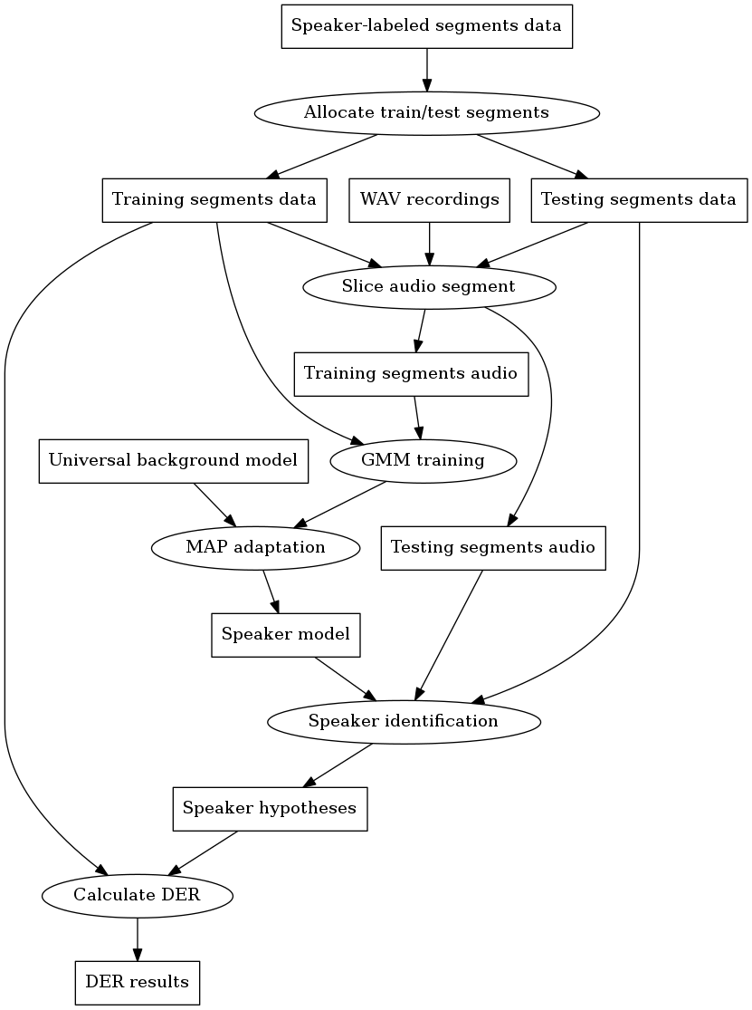
Figure 4: Data flow diagram for experiment baseline
In total, 236 speakers were identified. Due to the cross-checking method above, though, speakers with a lack of training data could not be verified, and there may be a number of double-counted speakers. The corpus contains 42.81 hours of speech, discounting silence, noise, and overlapping speaker segments. On average, each speaker has around 653.1 seconds of speech. However, due to the moderated nature of the meetings a small number of speakers contributed a large part of the recorded speech.

4 Experiment and Results

4.1 Overview and Evaluation Metrics
Experiments were conducted to ascertain the difference in speaker prediction accuracy between the online speaker diarization system and a baseline offline system. Both systems utilized the speaker model obtained in Section 3.3. The online system utilizes a different speaker segmentation method, essentially dividing the input audio stream at quiet sections and running speaker identification directly on these short segments whilst forgoing the clustering step. The baseline system utilizes the standard setup and is discussed below. Accuracy evaluation was conducted on a per frame basis as speaker segment boundaries and positions differed between the two methods.
The experiments are evaluated on Speaker Error Rate (SER), calculated as the percentage time (in terms of frames) wrongly attributed to another speaker. As the reference is labeled at the speaker segment level and not at the frame level, and due to the differences in speaker segmentation between the various systems, segment alignment between the hypothesized segments and reference segments is necessary.

4.2 Speaker Model
The speaker model was built using various amounts of speaker training data from the corpus, with validation testing conducted on the remainder of the speaker’s data. It is desirable to use the minimum amount of speech per speaker in training the speaker model, as this correlates to a shorter enrollment time in real life usage. Hence, speaker models using 60, 90, and 120 seconds of training data per speaker were trained and tested. For each of these models, the steps are as follows:
- For each speaker in the cleaned corpus, determine whether enough speech data is available for training; if a speaker has spoken for less than 60, 90, or 120 seconds throughout the entire corpus, they are excluded from training and testing.
- If enough data is available, set aside the first 60, 90, or 120 seconds of speech for training and the rest for testing. Note that this may be problematic when speakers’ voices change throughout the meeting, or when the first minute of speech has insufficient tonal variation.
- Run maximum a priori (MAP) adaptation against a suitable universal background model (UBM) for all speaker training data, resulting in a final speaker model containing all speakers. As an appropriate separate Indonesian language corpus was unavailable, the UBM was pre-built from a different source.
- Evaluate the speaker model using the test data set aside in step 2 by calculating the per frame speaker identification accuracy. The results of this step are detailed in Tbl. 2.
Training data (s) | SER (%) | # Speakers
30 | 49.12 | 223
60 | 21.71 | 201
90 | 13.62 | 178
120 | 13.21 | 157
150 | 10.15 | 138
180 | 11.65 | 123
Table 2: Speaker model validation
There is a difference between speaker model training on a corpus and training through speaker enrollment. When training on a corpus, as the amount of training data per speaker is increased, a larger proportion of speakers can no longer be trained and tested. This is noted in Tbl. 2, which notes the number of speakers trained and tested. Also, whereas in this case the speech taken for each speaker’s training is from the very beginning of their turns, in speaker enrollment we have the opportunity to obtain speech according to our specific needs. For instance, as speakers can often be discriminated from the sound of their vowels, we may want to provide a sentence containing mostly vowels for enrollment, which is not possible in corpus training without utilizing a phoneme recognizer beforehand. In this way, it is possible to obtain better results in less time through enrollment.

4.3 Baseline System
The baseline system utilizes the standard LIUM toolkit setup to implement offline speaker diarization using data obtained from the corpus discussed in Section 3. This process has been covered in depth in Meignier and Merlin (2010), with the relevant configuration for this experiment as follows:
- Feature extraction with 12 Mel-Frequency Cepstral Coefficients (MFCC) in Sphinx format from 16 kHz audio files with additional energy, delta, and delta-delta information calculated during pre-processing. Feature warping, cepstral mean normalization (CMS), and variance normalization are applied on a 300 frame sliding window for robustness purposes.
- Initial speaker segmentation, followed by classification of speech, music, and silence segments.
- GLR-based segmentation followed by linear and hierarchical clustering of resulting speaker segments.
- Segment adjustment by modeling the speaker clusters as Gaussian mixtures models (GMM) and running Viterbi decoding.
In the standard setup, these steps are succeeded by segmentation into speech and non-speech areas and gender/bandwidth detection. However, these steps were omitted in this setup as they were deemed unnecessary; non-speech is labeled as noise in the corpus and gender/bandwidth was irrelevant for the scope of the study. Instead, the re-segmented portions were used to evaluate the accuracy of the system.
The system is evaluated by decoding and identifying the corpus assembled in Section 3, with the results displayed in Table 3. It should be noted that as the speaker model itself is built from this data, portions of the training data are evaluated by the system.

4.4 Proposed System
The online system implements a simple voice activity detector (VAD) to detect the beginnings and endings of utterances, splitting the incoming audio stream into a separate segment whenever voice activity is not detected. LIUM toolkit is then used to run speaker identification on the segment against the speaker model obtained in Section 4.1. For the current utterance, the system outputs the most likely speaker calculated over a sliding window.
In detail, as illustrated in Fig. 2, the process can be broken down into the following steps: 1. Read the incoming audio stream in blocks. 2. Extract MFCC features, including energy. 3. Check whether the average energy of the given block is above a specified energy threshold, upon which the block is considered silent or non-silent. 4. Calculate the speaker distance between the current and previous block, using a metric such as BIC, GLR, or KL2. If the distance score exceeds a specified threshold, the block is considered a new turn. 5. If the given audio block is not considered silent or belonging to a new speaker, store the samples of the audio block. 6. After a specified duration of consecutive silent/new speaker blocks are encountered, ‘split’ the stream by writing the stored samples into a new audio file, creating a new speaker segment. 7. Run speaker identification on the segment against the speaker model obtained in Section 4.1, storing the likelihoods of all speakers. 8. Take all speaker likelihood scores from a specified amount of preceding segments, and perform a time-weighted averaging for each speaker. The speaker with the highest score is given as the prediction.
For the experiments below, the block length is set at 1024 samples, the energy threshold in step 3 is set at -15 dBV, the duration of consecutive silent/new speaker blocks is set at 0.65 seconds, and the window size for averaging is set variously at 3, 5, and 7 segments. The use of speaker turn detection, however, is omitted from the final experiment, as it was found to perform poorly without proper experimentation to determine a suitable threshold and penalty value.
The results of the baseline and proposed systems for the 90, 120, and 150 second speaker models is detailed in Tbl. 3.
Model | Method | SER (%)
90 | online | 38.21
 | 3-win | 30.76
 | 5-win | 29.92
 | base | 21.05
120 | online | 34.93
 | 3-win | 27.03
 | 5-win | 25.52
 | base | 18.48
150 | online | 31.41
 | 3-win | 24.60
 | 5-win | 24.92
 | base | 19.59
Table 3: Speaker diarization and identification results for the various systems

Of note, the results of baseline system evaluation are consistently superior to the proposed system. The simplicity of the speaker segmentation method employed in the proposed system results in often inaccurate segments, specifically during periods of back and forth conversation. This is mitigated somewhat by the windowing method used, which on average results in a small improvement in accuracy. However, accuracy improvements quickly subside with larger window sizes. Furthermore, this method may break down in more dynamic conversations, where speaker turns occur more rapidly.
The various steps in the proposed system contribute to the final latency of the system. Using the 120 second speaker model, and utilizing a five frame window, the average latency as measured from the end of a speaker segment to the moment of speaker prediction is 0.77 seconds, with the average speaker segment being 5.23 seconds long. This measure of latency includes the time needed for segment splitting, speaker identification, and average windowing. The average ratio between latency and segment duration is 0.21. This indicates that, on average, 0.21 times the duration of the input segment is needed to produce a prediction. By comparison, in Adianto, Satriawan, and Lestari (2017) the latency is calculated as 1.10 times the duration of the input file.
Generally speaking, the largest contributor to total latency is the identification process itself, namely the LIUM toolkit identification program. Based on code profiling, on average this process contributes to 98.85% of the computation time. This can be attributed to the lengthy startup time of the Java Virtual Machine (JVM) which is initialized each call, evidenced by the proportionally lower latency-duration ratio for longer segments. To bypass this startup time, it would be necessary to implement the program as a daemon or service that waits instead of terminates on each call. Another option would be to implement the program in another language altogether.

5 Conclusion
In this research, the development of an Indonesian language diarization corpus and the construction of an online speaker diarization system is explored in detail. The resulting corpus is available for research purposes to the Indonesian public. For the purpose of meeting transcription, a speaker model was built using the corpus data, from which further corrections to the corpus were made.
A simple online system utilizing energy-based speaker segmentation and MAP adapted GMM-based speaker identification was constructed, with window-averaged predictions to boost speaker prediction accuracy. The system is then tested and compared against a baseline offline speaker diarization system. Results show that the offline system retains the advantage in terms of prediction accuracy, although it requires knowledge of the entire audio stream beforehand. On a speaker model derived from 120 seconds of user speech, the online system with a 5-segment window produced a SER of 25.52% compared to 18.48% for the baseline system. The latency of this system is 0.21 times the duration of input speech, compared to 1.10 for the baseline offline system.

6 Bibliography
Adianto, R., C. H. Satriawan, and D. P. Lestari. 2017. “Transcriber: An Android Application That Automates the Transcription of Interviews in Indonesian.” In 2017 International Conference on Advanced Informatics, Concepts, Theory, and Applications (Icaicta), 1–6. https://doi.org/10.1109/ICAICTA.2017.8090955.
Alumäe, Tanel. 2014. “Full-Duplex Speech-to-Text System for Estonian.” In Baltic Hlt 2014. Kaunas, Lithuania.
Dehak, Najim, Patrick J. Kenny, Réda Dehak, Pierre Dumouchel, and Pierre Ouelett. 2011. “Front-End Factor Analysis for Speaker Verification.” In IEEE Transactions on Audio, Speech, and Language Processing. Vol. 19. 4.
Delacourt, P., and C. J. Wellekens. 1999. “Audio Data Indexing: Use of Second-Order Statistics for Speaker-Based Segmentation.” In IEEE International Conference on Multimedia, Computing and Systems. Florence, Italy.
Friedland, Gerald. 2012. “Using a Gpu, Online Diarization = Offline Diarization,” January.
Li, Daben, and Francis Kubala. 2003. “Online Speaker Clustering.” In Proc. ICASSP 2003.
———. 1999. “Fast Speaker Change Detection for Broadcast News Transcription and Indexing.” In Sixth European Conference on Speech Communication and Technology, Eurospeech 1999.
Li, Daben, Daniel Kiecza, Amit Srivastava, and Francis Kubala. 2005. “Online Speaker Adaptation and Traking for Real-Time Speech Recognition.” In INTERSPEECH 2005 - Eurospeech, 9th European Conference on Speech Communication and Technology.
Meignier, S, and T Merlin. 2010. “LIUM Spkdiarization: An Open Source Toolkit for Diarization.” In Proc. CMU Spud Workshop.
Reynolds, Douglas A., Thomas F. Quatieri, and Robert B. Dunn. 2000. “Speaker Verification Using Adapted Gaussian Mixture Models.” In Digital Signal Processing, 10:19–41.
Rouvier, M, G Dupuy, P Gay, E Khoury, T Merlin, and S Meignier. 2013. “An Open-Source State-of-the-Art Toolbox for Broadcast News Diarization.” In Interspeech 2013.
Siegler, Matthew A., Uday Jain, Bhiksha Raj, and Richard M. Stern. 1997. “Automatic Segmentation, Classification and Clustering of Broadcast News Audio.” In Proc. DARPA Speech Recognition Workshop, 97–99.
Torfi, Amirsina. 2017. “SpeechPy: Speech recognition and feature extraction.” https://doi.org/10.5281/zenodo.840395.

