ASSINGNMENT1

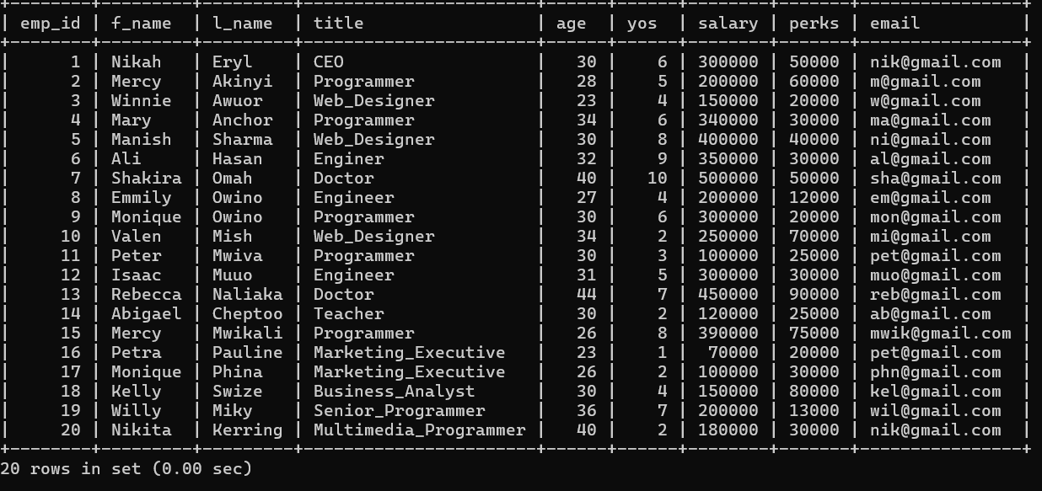

1. mysql> create database address_book;

Query OK, 1 row affected (0.01 sec)

1. describe, show

mysql> select * from table_name;

mysql> select* from employee­_data;

1. mysql> show databases;

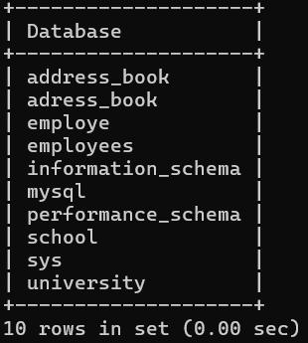

4.mysql>insert into employee_data(First_name,last_name,title,age,years,salary,perks,email)

->values

->(“Rudolf”,”Reindeer”,”Business_Analyst”,34,2,95000,17000,”rudolf@budget.com”);

5. select * from employee_data;



mysql> select f_name,l_name,title,age,yos,salary,perks, email from employee_data;

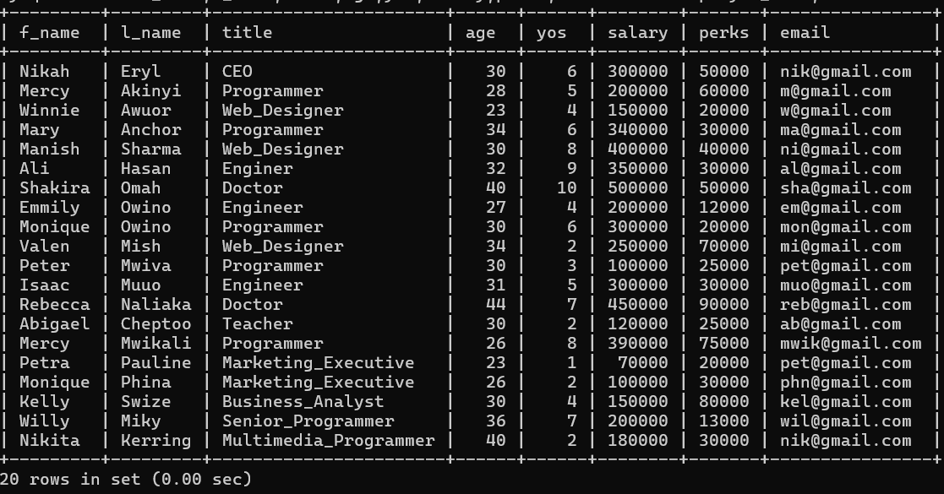

1. mysql> select f_name,email from employee_data;

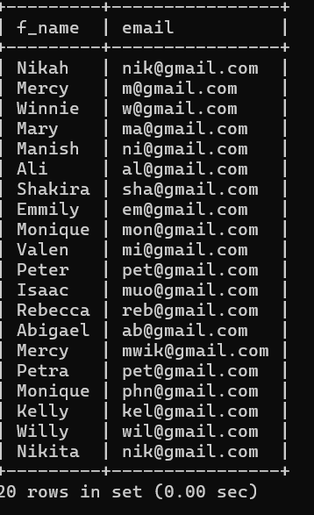

7. mysql> select salary,perks,yos from employee_data;

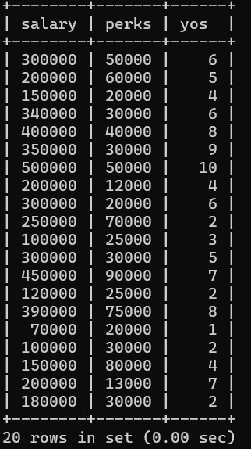

8. mysql> select count(*) from employee_data;

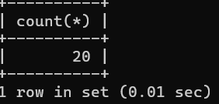

9. mysql> select salary,l_name from employee_data;

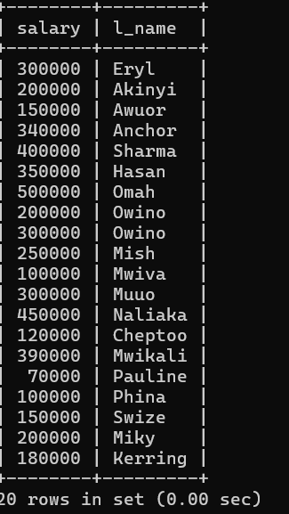

ASSIGNMENT2

1.mysql> select emp_id from employee_data where age>30;

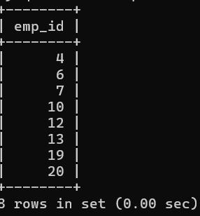

2. mysql> select f_name,l_name from employee_data where title="web_Designer";

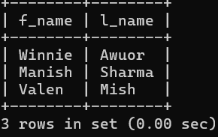

3. mysql> select *from employee_data where salary<=100000;

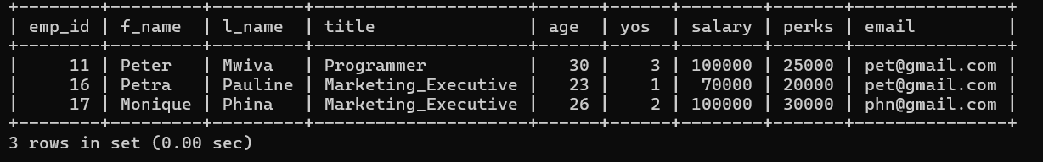

4.mysql> select salary,perks from employee_data where perks>16000;

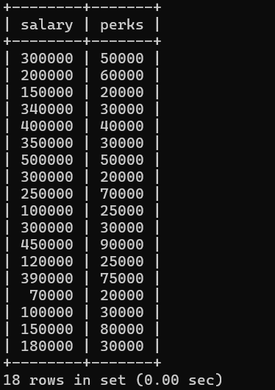

5.mysql> select l_name,f_name from employee_data where title="Marketing­­_Executive";

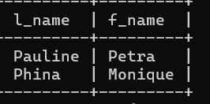

ASSIGNMENT3

1. mysql> select f_name,l_name from employee_data where l_name like 'p%';

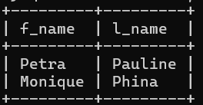

2. mysql> select f_name,l_name from employee_data where title like "%marketing%";

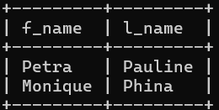

3. mysql> select f_name,l_name,salary from employee_data where f_name like "%k%";

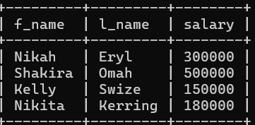

4.mysql> select l_name,title from employee_data where title="programmer";

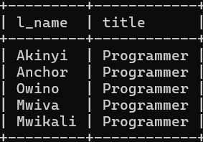

ASSIGNMENT4

1. mysql> select f_name,l_name from employee_data where salary<=90000 and title

NOT LIKE "%programmer%";

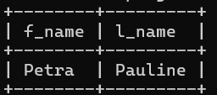

2. mysql> select l_name,f_name from employee_data where title NOT LIKE "%marketing%” AND age<30;

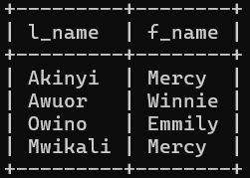

3.mysql> select emp_id,f_name,l_name from employee_data where age>=32 AND age<=40;

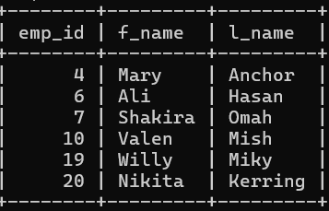

4. mysql> select f_name,l_name from employee_data where age=32 AND title NOT LIKE "%programmer%";

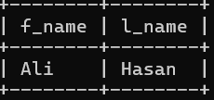

ASSIGNMENT5

1.mysql> select f_name,l_name from employee_data where title="Senior_Programmer" OR title="Multimedia_Programmer";

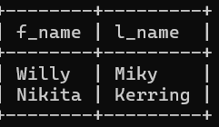

2.mysql> select f_name,l_name,salary from employee_data where salary BETWEEN 70000 AND

90000;

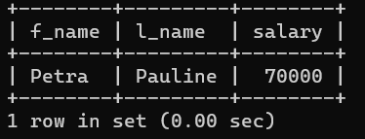

3. mysql> select f_name,l_name,title from employee_data where title NOT IN('Programmer','Senior_Programmer','Multimedia_Programmer');

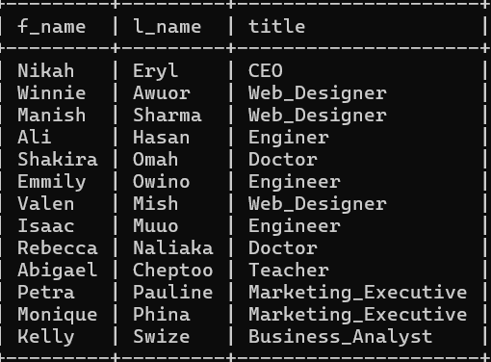

4. mysql> select f_name,l_name,title,age from employee_data where title NOT IN('Programmer','Senior_Programmer','Multimedia_Programmer') AND age NOT BETWEEN 28 AND 32;

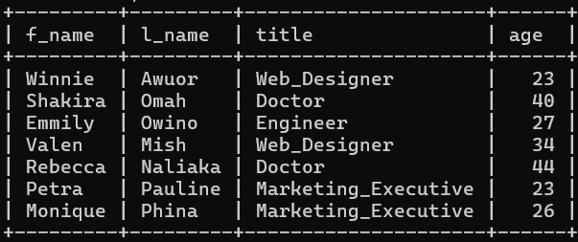

ASSIGNMENT6

1. mysql> select f_name,l_name from employee_data ORDER BY salary;

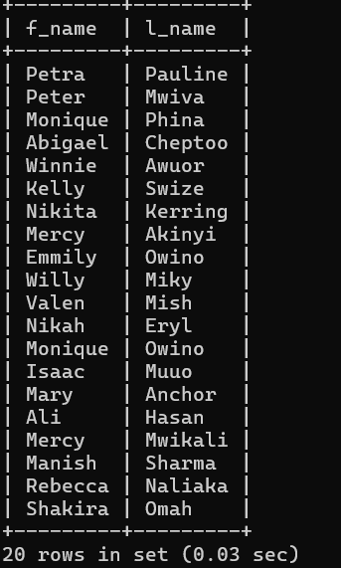

1. mysql> select f_name,l_name from employee_data ORDER BY yos DESC;

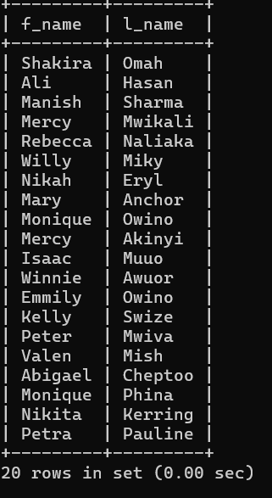

1. mysql> select emp_id,l_name,title,age from employee_data ORDER BY title DESC,age ASC;

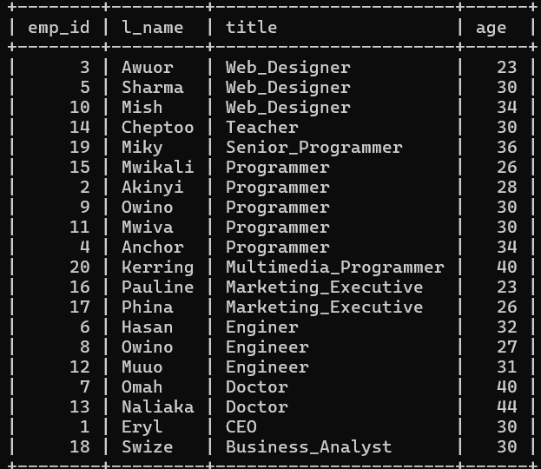

1. mysql> select l_name,f_name from employee_data where title IN('Programmer','Web_Designer') ORDER BY l_name ASC;

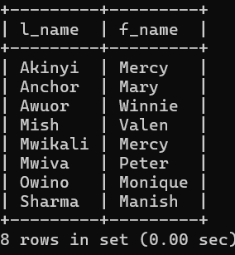

ASSIGNMENT7

1. mysql> select f_name,l_name,age from employee_data ORDER BY age LIMIT 5;

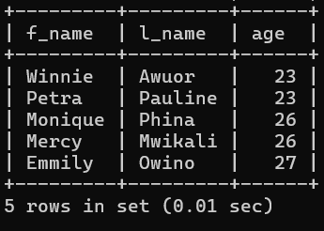

1. mysql> select * from employee_data LIMIT 10,5;

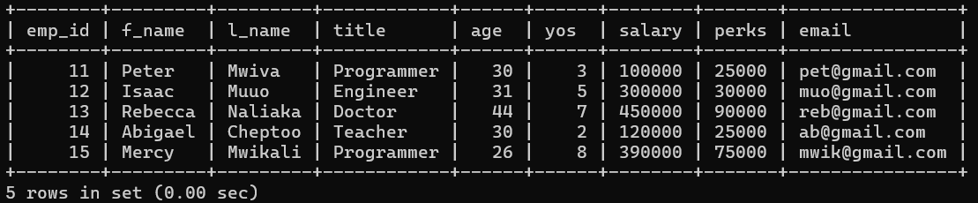

3.mysql> select f_name,l_name ,salary from employee_data ORDER BY salary DESC LIMIT 1;

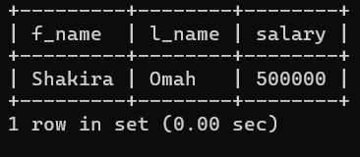

4.mysql> select emp_id,age,perks from employee_data ORDER BY perks DESC LIMIT 10;

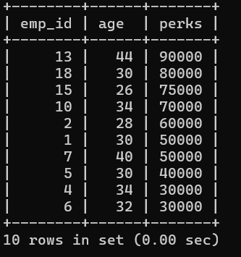

ASSIGNMENT8

1. mysql> Select DISTINCT salary from employee_data ORDER BY salary DESC;

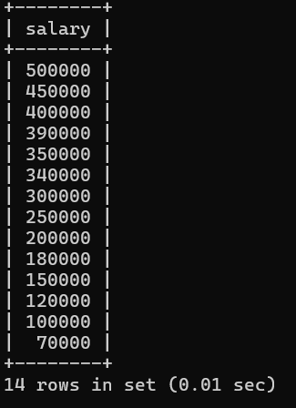

2. mysql> select DISTINCT f_name from employee_data;

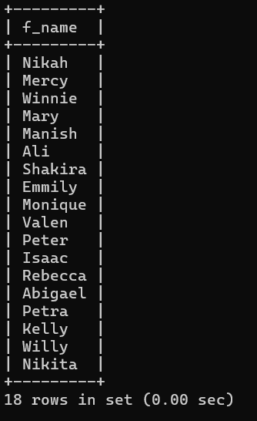

ASSIGNMENT9

1. mysql> select MIN(perks) from employee_data;

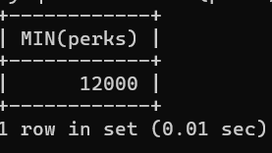

1. mysql> select MAX(salary) from employee_data where title="Programmer";

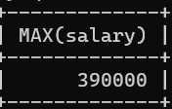

1. mysql> select age from employee_data where title="Marketing_Executive" ORDER

BY age DESC LIMIT 1;

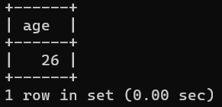

1. mysql> select f_name,l_name from employee_data ORDER BY age DESC LIMIT 1;

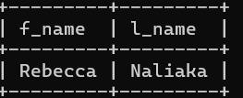

ASSIGNMENT10

1. mysql> select SUM(age) from employee_data;

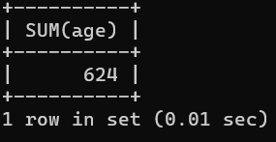

1. mysql> select sum(yos) from employee_data;

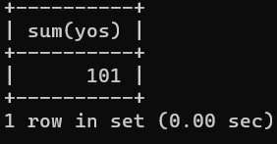

1. mysql> select SUM(salary) + avg(age) from employee_data where title="programmer";

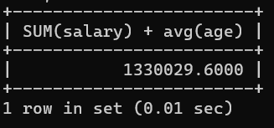

1. mysql> select (SUM(perks)/SUM(salary)*100) from employee_data;

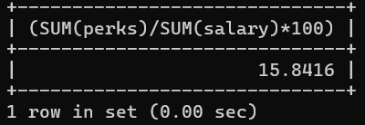

Gives the perks as a percentage.

ASSIGNMENT11

1.mysql> select count(*) from employee_data where yos>=4;

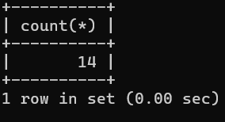

1. mysql> select age,count(*) as Number from employee_data GROUP BY age;

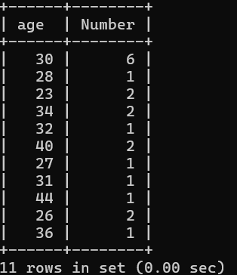

1. mysql> select age,count(*) as Number from employee_data GROUP BY age ORDER BY age DESC;

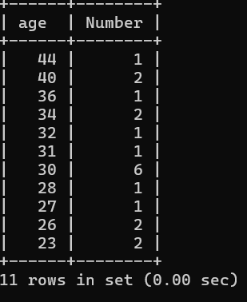

1. mysql> select title,avg(age) as 'Average Age' from employee_data GROUP BY title;

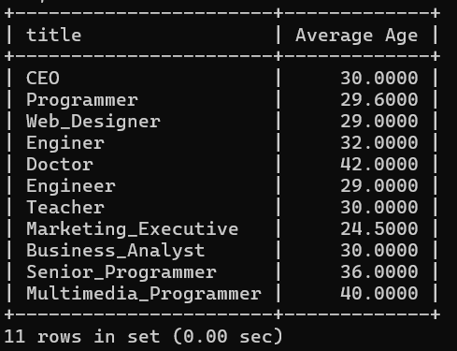

5. mysql> select title,avg(age) as Average from employee_data GROUP BY title ORDER BY Average DESC;

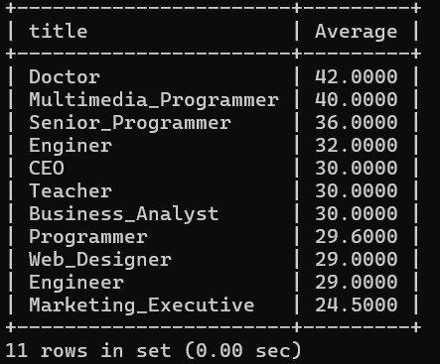

6. mysql> select f_name,l_name,((perks/salary)*100) as Percentage from employee

_data;

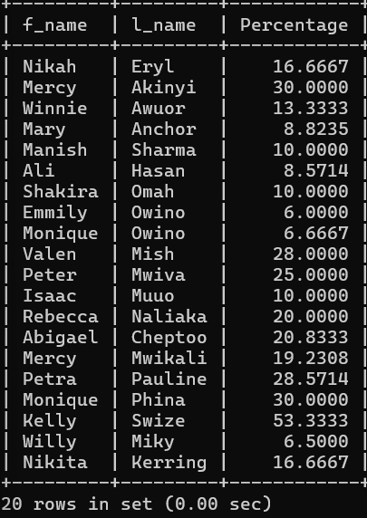

ASSIGNMENT12

1. mysql> select title,avg(age) from employee_data GROUP BY title HAVING avg(age)>30;

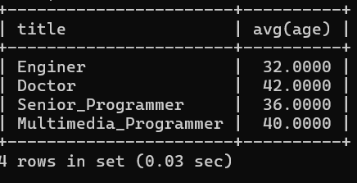

ASSIGNMENT13

1. mysql> select version();

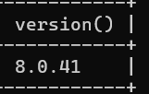

1. mysql> select (4*4*4) AS 'Cube of 4';

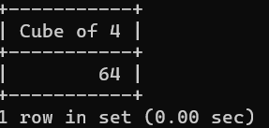

1. mysql> select 'Brivel Cheruto' AS Name;

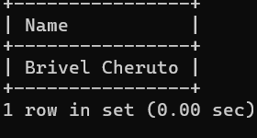

ASSIGNMENT14

1. 1. mysql> update employee_data

-> SET l_name='Sharma'

-> where f_name='Petra';

-> where f_name='Petra';





2. mysql> update employee_data

-> SET title='Multimedia Specialist'

-> where title='Programmer';

Query OK, 5 rows affected (0.01 sec)

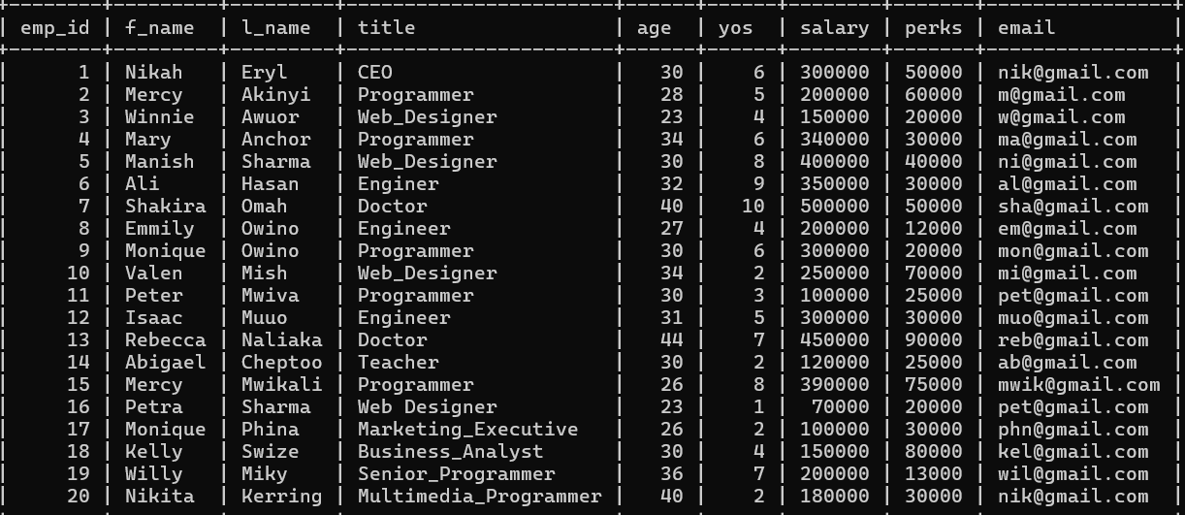

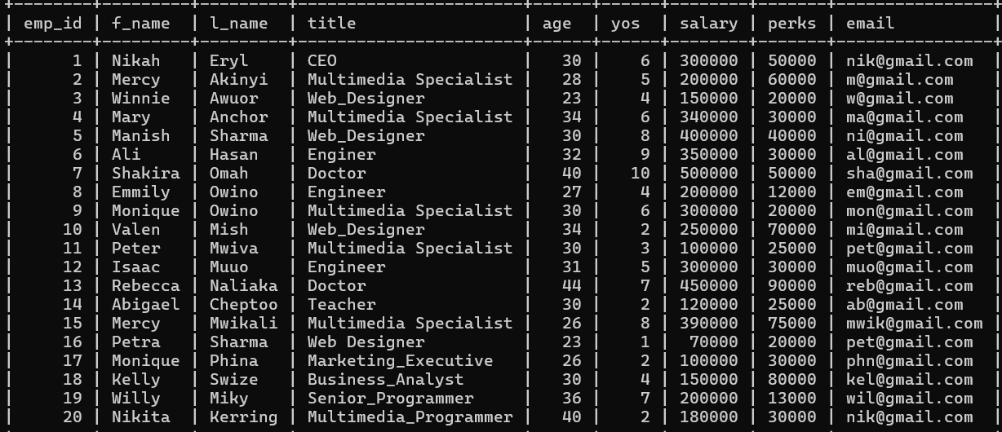

3. mysql> update employee_data

-> SET salary=salary+10000

-> where title !='CEO';

Query OK, 19 rows affected (0.01 sec)

Rows matched: 19 Changed: 19 Warnings: 0

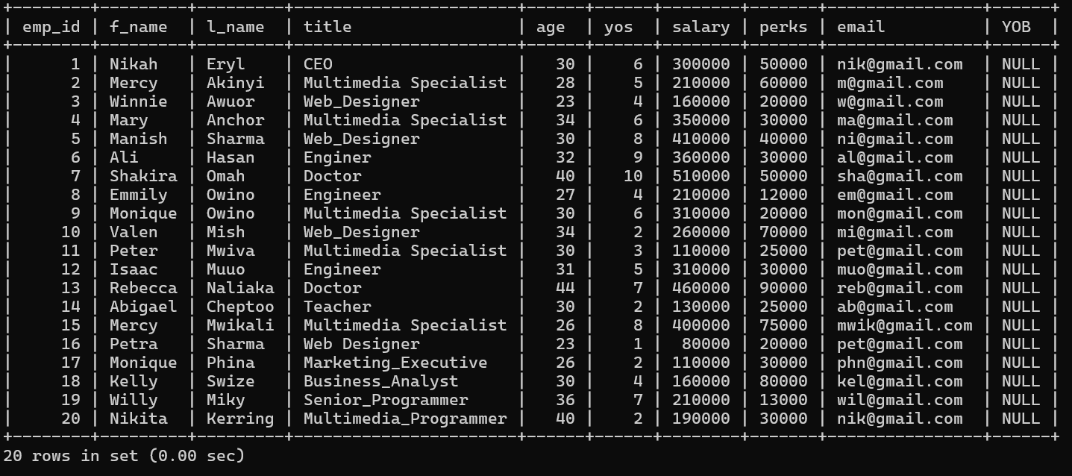

ASSIGNMENT15

1.List all employee ids and birth dates born before 1965

mysql> select e_id,birth_date from employee_per where birth_date <'1965-01-01;

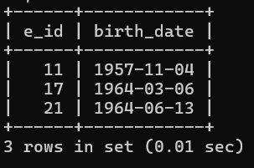

2 ID and birthdate between 1970 and 1972

mysql> select e_id,birth_date from employee_per where birth_date >='1970-01-01' AND birth_date <='1972-01-01';

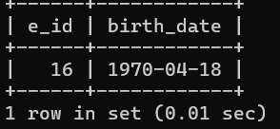

ASSIGNMENT16

1.mysql> select e_id,birth_date,p_email from employee_per where MONTHNAME(birth_date)='April';

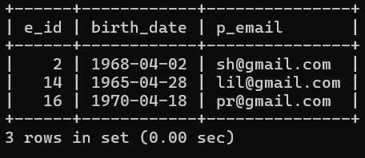

2. mysql> select e_id,birth_date,s_name from employee_per where year(birth_dat

e)=1969 ORDER BY s_name;

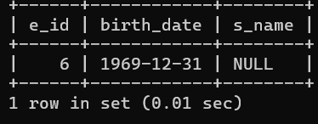

3.mysql> select e_id from employee_per where Month(birth_date)=MONTH(CURRENT_DATE);

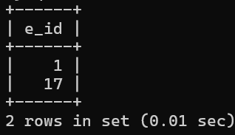

4. mysql> select DISTINCT year(birth_date) as 'Unique Birth Years' from e

mployee_per;

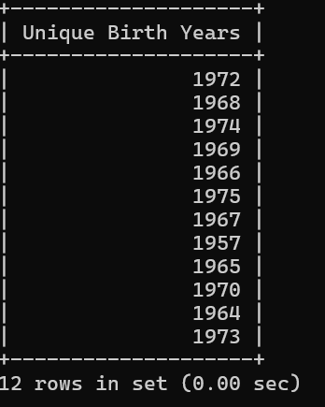

5.mysql> select DISTINCT year(birth_date),count(*) from employee_per GROUP BY year(birth_date);

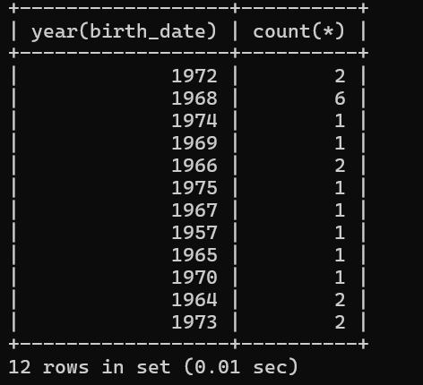

6.mysql> select DISTINCT Monthname(birth_date),count(*) from employee_per GROUP BY monthname(birth_date) ORDER BY count(*) DESC;

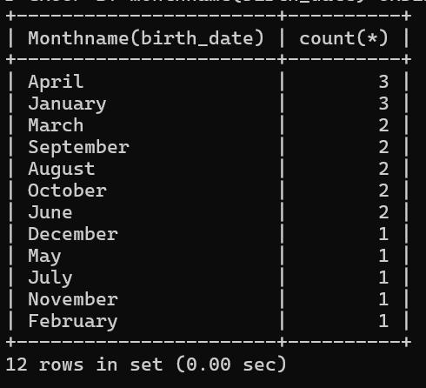

ASSIGNMENT17

1. mysql> select e_id,s_name from employee_per where m_status='Y';

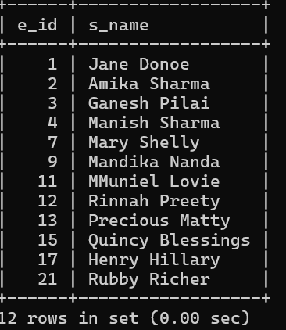

2. mysql> select e_id,s_name from employee_per where m_status='Y' ORDER BY

Y s_name;

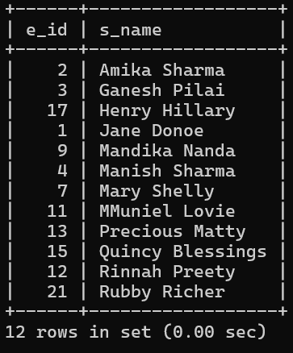

3.mysql> select sex,count(*) from employee_per GROUP BY sex;

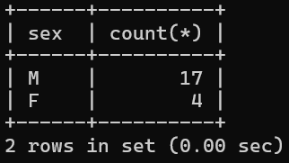

4.mysql> select m_status,count(*) from employee_per GROUP BY m_status;

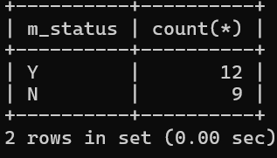

5.mysql> select sum(children) from employee_per;

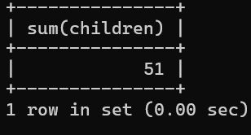

6.mysql> select DISTINCT children ,count(*) from employee_per GROUP BY children ORDER BY count(*) DESC;

