

VIS Framework Description

Project acronym: CIMPLEX
Project full title: Bringing CItizens, Models and Data together in Participatory, Interactive SociaL EXploratories.
Grant agreement No.: 641191

Due-Date: | Month X
Delivery: | Month Y
Lead Partner: | Deliverable Lead Partner
Dissemination Level: | Public or other
Status: | Draft / Final
Approved: | Steering Committee
Version: | Version_number

Disclaimer
This document contains material, which is the copyright of CIMPLEX Consortium parties, and no copying or distributing, in any form or by any means, is allowed without the prior written agreement of the owner of the property rights. The commercial use of any information contained in this document may require a license from the proprietor of that information.
Neither the CIMPLEX Consortium as a whole, nor a certain party of the CIMPLEX Consortium warrant that the information contained in this document is suitable for use, nor that the use of the information is free from risk, and accepts no liability for loss or damage suffered by any person using this information.
This document reflects only the authors’ view. The European Community is not liable for any use that may be made of the information contained herein.

DOCUMENT INFO

Authors
Authors | Institution | e-mail

0.2 Document History
Date | Version | Editor | Change | Status

Table of Contents
0.1 Authors 2
0.2 Document History 2
T3.1 Setup 4
T3.2 Usage 5
T3.3 VisFramework Configuration 5
T3.3.1 Default Configuration 5
T3.3.2 Custom Configurations 5
T3.3.3 View Configurations 6
T3.4 VisFramework Architecture 7
T3.4.1 Overview 7
T3.4.2 Connectors 7
T3.4.3 Data Model 7
T3.4.4 Filter 8
T3.4.5 Visual Mapping Functions 8
T3.4.6 Views 8
T3.5 Used Libraries 9
T3.6 Own Libraries 11
T3.7 Build System 12

VisFramework Documentation
Documentation for the visFramework javascript visualization framework.
For information on how to set up and run the framwork see README.md.

Configuration
The client configuration is stored in config/config.js. Depending on device type, display size and anticipated user expertise, different configuations may offer advantages over others.
The VisFramework automatically recognizes mobile devices and loads the respective configuration, but users may also change it via buttons.

Default Configuration
Config() is a constructor that takes an ID and description object and returns a configuration object with default values.
class Config {
constructor(id, description) {
// unique ID
this.id = id;
// general description and attributes
this.description = description;
// general interface
this.UI = {
// title may contain HTML
title: "Cimplex Visualization",
...
};
// filter configuration
this.filter = {
....
};
// views' configurations
this.timeline = {

};
...
}
}

Custom Configurations
You can create custom configurations by using this constructor and then overwriting only the specific attributes you want to change:
config.mobile = new Config("mobile", {
name: "mobile phone configuration",
expertise: "novice",
device: "mobile",
devicePerformance: "low"
});
config.mobile.UI.viewColumns = [12, 12, 12, 12];
config.mobile.UI.viewRows = 2;
config.mobile.UI.viewLimit = 2;
config.mobile.UI.viewDragAndDrop = false;
...

View Configurations
Views may have their own configuration inside the Config() constructor:
this.graph = {
edgeBundling: false,
showLabels: true,
labelLimit: 20,
showCommunities: true,
// directed links may be shown as undirected to reduce clutter
linkDirection: true,
// direction of links can be indicated via "doubleLines", "halfArrows" or "curvature"
linkDirectionIndicator: "doubleLines",
...
};
Users may change some of those attributes via buttons in the view’s title bar or settings panel.

Architecture
The following subsections explain the basic structure of the VisFramework.

Overview
Figure 1 shows an architecture diagram. The orange parts, i.e. services and respective connectors, have to be implemented by data service providers.
Administrators may change the Framework Configuration (blue) and third party developers may implement custom view modules.
The user interacts with the framework through the toolbar and the views.
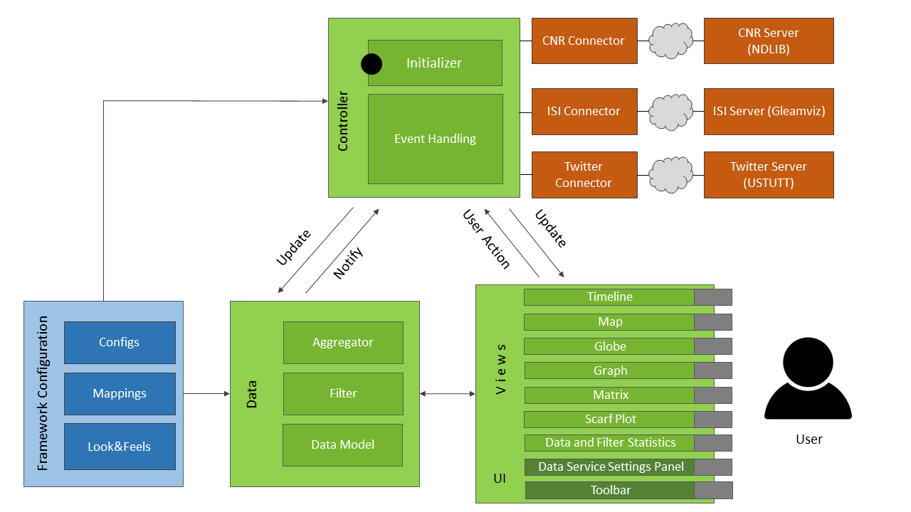Figure 1 The VisFramework’s architecture.

Configuration File
See the configuration section above.

Controller
The controller (/controller/) initializes the framework UI and event management.

Connectors
Connectors provide an interface between the VisFramework’s data model and online data services. We implemented the class connectorType in order to simplify the creation of custom connectors. The file types/_connectorTypeExample.js shows how to use this class.

Data
The dataModel/ directory contains all data management files. They are explained in the following subsections.

Model
The model.js file contains a list of regions, a list of transitions and a number of general data properties, e.g. the total timespan of the data.

Filter
The filter is implemented in filter.js and stores filered results in filteredData.js objects.
Views can offer brushing or selection interactions and then use the filter events to apply certain filters to the data. Currently we support filtering on a time span, reactangular geographic area, specific regions and a single community.

Aggregator
The file aggregator.js contains function for time dependent aggregation of transitions.

Community Detection
The file community.js implements jLouvain community detection.

Visual Mapping Functions
The visual mappings from data values to colors, sizes, etc. has to be provided by the connectors. They are then cached in config/mapping.js and can be accessed by views using the global MAPPING object.

Views
You can create views using the viewType class. The file types/_viewTypeExample.js contains example code for this task. Views have access to the data and to mappings (see above). ViewType takes care of window management entirely.
Views have complete freedom in how they display their content, they may use HTML, Canvas, SVG, WebGL, etc. Canvas and WebGL are prefered for many shown items due to performance issues caused by having many DOM elements.
Hovering, clicking or tapping a view's title shows a short instruction manual for it.

Libraries
The VisFRamework uses external and internal libraries that are listed below.

External
The table below lists all used external libraries and their respective uses.
Name | Used for
Bootstrap | general page layout
Colorbrewer | color palettes that are used in color mapping
Crossfilter | data filtering
d3 v3 | utility functions, scaling, interaction, colors and timeline.
d3 v4 | updated packages for some functionality
d3forcebundle | force directed edge bundling with d3
Font Awesome | icons
gLayers | canvas Layer for Leaflet
jLouvain | community detection
jQuery | HTTP requests
Leaflet | geographic map
Mustache | HTML logic-less templates
Sortable | view drag and drop to reorder views
inflection.js | word inflection

Internal
The table below lists our own libraries and their respective uses.
Name | Used for
vectorSimilarity | contains functions which compare vectors in order to be able to sort them by similarity
WebWorkerPool | controls the creation of webworker threads
edgeBundlingWorker | calculates the force directed edge bundling in a separate thread
dfkiDecoder | decodes data from DFKI data services
lib.js | utility functions
ui.js | UI functions

Build System
The build system automatically minimizes and concatenates all JavaScript code in order to maximize page load performance.
It is based on Node.js and executed via the following commands:
npm install
npm run build:development
or, for building a minified version
npm install
npm run build:production
Any new javascript files need to be added to scripts/build.js.

