Executive Summary Report

Protocol Number: ABC-123-XYZ

Blinding Status: unblinded

Meeting Date: 2024-08-26

Report Issued Date: 2024-07-27

Cutoff Date: 2024-06-27

Report Author: Frank

# Report Overview

Per the DMC charter 1.0, this unblinded report focuses on general safety assessment. This report reviews disposition, protocol deviations, demographics, medical history, prior medications, concomitant medications, Treatment-emergent adverse event, vital signs, hematology data, chemistry data, and urinalysis data based on the data available in the study database as of 27Jun2024. Summary tables, listings, and figures are provided in this report.

# Disposition Table

A total of 415 patients were initially screened for inclusion in the study. Of these, 91 patients were screening failures, where the main reason was Inclusion/Exclusion Criteria not met (85 patients). 310 patients were randomized into the study. 9 patients did not receive any medication, where the main reason was ADVERSE EVENT (6 patients). 301 patients received medications. The treated patients were divided into 2 groups: the Active Treatment group (163 patients) and the Control group (138 patients).

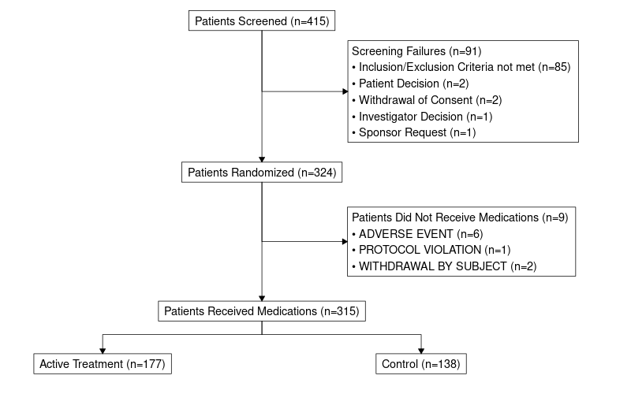

# Demographics Table

In total, there were 301 patients in the study. The mean (sd) age was 61.46 (11.91) with a median age of 63 and a range from 22 to 85.

The mean (sd) height at screening was 169.72 (9.75); the mean (sd) weight at screnning was 73.78 (15.25); the mean (sd) BMI at screening was 25.53 (4.42).

Of the 301 patients enrolled, 164 (54.49%) patients were male and 137 (45.51%) patients were female.

Of the 301 patients enrolled, 251 (83.39%) patients were White, 41 (13.62%) patients were Not Reported, 8 (2.66%) patients were Black or African American, and 1 (0.33%) patients were Multiple.

Of the 301 patients enrolled, 270 (89.7%) patients were Not Hispanic or Latino, 17 (5.65%) patients were Hispanic or Latino, and 14 (4.65%) patients were Not Reported.

|  | Active Treatment (N=163) | Control (N=138) | All Patients (N=301) |
| --- | --- | --- | --- |
| SEX |  |  |  |
| n | 163 | 138 | 301 |
| F | 79 (48.5%) | 58 (42%) | 137 (45.5%) |
| M | 84 (51.5%) | 80 (58%) | 164 (54.5%) |
| RACE |  |  |  |
| n | 163 | 138 | 301 |
| Black or African American | 3 (1.8%) | 5 (3.6%) | 8 (2.7%) |
| Multiple | 0 | 1 (0.7%) | 1 (0.3%) |
| Not Reported | 22 (13.5%) | 19 (13.8%) | 41 (13.6%) |
| White | 138 (84.7%) | 113 (81.9%) | 251 (83.4%) |
| ETHNIC |  |  |  |
| n | 163 | 138 | 301 |
| Hispanic or Latino | 10 (6.1%) | 7 (5.1%) | 17 (5.6%) |
| Not Hispanic or Latino | 142 (87.1%) | 128 (92.8%) | 270 (89.7%) |
| Not Reported | 11 (6.7%) | 3 (2.2%) | 14 (4.7%) |
| Age [years] |  |  |  |
| n | 163 | 138 | 301 |
| Mean (SD) | 61.35 (11.73) | 61.59 (12.16) | 61.46 (11.91) |
| 25% and 75%-ile | 52.0 - 71.0 | 54.0 - 71.0 | 52.0 - 71.0 |
| Median (Min - Max) | 62.0 (26.0 - 85.0) | 64.0 (22.0 - 84.0) | 63.0 (22.0 - 85.0) |
| Weight [kg] |  |  |  |
| n | 163 | 138 | 301 |
| Mean (SD) | 72.51 (15.94) | 75.28 (14.30) | 73.78 (15.25) |
| 25% and 75%-ile | 60.0 - 82.0 | 64.6 - 84.0 | 63.0 - 83.0 |
| Median (Min - Max) | 70.0 (41.2 - 132.0) | 73.1 (40.0 - 116.0) | 72.0 (40.0 - 132.0) |
| Height [cm] |  |  |  |
| n | 163 | 138 | 301 |
| Mean (SD) | 168.82 (10.17) | 170.79 (9.15) | 169.72 (9.75) |
| 25% and 75%-ile | 161.0 - 176.0 | 164.5 - 177.0 | 163.0 - 176.0 |
| Median (Min - Max) | 169.0 (145.0 - 194.0) | 171.5 (145.0 - 195.0) | 170.0 (145.0 - 195.0) |
| Body mass index [kg/m^2] |  |  |  |
| n | 163 | 138 | 301 |
| Mean (SD) | 25.35 (4.69) | 25.74 (4.09) | 25.53 (4.42) |
| 25% and 75%-ile | 21.9 - 28.0 | 22.8 - 28.1 | 22.3 - 28.0 |
| Median (Min - Max) | 25.0 (15.7 - 41.1) | 25.4 (17.1 - 37.5) | 25.1 (15.7 - 41.1) |

# Protocol Deviations Table

There were 1547 major protocol deviations in total. 162 patients in the Active Treatment group had 841 deviations and 120 patients in the Control group had 706 deviations. The most common major protocol deviation was LABORATORY ASSESSMENTS/PROCEDURES in 200 patients.

|  | Active Treatment (N=177) | Control (N=138) | All Patients (N=315) |
| --- | --- | --- | --- |
| Total number of major protocol deviations | 841 | 706 | 1547 |
| Total number of patients with major protocol deviations | 162 (91.5%) | 120 (87.0%) | 282 (89.5%) |
| LABORATORY ASSESSMENTS/PROCEDURES | 116 (65.5%) | 84 (60.9%) | 200 (63.5%) |
| STUDY PROCEDURES | 97 (54.8%) | 77 (55.8%) | 174 (55.2%) |
| VISIT SCHEDULE/INTERVAL | 34 (19.2%) | 24 (17.4%) | 58 (18.4%) |
| RANDOMIZATION PROCEDURES/STUDY DRUG DOSING | 26 (14.7%) | 22 (15.9%) | 48 (15.2%) |
| INCLUSION/EXCLUSION CRITERIA | 22 (12.4%) | 15 (10.9%) | 37 (11.7%) |
| SERIOUS ADVERSE EVENT REPORTING | 13 (7.3%) | 12 (8.7%) | 25 (7.9%) |
| INFORMED CONSENT PROCEDURES | 13 (7.3%) | 8 (5.8%) | 21 (6.7%) |
| OTHER | 8 (4.5%) | 8 (5.8%) | 16 (5.1%) |
| CONCOMITANT MEDICATION/THERAPY | 5 (2.8%) | 5 (3.6%) | 10 (3.2%) |

# Adverse Events Table

Of the 315 patients enrolled in the study, a total of 3947 Treatment-Emergent AEs (TEAEs) were reported in 307 (97.46%) patients. Of these 3947 TEAEs, 2083 (52.77%) were reported in 170 patients (arm total 177 patients) from the active treatment arm and 1864 (47.23%) were reported in 137 patients (arm total 138 patients) from the control arm.

|  | Active Treatment (N=177) | Control (N=138) |
| --- | --- | --- |
| Before first dose | 57 (32.2%) | 48 (34.8%) |
| Total number of patients with at least one TEAE | 170 (96.0%) | 137 (99.3%) |
| All TEAE | 2083 | 1864 |
| Serious adverse event | 45 (25.4%) | 47 (34.1%) |
| Related to study treatment | 120 (67.8%) | 94 (68.1%) |
| Outcome |  |  |
| FATAL | 7 (4%) | 9 (6.5%) |
| RECOVERED/RESOLVED | 168 (94.9%) | 132 (95.7%) |
| RECOVERED/RESOLVED WITH SEQUELAE | 8 (4.5%) | 17 (12.3%) |
| UNKNOWN | 11 (6.2%) | 17 (12.3%) |
| Action taken |  |  |
| DOSE NOT CHANGED | 170 (96%) | 137 (99.3%) |
| DOSE REDUCED | 7 (4%) | 10 (7.2%) |
| DRUG INTERRUPTED | 27 (15.3%) | 34 (24.6%) |
| DRUG WITHDRAWN | 18 (10.2%) | 17 (12.3%) |
| UNKNOWN | 0 | 1 (0.7%) |