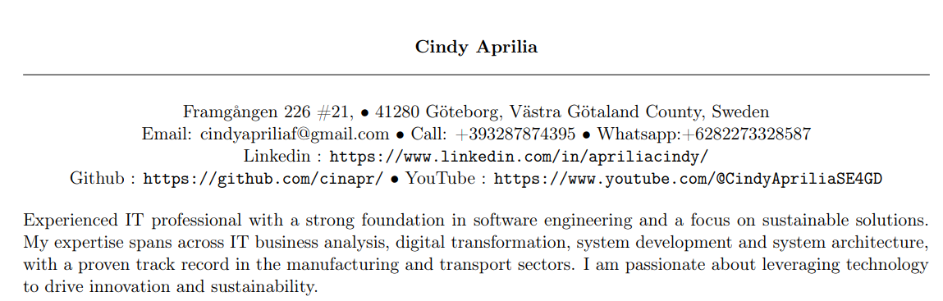

|  |  |  |  |  |  |  |
| --- | --- | --- | --- | --- | --- | --- |
| Education | | |  | Work |  | Publications |
| Bachelor of Computer Science Universitas Sumatera Utara (01 July 2013 – 25 January 2018) | | | 2013 |  | 2013 |  |
| 2014 |  | 2014 |  |
| 2015 | Teaching Assistant  Universitas Sumatera Utara  Medan, Indonesia (01 September 2015 – 31 August 2017) | 2015 |  |
| 2016 | 2016 | Seniman et al. Data Communication and Computer Networks (Practical) Handbook. internal use of Technology Information Department, Universitas Sumatera Utara. Medan: Percetakan Bumibaru, 2016. |
| 2017 | 2017 | Opim Salim Sitompul et al. Fundamentals of Artificial Intelligence with Prolog (Second Revision). internal use of Technology Information Department, Universitas Sumatera Utara. Medan: USU Press, 2017. isbn: 979-458-960-8. |
| 2018 | Wilmar Consultancy Services  Full Stack Software Engineer  Medan, Indonesia  02 July 2018 – 31 May 2022 | 2018 | Aprilia, C. (2018). *Klasifikasi Kecerdasan Majemuk pada Anak Berdasarkan Aktivitas Posting di Sosial Media dengan Menggunakan Sentistrength dan Spearman's Rank Correlation Coefficient* (Doctoral dissertation, Universitas Sumatera Utara). |
|  | | | 2019 | 2019 | Baihaqi Siregar et al. “Klasifikasi Kecerdasan Majemuk pada Anak Berdasarkan Posting Aktivitas di Media Sosial Menggunakan SentiStrength dan Spearman’s Rank Correlation Coefficient (Classification of Multiple Intelligences in Children Based on Posting Activities on Social Media Using Sentistrength and Spearman’s Rank Correlation Coefficient)”. Em: Jurnal Media Informatika Budidarma 3.4 (2019), pp. 357–365. |
|  | | | 2020 | 2020 |  |
|  | | | 2021 | 2021 |  |
| Università degli Studi dell’Aquila  L’Aquila, Italy M.Sc. (Joint Erasmus Mundus) Software Engineers For Green Deal (Sustainability)  September 2022-August 2024 | LUT University (Lappeenranta-Lahti University of Technology)  Lappeenranta, Finland  M.Sc. (Joint Erasmus Mundus) Software Engineers For Green Deal (Sustainability)  September 2022-August 2024 | Vrije Universiteit Amsterdam  Amsterdam, Netherlands  M.Sc. (Joint Erasmus Mundus) Software Engineers For Green Deal (Sustainability)  September 2022-August 2024 | 2022 | 2022 |  |
| 2023 | SOLITA Finland (WFA) Intern Software Developer April 2023 – June 2023 | 2023 |  |
| 2024 | Breakthrough Technology Innovation Research Group (Vrije Universiteit Amsterdam) Netherlands Master Student Researcher November 2023 – January 2024 | 2024 |  |
| LUT University (Lappeenranta-Lahti University of Technology) Lappeenranta, Finland University Research Asistant June 2023 – August 2023 |