**Mathematical Modeling**

They use a techno-economical model called GEOPHIRES to simulate a deep geothermal system. This simulator provides costs associated with (a) electricity production, (b) direct-use heat, and (c) combined heat and power (CHP or cogeneration) from the geothermal system.

An example of technical and financial parameters is given in Table 5.4.

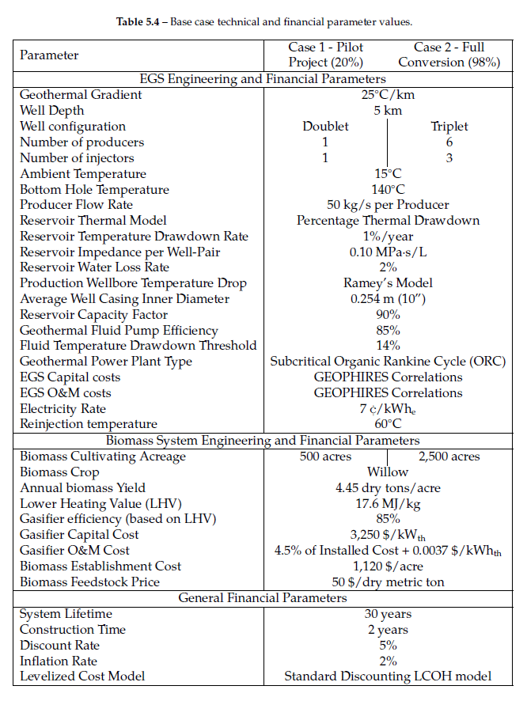

The simulation outputs are summarized in Table 5.5.

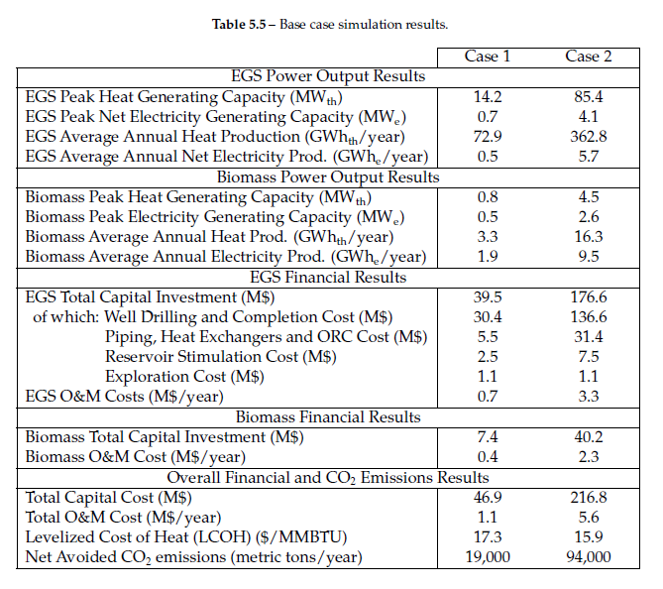

**If we use the geothermal system for purpose (a):**

We are interested in how much the airport energy consumption would decrease if they switched to a geothermal system. Given the inputs to the simulator, the performance of the geothermal system is calculated using total cost of ownership calculations.

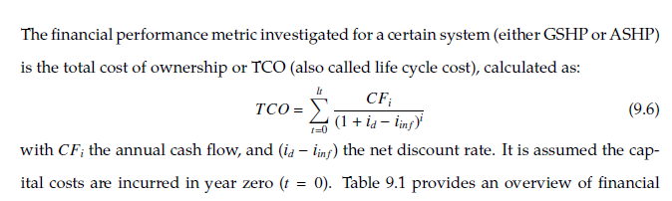

We need a model to calculate the current cost of ownership (i.e., purely electricity). We can then compare this with the total cost of ownership obtained from the simulations to assess the feasibility of the geothermal system. The total cost of ownership can then simply be calculated via (Electricity rate X Consumption) considering the lifetime of the geothermal system. The CO2 emission rate may also be relevant here.

**Electricity rate**

Cost per kWh paid by the airport. Are they charged the base rate?

**Electricity consumption data**

All the airport facilities. Use monthly or annual.

**Operational CO2 Emissions**

Do they have any data tied to CO2 emissions? This data is needed for environmental impact assessment. (See Ch. 9.1.10.)

**If we use the geothermal system for purpose (c):**

Now the geothermal system will also be used for heating (or cooling) and electricity generation. They use TRNSYS systems model (Ch. 9.1) to simulate geothermal heat pump system.

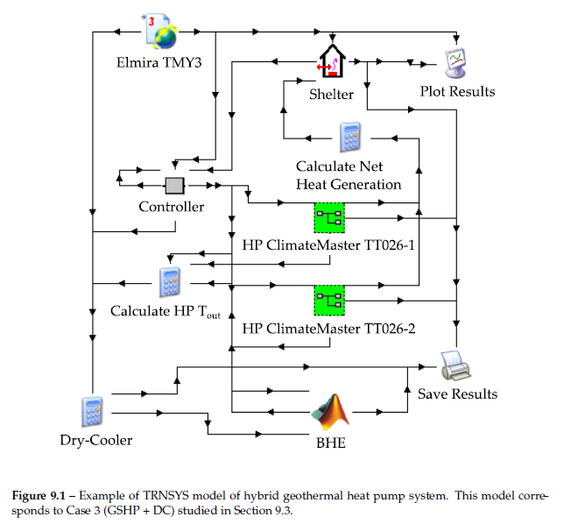

They couple the TRNSYS systems model with GEOPHIRES to optimize TCO. Some inputs we might need about the current system are as follows (not all are explicitly stated in the text, but I figured we might need the following):

**Heating and cooling requirements**

Average heating and cooling loads. If possible, by season.

**Current HVAC system specifications**

Type, capacity, and energy efficiency (COP or EER)

**Shelter/Building Heat Generation**

Internal heat generated within airport. These could be coming from electronics, appliances, or equipment.