## How to “open” and how to “close” a fellowship application specialty (allowed by fellowship and platform administrators)

1. Click the “Application Form Status and Appearance” link under the configuration navigation bar on the top of the “Fellowship Applications” system.

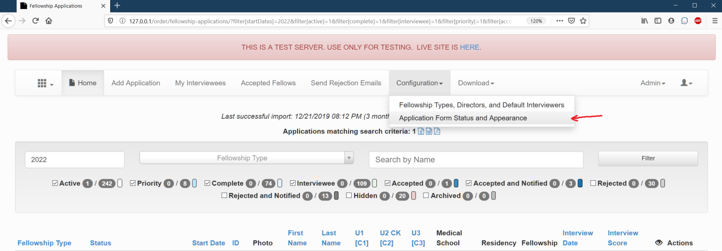

1. In the “Fellowship Application Types” field add or remove specialty. On this page it is possible to update all other settings on the fellowship application form.

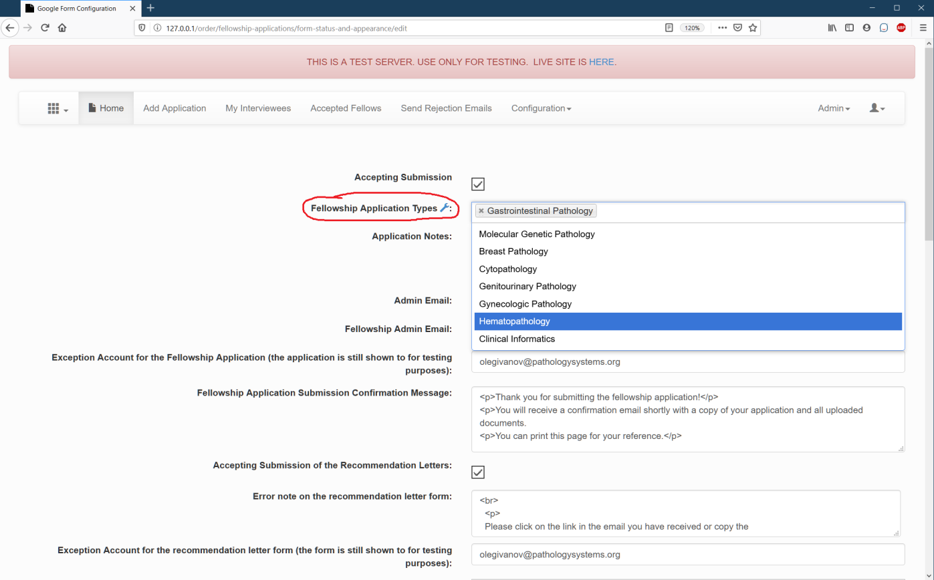

1. Click “Update Config File Locally”. This will update the configuration file locally. The current configuration file on the Google drive is shown below on this page.

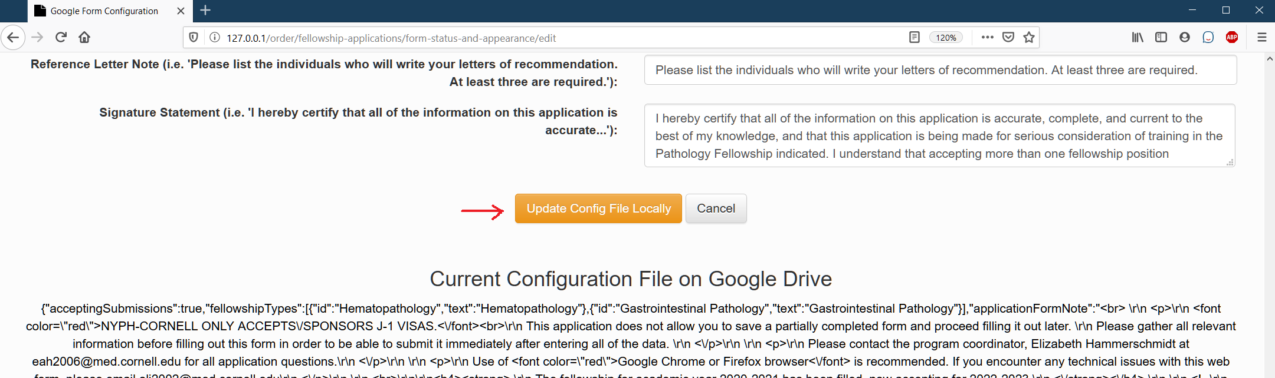

1. Sync the local configuration file with the configuration file on the Google drive by clicking the button “Update Fellowship Application Form on Google”.

