# Create Google Apps Script (GAS) on Google Weill Cornell Pathology Fellowship Application

To install the Google Apps Script, it is required to install open-source tool “clasp” https://developers.google.com/apps-script/guides/clasp

# Create GAS for the “Fellowship Application” online form (https://wcmc.pathologysystems.org/fellowship-application)

* Create new folder, for example “MyFellowshipApplication”
* Go to this folder and open the command line interface, for example “Power Shell”
* Login to your Google Account: *$ clasp login*

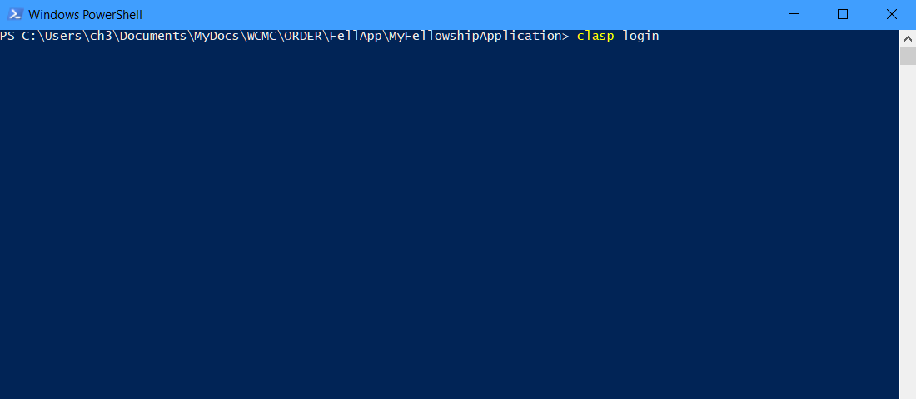

* Create a new Apps Script project: *$ clasp create --title “MyFellApp” --type webapp*
* A newly created webapp script can be opened by command: *$ clasp open*
* Copy all GAS files from “order-lab\orderflex\src\App\FellAppBundle\Util\GoogleForm\FellowshipApplication\script” to your working directory, except .clasp.json
* Push all files from local folder to Google Drive: *$ clasp push*
* Create new version: *$ clasp version*
* This command displays the newly created version number. Using that number, you can deploy instances of your project: *$ clasp deploy -V 1*
* Go to your project on the Google Script web page and set the permissions for the script: choose Code.gs and click Run. Review and Allow permissions.

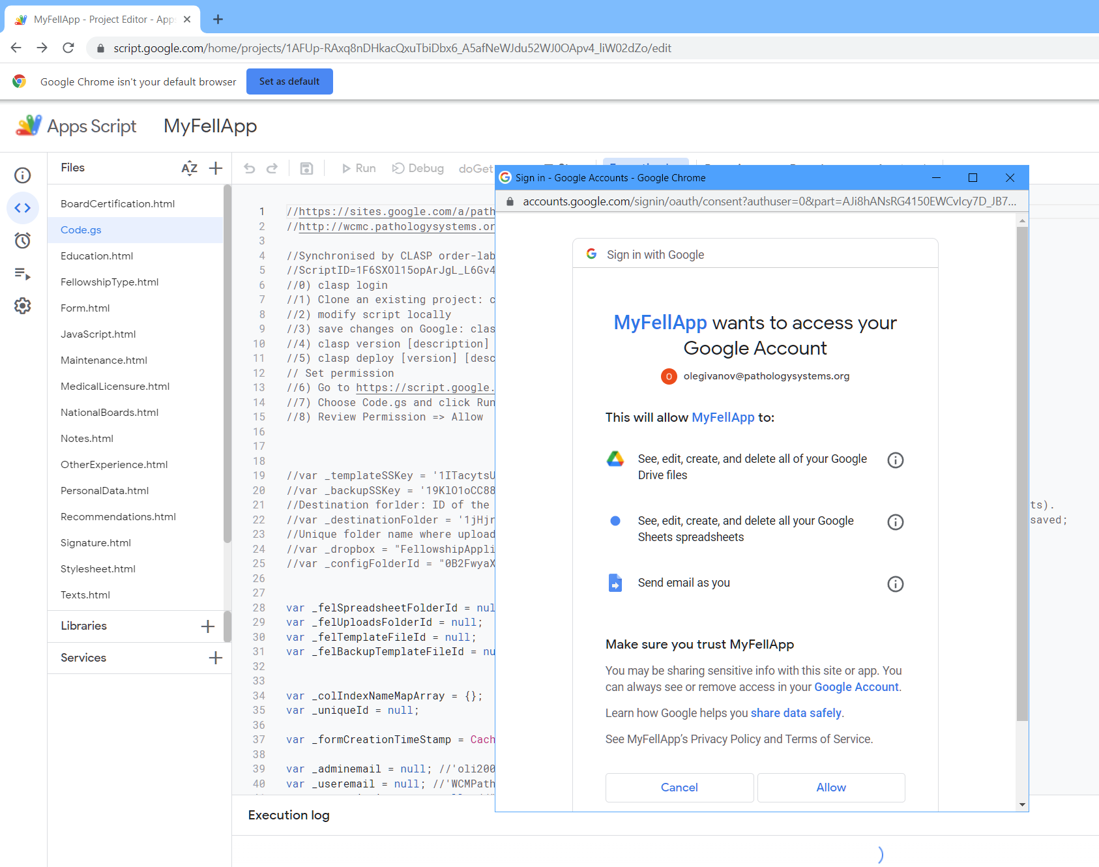

* Alternatively permission can be set by clicking ‘Deploy’ -> ‘Manage deployments’ -> click edit icon -> click ‘Deploy’ on the bottom -> click ‘Authorize access’ -> choose account -> click ‘Allow’

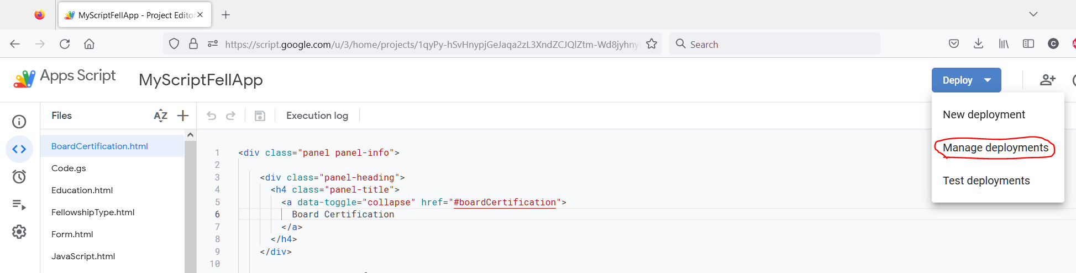

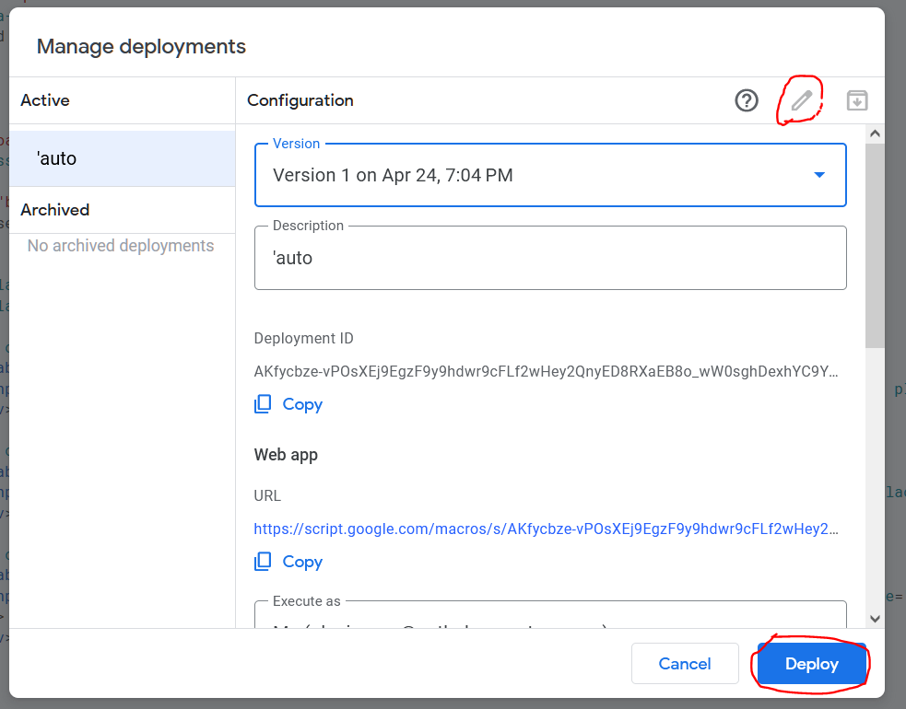

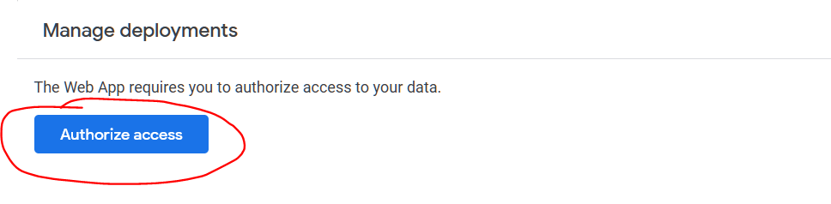

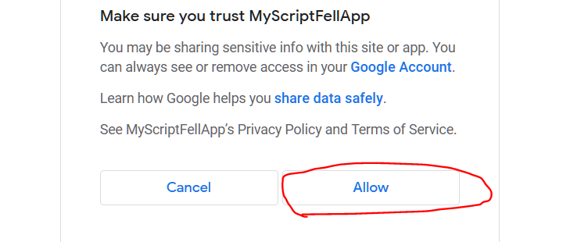

* Test the script by copying the web url and text this url in the new private web browser

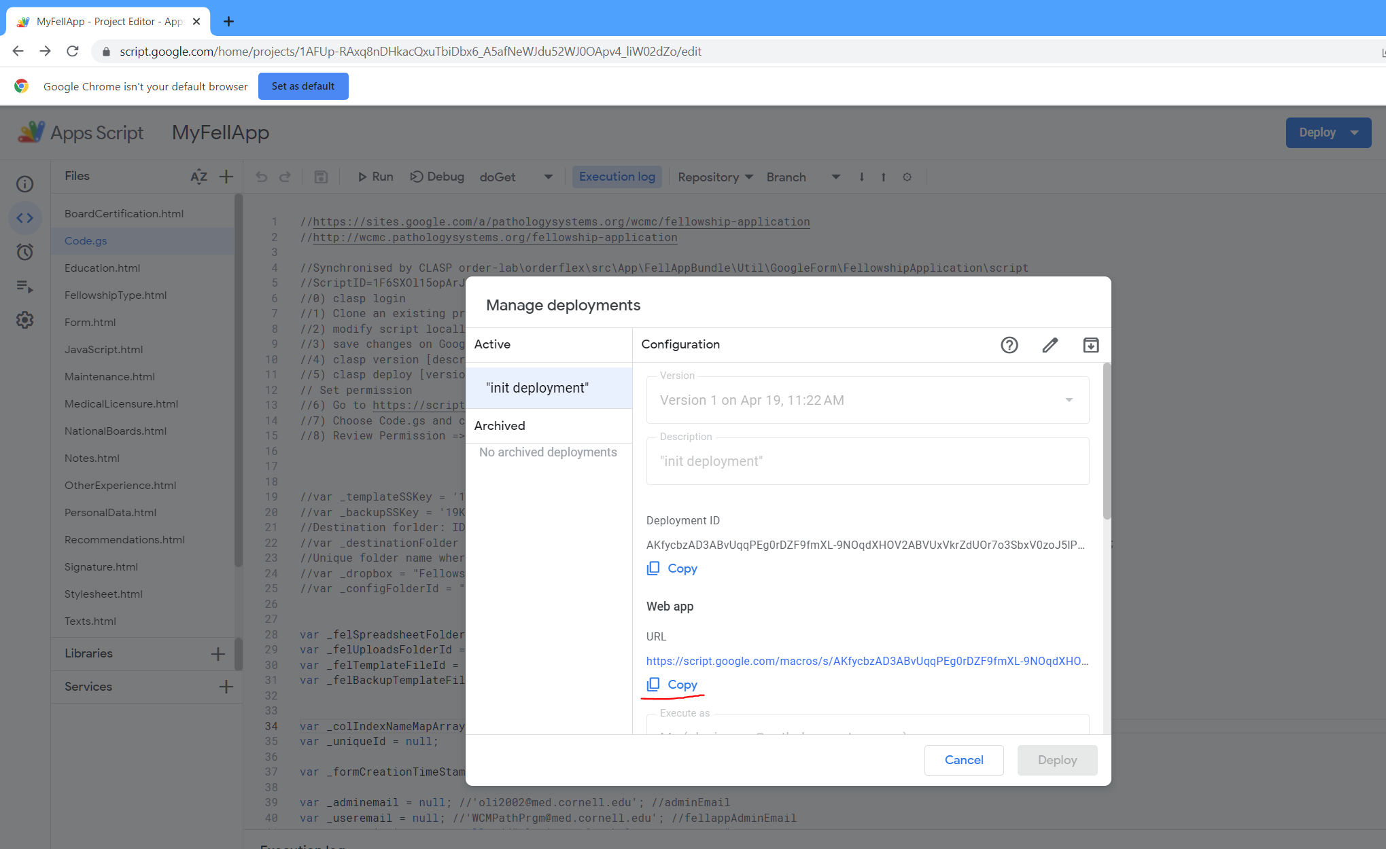

* You should see the submission form

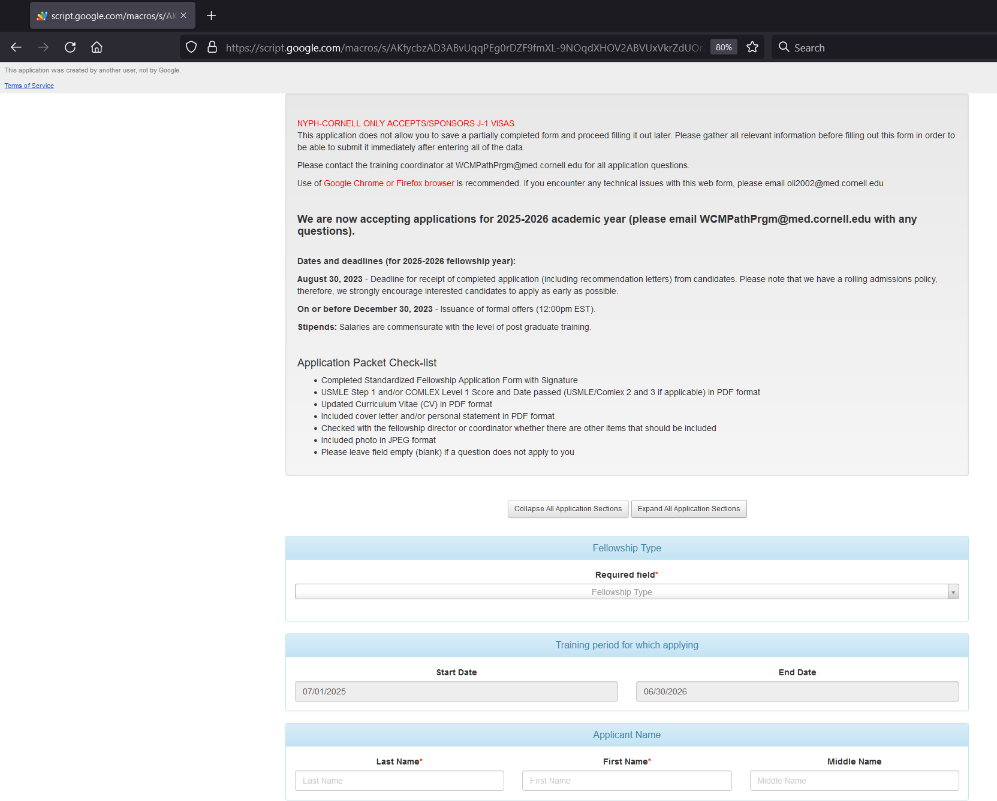

# Create GAS for the “Recommendation Letter” online form

Basically all the steps are the same as for the Fellowship Application script listed above in 1.1

* Create new folder, for example “MyFellowshipRecLetters”
* Go to this folder and open the command line interface, for example “Power Shell”
* Login to your Google Account: *$ clasp login*
* Create a new Apps Script project: *$ clasp create --title “MyRecLetter” --type webapp*
* A newly created webapp script can be opened by command: *$ clasp open*
* Copy all GAS files from “order-lab\orderflex\src\App\FellAppBundle\Util\GoogleForm\FellowshipRecLetters\script” to your working directory, except .clasp.json
* Push all files from local folder to Google Drive: *$ clasp push*
* Create new version: *$ clasp version*
* This command displays the newly created version number. Using that number, you can deploy instances of your project: *$ clasp deploy -V 1*
* Go to your project on the Google Script web page and set the permissions for the script: choose Code.gs and click Run. Review and Allow permissions.
* Test the script by copying the web url and text this url in the new private web browser
* You should see the submission form

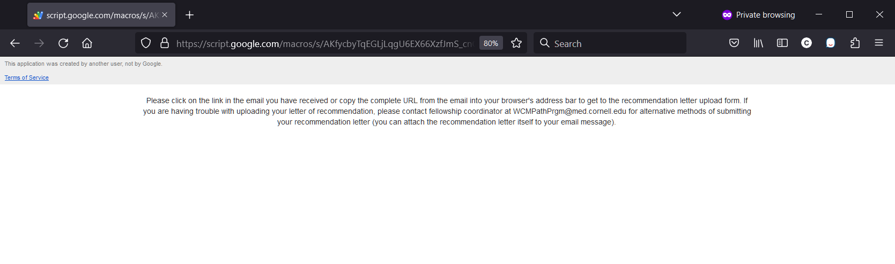

* You will see the warning message because Recommendation Letter submission form requires url’s parameters such as Reference-Letter-ID, Identification, Applicant-First-Name, Applicant-Last-Name, Applicant-E-Mail etc.

# Create Google Apps Script (GAS) on Google Weill Cornell Pathology Fellowship Application

Google replaced the Classic Sites with New Sites. Creating and editing in classic Sites are no longer supported. As of January 30, 2023: Editing of classic sites is turned off. You can migrate your Classic Sites for a smooth transition. If you don't migrate your Classic Sites, your classic sites will be automigrated to New Sites

# 2.1 Create web page for the Fellowship Application online form <http://wcmc.pathologysystems.org/fellowship-application>

* Create a new site: https://sites.google.com/new
* On a new site, in editing mode, click “Insert” -> “Embed” and paste the url from “Manage Deployment” on the Fellowship Application script.



* Adjust the width and height of the scrolling window
* The url of the new site will be something like <https://sites.google.com/d/1vBoh3G1i3nrevQIFjp7agCAPafxs79fP/p/1jl5ndj6ErlmD9bMYCTgxwgFoEW3M2XUG/edit>
* It is possible to set custom path on the “Pages” -> “Properties” tab on the left

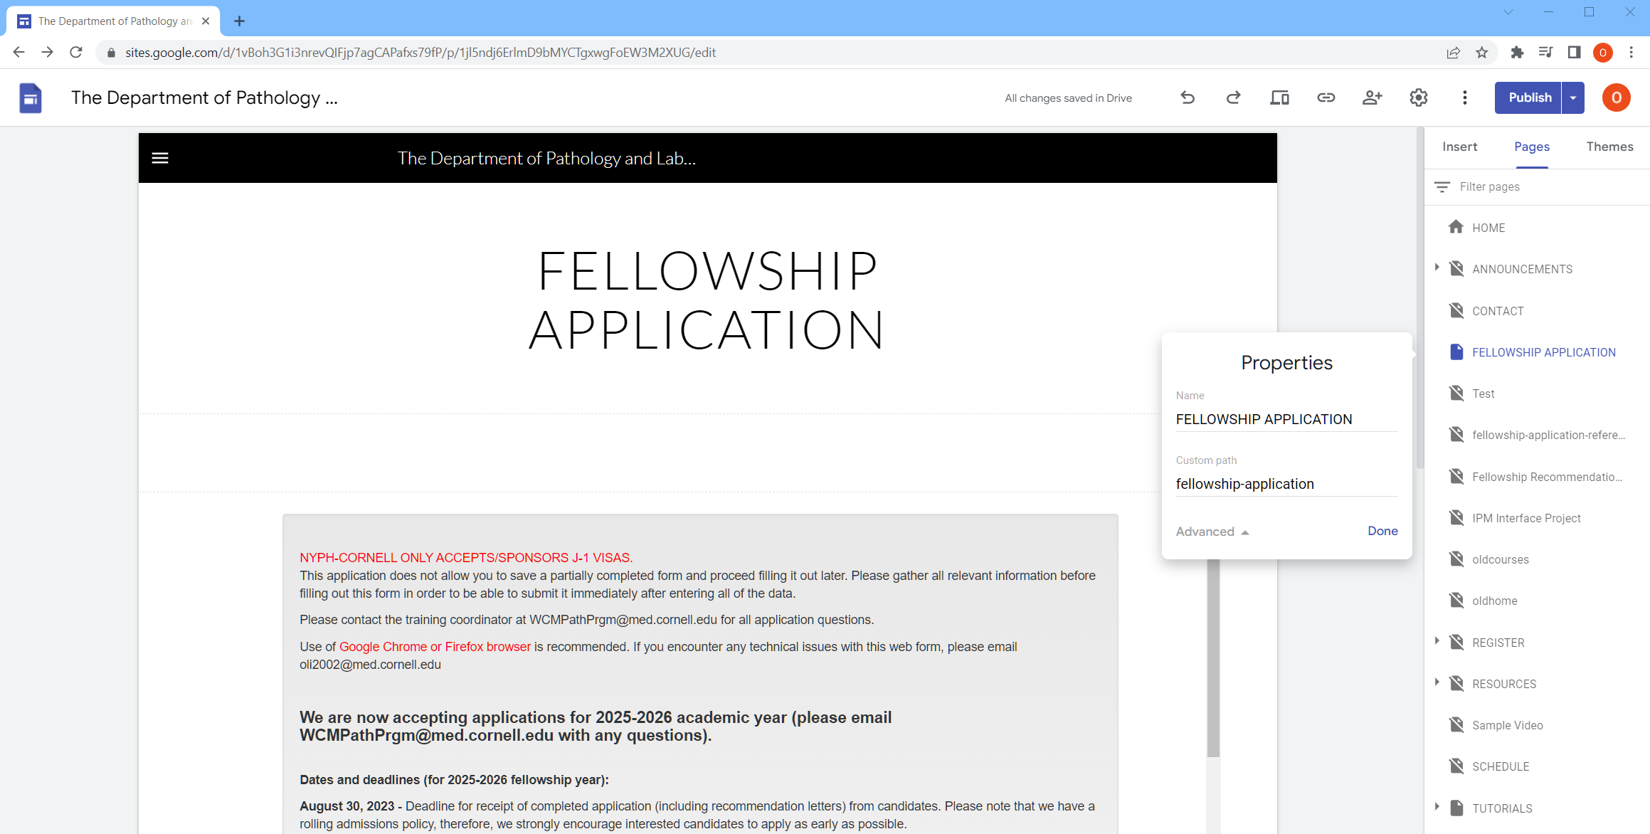

* Optionally, it is possible to embed the JS script showing something like “Please wait…” when the page is loading and the page is empty:

*<div id="welcome-note">Please wait for this page to load ...</div>*

*<script>*

*var delayInMilliseconds = 12000; //12000 milliseconds is 12 second*

*setTimeout(function() {*

*document.getElementById("welcome-note").remove();*

*}, delayInMilliseconds);*

*</script>*

# 2.2 Create web page for the Fellowship Recommendation Letter Submission online form

New Google site does not allow to pass the url’s parameters for the Recommendation Letter form to the embedded script. Therefore, we use the web link url directly from the “Manage deployments” on the Google script page.

* Open the Recommendation Letter script on the https://script.google.com/home
* Click on “Deploy” -> “Manage deployments”
* Copy the web URL and paste it to the field “Web app url from deployment GAS” on the Fellowship Site settings page as shown on the screenshots below
* This URL will be used by the Fellowship Applications system on the ORDER site with the applicant’s parameters and send by email to the referees provided on the fellowship application form.
* For example, if the URL is <https://script.google.com/macros/s/AKfycbyTqEGLjLqgU6EX66XzfJmS_cnQGBWYsiEcEq6jUKc8GKlagF8_U7s0Y9VJU0NziS8f/exec>

the full URL send by email will be:

[https://script.google.com/macros/s/AKfycbyTqEGLjLqgU6EX66XzfJmS_cnQGBWYsiEcEq6jUKc8GKlagF8_U7s0Y9VJU0NziS8f/exec?Reference-Letter-ID=abc1112233gdfgfdgfg1119&Identification=wcmpath&Applicant-First-Name=Test1&Applicant-Last-Name=Test2&Applicant-E-Mail=test@testemail.edu&Fellowship-Type=Gynecologic Pathology&Fellowship-Start-Date=07/01/2025&Fellowship-End-Date=06/30/2026&Reference-First-Name=Ref1&Reference-Last-Name=Ref2&Reference-Degree=MD&Reference-Title=Program director&Reference-Institution=&Reference-Phone=&Reference-EMail=refemail@testemail.edu](https://script.google.com/macros/s/AKfycbyTqEGLjLqgU6EX66XzfJmS_cnQGBWYsiEcEq6jUKc8GKlagF8_U7s0Y9VJU0NziS8f/exec?Reference-Letter-ID=abc1112233gdfgfdgfg1119&Identification=wcmpath&Applicant-First-Name=Test1&Applicant-Last-Name=Test2&Applicant-E-Mail=test@testemail.edu&Fellowship-Type=Gynecologic%20Pathology&Fellowship-Start-Date=07/01/2025&Fellowship-End-Date=06/30/2026&Reference-First-Name=Ref1&Reference-Last-Name=Ref2&Reference-Degree=MD&Reference-Title=Program%20director&Reference-Institution=&Reference-Phone=&Reference-EMail=refemail@testemail.edu)

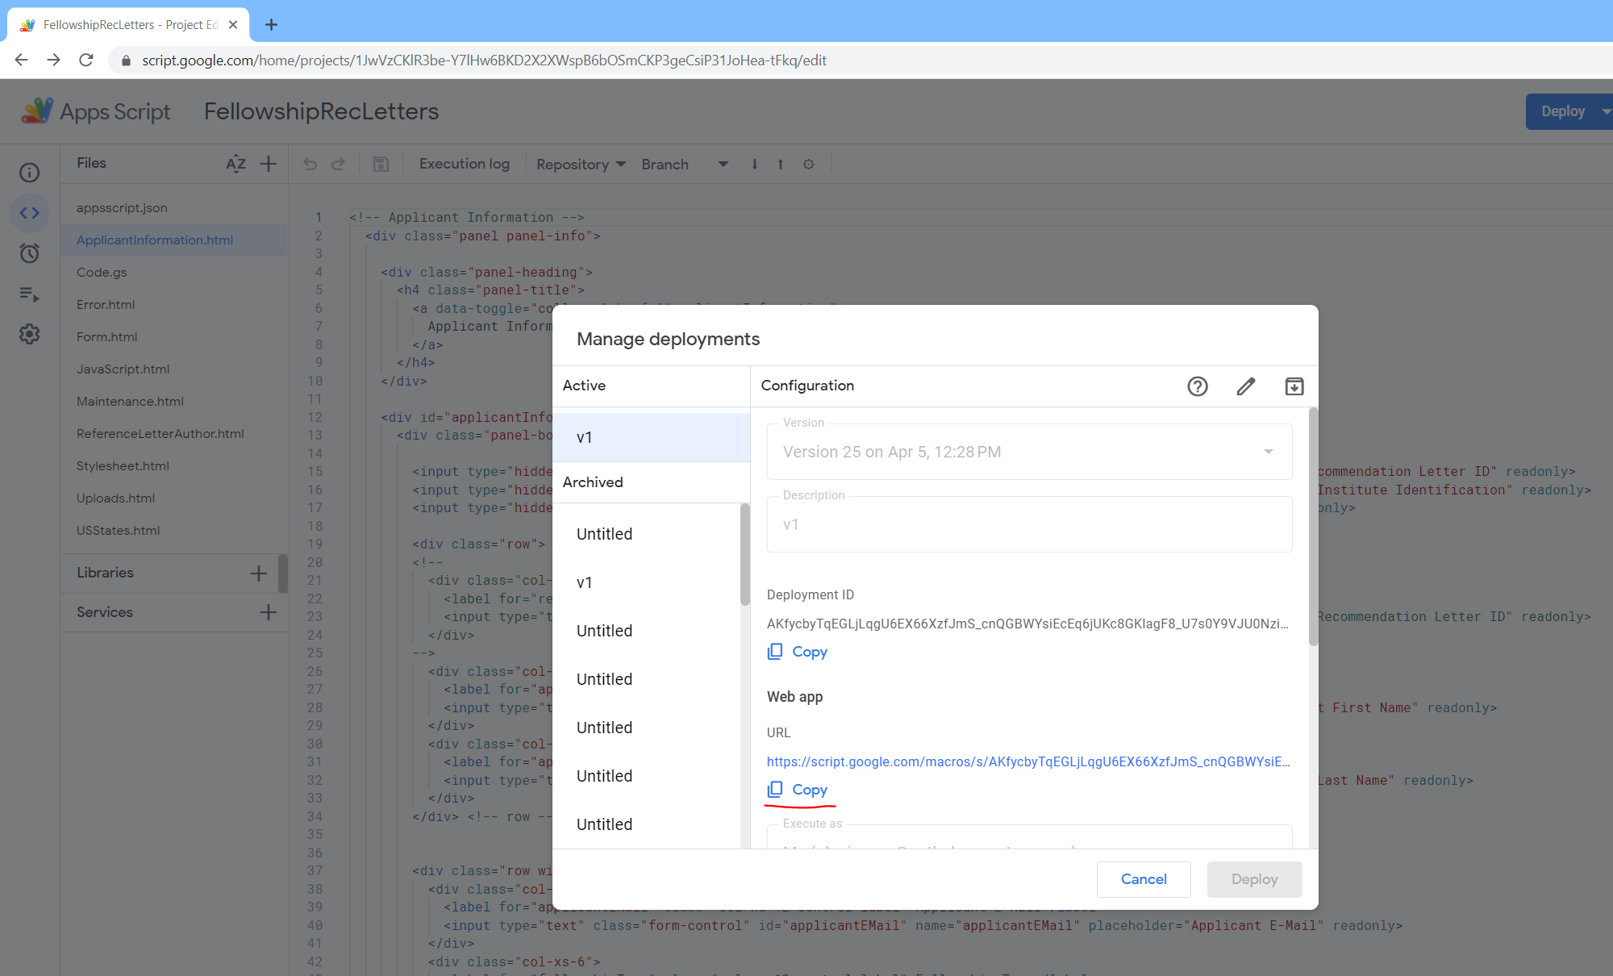

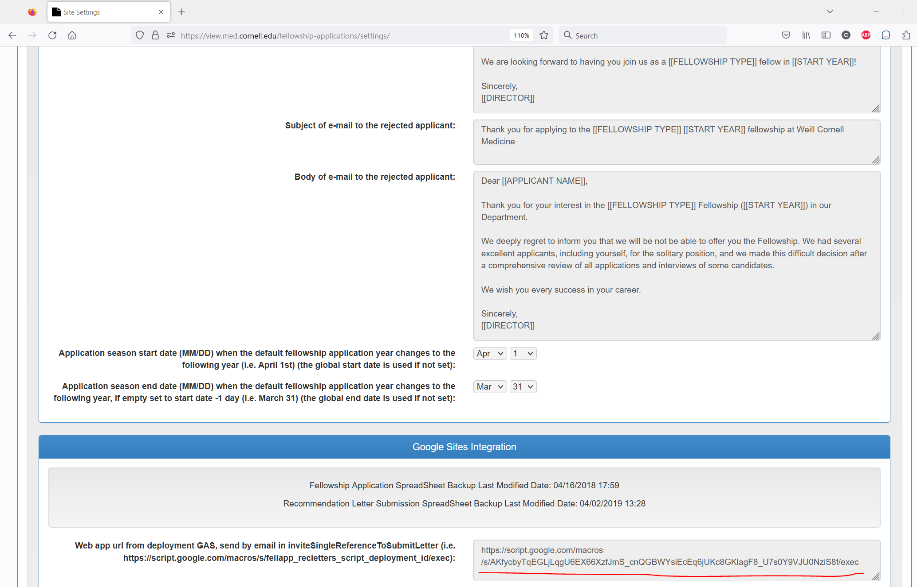

# Create folders in Google Drive to store application’s spreadsheets and uploaded files

All files are located here orderflex\src\App\FellAppBundle\Util\GoogleForm\FellowshipApplication and on orderflex\src\App\FellAppBundle\Util\GoogleForm\ FellowshipRecLetters

* On the Google Drive create folder “FellowshipApplication”
* Inside “FellowshipApplication” folder, create empty file “config-fellapp.json”
* Inside “FellowshipApplication” folder create two new folders to store responses from fellowship application and recommendation letter online forms
* For example, current structure is FellowshipApplication -> Responses -> FellowshipApplications and FellowshipApplication -> Responses -> RecommendationLetters
* Under each folder FellowshipApplications and RecommendationLetters create three new folders “Uploads”, “Spreadsheets” and “Templates”
* Copy two templates BackupSpreadsheet.xlsx and TemplateSpreadsheet.xlsx from the order-lab\orderflex\src\App\FellAppBundle\Util\GoogleForm\FellowshipApplication to the folder FellowshipApplications -> Templates
* Copy two templates BackupSpreadsheet.xlsx and TemplateSpreadsheet.xlsx from the order-lab\orderflex\src\App\FellAppBundle\Util\GoogleForm\ FellowshipRecLetters to the folder RecommendationLetters -> Templates

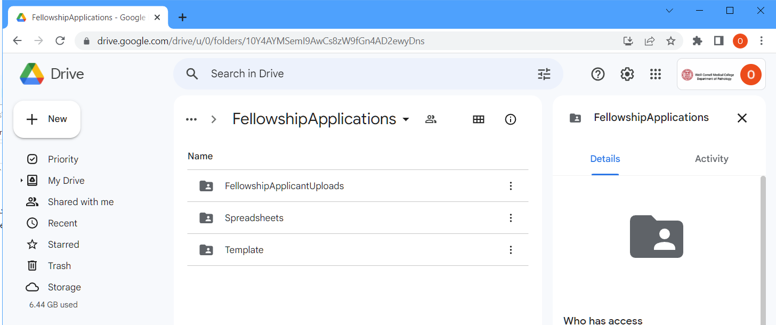

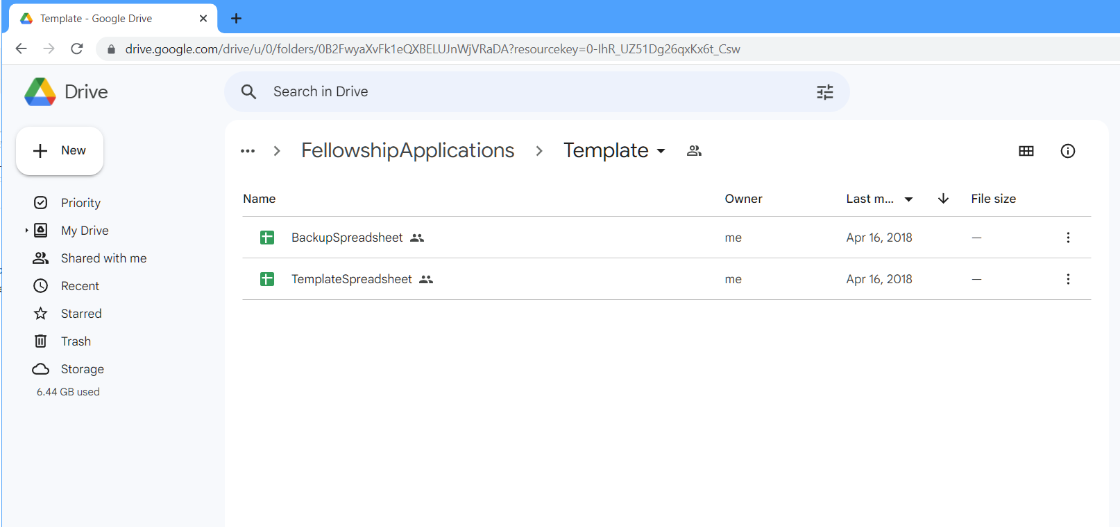

# Add IDs of the folders and files on the Google Drive to the Configuration page on the Fellowship Applications system on the ODRER

Go to <https://view.med.cornell.edu/fellowship-applications/form-status-and-appearance/edit>

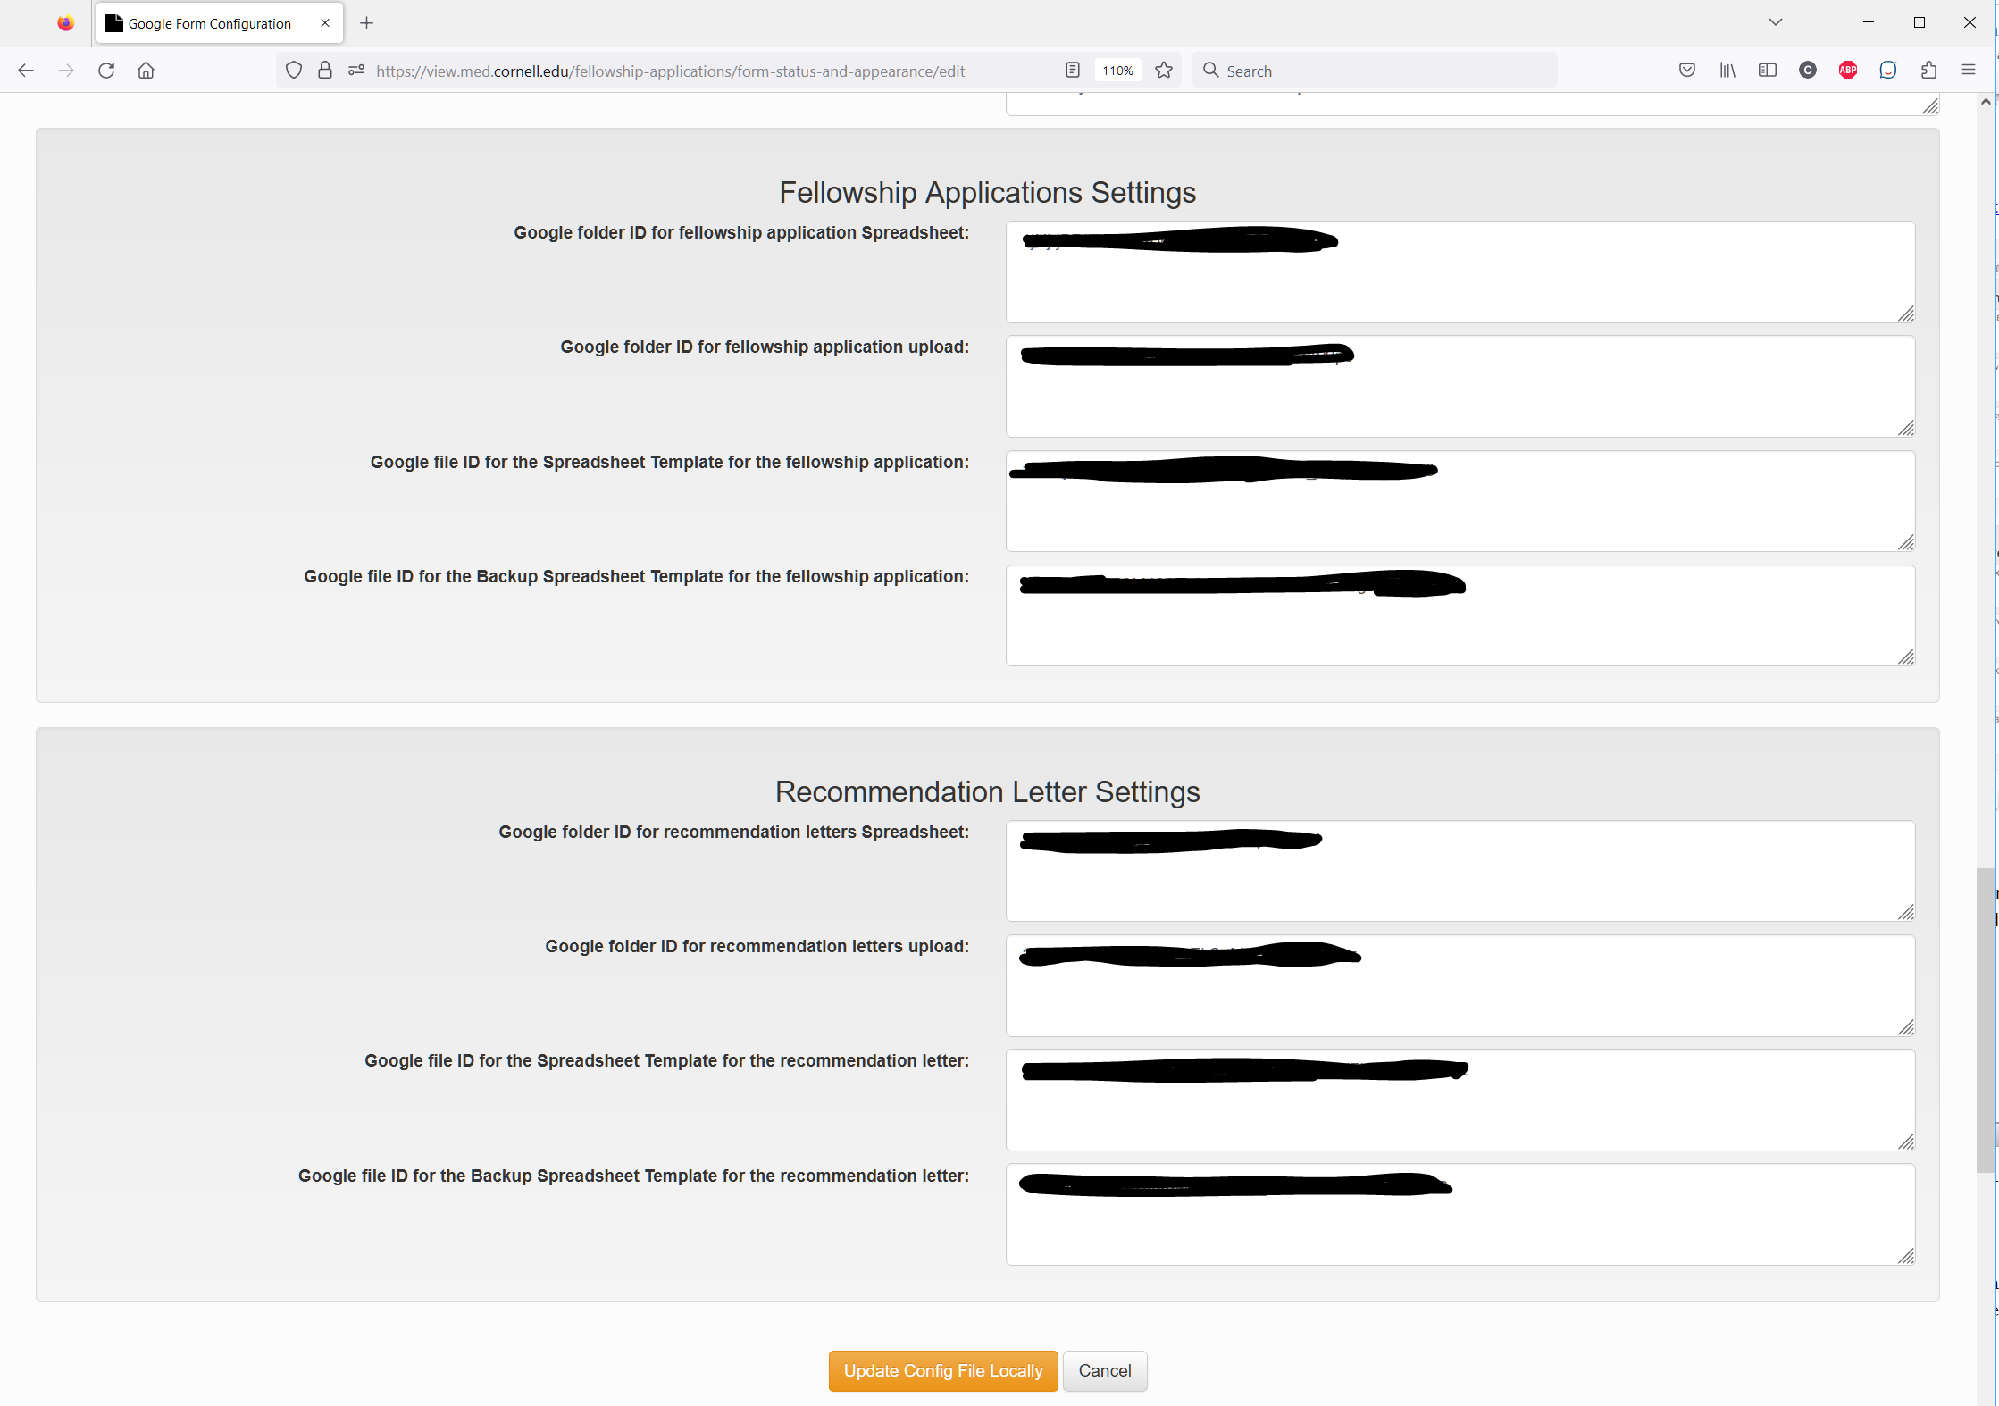

Fill out all IDs corresponding to the folders and file IDs from the Google Drive, click “Upload Config File Locally”. Only on the live server click on the “Update Fellowship Application Form on Google”. Those IDs will be passed to the config-fellapp.json.

The resulting Configure page will look like this

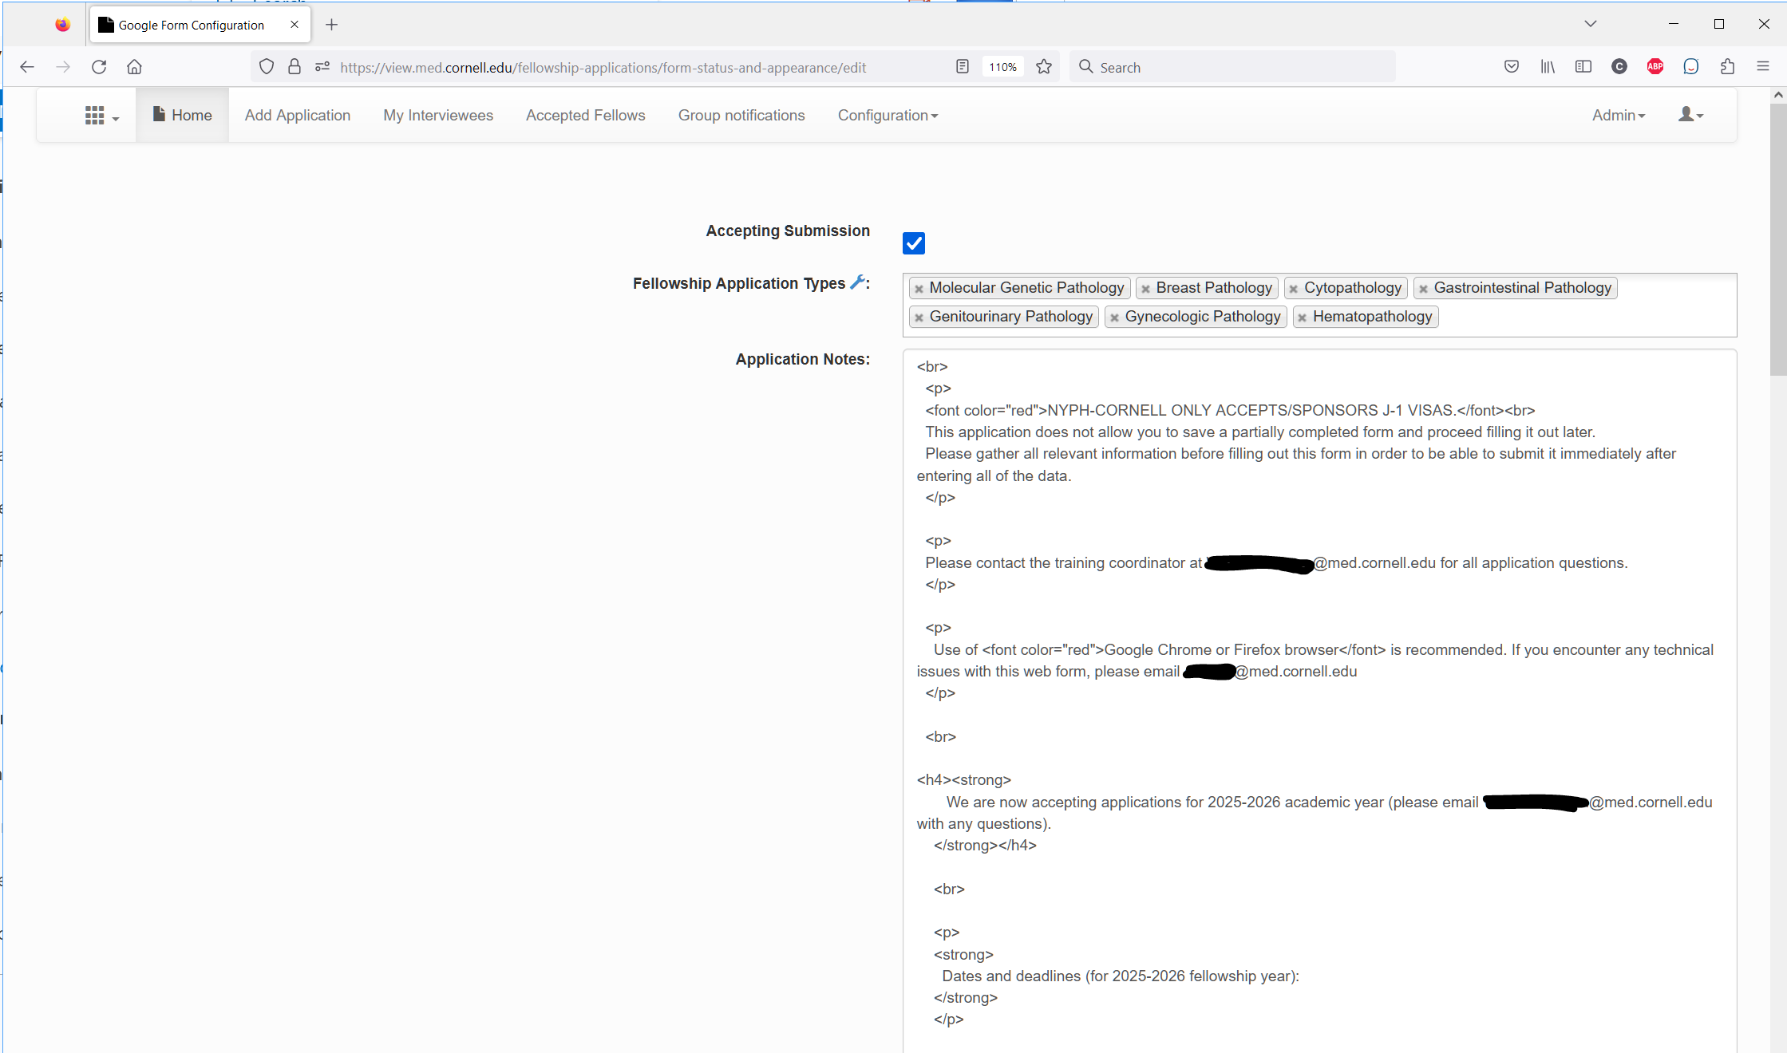

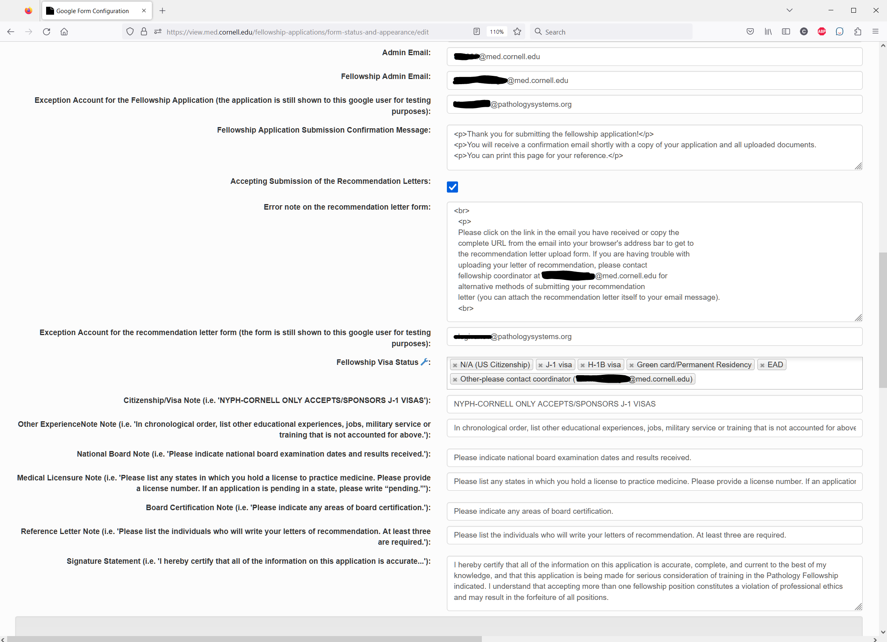



# Authentication by PHP to use Google API to download/upload files on the Google Drive

* Go to <https://console.cloud.google.com/welcome>
* Create new project or choose from the existing projects
* The existing project will look like this <https://console.cloud.google.com/apis/credentials?project=quickstart-1563304352237>

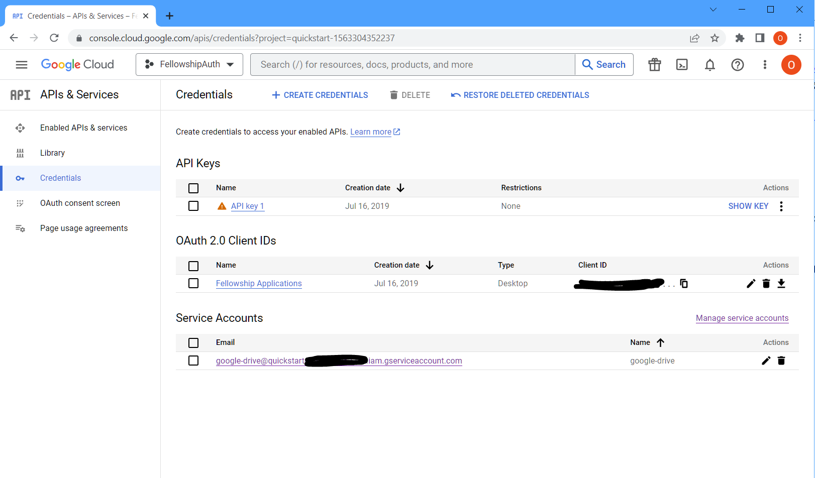

* Click “Create Credentials” and choose “Service Account”
* Follow the steps and create JSON credentials file
* Share Google Drive’s folder (for example, “FellowshipApplication” folder created in section 3) containing the Fellowship Application files to the service account client from the generated JSON credentials file. This user is specified in JSON with the key ‘client_x509_cert_url’
* Update the Fellowship Site Settings’ field “Full path to the credential authentication JSON file for Google” on the <https://view.med.cornell.edu/fellowship-applications/settings/> with the full path to the credentials JSON file as shown below
* Update the field “Google Drive API URL” with the scopes https://www.googleapis.com/auth/drive <https://spreadsheets.google.com/feeds> as shown below

