# Create Weill Cornell Pathology Fellowship Application

# Create Apps Script

* + 1. <https://script.google.com/home>
    2. Click on “CREATE APPS SCRIPT”

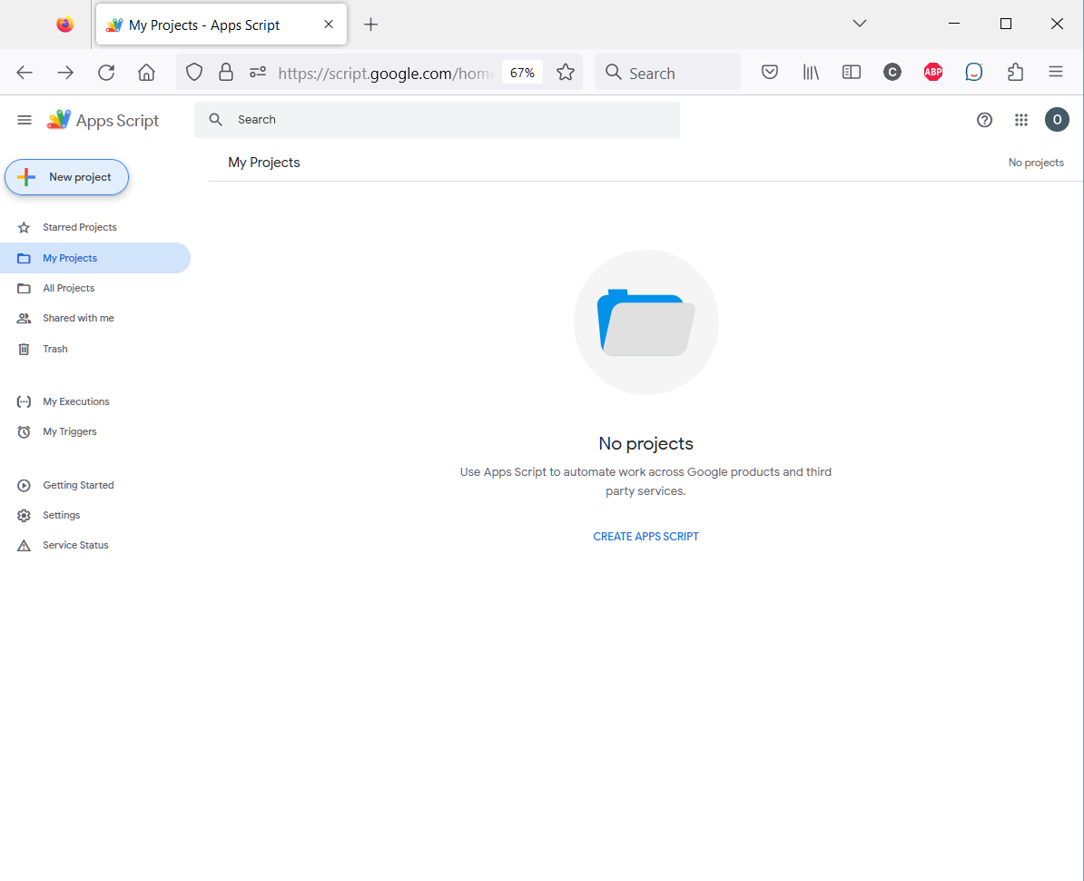

* + 1. Copy all files from existing script “ApplicationWithUploadNew”. These files can be copied from orderflex\src\App\FellAppBundle\Util\GoogleForm\FellowshipApplication
    2. This script is stored in the Google Drive

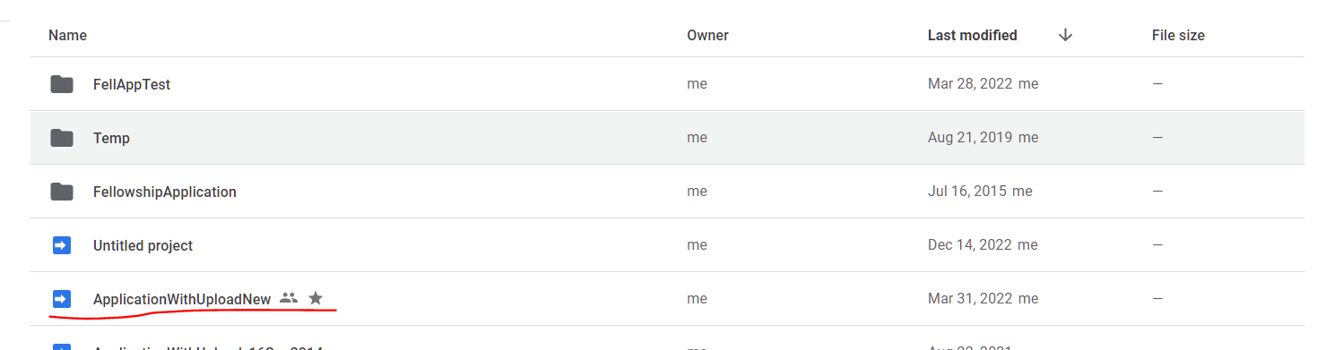

# Create folders in Google Drive to store application’s spreadsheets and uploaded files

All files are located here orderflex\src\App\FellAppBundle\Util\GoogleForm\FellowshipApplication

* + 1. Create folder “FellowshipApplication”
    2. In “FellowshipApplication” folder, create empty file “config.json”
    3. In “FellowshipApplication” folder, create new folder “Responses”
    4. In “Responses” folder, create new folders:

FellowshipApplicantUploads

RecommendationLetters

Spreadsheets

Template

* + 1. In “Template” folder, create new files:

BackupSpreadsheet – copy/paste from orderflex\src\App\FellAppBundle\Util\GoogleForm\FellowshipApplication\ BackupSpreadsheet.xlsx

TemplateSpreadsheet - copy/paste from orderflex\src\App\FellAppBundle\Util\GoogleForm\FellowshipApplication\ TemplateSpreadsheet.xlsx

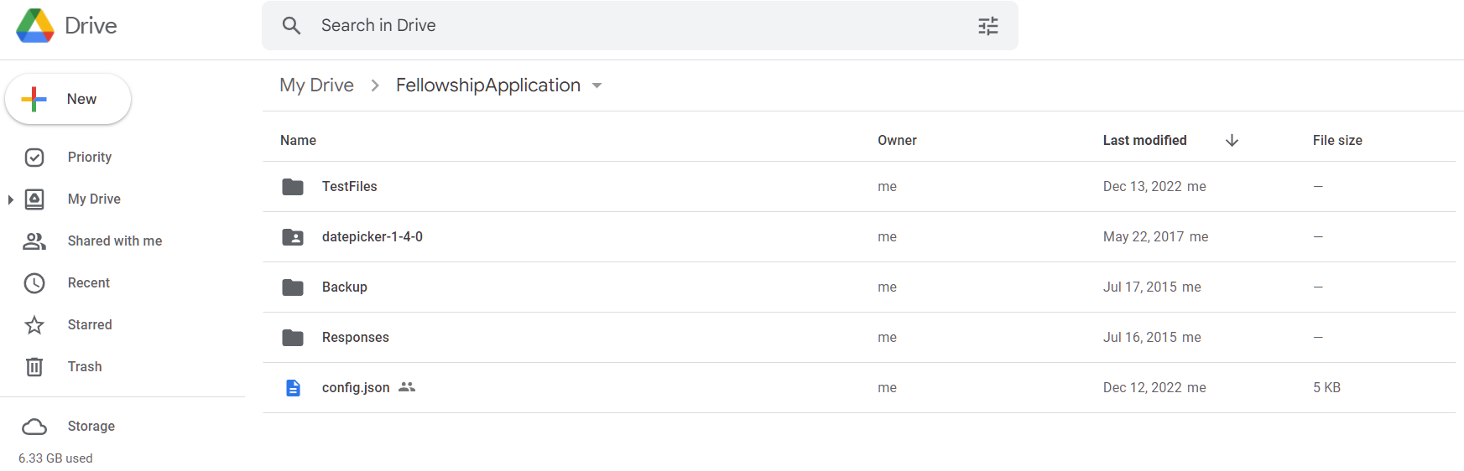

# Create folders in Google Drive to store application’s spreadsheets and uploaded files for the Fellowship Recommendation Letter Submission

All files are located here orderflex\src\App\FellAppBundle\Util\GoogleForm\FellowshipRecommendationLetters

1. Create folder “FellowshipApplication” (the same as in 1.1)
2. In “FellowshipApplication” folder, create empty file “config.json” (the same as in 1.2)
3. In “FellowshipApplication” folder, create new folder “Responses” (the same as in 1.3)
4. In “Responses” folder, create new folders:

RecommendationLetters (the same as in 1.4)

1. In “RecommendationLetters” folder, create new folders:

“RecommendationLetterUploads”

“Template”

“Spreadsheets”

1. In “Template” folder, create new files:

BackupSpreadsheet – copy/paste from orderflex\src\App\FellAppBundle\Util\GoogleForm\ \FellowshipRecommendationLetters\BackupSpreadsheet.xlsx

TemplateSpreadsheet - copy/paste from orderflex\src\App\FellAppBundle\Util\GoogleForm\ \FellowshipRecommendationLetters\TemplateSpreadsheet.xlsx

# Adding IDs to the script ApplicationWithUploadNew

1. Assign folder id of the BackupSpreadsheet to _backupSSKey
2. Assign folder id of the TemplateSpreadsheet to _templateSSKey
3. Assign folder id of the Spreadsheets to _destinationFolder
4. Assign folder name “FellowshipApplicantUploads” to _dropbox
5. Assign folder id of the “FellowshipApplicantUploads” to _configFolderId

# Assign folder IDs to the Fellowship’s Site Settings

1. Google Drive Folder ID where config file is located (field configFileFolderIdFellApp)
2. Backup Google Spreadsheet ID (field backupFileIdFellApp)

# Create web page <http://wcmc.pathologysystems.org/fellowship-application>

Create a new google site on <https://sites.google.com/site>.

Creating and editing in classic Sites are no longer supported.

https://apps.google.com/supportwidget/articlehome?article_url=https%3A%2F%2Fsupport.google.com%2Fa%2Fanswer%2F9958187&assistant_id=generic-unu&product_context=9958187&product_name=UnuFlow&trigger_context=a

* As of January 30, 2023: Editing of classic sites is turned off. You can migrate your Classic Sites for a smooth transition. If you don't migrate your Classic Sites, your classic sites will be automigrated to New Sites.

Create new site: <https://sites.google.com/new?tgif=d>

Click embed and paste the url from “Manage Deployemnt” on ApplicationWithUploadNew script.

# Create web page <http://wcmc.pathologysystems.org/fellowship-application-reference-letter-upload>