Controller Pro
BETA
(Taking suggestions for a better name!)

Adds four independent ports that turn an original NES, SNES, or N64 controller into a standard USB joystick

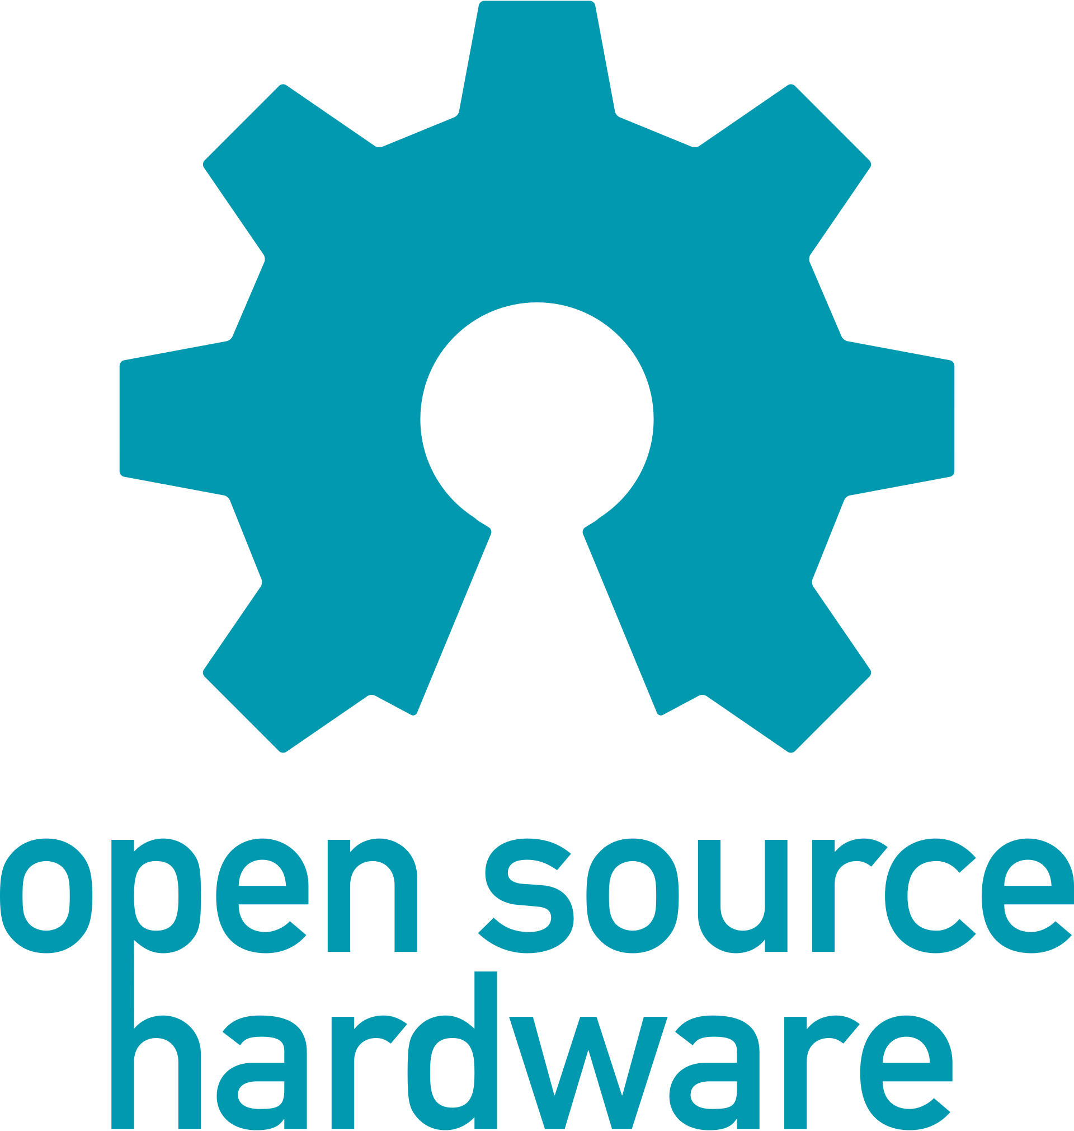
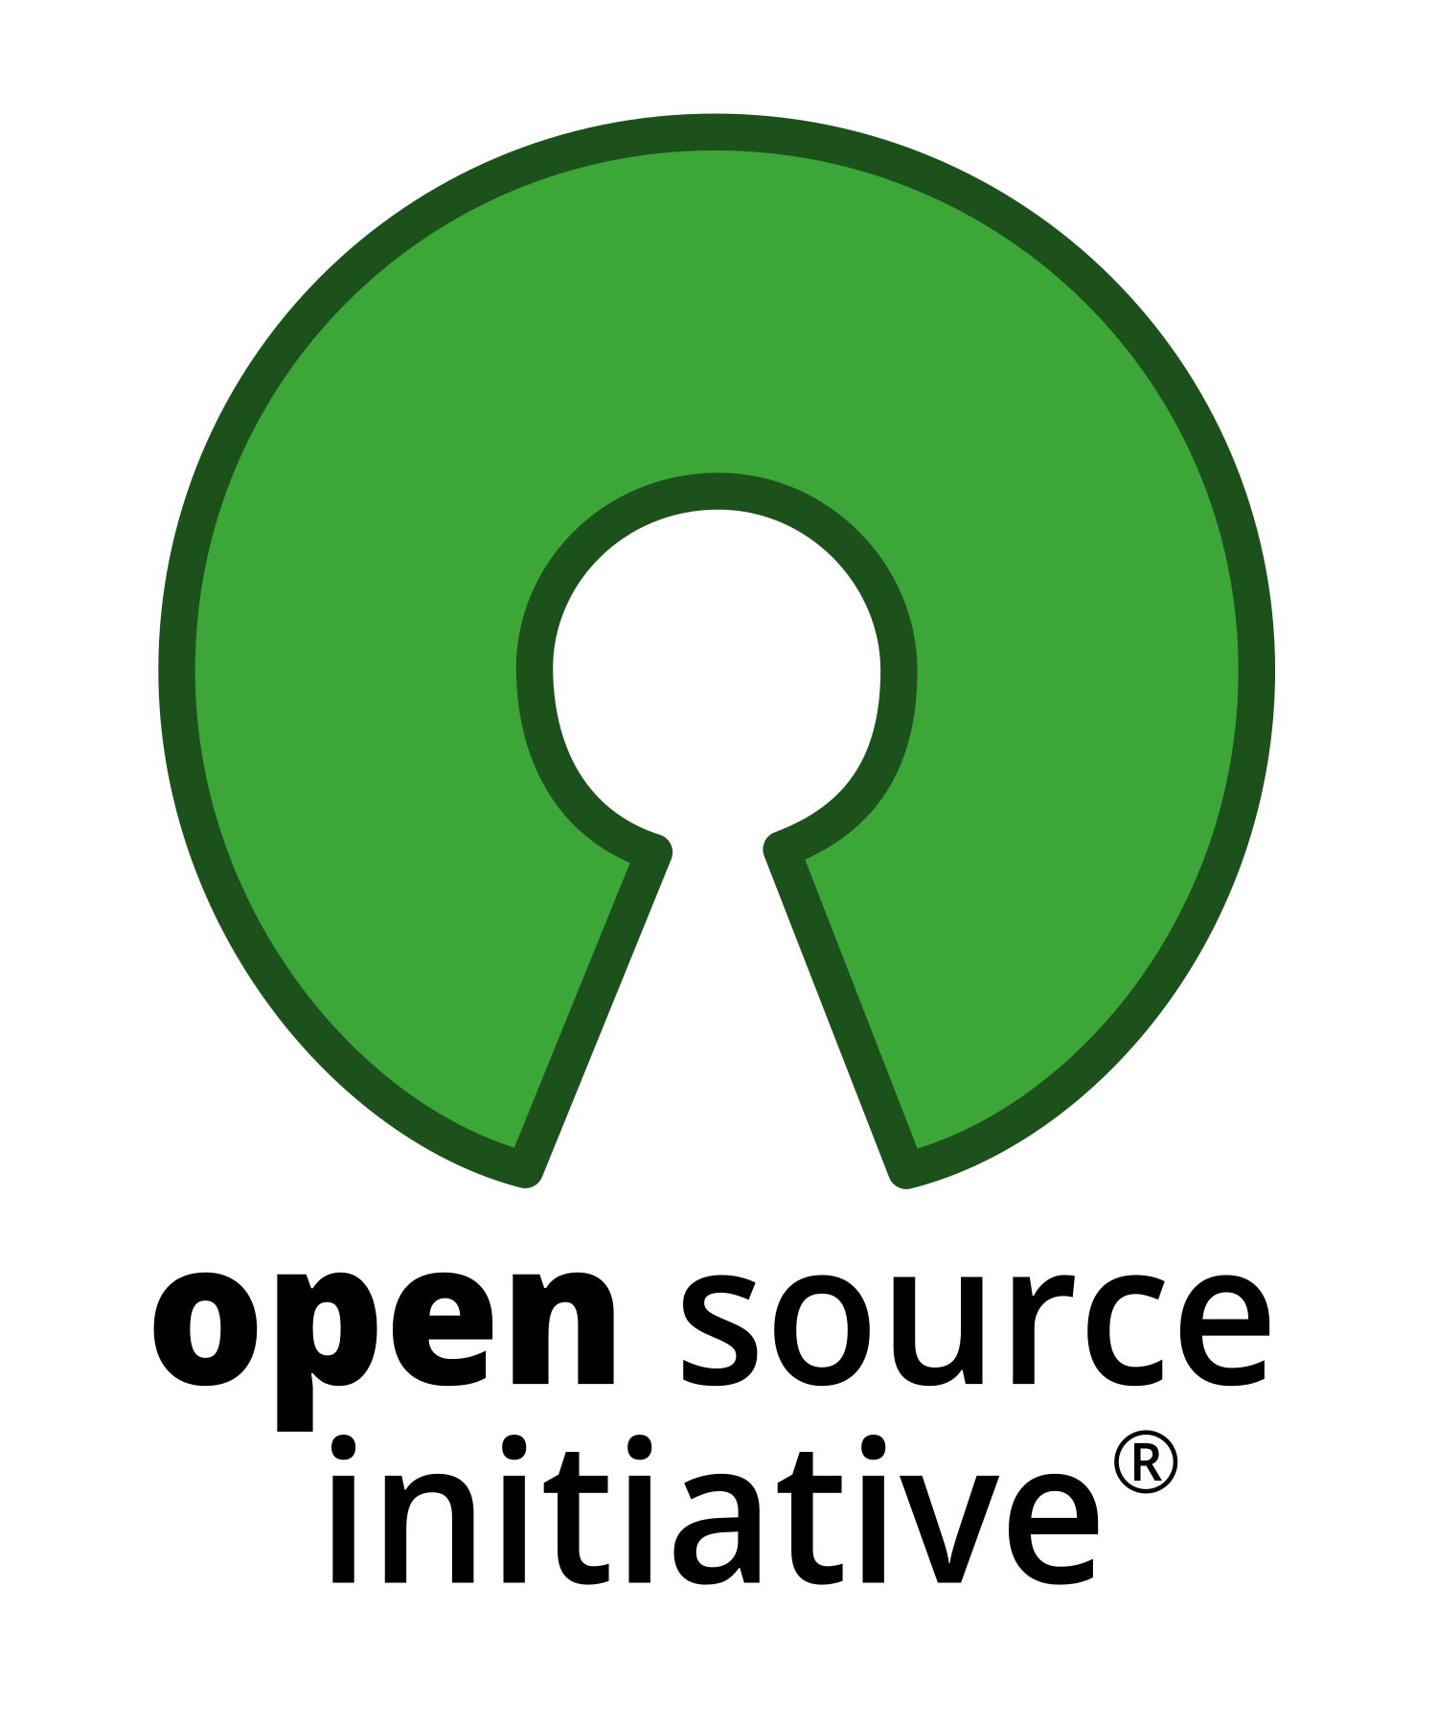
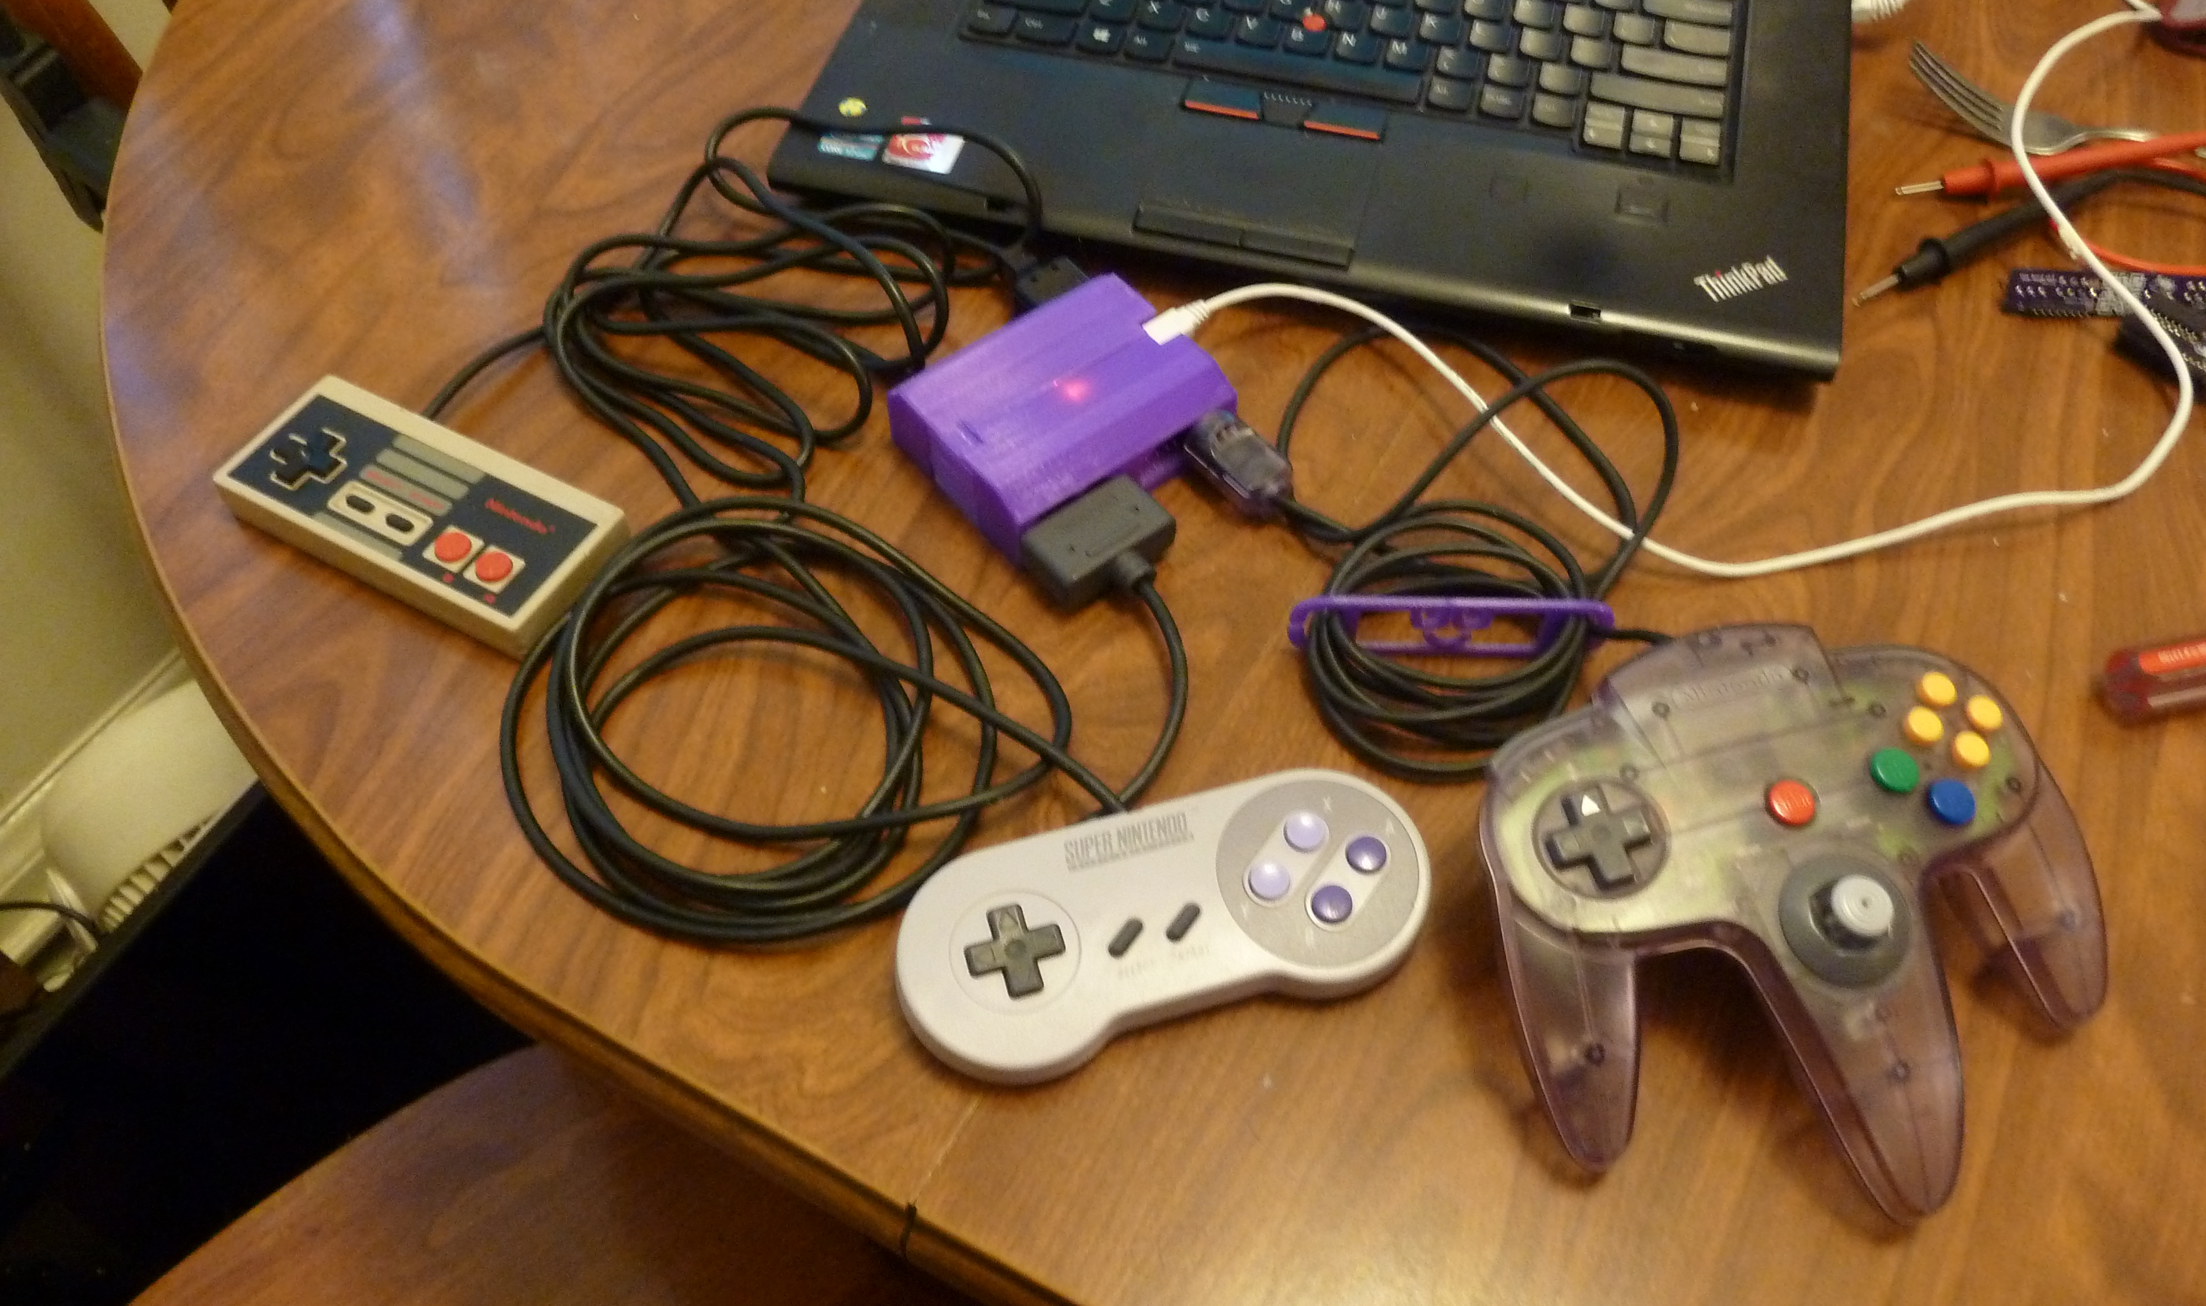
Use your original Nintendo® controller hardware on your computer or Switch® without chopping them up or juggling a separate dongle for each controller!

Entirely open-source, available here as a solder-it-yourself kit (only basic soldering skills required), or on order as an assembled unit. If you’re just curious, get on the mailing list and I’ll let you know when new versions are out.
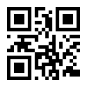5of0.co/ctlpro

Current kits are for beta testing, and are sold at-cost. Feedback appreciated!

