**DSAA 5002 - Data Mining and Knowledge Discovery in Data Science**

(Fall Semester 2023)

**Homework 1 Solution**

**Q1:**

Step 1: Scan the transaction database, generate the candidate 1-itemset , and calculate the support of each itemset.

|  |  |
| --- | --- |
| **Itemset** | **Support Count** |
| {A} | 3 |
| {B} | 3 |
| {C} | 4 |
| {D} | 1 |
| {E} | 4 |

Step 2: Determine the frequent 1-itemset .

|  |  |
| --- | --- |
| **Itemset** | **Support Count** |
| {A} | 3 |
| {B} | 3 |
| {C} | 4 |
| {E} | 4 |

Step 3: Generate the candidate 2-itemset , = *.

|  |
| --- |
| **Itemset** |
| {A,B} |
| {A,C} |
| {A,E} |
| {B,C} |
| {B,E} |
| {C,E} |

Step 4: Scan the transaction database and calculate the support of each itemset.

|  |  |
| --- | --- |
| **Itemset** | **Support Count** |
| {A,B} | 1 |
| {A,C} | 3 |
| {A,E} | 2 |
| {B,C} | 2 |
| {B,E} | 3 |
| {C,E} | 3 |

Step 5: Determine the frequent 2-itemset .

|  |  |
| --- | --- |
| **Itemset** | **Support Count** |
| {A,C} | 3 |
| {A,E} | 2 |
| {B,C} | 2 |
| {B,E} | 3 |
| {C,E} | 3 |

Step 6: Generate the candidate 3-itemset , = *. Prun on Apriori principle.

Apriori principle: If an itemset is frequent, then all of its subsets must also be frequent.

Apriori pruning principle: If there is any itemset which is infrequent, its superset should not be generated/tested.

|  |  |  |  |  |
| --- | --- | --- | --- | --- |
| **Itemset** | 2-item subset | 2-item subset | 2-item subset | Prunned |
| {A,C,E} | {A,C} | {A,E} | {C,E} | √ |
| {A,B,C} | ~~{A,B}~~ | {A,C} | {B,C} | × |
| {A,B,E} | ~~{A,B}~~ | {A,E} | {B,E} | × |
| {B,C,E} | {B,C} | {B,E} | {C,E} | √ |

{A,B} item subset is not belong to , so {A,B,C} and {A,B,E} are prunned.

Prunned

|  |
| --- |
| **Itemset** |
| {A,C,E} |
| {B,C,E} |

Step 7: Scan the transaction database and calculate the support of each itemset.

|  |  |
| --- | --- |
| **Itemset** | **Support Count** |
| {A,C,E} | 2 |
| {B,C,E} | 2 |

Step 8: Determine the frequent 3-itemset .

|  |  |
| --- | --- |
| **Itemset** | **Support Count** |
| {A,C,E} | 2 |
| {B,C,E} | 2 |

Step 9: Generate the candidate 4-itemset , = *.

|  |  |  |  |  |  |
| --- | --- | --- | --- | --- | --- |
| **Itemset** | 3-item subset | 3-item subset | 3-item subset | 3-item subset | Prunned |
| {A,B,C,E} | ~~{A,B,C}~~ | ~~{A,B,E}~~ | {B,C,E} | {A,C,E} | × |

{A,B,C} and {A,B,E} item subsets are not belong to , so {A,B,C,E} is prunned.

Prunned

Step 10: Generate the association rules from frequent itemsets and calculate confidence levels.

confidence(S->(I-S)) = support(I)/support(S)

For the 2-Itemset

|  |  |  |  |  |  |  |
| --- | --- | --- | --- | --- | --- | --- |
| **Frequent**  **Itemset** | Subset | Association rules | Support(I) | Support(S) | Confidence | Confidence(%) |
| {A,C} | {A} | {A}->{C} | 3 | 3 | 3/3 | 100% |
|  | {C} | {C}->{A} | 3 | 4 | 3/4 | 75% |
| {A,E} | {A} | {A}->{E} | 2 | 3 | 2/3 | 66.66% |
|  | {E} | ~~{E}->{A}~~ | 2 | 4 | 2/4 | 50% |
| {B,C} | {B} | {B}->{C} | 2 | 3 | 2/3 | 66.66% |
|  | {C} | ~~{C}->{B}~~ | 2 | 4 | 2/4 | 50% |
| {B,E} | {B} | {B}->{E} | 3 | 3 | 3/3 | 100% |
|  | {E} | {E}->{B} | 3 | 4 | 3/4 | 75% |
| {C,E} | {C} | {C}->{E} | 3 | 4 | 3/4 | 75% |
|  | {E} | {E}->{C} | 3 | 4 | 3/4 | 75% |

Given the minimum confidence level to 60%, so the final association rules:

Rule1: {A}->{C}

Rule2: {C}->{A}

Rule3: {A}->{E}

Rule4: {B}->{C}

Rule5: {B}->{E}

Rule6: {E}->{B}

Rule7: {C}->{E}

Rule8: {E}->{C}

For the 3-Itemset

|  |  |  |  |  |  |  |
| --- | --- | --- | --- | --- | --- | --- |
| **Frequent**  **Itemset** | Subset | Association rules | Support(I) | Support(S) | Confidence | Confidence(%) |
| {A,C,E} | {A} | {A}->{C,E} | 2 | 3 | 2/3 | 66.66% |
|  | {C} | ~~{C}~~~~->{A,E}~~ | 2 | 4 | 2/4 | 50% |
|  | {E} | ~~{E}->{A,C}~~ | 2 | 4 | 2/4 | 50% |
|  | {A,C} | {A,C}->{E} | 2 | 3 | 2/3 | 66.66% |
|  | {A,E} | {A,E}->{C} | 2 | 2 | 2/2 | 100% |
|  | {C,E} | {C,E}->{A} | 2 | 3 | 2/3 | 66.66% |
| {B,C,E} | {B} | {B}->{C,E} | 2 | 3 | 2/3 | 66.66% |
|  | {C} | ~~{C}->{B,E}~~ | 2 | 4 | 2/4 | 50% |
|  | {E} | ~~{E}->{B,C}~~ | 2 | 4 | 2/4 | 50% |
|  | {B,C} | {B,C}->{E} | 2 | 3 | 2/3 | 66.66% |
|  | {B,E} | {B,E}->{C} | 2 | 2 | 2/2 | 100% |
|  | {C,E} | {C,E}->{B} | 2 | 3 | 2/3 | 66.66% |

Given the minimum confidence level to 60%, so the final association rules:

Rule1: {A}->{C,E}

Rule2: {A,C}->{E}

Rule3: {A,E}->{C}

Rule4: {C,E}->{A}

Rule5: {B}->{C,E}

Rule6: {B,C}->{E}

Rule7: {B,E}->{C}

Rule8: {C,E}->{B}

**Q2:**

Step 1: Scan the transaction database, generate the candidate 1-itemset , and calculate the support of each itemset.

|  |  |
| --- | --- |
| **Itemset** | **Support Count** |
| {A} | 2 |
| {B} | 4 |
| {C} | 1 |
| {D} | 2 |
| {E} | 3 |

Step 2: Determine the frequent 1-itemset .

|  |  |
| --- | --- |
| **Itemset** | **Support Count** |
| {A} | 2 |
| {B} | 4 |
| {D} | 2 |
| {E} | 3 |

Step 3: Find all 2-itemset of each transaction.

|  |  |  |
| --- | --- | --- |
| **TID** | **Item** | 2-itemset |
| T1 | A,B,C | {A,B},{A,C},{B,C} |
| T2 | B,D,E | {B,D},{B,E},{D,E} |
| T3 | A,B,D,E | {A,B},{A,D},{A,E},{B,D},{B,E},{D,E} |
| T4 | B,E | {B,E} |

Step 4: Map the 2-itemset of transactions into the hash table

Items = A, B, C, D, E

Order = 1, 2, 3, 4, 5

Hash function bucket #= h({x y}) = ((order of x)*10+(order of y)) % 7

|  |  |  |  |  |  |  |  |
| --- | --- | --- | --- | --- | --- | --- | --- |
|  |  |  |  | {D,E} |  |  |  |
|  |  |  |  | {B,D} | {B,E} |  |  |
|  |  |  |  | {D,E} | {B,E} | {A,B} |  |
|  | {A,D} | {A,E} | {B,C} | {B,D} | {B,E} | {A,B} | {A,C} |
| Number | 1 | 1 | 1 | 4 | 3 | 2 | 1 |
| Bucket | 0 | 1 | 2 | 3 | 4 | 5 | 6 |

Step 5: *

|  |  |
| --- | --- |
| * | #in the bucket |
| {A,B} | 2 |
| {A,D} | 1 |
| {A,E} | 1 |
| {B,D} | 4 |
| {B,E} | 3 |
| {D,E} | 4 |

Step 6: Choose the itemsets where the number of content in its bucket is above the minimum support.

After DHP

|  |
| --- |
| 2-itemset |
| {A,B} |
| {B,D} |
| {B,E} |
| {D,E} |

Step 7: Determine the frequent 2-itemset .

|  |  |
| --- | --- |
| 2-itemset | Count |
| {A,B} | 2 |
| {B,D} | 2 |
| {B,E} | 3 |
| {D,E} | 2 |

Step 8: Discard transactions using DHP

DHP:

If an item occurs in a frequent (k+1)-itemset, it must occur in at least k candidate k-itemsets (necessary but not sufficient)

Discard an item if it does not occur in at least k candidate k-itemsets during support counting

|  |  |  |  |
| --- | --- | --- | --- |
| **TID** | **Item** | **2-itemset** | **DHP Pruned** |
| ~~T1~~ | ~~A,B,C~~ | {A,B} | Discard |
| T2 | B,D,E | {B,D},{B,E},{D,E} | Keep{B,D,E} |
| T3 | A,B,D,E | {A,B},{B,D},{B,E},{D,E} | Keep{B,D,E} |
| ~~T4~~ | ~~B,E~~ | {B,E} | Discard |

So, the = {<T2,B C E>,<T3,B C E>} after discarding transactions using DHP

**Q3:**

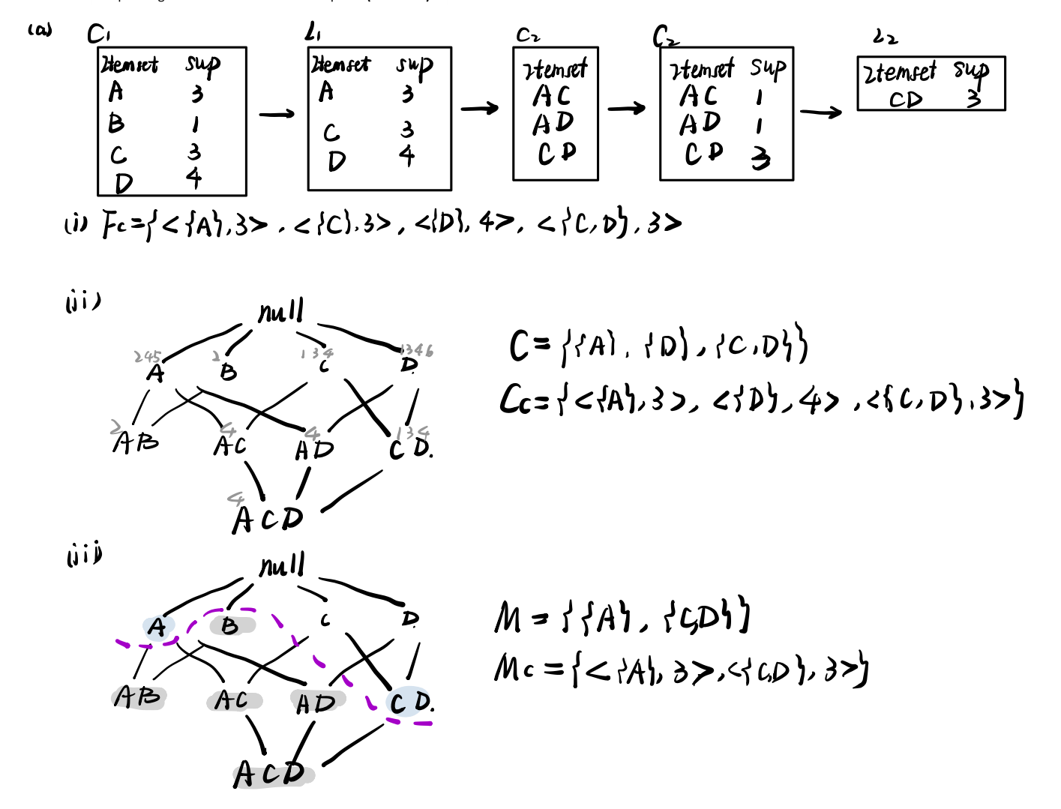

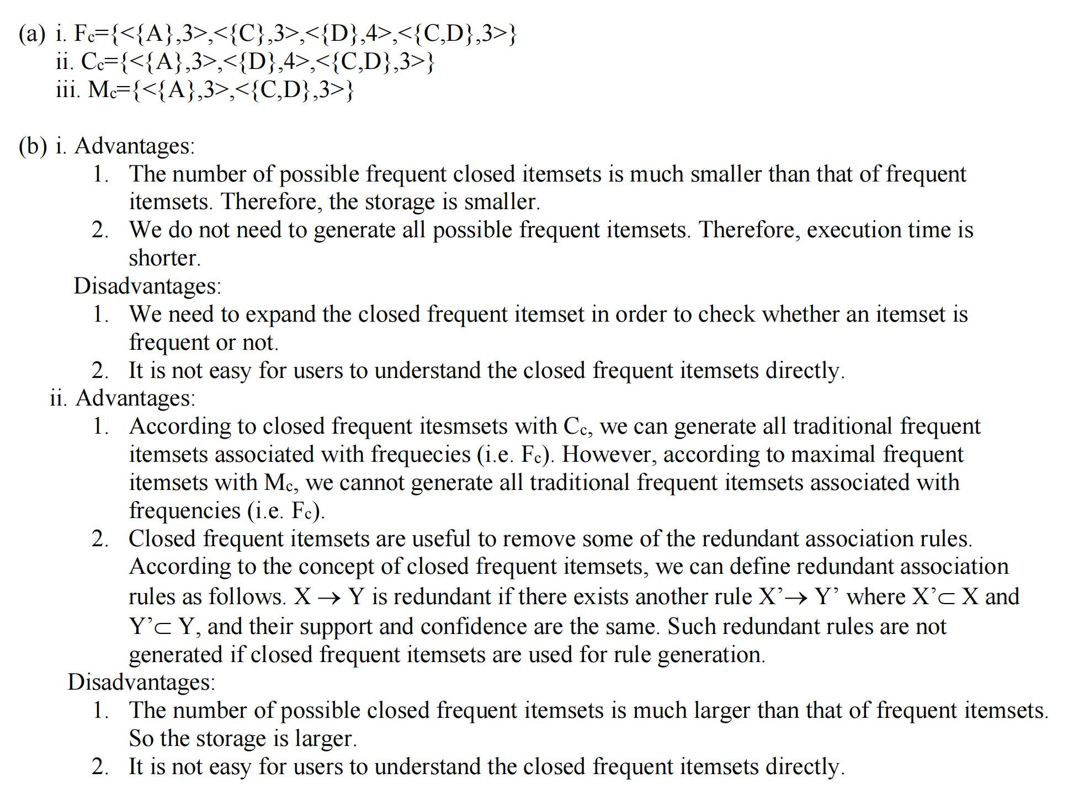

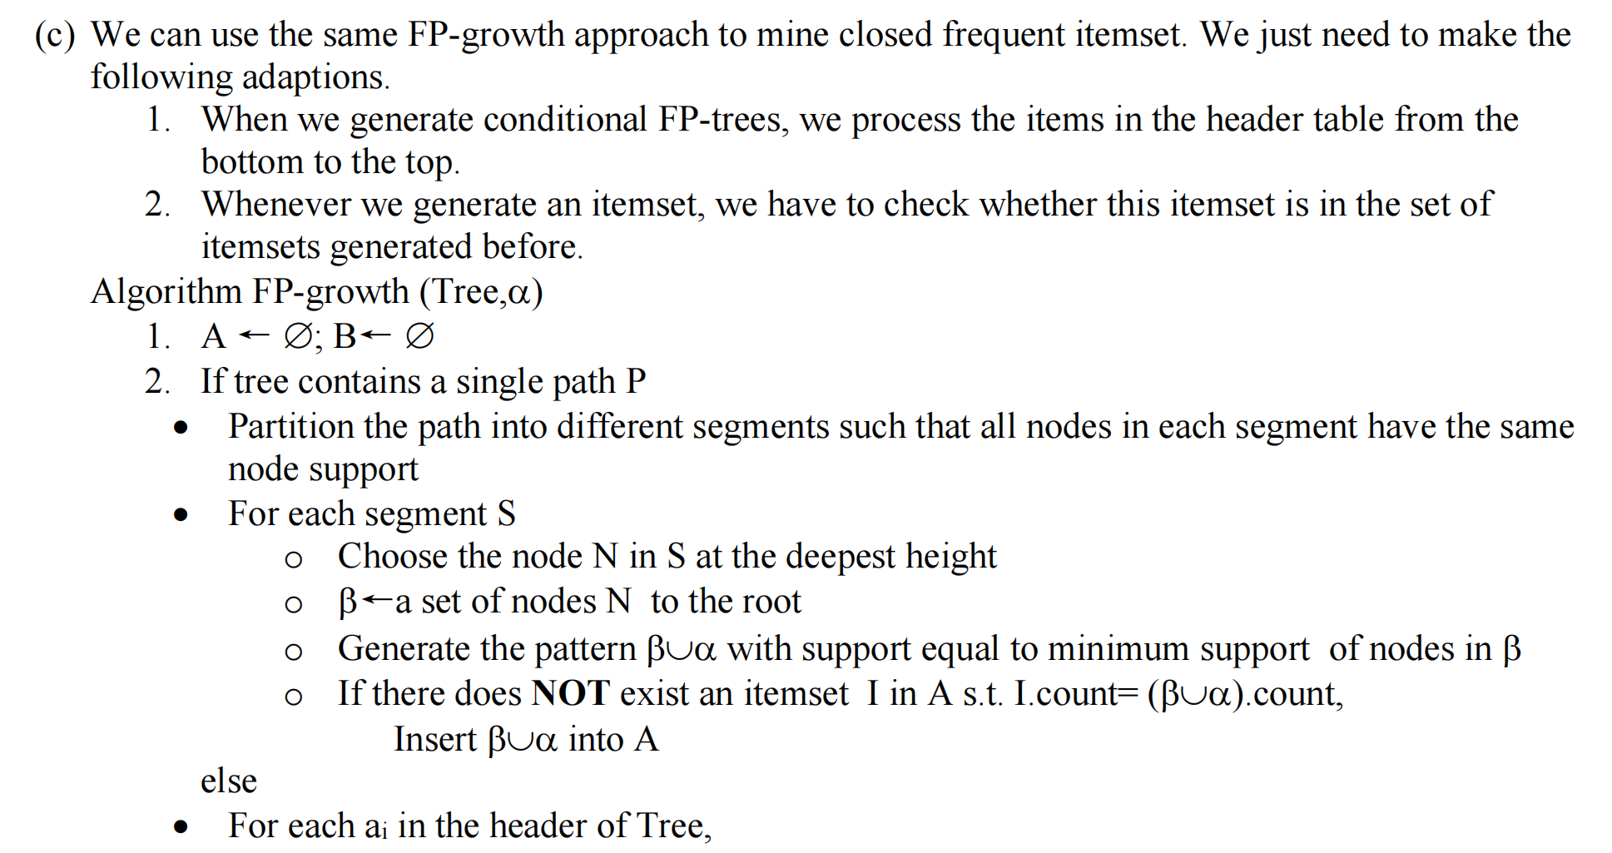

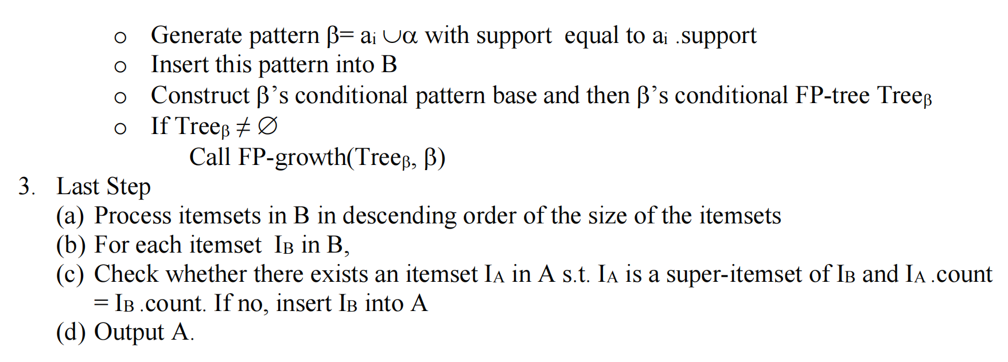

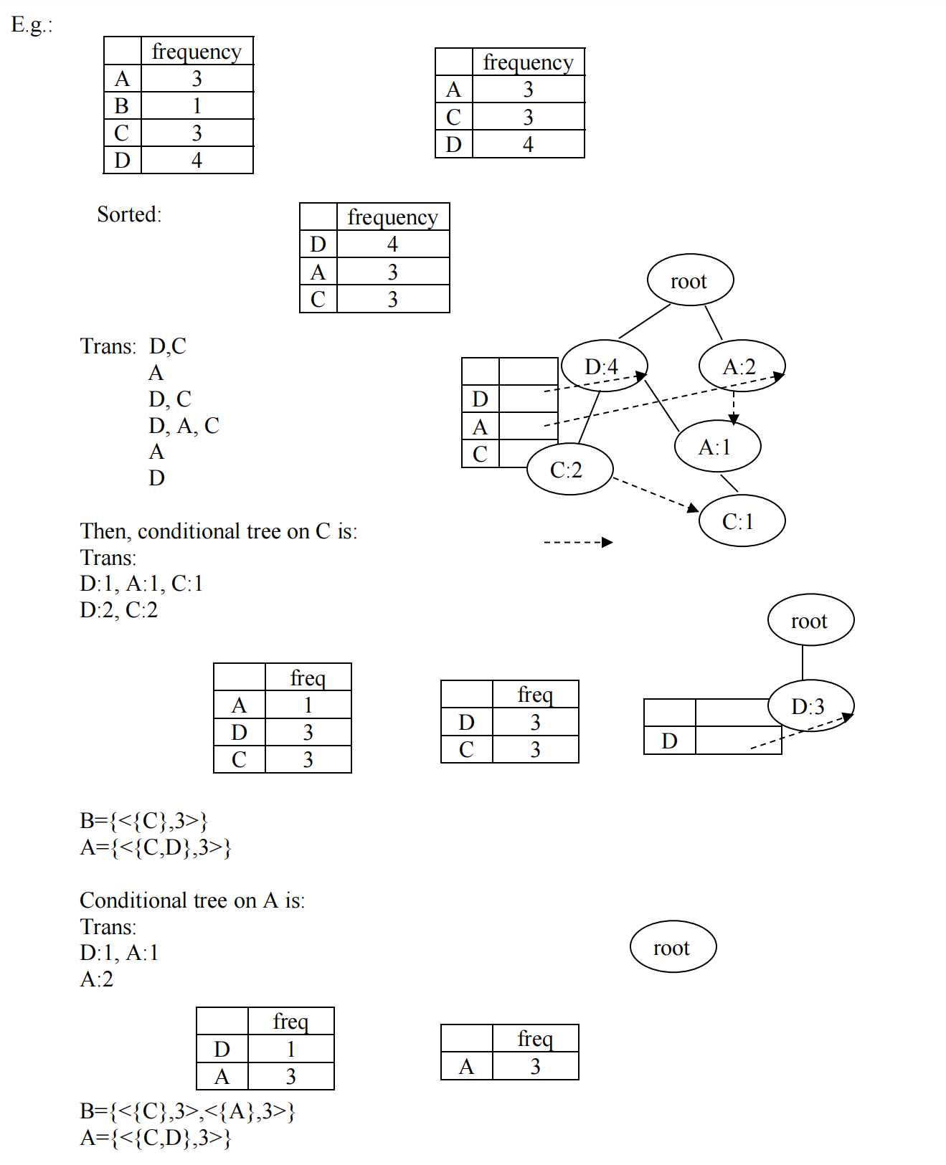

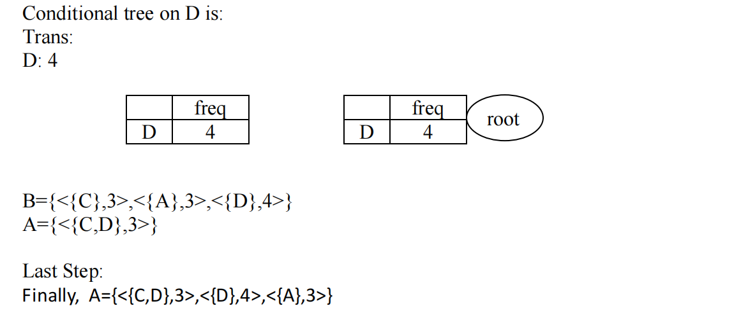

**Q4:**

1. (5 marks){ ‘Upload Songs’}: 80%, {‘Add Tags’}: 60%, {‘Share’}: 60%, {‘Listen’}: 60%
2. **(10marks) 2-sequences Candidate Generation:**

**<**{ ‘Upload Songs’, ‘Add Tags’}**>, <**{ ‘Upload Songs’, ‘Share’}**>, <**{ ‘Upload Songs’, ‘Listen’}**>,**

**<**{‘Add Tags’, ‘Share’}**>, <**{‘Add Tags’, ‘Listen’}**>, <**{‘Share’, ‘Listen’}**>,**

**<**{‘Upload Songs’}, {‘Upload Songs’}**>, <**{‘Upload Songs’}, {‘Add Tags’}**>, <**{‘Upload Songs’}, {‘Share’}**>, <**{‘Upload Songs’}, {‘Listen’}**>,**

**<**{‘Add Tags’}, {‘Upload Songs’}**>, <**{‘Add Tags’}, {‘Add Tags’}**>, <**{‘Add Tags’}, {‘Share’}**>,**

**<**{‘Add Tags’}, {‘Listen’}**>,**

**<**{‘Share’}, {‘Upload Songs’}**>, <**{‘Share’}, {‘Add Tags’}**>, <**{‘Share’}, {‘Share’}**>,**

**<**{‘Share’}, {‘Listen’}**>,**

**<**{‘Listen’}, {‘Upload Songs’}**>, <**{‘Listen’}, {‘Add Tags’}**>, <**{‘Listen’}, {‘Share’}**>,**

**<**{‘Listen’}, {‘Listen’}**>**

**Candidate Pruning:** Remain unchanged

1. **(5 marks) Frequent 2-sequences:**

**<**{ ‘Upload Songs’, ‘Add Tags’}**>**: 40%, **<**{‘Share’, ‘Listen’}**>**: 40%,

**<**{‘Upload Songs’}, {‘Listen’}**>**: 40%, **<**{‘Add Tags’}, {‘Listen’}**>**: 40%

1. **(10 marks) 3-sequences Candidate Generation:**

**<**{ ‘Upload Songs’, ‘Add Tags’}, {‘Listen’}**>, <**{‘Upload Songs’}, {‘Share’, ‘Listen’}**>,**

**<**{‘Add Tags’}, {‘Share’, ‘Listen’}**>**

**Candidate Pruning:**

1. **<**{ ‘Upload Songs’, ‘Add Tags’}, {‘Listen’}**>** should not be pruned
2. **<**{‘Upload Songs’}, {‘Share’, ‘Listen’}**>** should be pruned because one 2-subsequence <{‘Upload Songs’}, {‘Share’}> is not frequent
3. **<**{‘Add Tags’}, {‘Share’, ‘Listen’}**>** should be pruned because one 2-subsequence <{‘Add Tags’}, {‘Share’}> is not frequent
4. **(5 marks) Frequent** 3-sequences**:**

Since the support of **<**{ ‘Upload Songs’, ‘Add Tags’}, {‘Listen’}**> is 20%. There is no frequent 3-sequence.**