Group Project: Flight Delays EDA
Cindy Zhao’s Contribution to Group 4
2025-11-18

Summary
Analyzing and Predicting Flight Delays Using Bureau of Transportation Statistics Data
This project analyzes and predicts U.S. airline flight delays using the On-Time Performance dataset.The data include all of ~70,000 flights from July 2025 with fields such as airline, airport, date, scheduled and actual times, delay durations, and causes (weather, carrier, system, and late aircraft).
Delay Extremes:
Identify airlines with the most and least delays (>15 min) Identify airports with the most and least delays Look at arrival delays (ARR_DEL15)
Delay Duration Dynamics:
Analyze the distribution of delay times through histograms Highlight airlines/airports with the highest and lowest average delay durations
Temporal and Operational Patterns:
Visualize how delays vary by time of day and delay segments (using DEP_TIME_BLK and ARR_DELAY) Examine how delays are caused by a previous event, showing how a “hotspot” spreads to the current flight (LATE_AIRCRAFT_DELAY)

Data
The data is available from the Bureau of Transportation Statistics (BTS): https://transtats.bts.gov/DL_SelectFields.aspx?gnoyr_VQ=FGK&QO_fu146_anzr=b0-gvzr

Preview the data set
Flight delays (first 3 rows and first 10 columns of dataset)
YEAR | MONTH | DAY_OF_MONTH | DAY_OF_WEEK | FL_DATE | MKT_UNIQUE_CARRIER | ORIGIN | ORIGIN_CITY_NAME | ORIGIN_STATE_NM | DEST
2,025 | 7 | 1 | 2 | 7/1/2025 12:00:00 AM | AA | ABE | Allentown/Bethlehem/Easton, PA | Pennsylvania | CLT
2,025 | 7 | 1 | 2 | 7/1/2025 12:00:00 AM | AA | ABE | Allentown/Bethlehem/Easton, PA | Pennsylvania | CLT
2,025 | 7 | 1 | 2 | 7/1/2025 12:00:00 AM | AA | ABI | Abilene, TX | Texas | DFW

EDA (Exploratory Data Analysis) of arrival flight delays:
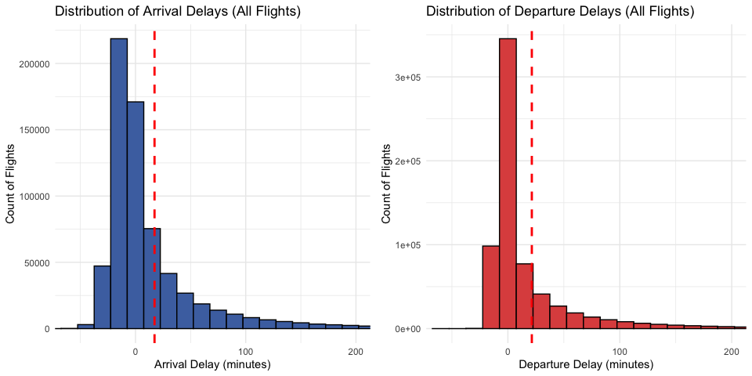

Identify airlines with the most and least Arrival Delays (>15 min)
Airlines with the highest Delay_Percentage
MKT_UNIQUE_CARRIER | Total_Flights | Total_Delayed_Flights | Delay_Percentage
F9 | 16,409 | 5,722 | 34.87111
B6 | 20,690 | 6,580 | 31.80280
AA | 177,933 | 53,193 | 29.89496
G4 | 13,978 | 4,171 | 29.83975
UA | 129,924 | 37,445 | 28.82070
WN | 125,677 | 35,731 | 28.43082
AS | 39,313 | 10,109 | 25.71414
NK | 17,307 | 4,213 | 24.34275
DL | 147,752 | 34,292 | 23.20916

Airlines with the Lowest Delay_Percentage
MKT_UNIQUE_CARRIER | Total_Flights | Total_Delayed_Flights | Delay_Percentage
HA | 7,066 | 1,432 | 20.26606
DL | 147,752 | 34,292 | 23.20916
NK | 17,307 | 4,213 | 24.34275
AS | 39,313 | 10,109 | 25.71414
WN | 125,677 | 35,731 | 28.43082
UA | 129,924 | 37,445 | 28.82070
G4 | 13,978 | 4,171 | 29.83975
AA | 177,933 | 53,193 | 29.89496
B6 | 20,690 | 6,580 | 31.80280
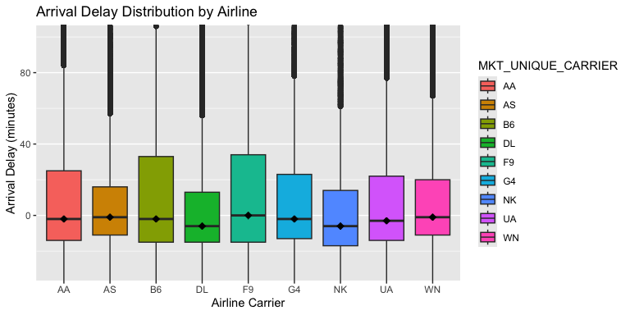

Identify destination airports with the most and least Arrival Delays (>15 min)
Destination Airports with the Highest Arrival Delay Percentage (>15 min)
DEST | Total_Arrivals | Total_Arrival_Delays | Arrival_Delay_Percentage
USA | 61 | 34 | 55.73770
TOL | 31 | 17 | 54.83871
HGR | 45 | 23 | 51.11111
SFB | 1,075 | 525 | 48.83721
HYS | 53 | 24 | 45.28302
PQI | 31 | 14 | 45.16129
SLN | 93 | 42 | 45.16129
CMX | 83 | 37 | 44.57831
CKB | 36 | 16 | 44.44444

Destination Airports with the Lowest Arrival Delay Percentage (>15 min)
DEST | Total_Arrivals | Total_Arrival_Delays | Arrival_Delay_Percentage
EKO | 48 | 0 | 0.000000
STC | 9 | 0 | 0.000000
CDC | 53 | 2 | 3.773585
PIH | 36 | 2 | 5.555556
FLO | 84 | 5 | 5.952381
SPN | 31 | 2 | 6.451613
LWS | 62 | 5 | 8.064516
YAK | 62 | 5 | 8.064516
APN | 52 | 5 | 9.615385
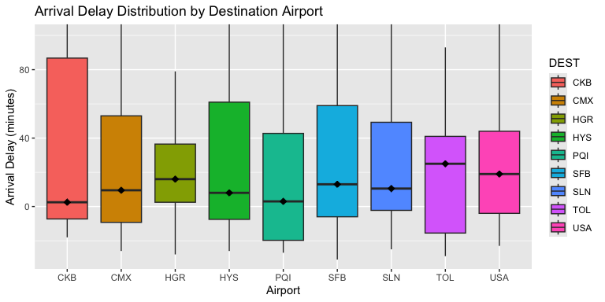

Histograms for the Most Delayed Destination Airports
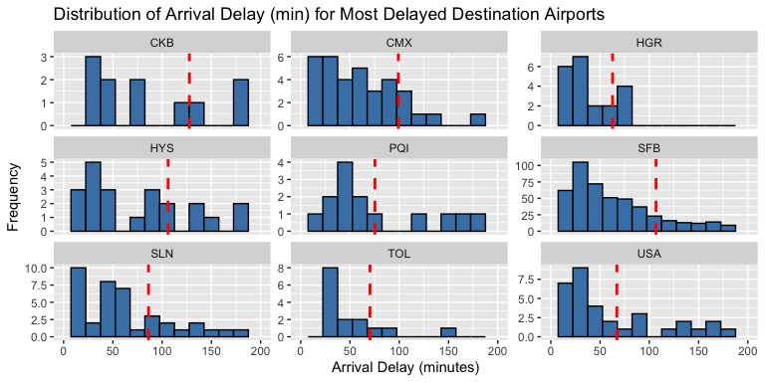

Histograms for the Least Delayed Destination Airports
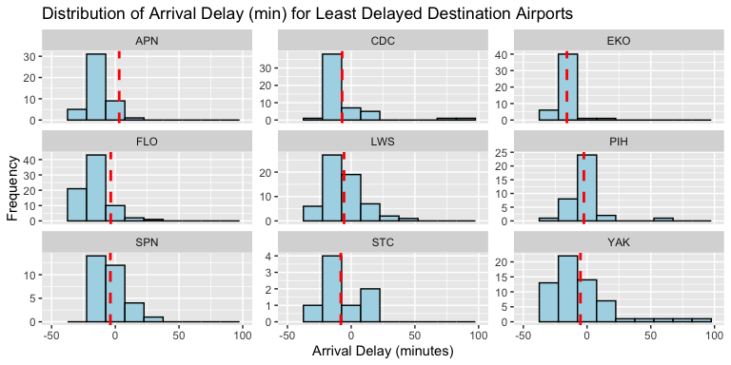

Flight delays grouped by DEP_TIME_BLK
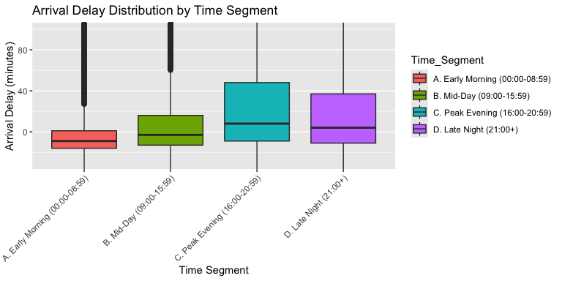
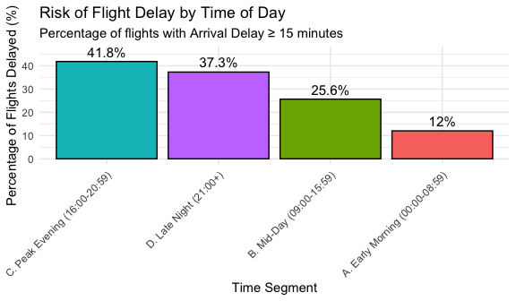

Population growth of flight delays grouped by ARR_DELAY
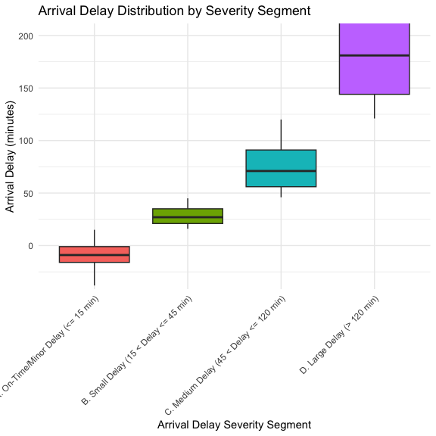
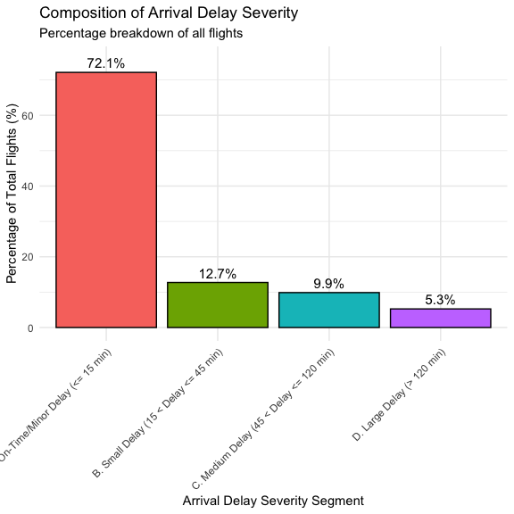

LATE_AIRCRAFT_DELAY influencing Flight Delays
Examine how delays are caused by a previous event, showing how a “hotspot” spreads to the current flight (LATE_AIRCRAFT_DELAY)
