Group Project: Flight Delays
EDA Contribution: Cindy Zhao
2025-11-10

Summary
Project Proposal: Analyzing and Predicting Flight Delays Using Bureau of Transportation Statistics Data
This project analyzes and predicts U.S. airline flight delays using the Bureau of Transportation Statistics (BTS) On-Time Performance dataset.The data include around 70,000 flights from July 2025 with fields such as airline, airport, date, scheduled and actual times, delay durations, and causes (weather, carrier, system, and late aircraft).
Columns(35) include: YEAR MONTH DAY_OF_MONTH DAY_OF_WEEK FL_DATE MKT_UNIQUE_CARRIER ORIGIN ORIGIN_CITY_NAME ORIGIN_STATE_NM DEST DEST_CITY_NAME DEST_STATE_NM CRS_DEP_TIME DEP_TIME DEP_DELAY DEP_DELAY_NEW DEP_DEL15 DEP_TIME_BLK TAXI_OUT TAXI_IN CRS_ARR_TIME ARR_TIME ARR_DELAY ARR_DELAY_NEW ARR_DEL15 CANCELLED CANCELLATION_CODE DIVERTED AIR_TIME DISTANCE CARRIER_DELAY WEATHER_DELAY NAS_DELAY SECURITY_DELAY LATE_AIRCRAFT_DELAY
Delay Extremes:
Identify airlines with the most and least delays (>15 min) Identify airports with the most and least delays Look at both departure delays (DEP_DEL15) and arrival delays (ARR_DEL15)
Delay Duration Dynamics:
Analyze the distribution of delay times through histograms Highlight airlines/airports with the highest and lowest average delay durations Look at variation (standard deviation) in delays
Temporal and Operational Patterns:
Visualize how delays vary by time of day (using DEP_TIME_BLK) Examine how delays differ by day of week Explore relationship between distance and delays

Data

Preview the data set
Flight delays (first 3 rows and first 10 columns of dataset)
YEAR | MONTH | DAY_OF_MONTH | DAY_OF_WEEK | FL_DATE | MKT_UNIQUE_CARRIER | ORIGIN | ORIGIN_CITY_NAME | ORIGIN_STATE_NM | DEST
2,025 | 7 | 1 | 2 | 7/1/2025 12:00:00 AM | AA | ABE | Allentown/Bethlehem/Easton, PA | Pennsylvania | CLT
2,025 | 7 | 1 | 2 | 7/1/2025 12:00:00 AM | AA | ABE | Allentown/Bethlehem/Easton, PA | Pennsylvania | CLT
2,025 | 7 | 1 | 2 | 7/1/2025 12:00:00 AM | AA | ABI | Abilene, TX | Texas | DFW

Part 1: EDA (Exploratory Data Analysis) of flight delays:

Identify airlines with the most and least Arrival Delays (>15 min)
Airlines with the highest Delay_Percentage
MKT_UNIQUE_CARRIER | Total_Flights | Total_Delayed_Flights | Delay_Percentage
F9 | 16,409 | 5,722 | 34.87111
B6 | 20,690 | 6,580 | 31.80280
AA | 177,933 | 53,193 | 29.89496
G4 | 13,978 | 4,171 | 29.83975
UA | 129,924 | 37,445 | 28.82070
WN | 125,677 | 35,731 | 28.43082
AS | 39,313 | 10,109 | 25.71414
NK | 17,307 | 4,213 | 24.34275
DL | 147,752 | 34,292 | 23.20916
Airlines with the Lowest Delay_Percentage
MKT_UNIQUE_CARRIER | Total_Flights | Total_Delayed_Flights | Delay_Percentage
HA | 7,066 | 1,432 | 20.26606
DL | 147,752 | 34,292 | 23.20916
NK | 17,307 | 4,213 | 24.34275
AS | 39,313 | 10,109 | 25.71414
WN | 125,677 | 35,731 | 28.43082
UA | 129,924 | 37,445 | 28.82070
G4 | 13,978 | 4,171 | 29.83975
AA | 177,933 | 53,193 | 29.89496
B6 | 20,690 | 6,580 | 31.80280

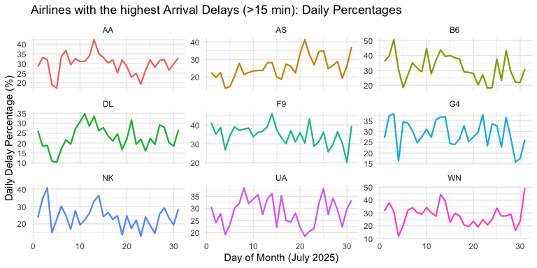

Identify origin airports with the most and least Arrival Delays (>15 min)
Origin Airports with the Highest Arrival Delay Percentage (>15 min)
ORIGIN | Total_Arrivals | Total_Arrival_Delays | Arrival_Delay_Percentage
STC | 9 | 7 | 77.77778
CKB | 36 | 22 | 61.11111
USA | 61 | 35 | 57.37705
ADK | 9 | 5 | 55.55556
TOL | 31 | 17 | 54.83871
SWF | 58 | 31 | 53.44828
HGR | 45 | 24 | 53.33333
BFF | 52 | 25 | 48.07692
EGE | 202 | 84 | 41.58416
Origin Airports with the Lowest Arrival Delay Percentage (>15 min)
ORIGIN | Total_Arrivals | Total_Arrival_Delays | Arrival_Delay_Percentage
PQI | 31 | 0 | 0.000000
EKO | 48 | 1 | 2.083333
PIH | 37 | 1 | 2.702703
LWS | 62 | 3 | 4.838710
TWF | 62 | 3 | 4.838710
INL | 64 | 4 | 6.250000
GUM | 62 | 4 | 6.451613
CDV | 62 | 5 | 8.064516
FLO | 84 | 7 | 8.333333

