Group 4: Arina Vasileva, Trang Vu, Bishwa Ghimire, Alexander Buchanan

Stress Measuring with Raspberry Pi

**Project Plan**

First Year Hardware Project

School of ICT

Metropolia University of Applied Sciences

03.03.2023 (v1.2)

**Version history**

|  |  |  |  |
| --- | --- | --- | --- |
| **Ver** | **Description** | **Date** | **Author(s)** |
| 1.0 | Created structure for the project plan. Added instructions for what should be included in the different parts of the document | 13.02.2023 | Arina Vasileva, Trang Vu, Bishwa Ghimire, Alexander Buchanan |
| 1.1 | Review meeting. Project plan was reviewed, and tasks are assigned individually | 17.2.2023 | Arina Vasileva, Trang Vu, Bishwa Ghimire, Alexander Buchanan |
| 1.2 | Updated assigned tasks according to what was decided in the review meeting. Managed channels in Microsoft Teams. Created Metropolia GitLab | 28.02.2023 | Arina Vasileva, Trang Vu |
| 1.3 | Changed the name of the document. Edited the Project Plan template. Updated GitLab files and Microsoft Teams channel | 03.03.2023 | Arina Vasileva, Trang Vu, Bishwa Ghimire |
| 1.4 | Added Schedule information, fixed a few spelling mistakes and a block diagram was added | 04.03.2023 | Alexander Buchanan |
| 1.5 | Updated the project plan. Completed GANTT template (Project timeline planning) | 05.03.2023 | Trang Vu, Arina Vasileva |
| 1.6 | Finalized project plan and submission | 06.03.2023 | Arina Vasileva, Bishwa Ghimire, Trang Vu, Alexander Buchanan |

Contents

1 Introduction 4

2 Project Description 5

Hardware: 6

Software: 7

3 Communication 9

4 Version Control 9

5 Schedule 10

6 Goals 11

# Introduction

The purpose of the document is to introduce a methodology to record the heart rate to measure the stress level by analyzing the data and updating via Raspberry Pi. We have been working on the Health Tech - Hardware 1 project. This document is a detailed description about the working method that we have engaged with during the study, which happens during spring term 2023.

Heart rate variability (HRV) has been widely used as an indicator of stress level in recent years. HRV refers to the variation in time between successive heartbeats, which can provide insights into the activity of the autonomic nervous system (ANS). The ANS is responsible for regulating physiological processes such as heart rate, blood pressure, and respiration, and plays a key role in the body's response to stress.

In order to measure stress level, the recorded HRV data needs to be analyzed using appropriate algorithms. One common method is to calculate the standard deviation of the intervals between successive heartbeats, known as the standard deviation of NN intervals (SDNN). Higher SDNN values indicate greater variability in the heart rate, which is generally associated with lower stress levels.

To automate the process of recording and analyzing HRV data, a Raspberry Pi can be used as a central hub to collect data from multiple PPG sensors. Raspberry Pi is a small computer that can be easily programmed using various programming languages such as Python or C++. It is equipped with various connectivity options such as Wi-Fi and Bluetooth, making it easy to interface with PPG sensors. In this project, we will specifically use Python for algorithm. Figure 1 shows Raspberry Pi Pico Series.

*Figure 1: Raspberry Pi Pico Series*

Raspberry Pi can be programmed to collect HRV data from multiple sensors simultaneously and store the data in a database. This data can then be analyzed using algorithms such as SDNN to determine stress levels. Raspberry Pi can also be programmed to send notifications to the user when their stress levels are high, reminding them to take steps to reduce stress. Also, Raspberry Pi can be programmed to interface with other devices such as smartwatches or smartphones, allowing for real-time monitoring of stress levels. Therefore, we can keep track, update, and figure out how the stress level is going to be connected through the index and data in Raspberry Pi by using algorithm coded by Python, which is the final object of the project.

# Project Description

In this project, we will be using a combination of hardware and software tools to record the heart rate and measure the stress level of an individual. The hardware and software are introduced below.

# Hardware:

Heart rate sensor: We will be using a heart rate sensor module to measure the heart rate of an individual. The sensor will be attached to the fingertip, and it will detect the changes in blood flow that occur with each heartbeat.

Raspberry Pi: We will be using a Raspberry Pi single-board computer to collect and process the heart rate data from the sensor. The Raspberry Pi will also be used to display the stress level and other relevant information. Table 1 lists the components used in the proof-of-concept product.

|  |  |  |
| --- | --- | --- |
| Component | Description | More info |
| Raspberry Pi Pico | Dual-core ARM processor microcontroller having 246 kB SRAM and 2 MB on-board Flash. It also includes 2.4 GHz wireless LAN and 26 multifunction GPIO pins | [Raspberry](https://www.raspberrypi.com/products/raspberry-pi-pico/)  Pi Pico series [– Raspberry Pi](https://www.raspberrypi.com/products/raspberry-pi-pico/) |
| Crowtail Pulse Sensor v2.0 | Optical heart rate sensor having LED, photodiode, analog amplifier, and analog signal output. Operating voltage 3-5 V | [Crowtail-](https://www.elecrow.com/crowtail-pulse-sensor-p-1673.html) Pulse Sensor 2.0 [(elecrow.com)](https://www.elecrow.com/crowtail-pulse-sensor-p-1673.html) |
| OLED display | SSD1306 compatible 128x64 monochrome organic LED-display.  Communicates with I2C or UART-protocol | [Sensors Modules SSD1306 Oled Display | Sensors Modules](https://www.electronicwings.com/sensors-modules/ssd1306-oled-display)  Using a SSD1306 OLED display - MicroPython latest  [documentation](https://docs.micropython.org/en/latest/esp8266/tutorial/ssd1306.html) |
| Protoboard | Passive protoboard specially designed for this project to help connect the other components to the Raspberry Pi Pico | Joseph Hotchkiss, Project Engineer, Metropolia UAS |
| Rotary knob | Digital rotary knob with push button | Joseph Hotchkiss, Project Engineer, Metropolia UAS |

*Table 1. Components used in the proof-of-concept product*

# Table 1 provides a list of components used in a proof-of-concept product related to hardware used in this project. The components include a Raspberry Pi Pico microcontroller with a dual-core ARM processor, an optical heart rate sensor Crowtail Pulse Sensor v2.0, an OLED display, a passive protoboard, and a digital rotary knob with a push button. The table also provides additional information such as the operating voltage, communication protocol, and compatible series for each component.

# Software:

Python: We will be using the Python programming language to develop the software that will collect and process the heart rate data from the sensor.

Matplotlib: We will be using the Matplotlib library in Python to visualize the heart rate data and display the stress level. Matplotlib is a popular library for creating charts and graphs in Python.

Flask: We will be using the Flask framework to create a web-based interface for displaying the stress level and other relevant information. Flask is a lightweight web framework that is easy to use and well-suited for small projects.

Together, these hardware and software tools will allow us to accurately measure the heart rate and stress level of an individual in real-time. The data collected will be processed and displayed via the Raspberry Pi and a web-based interface, allowing the user to track their stress levels over time and make any necessary adjustments to their lifestyle to improve their overall health and wellbeing. Figure 2 illustrates a block diagram visualizing the different devices, components, and connections in the system.

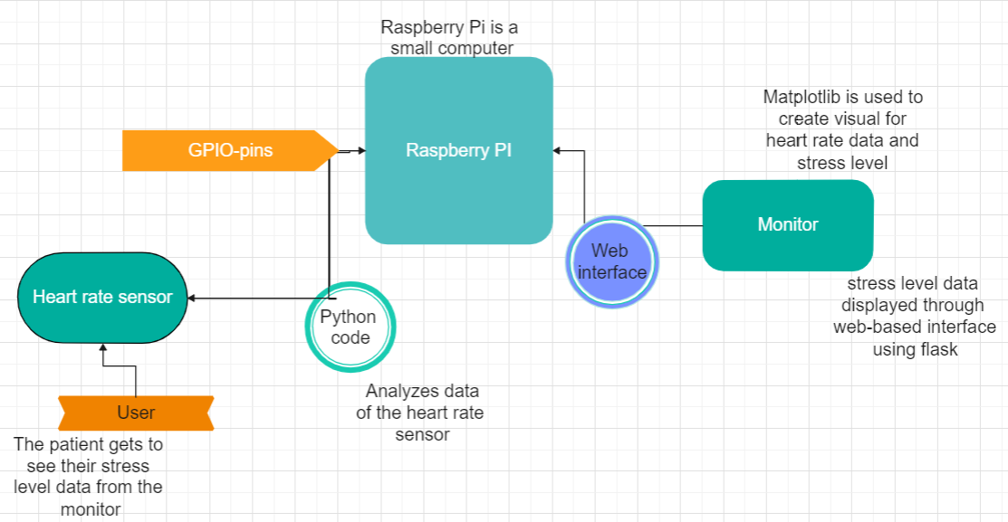

*Figure 2: Block diagram visualizing the different devices, components, and connections in the system.*

The heart rate sensor will be connected to the Raspberry Pi via GPIO pins, which will allow the Raspberry Pi to read the heart rate data. The Raspberry Pi will process the data using Python code, which will analyze the data to determine the stress level of the user. The stress level data will be displayed on a web-based interface created using the Flask framework. Matplotlib will be used to create visualizations of the heart rate data and stress level, which will be displayed on the web-based interface. The Raspberry Pi will also be connected to a monitor or display to display the stress level data in real-time.

Overall, the system will consist of the heart rate sensor, Raspberry Pi, and a web-based interface created using Flask. The heart rate data will be collected and processed using Python code, and the stress level will be displayed on the web-based interface using Matplotlib visualizations. The user will be able to track their stress level over time and make any necessary adjustments to their lifestyle to improve their overall health and wellbeing.

# Communication

Team members are going to communicate through Microsoft Teams channels. We created a Microsoft Teams workspace for also storing your project-related materials. The meetings are held up by in-person and online meetings. We schedule regular team meetings (weekly or bi-weekly), to discuss the progress of the project, assign tasks, and identify any challenges or issues that need to be addressed.

We post and update the status of project in Teams at the Post sections. Microsoft Teams and WhatsApp can be used for instant messaging, file sharing, and video conferencing. Meeting notes and a summary of the event on the GANTT schedule and on the Project Plan file, which stores all the materials there.  Additionally, each team member gets clear task assignment roles and responsibilities with timelines and deliverables.

# Version Control

Version control is an essential aspect of software development, and it enables our team to manage the codebase effectively and collaborate efficiently with other team members. That is the reason we created a private repository in [Metropolia GitLab.](https://gitlab.metropolia.fi/users/sign_in)  The link to our repository in the project plan is [Group 4_HealthTech.](https://gitlab.metropolia.fi/group-4/health-tech-project) We added Keijo Länsikunnas - the project teacher to be our co-operator.

We store other documents and material we need for your project-related material in Microsoft Teams workspace. There are three subdirectories created:

* Project-related information and material given by teachers.
* Useful reference material we find useful in our project.
* Our own documents such as project plan, schedule, meeting notes and project report.

We keep track of version control for our group document so that we can avoid confusion, maintain organization, and ensure that the latest version of the document is being used. We discussed and agreed with each other to execute in the following way:

* Use a clear naming convention, take advantage of features like version history, rollback, and collaboration.
* Maintain a document repository by storing all versions of the document in one place, so that it becomes easier to track changes and maintain version control.
* Keep a version control log that tracks changes made to a document over time. This log can include information like the version number, date of the change, and a brief description of the change made.

# Schedule

In order to ensure that we remain on track and meet our project milestones ahead of schedule, we have adopted a proactive approach that emphasizes clear and consistent communication, documentation, and progress tracking. Specifically, we maintain a comprehensive schedule sheet in Microsoft Excel that is regularly updated with the latest progress updates and milestones.

Excel allows creating spreadsheets, which can be used to store and manage data. Excel can be used to create and maintain a schedule sheet that lists important milestones, deadlines, and progress updates. By using Excel in this way, we can easily keep track of time and ensure that they are staying on schedule. Excel can be accessed from multiple devices and locations. This means that team members can update the schedule sheet and view it from anywhere, allowing them to stay up-to-date and collaborate effectively even when working remotely. The link to the sheet: [Group 4 schedule](https://metropoliafi-my.sharepoint.com/:x:/g/personal/arinava_metropolia_fi/EaxzWTi9esdMqkyWzCdN7TIBb03BMfxtlAMh6afezUL6Tg?e=hEijVo)

# Goals

Our team wants to use the stress-measuring technology project to improve our understanding of stress and its impact on our health and others' health, which can show us a different perspective and better treatments for stress-related conditions. The team aims to get a grade of 5. As we work on the project to gain knowledge as well as to get good grades. Our team members are also looking to learn the following things:

* Technical skills: Understanding of computer programming, software development, and hardware engineering, learning new programming languages, software tools, and other technical skills that can be applied to future projects.
* Project management skills: Health technology projects typically involve complex development processes, such as project planning, risk management.
* Problem-solving skills: Overcoming technical challenges and finding creative solutions to complex problems, practising critical thinking, analytical reasoning that can be applied in a wide range of professional contexts.
* Collaboration and teamwork skills: Working with interdisciplinary teams, including developers, designers, medical professionals, and other stakeholders, developing skills such as teamwork, collaboration, and effective communication that can be applied in a wide range of professional settings.
* Knowledge of healthcare and medical systems: Understanding of healthcare systems, medical procedures, and patient needs.

As a group and individuals, we wish to learn the following:

* Practice active listening: Paying attention to what others are saying, asking questions, and paraphrasing what they say to ensure understanding, building stronger relationships.
* Develop empathy: Considering others’ perspective to improve the ability to empathize.
* Communicate clearly: Being clear and concise when communicating our thoughts and ideas to others. Avoid using jargon or technical terms that may not be familiar to everyone in the group.
* Build trust: Being reliable, keep promises, and communicate honestly and openly with others.
* Be open to feedback: Accepting feedback from others, even if it is constructive criticism, using feedback to improve skills and abilities.
* Collaborate effectively: Working together with others to achieve common goals, encouraging everyone to contribute ideas and work together to find solutions.
* Managing conflicts: Listening to all sides of the conflict if there is any, identifying the root cause, and working together to find a resolution that everyone can agree on.

In order to reach these personal goals, we are going to do the following:

* Set clear goals: Defining what the group hopes to achieve and the specific steps that need to be taken to achieve these goals, establishing clear and specific goals can help keep everyone on track and motivated.
* Assign roles and responsibilities: Assigning roles and responsibilities to each member of the group based on their strengths and expertise. This ensures that everyone knows what is expected of them and can contribute effectively to the project.
* Establish clear communication channels: Establishing a regular meeting schedule to ensure that everyone is on the same page, encouraging open and honest communication among group members so that everyone can share their thoughts and ideas freely, and actively listen to each other.

The objective of the Stress Measuring with Raspberry Pi project is not solely to obtain great academic results but also to enhance research and comprehension regarding stress and its health ramifications. Our team endeavors to acquire proficiencies in technical abilities, project management, problem-solving, teamwork and collaboration, as well as in healthcare and medical systems. As individuals, we aspire to practice active listening, cultivate empathy, communicate with clarity, establish trust, accept feedback, collaborate effectively, and manage conflicts. To achieve these goals, our team intends to establish distinct targets, assign roles and responsibilities, and establish clear communication channels.