Team name: Trang Vu, Arina Vasileva, Alexander Buchanan

<Measuring Stress Level with Raspberry Pi Pico-Based System>

**Project Report**

First-year Hardware Project

School of ICT

Metropolia University of Applied Sciences

9 April 2023

Abstract

Instructions (REMOVE WHEN READY): The abstract is a brief summary of the complete project report. It includes a brief introduction of your **topic**, **methods**, project work, **results**, and conclusions. The abstract is the first part of the report but typically written last. A suitable length for the abstract is half a page to one page.

The meaning of the abstract is to give a reader an overall view of your research/project. After reading the abstract, the reader can also decide if they should read the rest of the report.

Write the abstract in past tense. If you can summarize the whole project, it has already been finished. Do not introduce any new material in the abstract.

**Version history**

|  |  |  |  |
| --- | --- | --- | --- |
| **Ver** | **Description** | **Date** | **Author(s)** |
| 1.0 | Reviewed the structure for the project report. Discussed what should be included in the different parts of the document. | 03.4.2023 | Trang Vu, Arina Vasileva |
| 1.1 | Project plan was reviewed, and tasks are assigned individually | 04.4.2023 | Trang Vu, Arina Vasileva |
| 1.2 | Changed the name of the document. | 07.4.2023 | Trang Vu, Arina Vasileva |
| 1.3 | Updated Introduction and Theoretical Background with inline reference. Created list of references. | 07.4.2023 | Trang Vu, Arina Vasileva, Alexander Buchanan |
|  |  |  |  |
|  |  |  |  |
|  |  |  |  |
|  |  |  |  |
|  |  |  |  |

Contents

1 Introduction 1

2 Theoretical Background 1

3 Methods and Material 2

4 Implementation 2

5 Conclusions 3

References 4

Appendices

Appendix 1: Introducing Figures and Other Items

Appendix 2: Using Appendices

# Introduction

Heart-related conditions are among the top causes of mortality for both genders, as is well recognized. The WHO's 2023 report estimates that over 18 million people will die from cardiac illnesses worldwide. [WHO, 2023] The appropriate interventions determined by healthcare professionals in helping patients with his/her stress levels would be significantly beneficial. Therefore, the purpose of the document is to introduce a methodology to record the heart rate for measuring the stress level by analyzing and investigating Raspberry Pi as a platform for heart rate data collection. The stress level will be analyzed based on the sympathetic nervous system index (SNS index), which is computed in Kubios HRV software. The mentioned topic will be discussed in the following parts of this document.

The project requires using the Raspberry Pi computer and the Thonny software, among other tools, to program in Python and to enable functionality in hardware board. The final goal of this project is to address the expanding matter of heart-related disorders. Besides, this is also considered as an opportunity for all the team member to comprehensively grasp the definition and practice of a variety of hardware and software capabilities. The specified Raspberry Pi computer will play an important role as a learning tool for hardware concepts, for example, integrating and connecting components to a computer. Thonny programming software, on the other hand, is beneficial for learning how to program and other associated software duties.

Raspberry PI Pico, its add-ons, and Thonny software are used in this Hardware 2 Course project. The course has covered the basic operations of Raspberry Pi parts, including how to use various pins and ports, comprehend the operation of the rotary encoder and OLED screen, and investigate the Crowtail pulse sensor.

Raspberry Pi is connected to the pulse sensor and OLED-screen components via GPIO pins, with the OLED-screen showing the patient's heart rate while the pulse sensor gauges it. This project seeks to accomplish several objectives, including learning how to build a healthcare device utilizing Raspberry Pi and Thonny together and getting a great grade while managing time well. Furthermore, the following figure is a simple explanation of the components used in this project.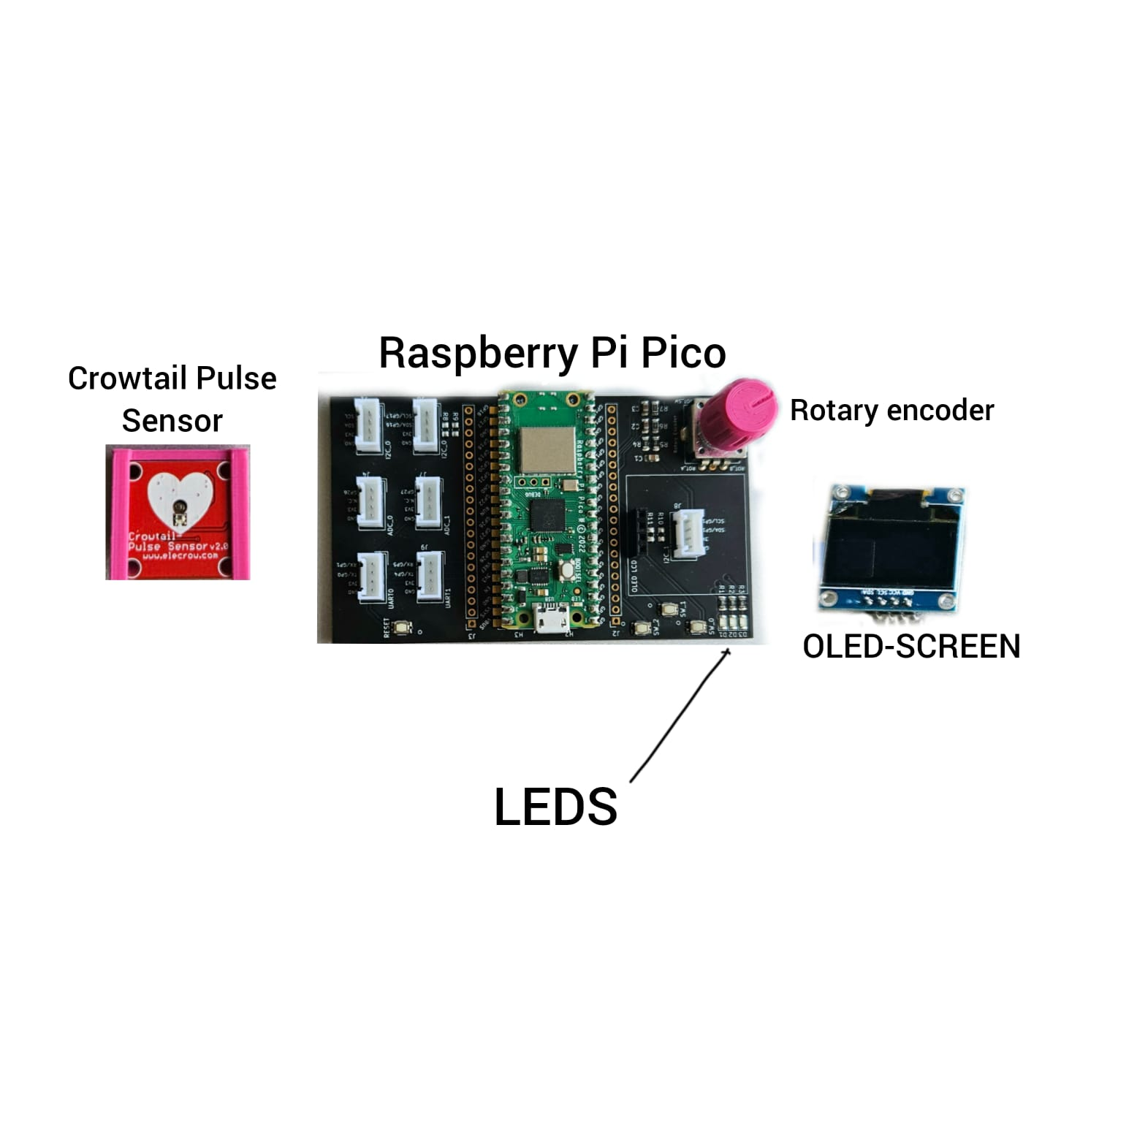

Figure 1: The descriptive model of Raspberry Pi system used in the project

Instructions (REMOVE WHEN READY): This document is a report template for the first-year hardware project on the Hardware 2 course. A suitable length for the report is 10-15 pages. Use figures, tables, and other visual elements to help the reader understand your project.

This template introduces the basic structure for the report, including what information should be included in different parts of the report. The purpose of the template is to guide in writing the report, but the structure and headings of your report do not have to match the template exactly. Appendix 1 contains instructions for introducing figures and other visual items in your report. Appendix 2 explains how appendices are used.

# Theoretical Background

It is very common that most people misunderstand the differences between such metrics as Heart Rate (HR) and Heart Rate Variability (HRV). Even though they are considered almost the same, the application of those systems of measurement varies according to the heart state.

Heart Rate is a metric which identifies the number of times per minute, and it is usually expressed in beats per minute (BPM). It tends to accelerate and get faster due to, for instance, exercising, psychological events like stressing and excitement. However, whenever a human rests and overall feels at peace, their heart rate slows down, gradually returning to the normal pace. That is extremely crucial to check on heart rate level. Whenever it is odd and not matching with the norms, that may rapidly lead to heart and health issues overall.

Unlike heart rate, Heart Rate Variability focuses more on the details of heart performance by measuring the specific changes in a certain period of time (usually in milliseconds) between heart beats which is called Inter-beat Interval (IBI). The example of HRV is illustrated on Figure 1.

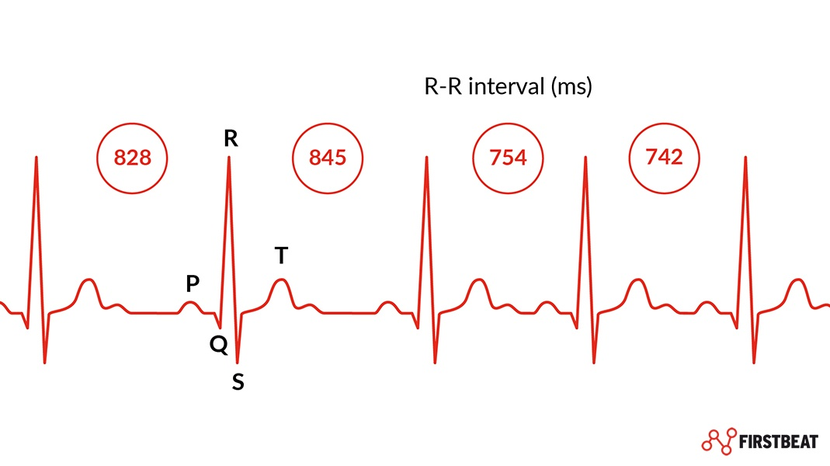

*Figure 1: Heart Rate Variability with outlined R-R intervals (or IBI) measured in ms*

Autonomic nervous system is divided into the sympathetic nervous system, which is responsible of organism's state during exercising or stressing, and the parasympathetic nervous system, which is indicating relaxation.

Talking about the psychological phenomenon associated with HR and HRV, we should point out such term as emotional regulation. This definition refers to the process of controlling the frequency and duration of various emotional states. Using Heart Rate and Heart Rate Variability, it is highly possible to learn about the psychological state of a person, based on his physical indicators. The higher the level of HRV, the more it is likely for a body to be able to calmly face and endure stressful situations, as well as to recover after previously accumulated stress and psychological problems in general.

As a result of various investigations, we may draw the conclusion that Heart rate is fairly easier to measure, especially during workouts or stressful situations. However, it is limited mainly to the measurement of cardiovascular activity.

On the other hand, Heart Rate Variability is a more accurate metric of autonomic nervous system activity comparing to Heart Rate. Moreover, it can detect various stressors. It also integrates the nervous, cardiovascular, and respiratory systems and can be measured with affordable consumer grade heart rate monitors. Nevertheless, it is quite complicated to measure HRV during exercising, thus, the best moment to do so is when the heart is at rest. Additionally, some heart rate monitors are not always accurate in calculations.

According to The American Heart Association (AHA), normally the resting heart rate varies for different people, which ranges from 60 to 100 beats per minutes (bpm) for adults when they are seated or lying down, calmed, relaxed and heathy. The rough resting heart rate range between 40 and 60 bpm is applied for athletes and physically healthy individuals, because their heart muscle is in better shape and there is no need to work as hard to sustain a regular beat, active people frequently have lower resting heart rates (as low as 40). Usually, only a small amount of exercise will significantly alter the resting pulse. Additionally, factors such as genetic, age, or lifestyle can also affect the HRV values in different individuals (Shaffer & Ginsberg, 2017). If one is rarely exercising, their heart is pumping the least quantity of blood at their resting heart rate. (AHA, 2023). Besides, a heart rate below 60 does not always indicate illness. It can be a side effect of using a medication like a beta blocker. However, Thayer also pointed out that good cardiovascular health and stress resilience are usually indicated by a higher HRV (Thayer et al., 2010).

The Crowtail Pulse Sensor v2.0 is an optical heart rate sensor that measures changes in blood volume in the microvascular bed of tissue using photoplethysmography (PPG) technology. (Elecrow, n.d.). The sensor is made up from a LED (Light Emitting Diode), a photodiode, an analog amplifier, and an analog signal output. The LED emits light that penetrates the skin (in this case the fingertip) due to the pulsatile nature of blood flow, and then the reflected light is detected by photodiode, which creates the fluctuation when the blood volume changes. (Tamura et al., 2014). The signal varies according to the heart rate, which creates the periodical peaks. The heart rate is the inverse of peak-to-peak interval (PPI). The signal is processed by the analog amplifier, and data on HR and HRV can be extracted from the analog output by further digitizing and analyzing it. The digitalization and analyzing process is achieved by conducting an algorithm running on Thonny and recording a wide variety of data from different users for better modification and accurate results.

# Methods and Material

Instructions (REMOVE WHEN READY): This section discusses how the project was carried out. Introduce the materials used in the project: the sensor, software, devices, and their most important technical properties. Furthermore, you should discuss how you tested the system and verified that it produces valid readings for the measured parameters.

Note: You should not discuss the implemented system or any results from your measurements in this section.

# Implementation

Instructions (REMOVE WHEN READY): This section discusses the final system your team developed during the project. In this section you must describe the finished system as well as the algorithms you developed for the heart rate and HRV measurements. This section must also include a system diagram. Explain what happens in each part of the system.

Include the following:

* System: The final end-to-end system, including devices and connections.
* Algorithms: The developed algorithms used for calculating heart rate and heart rate variability.
* Data: How much data was collected and for how long? Where and how was the data processed?

# Conclusions

Instructions (REMOVE WHEN READY): In the conclusions section, you should wrap up the report and evaluate how well the original goals of the project were achieved.

The section should answer the following questions:

1. How well did the project go?
2. Were the goals reached?
3. What kind of problems occurred during the project? How did you handle them?
4. What limitations does your prototype measurement system have?
5. How could the work be improved or continued in the future?

References

Instructions (REMOVE WHEN READY): Use one of the referencing systems below. Remove the one that you do not use.

~~Harvard (author-date) system:~~

The reference list entries need to be in alphabetical order according to the last name of the author mentioned first in the list of authors.

Davies, Barbara; Jameson, Peter & Smith, John. 2013. Advanced economics. Oxford: Oxford University Press.

Mitchell, John Arnold & Thomson, Magdalena. 2017. A guide to citation. London: London Publishings.

Vancouver (numbering) system:

1. Mitchell, John Arnold & Thomson, Magdalena. 2017. A guide to citation. London: London Publishings.
2. Davies, Barbara; Jameson, Peter & Smith, John. 2013. Advanced economics. Oxford: Oxford University Press.
3. AHA. 2021. All About Heart Rate (Pulse). American Heart Association. Retrieved from <https://www.heart.org/en/health-topics/high-blood-pressure/the-facts-about-high-blood-pressure/all-about-heart-rate-pulse>
4. Elecrow. (n.d.). Crowtail- Pulse Sensor 2.0. Elecrow. Retrieved from <https://www.elecrow.com/crowtail-pulse-sensor-2-0.html>
5. Shaffer, F., & Ginsberg, J. P. 2017. An Overview of Heart Rate Variability Metrics and Norms. Frontiers in Public Health, 5, 258. doi:10.3389/fpubh.2017.00258
6. Quinn Mattingly, World Health Organization, 2023. Cardiovascular diseases, Health topics. < <https://www.who.int/health-topics/cardiovascular-diseases#tab=tab_1> > (Read 07.04.2023).
7. Thayer, J. F., Åhs, F., Fredrikson, M., Sollers, J. J., & Wager, T. D. 2010. A meta-analysis of heart rate variability and neuroimaging studies: Implications for heart rate variability as a marker of stress and health. Neuroscience and Biobehavioral Reviews, 36(2), 747-756. doi:10.1016/j.neubiorev.2011.11.009
8. Elite HRV [Internet]. Heart Rate Variability vs. Heart Rate - Elite HRV; [cited 2023 Apr 7]. Available from: <https://elitehrv.com/heart-rate-variability-vs-heart-rate>
9. Cleveland Clinic [Internet]. What to Know About Your Heart Rate and Pulse; [cited 2023 Apr 7]. Available from: <https://my.clevelandclinic.org/health/diagnostics/17402-pulse--heart-rate>
10. PubMed Central (PMC) [Internet]. The physiological basis and measurement of heart rate variability in humans; [cited 2023 Apr 7]. Available from: <https://www.ncbi.nlm.nih.gov/pmc/articles/PMC5039876/>.

**Images**

1. Google [Internet]. Weiterleitungshinweis [image]; [cited 2023 Apr 7]. Available from: <https://www.google.com/url?sa=i&amp;url=https://www.firstbeat.com/en/blog/what-is-heart-rate-variability-hrv/&amp;psig=AOvVaw0Vj77ld1J2XvTG-S4ugKnE&amp;ust=1680981969979000&amp;source=images&amp;cd=vfe&amp;ved=0CBEQjRxqFwoTCKDy9Pq_mP4CFQAAAAAdAAAAABAE>

Introducing Figures and Other Items

Add figures, graphs, diagrams, code snippets, equations, tables, and other items into your text to make it more interesting and clearer to read.

All items must be **introduced** in the text. This includes appendices.

* If you cannot explain an item in the text, it probably should not be there.
* A good rule of thumb is to:
  + first introduce the item by its number
  + then present the item
  + lastly, tell the reader what they should pay attention to when examining the item. Explain or interpret the item.
* Each item must have a **caption** and be clear even without looking at the text.

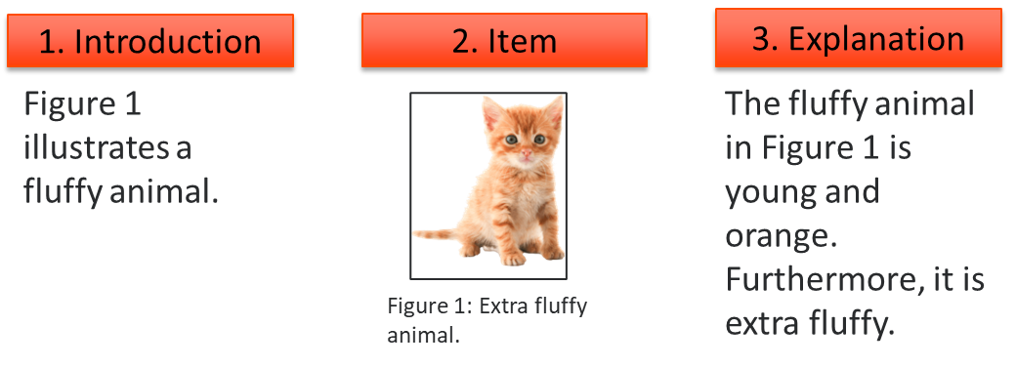

Using Appendices

If an item you want to present does not nicely fit within the text or is larger than half a page, it should be in the appendices. These items could include images, diagrams, code examples, test results or similar. Furthermore, material that provides additional information about the project such as a user manual could be placed in the appendices.

* You may try to resize large items, but make sure the content does not get blurry and the font sizes are large enough to read.
* The content of your report is more important than the length. Do not be afraid of "losing pages”. Use the appendices when you need to.
* The appendices have their own numbering, and the names of the appendices must be manually updated to the table of contents.

Examples of fitting a visual item on a single page:

Good:

Not good:

