Replication of Tables 1–2 and Figure 1 (VD Table 20260928)
Data: csdid_full7316 firm-year panel (filing-year counts of ultimately granted applications) and the application-level list linked through 2024 (forward citations). Estimator: Callaway–Sant’Anna group-time ATTs, never-treated controls, doubly robust (logit propensity score + OLS outcome model) with lagged log funding and lagged number of rounds measured in the base period, plus region and industry fixed effects; base period g−1 for post-treatment cells and t−1 for pre-treatment cells (Stata csdid default). Simple ATT weights post-treatment cells by cohort size; aggregated event study ATT is the mean of event-time ATTs at t = 0…4. p-values (in parentheses) come from a 49-replication firm-level bootstrap and are therefore approximate. Shaded rows show the original values.
Table 1. Staggered DiD Estimates on granted patent applications (replication)
DV: Granted patent applications (count) | (1) | (2) | (3) | (4) | (5)
 | All firms | No prior patent | Prior patent | Early stage | Late stage
Simple ATT | −0.225** | −0.013 | −0.836*** | −0.178* | −0.384**
 | (0.019) | (0.863) | (0.000) | (0.061) | (0.015)
Aggregated event study ATT | −0.201*** | −0.006 | −0.702*** | −0.137 | −0.395**
 | (0.009) | (0.902) | (0.001) | (0.111) | (0.011)
Original: Simple ATT | −0.226** | −0.05 | −0.817** | −0.138* | −0.528**
Original: Aggregated ATT | −0.190** | −0.034 | −0.650** | −0.07 | −0.531**
Controls | Yes | Yes | Yes | Yes | Yes
Region FE | Yes | Yes | Yes | Yes | Yes
Industry FE | Yes | Yes | Yes | Yes | Yes
Observations | 88,547 | 83,757 | 75,739 | 83,254 | 76,242
Original observations | 88,547 | 83,757 | 75,739 | 83,285 | 76,211
Firms | 7,273 | 6,892 | 6,255 | 6,860 | 6,287
Control | Never treat | Never treat | Never treat | Never treat | Never treat
Notes: *** p<0.01, ** p<0.05, * p<0.1. Sample: firm-years from founding through 2024; 43 firms whose first VD occurred in their founding year have no pre-period and drop out. Prior patent = at least one ultimately granted application filed through G−1. Early stage = Crunchbase latest stage in G−1 is Seed, Early Stage Venture, Convertible Note, Grant, Private Equity, Non-equity Assistance or missing (this rule reproduces the original firm counts, 6,860 and 6,287).
Table 2. Staggered DiD Estimates on forward citations (replication)
DV: Forward citations per granted application | (1) | (2) | (3) | (4) | (5)
 | All firms | No prior patent | Prior patent | Early stage | Late stage
Simple ATT | 0.181 | 1.271*** | −3.051*** | 0.236 | 0.052
 | (0.518) | (0.000) | (0.004) | (0.456) | (0.859)
Aggregated event study ATT | 0.139 | 0.967*** | −2.019*** | 0.269 | −0.122
 | (0.466) | (0.000) | (0.001) | (0.355) | (0.583)
Original: Simple ATT | 0.248 | 1.157 | −2.263 | 0.767 | −1.670
Original: Aggregated ATT | −0.717* | −0.045 | −2.183 | −0.251 | −2.130*
Controls | Yes | Yes | Yes | Yes | Yes
Region FE | Yes | Yes | Yes | Yes | Yes
Industry FE | Yes | Yes | Yes | Yes | Yes
Observations | 88,547 | 83,757 | 75,739 | 83,254 | 76,242
Original observations | 88,547 | 83,757 | 75,739 | 83,285 | 76,211
Firms | 7,273 | 6,892 | 6,255 | 6,860 | 6,287
Control | Never treat | Never treat | Never treat | Never treat | Never treat
Notes: *** p<0.01, ** p<0.05, * p<0.1. DV = mean forward citations (through 2024) per ultimately granted application filed in year t; zero for firm-years with no granted application. Of the definitions tested (sum, mean, log of sum), the mean comes closest to the original Simple ATTs, but the original citation variable could not be identified with certainty.
Figure 1. Diagnostic analysis for the staggered DID design (replication)
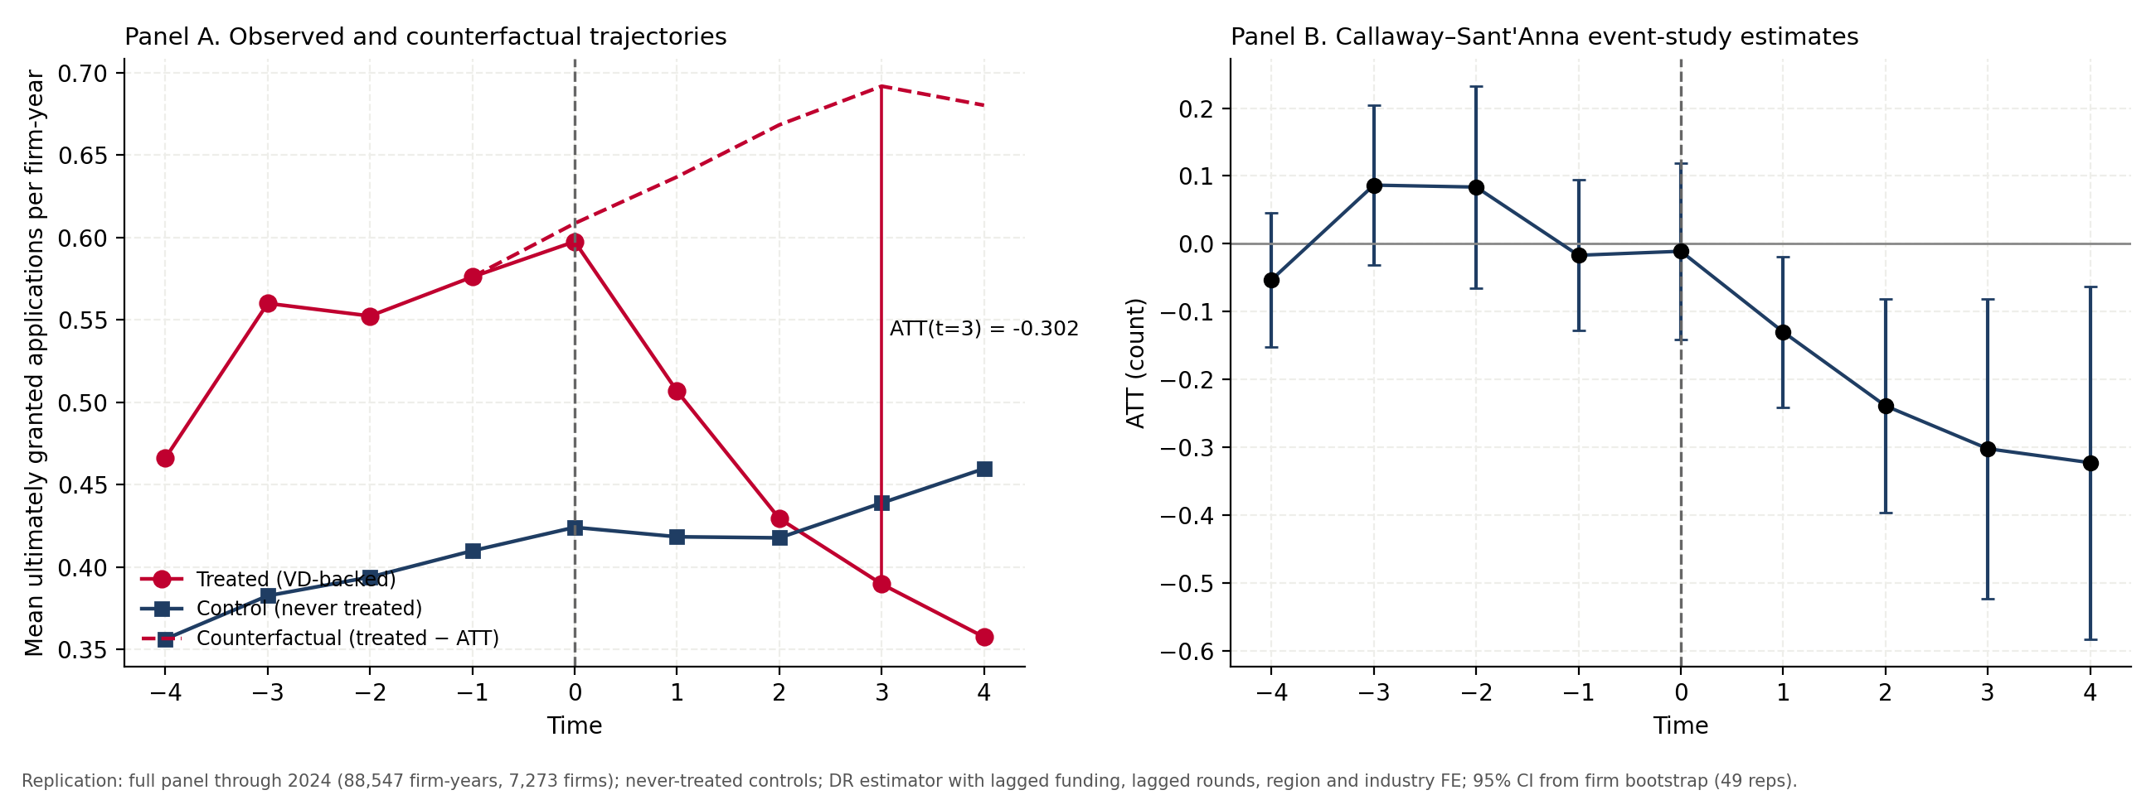
Panel A: treated mean = average count across VD-backed firm-years at each event time; control mean = never-treated mean in the same calendar year, weighted by the number of treated firm-years in each cohort at that event time. Counterfactual = treated mean − ATT(e) for e ≥ 0. Panel B: event-time ATTs with 95% bootstrap confidence intervals.
What was reproduced
Item | Original | Replication | Status
Observations / firms (all) | 88,547 / 7,273 | 88,547 / 7,273 | Exact
Prior / no-prior firm counts | 6,255 / 6,892 | 6,255 / 6,892 | Exact
Early / late firm counts | 6,860 / 6,287 | 6,860 / 6,287 | Exact (obs differ by 31)
Figure 1A treated means (t−4…t+4) | 0.466 … 0.358 | 0.466 … 0.358 | Exact, all 9 points
Figure 1A control means (t−4…t+4) | 0.356 … 0.460 | 0.356 … 0.460 | Exact, all 9 points
Table 1 col. 1 Simple / Aggregated ATT | −0.226 / −0.190 | −0.225 / −0.201 | Close
Table 1 col. 3 Prior patent | −0.817 / −0.650 | −0.836 / −0.702 | Close
Table 1 cols. 2, 4, 5 | −0.05; −0.138; −0.528 | −0.013; −0.178; −0.384 | Same sign, different size
Figure 1B event-time ATTs | −0.012 … −0.345 | −0.011 … −0.323 | Close; pre-period t−2 differs (+0.03 vs +0.08)
Table 2 (citations) | 0.248; 1.157; −2.263 … | 0.181; 1.271; −3.051 … | Partly; DV definition uncertain
Sensitivity to grant truncation (point estimates)
The outcome counts applications filed through 2024 that were granted by the end of 2024. Applications filed in 2021–2024 have mostly not yet been granted, so recent years are under-counted, and these years fall disproportionately in the post-treatment periods of later VD cohorts. Restricting to years where grant status is substantially observed reduces the estimates, especially for prior-patent firms:
Specification | All firms: Simple / Aggregated | Prior patent: Simple / Aggregated
Original definition, filing years ≤ 2024 (Table 1) | −0.225 / −0.201 | −0.836 / −0.702
Same outcome, filing years ≤ 2020 | −0.198 / −0.163 | −0.391 / −0.371
Granted within 3 years of filing, filing years ≤ 2021 | −0.186 / −0.133 | −0.237 / −0.216
These sensitivity rows are point estimates only (no bootstrap). The direction of the effect survives, but roughly half to two-thirds of the prior-patent effect in Table 1 appears to come from truncated recent years.

