**Project Phase 6: Security Recommendations**

Name: Yaling Wei

No: 000930508

Fall 2024

Mobile Application Development

(CPRG-303-F)

Date: Dec 15th.2024

**Security Recommendations for Parking App**

1. **What is your security recommendation? Why did you choose it?**

"The app only requests the minimum set of permissions necessary" (from Platform Interaction section of Android App Security Checklist).

Reasons for choice:

1.Our parking app requires several sensitive permissions based on code review:

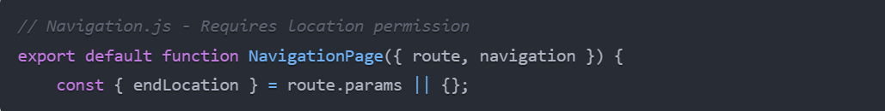

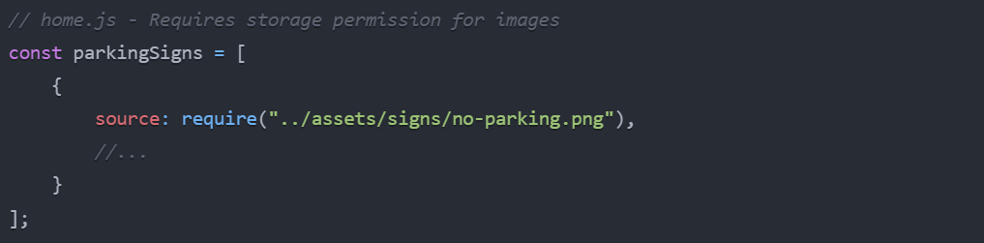

2. Currently lacks structured permission management

3.Critical for protecting user privacy and data security

4. Directly impacts core app functionality

1. **Who does the recommendation benefit (end-user, developer, etc.)?**

End Users:

* Protected from unnecessary data exposure
* Clear understanding of what permissions are needed and why
* Control over their personal data access
* Improved app trust and transparency

Developers:

* Clearer permission architecture
* Reduced security liability
* Easier debugging of permission-related issues
* Simplified maintenance

Business Stakeholders:

* Enhanced app store compliance
* Reduced risk of privacy-related incidents
* Increased user trust
* Better market reputation

1. **If the recommendation was found somewhere other than the provided checklist, include a link to it.**

Direct reference from Android App Security Checklist: <https://github.com/muellerberndt/android_app_security_checklist>

Section: Platform Interaction Item: "The app only requests the minimum set of permissions necessary"

1. **When would the recommendation have to be implemented (based on how serious the security risk is)?**

**Priority Level:** High - Must be implemented before production release

**Proposed Schedule:**

* Week 1: Audit and Analysis
  + Review all current permissions
  + Document necessary vs unnecessary permissions
  + Create permission request flowchart
* Week 2: Implementation
  + Develop permission management system
  + Integrate with existing features
  + Testing and validation

**Rationale for Urgency:**

* Core security feature affecting user privacy
* Required for app store compliance
* Impacts main app functionality (navigation, image loading)
* Prevention of potential security incidents

1. **Why do you think your project needs your recommendation?**

**Current Code Review:**

1. Navigation Features:

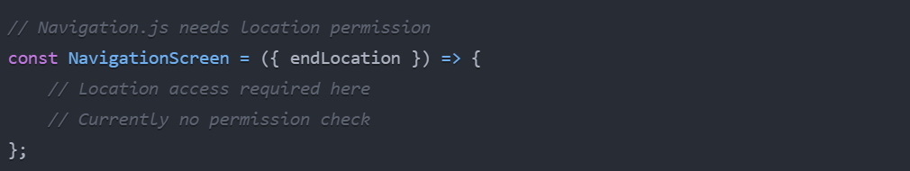

1. Asset Management:

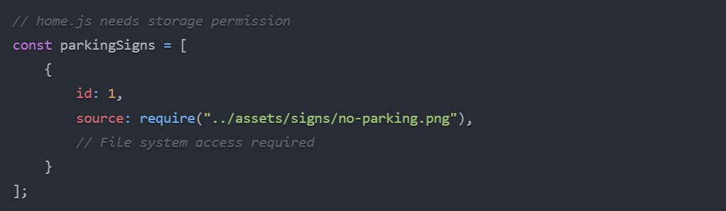

1. User Interface:

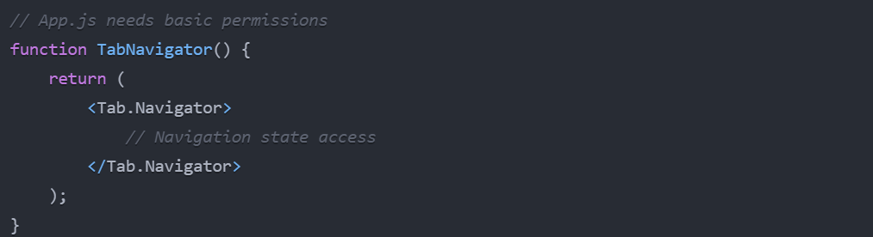

**Required Permissions:**

1. ACCESS_FINE_LOCATION - For navigation
2. READ_EXTERNAL_STORAGE - For loading parking signs
3. INTERNET - For data communication
4. ACCESS_NETWORK_STATE - For connectivity checks
5. **How do you think your recommendation could be applied?**
6. Permission Management System:

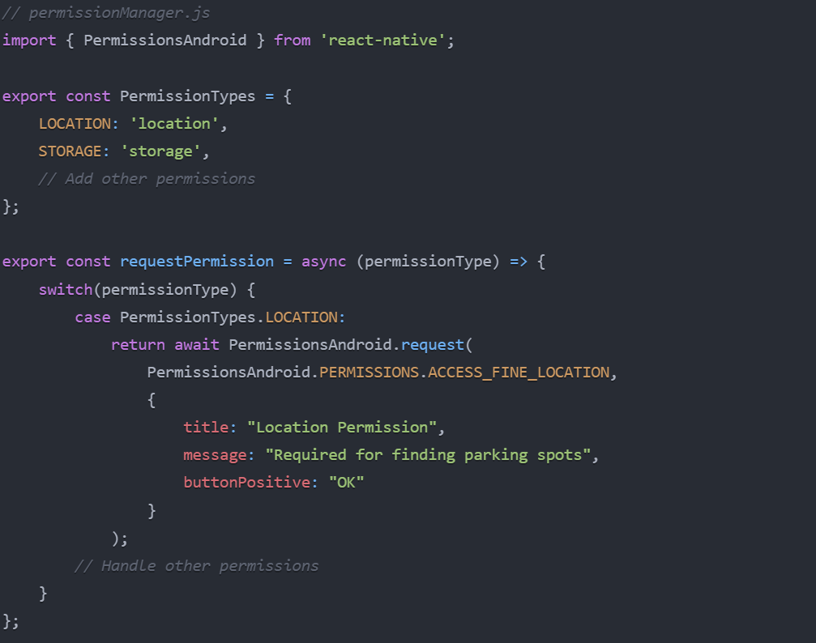

1. Integration Example:

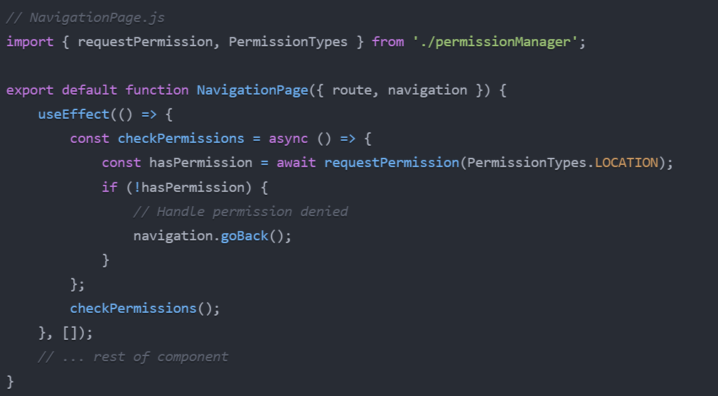

1. **How feasible would the implementation be?**

· Technical Requirements:

* React Native Permissions library
* Android SDK configuration updates
* Permission state management system

· Resource Requirements:

* Development time: 2 weeks
* Testing time: 1 week
* Documentation: 2-3 days

· Implementation Challenges:

* Handling permission denials gracefully
* Managing permission state across app
* Backward compatibility
* Testing on different Android versions

· Maintenance Considerations:

* Regular permission audit needed
* Updates for new Android versions
* User feedback monitoring
* Permission-related error tracking