Discriminant Analysis

Nadia Ahmad

2023-02-18

# PCA Analysis on Travel Discrimination

Dataset explanation: 1. Dependent Variable: * Q1 = travel frequency 2. Independent Variables: * Q6_15 = Checkin experience rate * Q6_16 = Bag drop off experience rate  
* Q6_17 = Security line experience rate * Q6_18 = Boarding airplane experience rate  
* Q6_19 = Travel experience compared to other travelers rate * Q14 = Age Group * Q15 = Gender * Q16 = US citizenship * Q17 = Race  
## Library

library(readr)  
library(tidyverse)  
library(XML)  
library(corrplot)  
library(factoextra)  
library(MASS)  
library(mvtnorm)  
library(MVN)  
library(psych)  
library(ggfortify)  
library(ggpubr)  
library(mvoutlier)  
library(heplots)  
library(e1071)  
library(caret)  
library(klaR)  
library(candisc)  
library(caTools)  
library(DMwR2)  
library(class)

## Read the dataset

travel_df <- read_csv("Travel Study 2.14.23.csv")  
head(travel_df)

## # A tibble: 6 × 89  
## Start…¹ EndDate Status IPAdd…² Progr…³ Durat…⁴ Finis…⁵ Recor…⁶ Respo…⁷ Recip…⁸  
## <chr> <chr> <chr> <chr> <chr> <chr> <chr> <chr> <chr> <chr>   
## 1 "Start… "End D… "Resp… "IP Ad… "Progr… "Durat… "Finis… "Recor… "Respo… "Recip…  
## 2 "{\"Im… "{\"Im… "{\"I… "{\"Im… "{\"Im… "{\"Im… "{\"Im… "{\"Im… "{\"Im… "{\"Im…  
## 3 "7/4/2… "7/4/2… "0" "72.31… "100" "177" "1" "7/4/2… "R_33D… <NA>   
## 4 "7/4/2… "7/4/2… "0" "172.5… "100" "174" "1" "7/4/2… "R_32K… <NA>   
## 5 "7/4/2… "7/4/2… "0" "174.2… "100" "570" "1" "7/4/2… "R_1K2… <NA>   
## 6 "7/4/2… "7/4/2… "0" "72.18… "100" "256" "1" "7/4/2… "R_2zB… <NA>   
## # … with 79 more variables: RecipientFirstName <chr>, RecipientEmail <chr>,  
## # ExternalReference <chr>, LocationLatitude <chr>, LocationLongitude <chr>,  
## # DistributionChannel <chr>, UserLanguage <chr>, `Text / Graphic` <chr>,  
## # Q1 <chr>, Q2 <chr>, Q3 <chr>, Q4 <chr>, Q5 <chr>, Q6_15 <chr>, Q6_16 <chr>,  
## # Q6_17 <chr>, Q6_18 <chr>, Q6_19 <chr>, Q7_0_GROUP <chr>, Q7_1_GROUP <chr>,  
## # Q7_2_GROUP <chr>, Q7_0_1_RANK <chr>, Q7_0_2_RANK <chr>, Q7_0_3_RANK <chr>,  
## # Q7_0_4_RANK <chr>, Q7_0_5_RANK <chr>, Q7_0_6_RANK <chr>, …

Dataset contains 230 rows and 89 columns which is still messy. Thus, we’ll conduct some data preprocessing steps.  
  
## DATA PREPROCESSING

# First, drop two first rows. Next, filter only data that has 100 in progress  
travel_df <- travel_df %>%   
 slice(-c(1,2)) %>%  
 filter(Progress == '100')  
  
# Drop the first 11 columns since it contains the questionnaire status  
travel_df_clean <- travel_df[-c(1:18)]  
  
# Drop all column that contains _RANK in the end of the name  
travel_df_clean <- travel_df_clean[!grepl("_RANK$", names(travel_df_clean))]  
  
# Drop optional column named Q20 and column contains _TEXT in the end of name  
travel_df_clean <- travel_df_clean[!grepl("_TEXT$", names(travel_df_clean))]

# Select used columns  
travel_df_clean <- subset(travel_df_clean, select = c(Q1, Q6_15, Q6_16,  
 Q6_17, Q6_18, Q6_19,  
 Q14, Q15, Q16, Q17))

# CHECK MISSING VALUE----  
# Count the missing values by column wise  
print("Count of missing values by column wise")

## [1] "Count of missing values by column wise"

sapply(travel_df_clean, function(x) sum(is.na(x)))

## Q1 Q6_15 Q6_16 Q6_17 Q6_18 Q6_19 Q14 Q15 Q16 Q17   
## 0 4 8 6 6 8 1 1 1 1

# Missing value imputation  
# Since our data contains 46 missing value, let's impute with mode  
# Function to see mode  
calc_mode <- function(x){  
   
 # List the distinct / unique values  
 distinct_values <- unique(na.omit(x))  
   
 # Count the occurrence of each distinct value  
 distinct_tabulate <- tabulate(match(x, distinct_values))  
   
 # Return the value with the highest occurrence  
 distinct_values[which.max(distinct_tabulate)]  
}  
  
# Impute missing value----  
travel_df_clean <- travel_df_clean %>%   
 mutate(across(everything(), ~replace_na(.x, calc_mode(.x))))

# CONVERT DATA TYPE----  
# Convert all variables into integer  
# Convert column 2 to 6 to numeric  
travel_df_clean[,1:10] <- sapply(travel_df_clean[,1:10], as.integer)  
travel_df_clean[,2:6] <- sapply(travel_df_clean[,2:6], as.numeric)  
head(travel_df_clean)

## # A tibble: 6 × 10  
## Q1 Q6_15 Q6_16 Q6_17 Q6_18 Q6_19 Q14 Q15 Q16 Q17  
## <int> <dbl> <dbl> <dbl> <dbl> <dbl> <int> <int> <int> <int>  
## 1 4 54 50 71 50 51 2 1 1 6  
## 2 4 52 52 51 53 52 4 2 1 1  
## 3 3 50 50 50 50 50 7 2 1 6  
## 4 4 51 53 54 52 57 3 1 1 6  
## 5 4 48 100 100 100 100 3 2 2 6  
## 6 4 50 50 50 50 50 7 2 1 2

# Rename column name  
travel_df_clean <- travel_df_clean %>%   
 rename(travel_frequency = 1, checkin_exp = 2,  
 baggage_exp = 3, security_exp = 4, boarding_exp =5,  
 travel_exp = 6, age = 7, gender =8, citizenship = 9,  
 race = 10)  
head(travel_df_clean)

## # A tibble: 6 × 10  
## travel_fr…¹ check…² bagga…³ secur…⁴ board…⁵ trave…⁶ age gender citiz…⁷ race  
## <int> <dbl> <dbl> <dbl> <dbl> <dbl> <int> <int> <int> <int>  
## 1 4 54 50 71 50 51 2 1 1 6  
## 2 4 52 52 51 53 52 4 2 1 1  
## 3 3 50 50 50 50 50 7 2 1 6  
## 4 4 51 53 54 52 57 3 1 1 6  
## 5 4 48 100 100 100 100 3 2 2 6  
## 6 4 50 50 50 50 50 7 2 1 2  
## # … with abbreviated variable names ¹​travel_frequency, ²​checkin_exp,  
## # ³​baggage_exp, ⁴​security_exp, ⁵​boarding_exp, ⁶​travel_exp, ⁷​citizenship

## EXPLORATORY DATA ANALYSIS

### 1. Summary Statistics

mvn(travel_df_clean, univariatePlot = "qq")

## $multivariateNormality  
## Test HZ p value MVN  
## 1 Henze-Zirkler 2.053604 0 NO  
##   
## $univariateNormality  
## Test Variable Statistic p value Normality  
## 1 Anderson-Darling travel_frequency 14.4161 <0.001 NO   
## 2 Anderson-Darling checkin_exp 8.1987 <0.001 NO   
## 3 Anderson-Darling baggage_exp 11.4048 <0.001 NO   
## 4 Anderson-Darling security_exp 1.7367 2e-04 NO   
## 5 Anderson-Darling boarding_exp 9.7366 <0.001 NO   
## 6 Anderson-Darling travel_exp 12.4107 <0.001 NO   
## 7 Anderson-Darling age 5.5692 <0.001 NO   
## 8 Anderson-Darling gender 17.1722 <0.001 NO   
## 9 Anderson-Darling citizenship 32.1842 <0.001 NO   
## 10 Anderson-Darling race 12.9843 <0.001 NO   
##   
## $Descriptives  
## n Mean Std.Dev Median Min Max 25th 75th  
## travel_frequency 136 3.294118 0.6338319 3 2 4 3 4.00  
## checkin_exp 136 54.448529 19.7258319 50 0 100 50 60.00  
## baggage_exp 136 56.272059 16.8709555 50 0 100 50 60.00  
## security_exp 136 50.345588 26.2431307 50 0 100 30 70.00  
## boarding_exp 136 55.691176 18.2227024 50 0 100 50 60.25  
## travel_exp 136 56.250000 17.1911907 50 5 100 50 60.00  
## age 136 3.852941 1.6712356 4 2 7 2 5.00  
## gender 136 1.566176 0.6520873 2 1 5 1 2.00  
## citizenship 136 1.352941 1.0578063 1 1 7 1 1.00  
## race 136 5.102941 2.4533557 6 1 11 2 6.00  
## Skew Kurtosis  
## travel_frequency -0.326729731 -0.7155349  
## checkin_exp 0.053050339 1.0952834  
## baggage_exp 0.739915663 1.4220413  
## security_exp -0.008747504 -0.6426500  
## boarding_exp 0.372732355 1.4279178  
## travel_exp 0.658496427 1.7247166  
## age 0.382441118 -1.1282366  
## gender 1.983934918 8.6788556  
## citizenship 4.485652051 20.9228723  
## race 0.013401814 -0.5532205

### 2. Detecting Outliers  
We’ll look at outlier in first 6 columns in variable.

aq.plot(travel_df_clean[,1:6])

## Projection to the first and second robust principal components.  
## Proportion of total variation (explained variance): 0.7883824

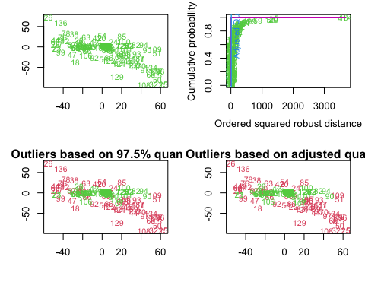

## $outliers  
## [1] FALSE FALSE FALSE FALSE TRUE FALSE FALSE TRUE FALSE TRUE FALSE TRUE  
## [13] FALSE FALSE TRUE TRUE TRUE TRUE TRUE TRUE FALSE FALSE FALSE TRUE  
## [25] TRUE TRUE FALSE FALSE TRUE TRUE FALSE TRUE FALSE FALSE TRUE FALSE  
## [37] FALSE TRUE FALSE FALSE TRUE TRUE FALSE TRUE TRUE TRUE TRUE FALSE  
## [49] TRUE TRUE TRUE FALSE FALSE TRUE FALSE TRUE TRUE TRUE TRUE TRUE  
## [61] FALSE FALSE TRUE FALSE FALSE TRUE TRUE FALSE TRUE TRUE FALSE FALSE  
## [73] FALSE FALSE FALSE TRUE FALSE TRUE FALSE FALSE FALSE FALSE TRUE TRUE  
## [85] TRUE TRUE TRUE TRUE FALSE FALSE FALSE TRUE TRUE FALSE TRUE TRUE  
## [97] TRUE FALSE TRUE FALSE FALSE FALSE FALSE FALSE FALSE FALSE FALSE TRUE  
## [109] TRUE FALSE TRUE TRUE FALSE FALSE FALSE FALSE FALSE FALSE FALSE TRUE  
## [121] FALSE TRUE FALSE TRUE FALSE FALSE FALSE FALSE TRUE TRUE FALSE TRUE  
## [133] TRUE TRUE FALSE TRUE

### 3. QQ-Plot Since we got error in integer variable, system is exactly singular: U[2,2] = 0, thus we’ll do chi-square quantile plot in numeric (var 1 to 6) only.

mvn(travel_df_clean[,1:6], mvnTest = "hz", multivariatePlot = "scatter",   
 multivariateOutlierMethod="quan")

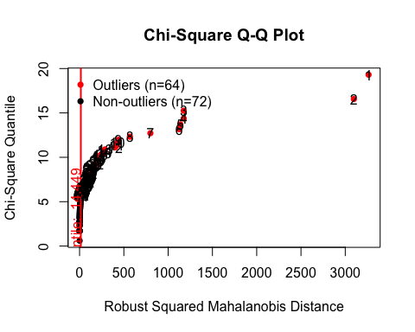

## $multivariateNormality  
## Test HZ p value MVN  
## 1 Henze-Zirkler 6.820019 0 NO  
##   
## $univariateNormality  
## Test Variable Statistic p value Normality  
## 1 Anderson-Darling travel_frequency 14.4161 <0.001 NO   
## 2 Anderson-Darling checkin_exp 8.1987 <0.001 NO   
## 3 Anderson-Darling baggage_exp 11.4048 <0.001 NO   
## 4 Anderson-Darling security_exp 1.7367 2e-04 NO   
## 5 Anderson-Darling boarding_exp 9.7366 <0.001 NO   
## 6 Anderson-Darling travel_exp 12.4107 <0.001 NO   
##   
## $Descriptives  
## n Mean Std.Dev Median Min Max 25th 75th  
## travel_frequency 136 3.294118 0.6338319 3 2 4 3 4.00  
## checkin_exp 136 54.448529 19.7258319 50 0 100 50 60.00  
## baggage_exp 136 56.272059 16.8709555 50 0 100 50 60.00  
## security_exp 136 50.345588 26.2431307 50 0 100 30 70.00  
## boarding_exp 136 55.691176 18.2227024 50 0 100 50 60.25  
## travel_exp 136 56.250000 17.1911907 50 5 100 50 60.00  
## Skew Kurtosis  
## travel_frequency -0.326729731 -0.7155349  
## checkin_exp 0.053050339 1.0952834  
## baggage_exp 0.739915663 1.4220413  
## security_exp -0.008747504 -0.6426500  
## boarding_exp 0.372732355 1.4279178  
## travel_exp 0.658496427 1.7247166

### 4. PAIRS PLOT

my_cols <- c( "#FC4E07","#00AFBB", "#E7B800")   
pairs(travel_df_clean[,2:7], pch = 19, cex = 0.5,  
 col = my_cols[travel_df_clean$travel_frequency])

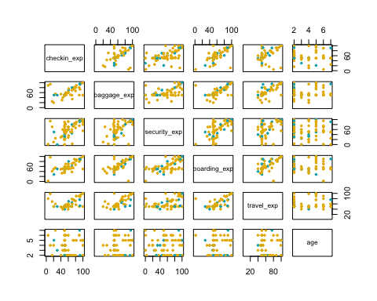

pairs.panels(travel_df_clean[,2:7],   
 method = "pearson", # correlation method  
 hist.col = "#00AFBB",  
 density = TRUE, # show density plots  
 ellipses = TRUE # show correlation ellipses  
 )

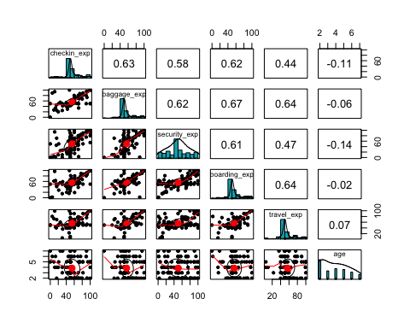

#   
corrplot(cor(travel_df_clean), method = "shade", tl.col = "black",  
 title = "", tl.cex = 0.5)

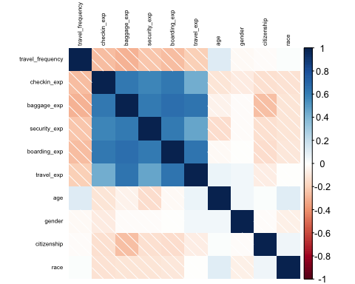

## DISCRIMINANT ANALYSIS : Box’s M Test

res <- boxM(travel_df_clean[, 2:10], travel_df_clean$travel_frequency)  
res

##   
## Box's M-test for Homogeneity of Covariance Matrices  
##   
## data: travel_df_clean[, 2:10]  
## Chi-Sq (approx.) = 171.12, df = 90, p-value = 5.497e-07

summary(res)

## Summary for Box's M-test of Equality of Covariance Matrices  
##   
## Chi-Sq: 171.1248   
## df: 90   
## p-value: 5.497e-07   
##   
## log of Covariance determinants:  
## 2 3 4 pooled   
## 18.27477 29.23418 26.88740 28.88102   
##   
## Eigenvalues:  
## 2 3 4 pooled  
## 1 2.789809e+03 1184.2516982 991.7000715 1246.9425150  
## 2 2.006836e+02 305.0701065 265.0773167 256.2821763  
## 3 1.073063e+02 211.8006628 191.3870988 190.7017421  
## 4 3.718787e+01 89.7146485 138.4337134 106.0105372  
## 5 1.048402e+01 53.6342078 54.0857507 81.5675913  
## 6 2.608863e+00 6.4090639 4.8602248 5.8535852  
## 7 1.554174e+00 2.6017449 2.5141851 2.6364432  
## 8 1.148517e-01 1.4368029 0.5192163 1.0304644  
## 9 7.923229e-03 0.5632593 0.1989103 0.4164921  
##   
## Statistics based on eigenvalues:  
## 2 3 4 pooled  
## product 8.642335e+07 4.968680e+12 4.753894e+11 3.490328e+12  
## sum 3.149756e+03 1.855482e+03 1.648776e+03 1.891442e+03  
## precision 7.348526e-03 3.278267e-01 1.317075e-01 2.529585e-01  
## max 2.789809e+03 1.184252e+03 9.917001e+02 1.246943e+03

Since the dataset didn’t achive the equal covariance assumption, we need to transform the dataset.

# Box cox transformation  
ind <- travel_df_clean[,-1]  
ind <- sqrt(ind)  
df_new <- cbind(travel_df_clean$travel_frequency, ind)  
head(df_new)

## travel_df_clean$travel_frequency checkin_exp baggage_exp security_exp  
## 1 4 7.348469 7.071068 8.426150  
## 2 4 7.211103 7.211103 7.141428  
## 3 3 7.071068 7.071068 7.071068  
## 4 4 7.141428 7.280110 7.348469  
## 5 4 6.928203 10.000000 10.000000  
## 6 4 7.071068 7.071068 7.071068  
## boarding_exp travel_exp age gender citizenship race  
## 1 7.071068 7.141428 1.414214 1.000000 1.000000 2.449490  
## 2 7.280110 7.211103 2.000000 1.414214 1.000000 1.000000  
## 3 7.071068 7.071068 2.645751 1.414214 1.000000 2.449490  
## 4 7.211103 7.549834 1.732051 1.000000 1.000000 2.449490  
## 5 10.000000 10.000000 1.732051 1.414214 1.414214 2.449490  
## 6 7.071068 7.071068 2.645751 1.414214 1.000000 1.414214

# Rename dependent variable  
df_new <- df_new %>%   
 rename(travel_frequency = 1)

# Test Box's M again  
res2 <- boxM(df_new[, 2:10], df_new$travel_frequency)  
res2

##   
## Box's M-test for Homogeneity of Covariance Matrices  
##   
## data: df_new[, 2:10]  
## Chi-Sq (approx.) = 183.93, df = 90, p-value = 2.039e-08

summary(res2)

## Summary for Box's M-test of Equality of Covariance Matrices  
##   
## Chi-Sq: 183.934   
## df: 90   
## p-value: 2.039e-08   
##   
## log of Covariance determinants:  
## 2 3 4 pooled   
## -16.798212 -6.924692 -7.284162 -6.286623   
##   
## Eigenvalues:  
## 2 3 4 pooled  
## 1 13.279489505 6.53094201 8.37630929 7.77236985  
## 2 1.948864692 1.88663543 2.21911124 1.78896453  
## 3 0.695580663 1.16747483 1.39673455 1.31711897  
## 4 0.371598461 0.55155820 1.22084811 0.70565371  
## 5 0.120836397 0.37459286 0.35837003 0.54030182  
## 6 0.073275399 0.25443962 0.28446667 0.33661708  
## 7 0.047120051 0.17007796 0.16122557 0.17069483  
## 8 0.013708598 0.11445292 0.04395433 0.08139106  
## 9 0.001324006 0.06679171 0.02997248 0.05699184  
##   
## Statistics based on eigenvalues:  
## 2 3 4 pooled  
## product 5.065580e-08 9.832057e-04 0.000686323 0.001861033  
## sum 1.655180e+01 1.111697e+01 14.090992262 12.770103704  
## precision 1.141432e-03 2.529000e-02 0.014138640 0.023053854  
## max 1.327949e+01 6.530942e+00 8.376309291 7.772369853

# Convert the travel_frequency to factor  
df_new$travel_frequency <- as.factor(df_new$travel_frequency)

## DISCRIMINANT ANALYSIS: Linear LDA

lda_model <- lda(travel_frequency ~., data = df_new)  
lda_model

## Call:  
## lda(travel_frequency ~ ., data = df_new)  
##   
## Prior probabilities of groups:  
## 2 3 4   
## 0.09558824 0.51470588 0.38970588   
##   
## Group means:  
## checkin_exp baggage_exp security_exp boarding_exp travel_exp age  
## 2 7.852995 8.294713 7.092386 7.984569 7.782902 1.837625  
## 3 7.437929 7.487044 7.111951 7.499173 7.586359 1.883587  
## 4 6.734485 7.073375 6.123599 6.954934 7.067300 1.978919  
## gender citizenship race  
## 2 1.191175 1.063725 2.270467  
## 3 1.248340 1.147458 2.124357  
## 4 1.211014 1.101390 2.231751  
##   
## Coefficients of linear discriminants:  
## LD1 LD2  
## checkin_exp -0.20069507 -0.20650029  
## baggage_exp -0.40145970 0.89934925  
## security_exp 0.01262291 -0.28836682  
## boarding_exp -0.11011986 0.11282853  
## travel_exp -0.26989173 -0.33685062  
## age 0.67987633 -0.01198983  
## gender -0.55932396 -1.43407268  
## citizenship -1.09422297 -0.56563158  
## race -0.10025985 0.64101934  
##   
## Proportion of trace:  
## LD1 LD2   
## 0.6549 0.3451

The percentage separation achieved by each discriminant function is 73.8% and 26.2% respectively.

### Scatter plot for discriminant function

lda_values <- predict(lda_model)  
plot(lda_values$x[,1], lda_values$x[,2])  
text(lda_values$x[,1], lda_values$x[,2], df_new$travel_frequency, cex = 0.7, pos = 4, col = "red")

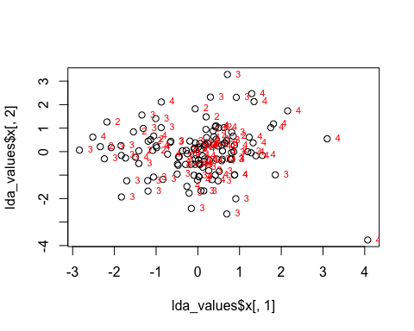

newdata <- data.frame(type = df_new[,1], lda = lda_values$x)  
ggplot(newdata) + geom_point(aes(lda.LD1, lda.LD2, colour = type), size = 2.5)

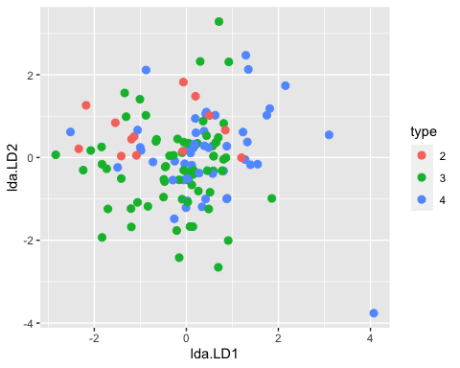

# Partition Plot  
partimat(travel_frequency~checkin_exp+baggage_exp+security_exp+boarding_exp+travel_exp,data=df_new,method="lda")

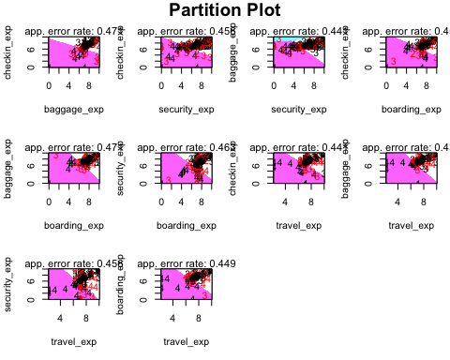

partimat(travel_frequency~age+gender+citizenship+race,data=df_new,method="lda")

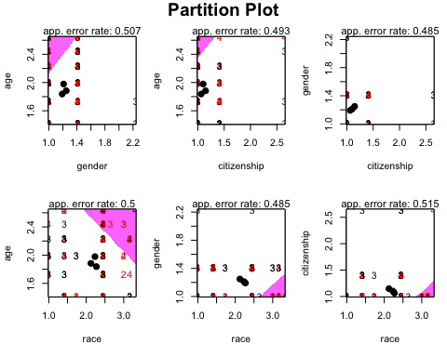

### Prediction Accuracy

#df_new$travel_frequency <- as.factor(df_new$travel_frequency)  
lda_predict <- train(travel_frequency ~ ., method = "lda", data = df_new)  
confusionMatrix(df_new$travel_frequency, predict(lda_predict, df_new))

## Confusion Matrix and Statistics  
##   
## Reference  
## Prediction 2 3 4  
## 2 0 8 5  
## 3 0 53 17  
## 4 1 31 21  
##   
## Overall Statistics  
##   
## Accuracy : 0.5441   
## 95% CI : (0.4566, 0.6297)  
## No Information Rate : 0.6765   
## P-Value [Acc > NIR] : 0.999526   
##   
## Kappa : 0.1364   
##   
## Mcnemar's Test P-Value : 0.002043   
##   
## Statistics by Class:  
##   
## Class: 2 Class: 3 Class: 4  
## Sensitivity 0.000000 0.5761 0.4884  
## Specificity 0.903704 0.6136 0.6559  
## Pos Pred Value 0.000000 0.7571 0.3962  
## Neg Pred Value 0.991870 0.4091 0.7349  
## Prevalence 0.007353 0.6765 0.3162  
## Detection Rate 0.000000 0.3897 0.1544  
## Detection Prevalence 0.095588 0.5147 0.3897  
## Balanced Accuracy 0.451852 0.5949 0.5721

We can only achieve 54.41% accuracy from our linear discriminant analysis model.  
  
## Quadratic Discriminant Analysis

qda_model <- qda(travel_frequency ~., data = df_new)  
qda_model

## Call:  
## qda(travel_frequency ~ ., data = df_new)  
##   
## Prior probabilities of groups:  
## 2 3 4   
## 0.09558824 0.51470588 0.38970588   
##   
## Group means:  
## checkin_exp baggage_exp security_exp boarding_exp travel_exp age  
## 2 7.852995 8.294713 7.092386 7.984569 7.782902 1.837625  
## 3 7.437929 7.487044 7.111951 7.499173 7.586359 1.883587  
## 4 6.734485 7.073375 6.123599 6.954934 7.067300 1.978919  
## gender citizenship race  
## 2 1.191175 1.063725 2.270467  
## 3 1.248340 1.147458 2.124357  
## 4 1.211014 1.101390 2.231751

### Accuracy for QDA

qda_predict <- train(travel_frequency ~ ., method = "qda", data = df_new)  
confusionMatrix(df_new$travel_frequency, predict(qda_predict, df_new))

## Confusion Matrix and Statistics  
##   
## Reference  
## Prediction 2 3 4  
## 2 12 0 1  
## 3 5 57 8  
## 4 2 31 20  
##   
## Overall Statistics  
##   
## Accuracy : 0.6544   
## 95% CI : (0.5681, 0.7338)  
## No Information Rate : 0.6471   
## P-Value [Acc > NIR] : 0.4677614   
##   
## Kappa : 0.3942   
##   
## Mcnemar's Test P-Value : 0.0002871   
##   
## Statistics by Class:  
##   
## Class: 2 Class: 3 Class: 4  
## Sensitivity 0.63158 0.6477 0.6897  
## Specificity 0.99145 0.7292 0.6916  
## Pos Pred Value 0.92308 0.8143 0.3774  
## Neg Pred Value 0.94309 0.5303 0.8916  
## Prevalence 0.13971 0.6471 0.2132  
## Detection Rate 0.08824 0.4191 0.1471  
## Detection Prevalence 0.09559 0.5147 0.3897  
## Balanced Accuracy 0.81152 0.6884 0.6906

It looks like our QDA model has better accuracy, which is 65.44% comparing to LDA model.

## STEP WISE LDA

# Wilk stepwise  
greedy.wilks(travel_frequency~.,data=df_new)

## Formula containing included variables:   
##   
## travel_frequency ~ baggage_exp + security_exp  
## <environment: 0x15227c478>  
##   
##   
## Values calculated in each step of the selection procedure:   
##   
## vars Wilks.lambda F.statistics.overall p.value.overall  
## 1 baggage_exp 0.9168516 6.030823 0.003110902  
## 2 security_exp 0.8900001 3.959857 0.003869904  
## F.statistics.diff p.value.diff  
## 1 6.030823 0.003110902  
## 2 1.991236 0.140576186

Only two independents variables that have significant affect on travel_frequency.

## WILK TEST

dependent <- df_new$travel_frequency  
independent <- as.matrix(df_new[,-1])  
manova1<-manova(independent ~ dependent)  
wilks.test<-summary(manova1,test="Wilks")  
wilks.test

## Df Wilks approx F num Df den Df Pr(>F)  
## dependent 2 0.82708 1.383 18 250 0.1399  
## Residuals 133

Wilk lambda explained how well the independent variable contributes to the model. The scale ranges from 0 to 1, where 0 means total discrimination, and 1 means no discrimination. Since our Wilk is close to 1, we can’t say the variables used in this model can’t explained the discriminant very well.  
  
## CANONICAL DISCRIMINANT ANALYSIS

# Canonical Discriminant Analysis  
cda <- candisc(manova1)  
print(cda)

##   
## Canonical Discriminant Analysis for dependent:  
##   
## CanRsq Eigenvalue Difference Percent Cumulative  
## 1 0.115827 0.131001 0.061977 65.492 65.492  
## 2 0.064568 0.069024 0.061977 34.508 100.000  
##   
## Test of H0: The canonical correlations in the   
## current row and all that follow are zero  
##   
## LR test stat approx F numDF denDF Pr(> F)  
## 1 0.82708 1.3830 18 250 0.1399  
## 2 0.93543 1.0871 8 126 0.3764

cda$coeffs.std

## Can1 Can2  
## checkin_exp -0.31468032 -0.323782641  
## baggage_exp -0.47082783 1.054747588  
## security_exp 0.02822710 -0.644840209  
## boarding_exp -0.14943060 0.153106218  
## travel_exp -0.31974200 -0.399068503  
## age 0.28996863 -0.005113687  
## gender -0.13494808 -0.345998694  
## citizenship -0.33988187 -0.175693552  
## race -0.05966683 0.381484625

cda$structure

## Can1 Can2  
## checkin_exp -0.72078632 -0.04732982  
## baggage_exp -0.79217106 0.40254418  
## security_exp -0.58278689 -0.29846977  
## boarding_exp -0.70456517 0.06981342  
## travel_exp -0.66153212 -0.13253366  
## age 0.35561290 0.04700353  
## gender -0.09026694 -0.32887897  
## citizenship -0.06516545 -0.35550263  
## race 0.12070332 0.35394728

plot(cda)

## Vector scale factor set to 7.203

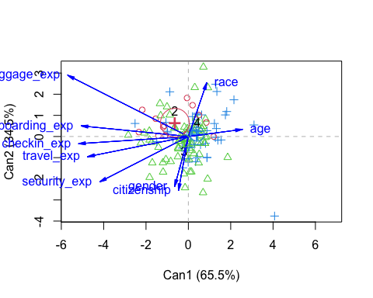

# Using only significance variable  
dependent <- df_new$travel_frequency  
independent2 <- as.matrix(df_new[,3:4])  
manova2<-manova(independent2 ~ dependent)  
wilks.test2<-summary(manova2,test="Wilks")  
wilks.test2

## Df Wilks approx F num Df den Df Pr(>F)   
## dependent 2 0.89 3.9599 4 264 0.00387 **  
## Residuals 133   
## ---  
## Signif. codes: 0 '***' 0.001 '**' 0.01 '*' 0.05 '.' 0.1 ' ' 1

## CANONICAL DISCRIMINANT ANALYSIS FOR SIGNIFICANT VARIABLE

cda2 <- candisc(manova2)  
print(cda2)

##   
## Canonical Discriminant Analysis for dependent:  
##   
## CanRsq Eigenvalue Difference Percent Cumulative  
## 1 0.083186 0.090733 0.060605 75.072 75.072  
## 2 0.029247 0.030128 0.060605 24.928 100.000  
##   
## Test of H0: The canonical correlations in the   
## current row and all that follow are zero  
##   
## LR test stat approx F numDF denDF Pr(> F)   
## 1 0.89000 3.9599 4 264 0.00387 **  
## 2 0.97075 4.0071 1 133 0.04734 *   
## ---  
## Signif. codes: 0 '***' 0.001 '**' 0.01 '*' 0.05 '.' 0.1 ' ' 1

cda2$coeffs.std

## Can1 Can2  
## baggage_exp -1.01762267 0.6377981  
## security_exp 0.03248253 -1.2005362

cda2$structure

## Can1 Can2  
## baggage_exp -0.9996545 -0.02628518  
## security_exp -0.5419874 -0.84038662

plot(cda2)

## Vector scale factor set to 2.799

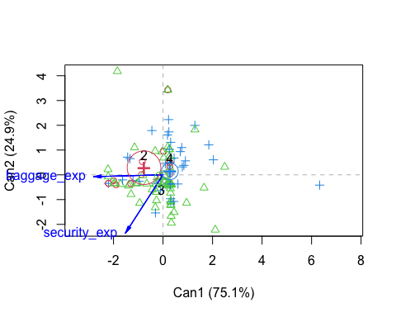  
## KNN

set.seed(42)  
sample <- sample(c(TRUE, FALSE), nrow(df_new), replace=TRUE, prob=c(0.75,0.25))  
train <- df_new[sample, ]  
test <- df_new[!sample, ]

knn <- knn(train = train, test = test, cl= train$travel_frequency, k=3)  
cm <- table(test$travel_frequency, knn)  
cm

## knn  
## 2 3 4  
## 2 1 2 0  
## 3 0 16 4  
## 4 0 3 10

# Calculate out of Sample error  
misClassError <- mean(knn != test$travel_frequency)  
print(paste('Accuracy =', 1-misClassError))

## [1] "Accuracy = 0.75"