Design Database for Taekwondo Online Stores

Author: Ngoc Dao

Part I. Database Design

# Full description of the objectives of your database system including the scope of the database

Database is created to manage online retail store which sells Taekwondo products such as, uniform, sparring gear, Taekwondo equipment, etc. The products are taken from either in or outside of the United States, but it sells to only consumers living in the United States.

The database totally contains sevens entities including Product, Supplier, Category, Order detail, Orders, Customer, and Shipping Detail.

Product entity is made up Product ID, Product Name, Supplier ID, Category ID, Color, Listing Price, Sale Price. It contains information of the character of the product and its origin.

Supplier entity comprises of Supplier ID, company name, location, and contact number.

Category entity includes Category ID, Category name and description.

Order entity: Order ID, order date, shipping id, freight, sale tax, bill amount, paid, and payment date. It is generated when customers make an order. One order can contain many products.

Order detail: Order Id, product id, quantity, price, discount, total, and order date. Each order detail represents each ordered product and its quantity.

Customer: customer id, first name, last name, phone number, email address, street, state, and zip code. It basically contains customer’s information

Shipping detail: shipping id, shipping company, ship date, status, and delivery date. This entity let both customer and store manager track the order once it is shipped.

# User requirements that the system will be able to address.

For sale, the database can generate the sale revenues monthly and annually bases on the Order and Order details entity.

For customer, the system helps customers track their order by having the shipping details

Because the products are taken from various suppliers, the database helps to manage product from different suppliers and stores their information such as, phone number and location. Also, the supplier entity helps to identify which supplier is most or less favorable toward their customers.

Customer entity storages customer’s information. From there, store manager can identify the regular customers who frequently place order and might give the discount rate for them.

The database also generates the most frequency products that are ordered in a certain time.

# Business rules

One supplier can have many products.

One product belongs to one supplier.

One order detail includes one product.

One product is included by many orders details.

One product belongs to one category.

One category describes many products.

One order has many orders detail.

One order detail belongs to one order.

One customer can generate many orders.

One order is generated by one customer.

One order has one shipping detail.

One shipping detail refer to one order.

# Entity-Relationship Diagram (ERD) of the system.

# The data dictionary of the system.

|  |  |  |  |  |  |  |  |  |
| --- | --- | --- | --- | --- | --- | --- | --- | --- |
| Table name | attribute name | CONTENTS | TYPE | FORMAT | RANGE | REQUIRED | PK OR FK | FK REFERENCED TABLE |
| PRODUCT | ProductID | product unique number | CHAR(5) | 99999 | 10000-99999 | Y | PK |  |
| ProductName | the name of product | VARCHAR(20) | xxxxxxxxx |  | Y |  |  |
| SupplierID | the number of the supplier | CHAR(3) | 999 | 100-999 | Y | FK | SUPPLIER |
| CategoryID | number of category | CHAR(2) | 99 | 10-99 | Y | FK | CATEGORY |
| Color | the color of product | VARCHAR(20) | xxxxxxxxx |  | Y |  |  |
| ListingPrice |  | NUMBER(4,2) | 9,999.99 |  | Y |  |  |
| SalePrice |  | NUMBER(4,2) | 9,999.99 |  |  |  |  |
| SUPPLIER | SupplierID | supplier unique number | CHAR(3) | 999 |  | Y | PK |  |
| CompanyName | name of supplier | VARCHAR(20) | xxxxxxxxx |  | Y |  |  |
| Location | supplier location | VARCHAR(20) | xxxxxxxxx |  | Y |  |  |
| ContacNumber | supplier phone number | CHAR(12) | 999-999-9999 |  | Y |  |  |
| CATEGORY | CategoryID | number of category | CHAR(2) | 99 | 10-99 | Y | PK |  |
| CategoryName | category name | VARCHAR(20) | xxxxxxxxx |  | Y |  |  |
| Description |  | VARCHAR(20) | xxxxxxxxx |  |  |  |  |
| ORDER | OrderID | unique number | CHAR(7) | 9999999 | 1000000-9999999 |  | PK |  |
| CustomerID | customer id | CHAR(6) | 999999 | 100000-999999 |  | FK | CUSTOMER |
| OrderDate | date on which order is generated | DATE | mm/dd/yyyy |  | Y |  |  |
| ShippingID | number of shipping id | CHAR(6) | 999999 | 123000-123999 | Y | FK | SHIPPING DETAIL |
| Freight | shipping fee | NUMBER(3,2) | 999.99 |  | Y |  |  |
| SaleTax | Tax of sale | NUMBER(3,2) | 999.99 |  | Y |  |  |
| BillAmount | the amount of all the product |  |  |  |  |  |  |
| TotalAmount | total amount of the bill (include tax and shipping fee) | NUMBER(4,2) | 9,999.99 |  | Y |  |  |
| Paid | amount paid by customers | NUMBER(4,2) | 9,999.99 |  | Y |  |  |
| PaymentDate | date on which bill is paid fully | DATE | mm/dd/yyyy |  | Y |  |  |
| ORDER DETAIL | OrderID | unique number | CHAR(7) | 9999999 | 1000000-9999999 |  | PK, FK | ORDER |
| ProductID | unique number | CHAR(5) | 99999 | 10000-99999 | Y | PK, FK | PRODUCT |
| Quantity | quantity of a product | NUMBER(3) | 999 | 1-999 | Y |  |  |
| Price | price of a product | NUMBER(4,2) | 9,999.99 | 10-9999 | y |  |  |
| Discount | discount of a product | NUMBER(1,2) | 9.99 | 0.01-0.5 |  |  |  |
| Total | Total amount of product | NUMBER(4,2) | 9,999.99 | 10-9999 | Y |  |  |
| OrderDate | orderdate of a product | DATE | mm/dd/yyyy |  | Y |  |  |
| CUSTOMER | CustomerID | customer id | CHAR(6) | 999999 | 100000-999999 | y | PK |  |
| FirstName |  | VARCHAR(20) | xxxxxxxxx |  | Y |  |  |
| LastName |  | VARCHAR(20) | xxxxxxxxx |  | Y |  |  |
| PhoneNumber |  | CHAR(12) | 999-999-9999 |  | Y |  |  |
| EmailAddress |  | VARCHAR(20) | xxxxxxxxx |  | Y |  |  |
| Street |  | VARCHAR(20) | xxxxxxxxx |  | Y |  |  |
| State |  | VARCHAR(20) |  |  | Y |  |  |
| ZipCode |  | CHAR(5) | 99999 |  | Y |  |  |
| SHIPPING DETAIL | ShippingID | number of shipping id | CHAR(6) | 999999 | 123000-123999 | Y | PK |  |
| ShippingCompany | name of the shipping company | VARCHAR(20) | xxxxxxxxx |  | Y |  |  |
| ShipDate | the date on which order was shipped | DATE | mm/dd/yyyy |  | Y |  |  |
| Status | either shipped, transit, or delivered | VARCHAR(20) | xxxxxxxxx |  | Y |  |  |
| DeliveryDate | the date on which order was delivered | DATE | mm/dd/yyyy |  | Y |  |  |

Part II. The Database System

# Create tables and Insert values

1. Create the all the tables including category, supplier, customer, order, orderdetail, shippingdetail, and product

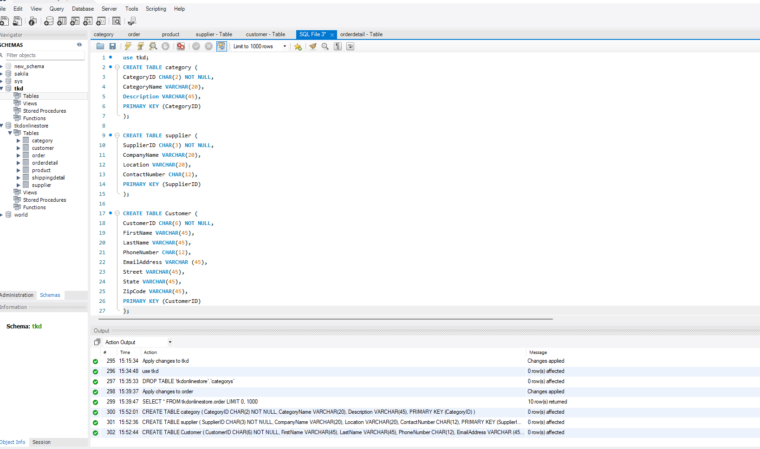

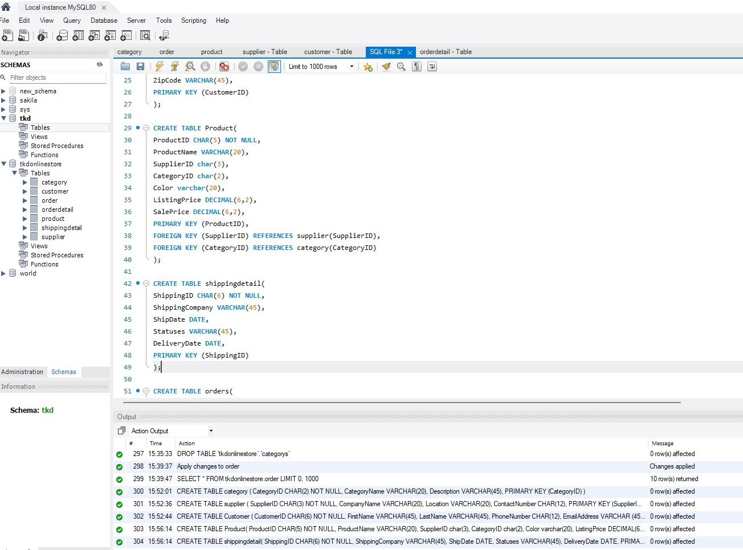

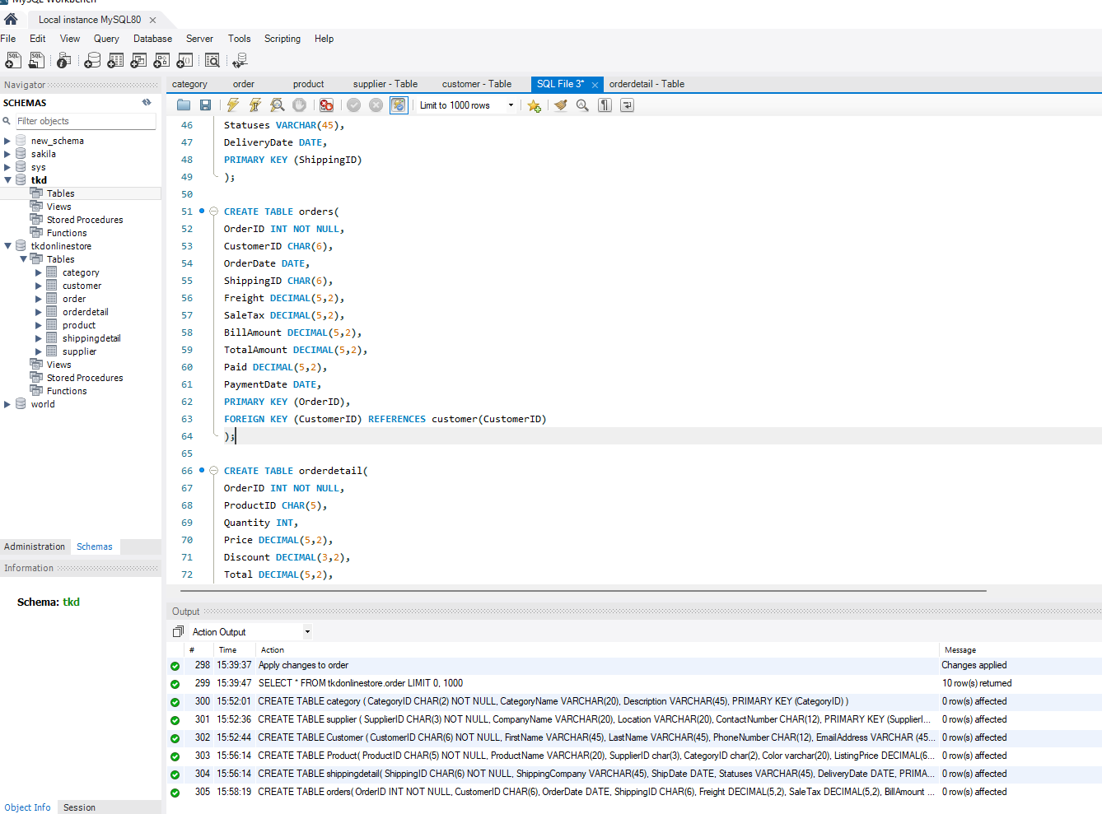

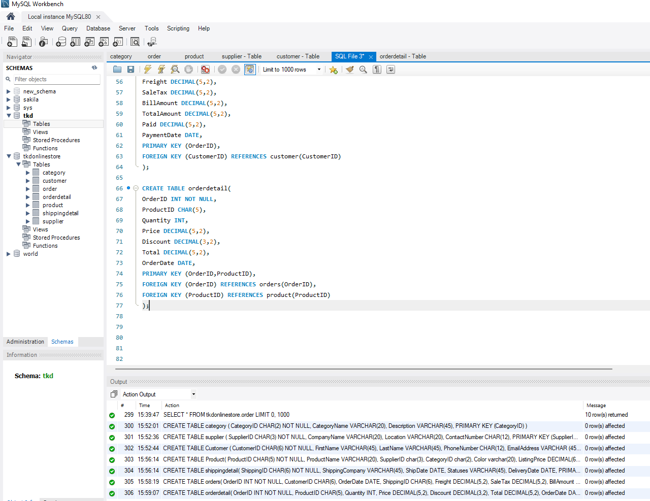

1. Insert data into supplier table

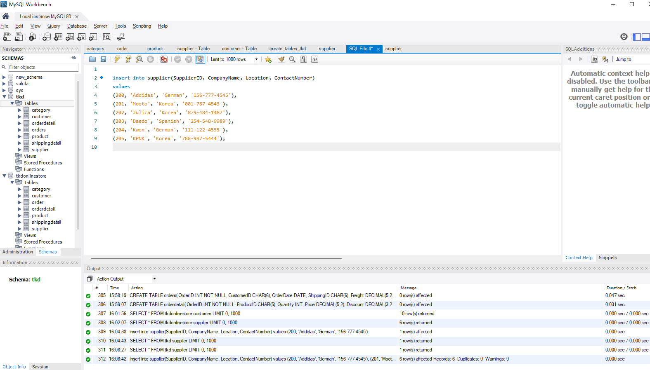

# Use SELECT statement in SQL

1. Shows all columns from supplier table ordered by supplierID.

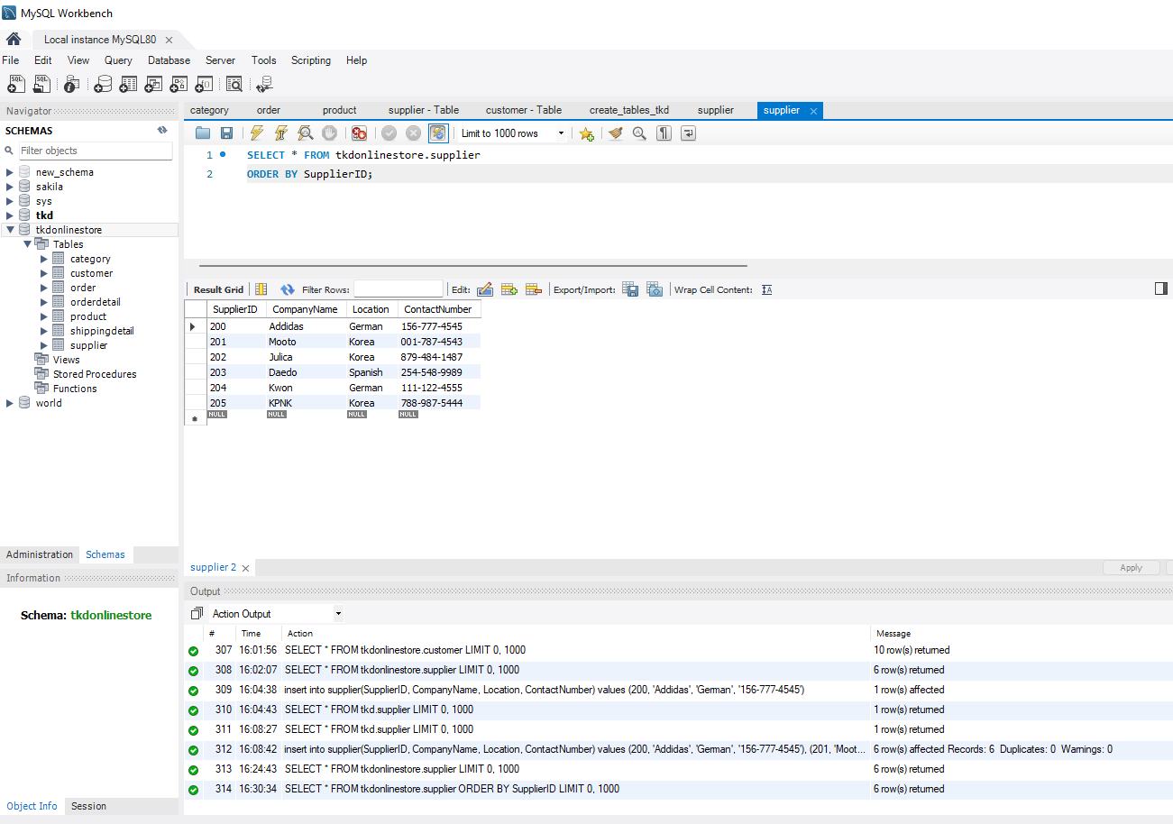

1. Shows customers’ first and last name who make order in 2022.

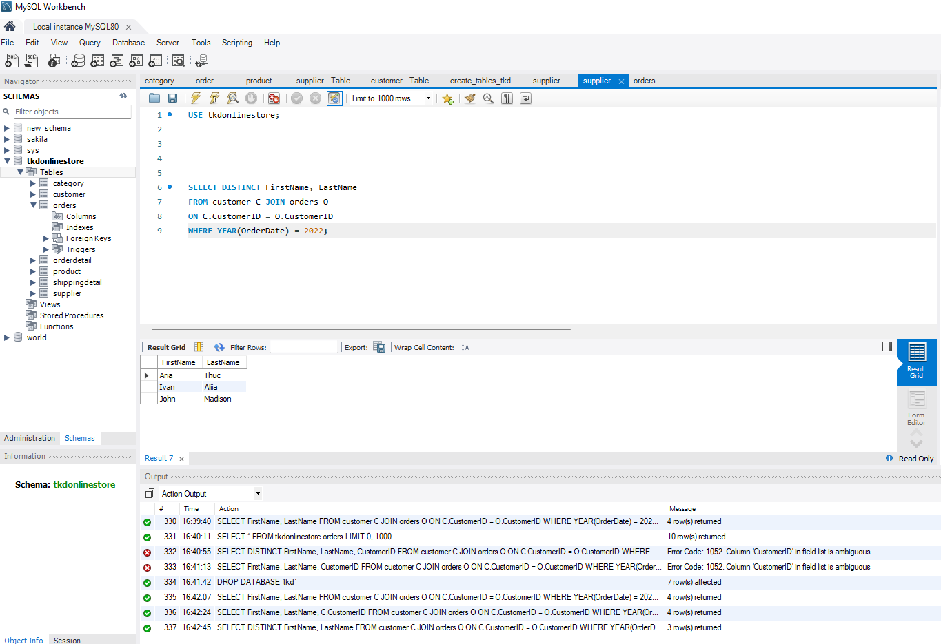

1. Show the product name that has the highest listing price.

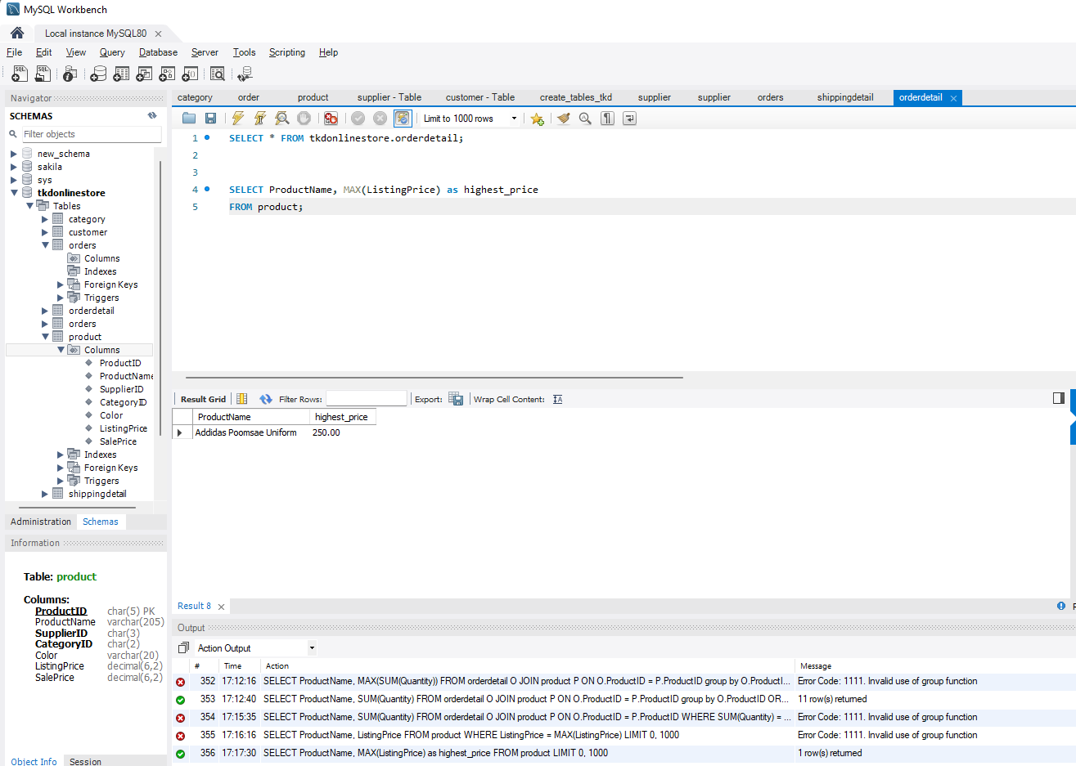

1. 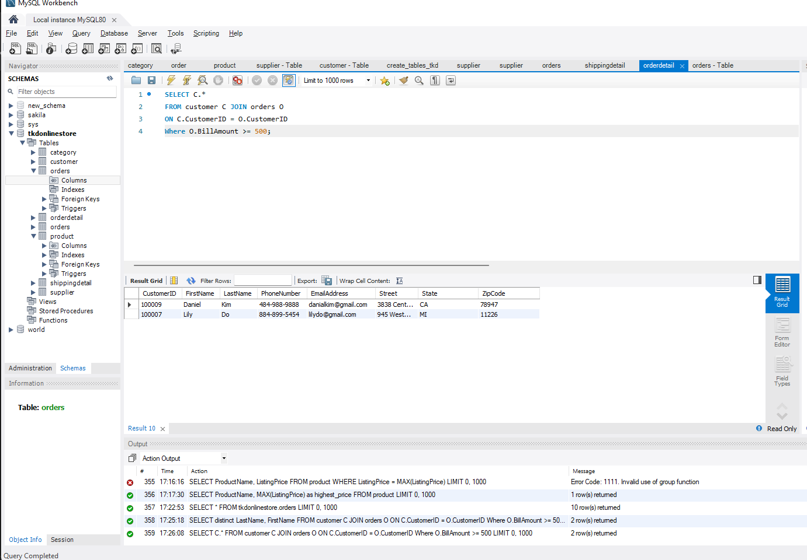Show all customers’ information who make order over $500 from customer table
2. Shows the frequencies products that being purchased and sorted in descending. (Shows product name and its frequencies)

