Class 14 Vaccination Rate Mini Project

Cindy Tran

2/13/2022

# Getting Started

# Import vaccination data  
vax <- read.csv("covid19vaccinesbyzipcode_test.csv")  
head(vax)

## as_of_date zip_code_tabulation_area local_health_jurisdiction county  
## 1 2021-01-05 94129 San Francisco San Francisco  
## 2 2021-01-05 92562 Riverside Riverside  
## 3 2021-01-05 92805 Orange Orange  
## 4 2021-01-05 92322 San Bernardino San Bernardino  
## 5 2021-01-05 94972 Sonoma Sonoma  
## 6 2021-01-05 94107 San Francisco San Francisco  
## vaccine_equity_metric_quartile vem_source  
## 1 4 Healthy Places Index Score  
## 2 3 Healthy Places Index Score  
## 3 1 Healthy Places Index Score  
## 4 NA No VEM Assigned  
## 5 NA No VEM Assigned  
## 6 4 Healthy Places Index Score  
## age12_plus_population age5_plus_population persons_fully_vaccinated  
## 1 3574.3 3900 NA  
## 2 53431.1 60184 12  
## 3 61414.4 69071 25  
## 4 581.0 632 NA  
## 5 25.0 25 NA  
## 6 28946.1 30103 12  
## persons_partially_vaccinated percent_of_population_fully_vaccinated  
## 1 NA NA  
## 2 868 0.000199  
## 3 977 0.000362  
## 4 NA NA  
## 5 NA NA  
## 6 836 0.000399  
## percent_of_population_partially_vaccinated  
## 1 NA  
## 2 0.014422  
## 3 0.014145  
## 4 NA  
## 5 NA  
## 6 0.027771  
## percent_of_population_with_1_plus_dose booster_recip_count  
## 1 NA NA  
## 2 0.014621 NA  
## 3 0.014507 NA  
## 4 NA NA  
## 5 NA NA  
## 6 0.028170 NA  
## redacted  
## 1 Information redacted in accordance with CA state privacy requirements  
## 2 Information redacted in accordance with CA state privacy requirements  
## 3 Information redacted in accordance with CA state privacy requirements  
## 4 Information redacted in accordance with CA state privacy requirements  
## 5 Information redacted in accordance with CA state privacy requirements  
## 6 Information redacted in accordance with CA state privacy requirements

Q1. What column details the total number of people fully vaccinated?

persons_fully_vaccinated

Q2. What column details the Zip code tabulation area?

zip_code_tabulation_area

Q3. What is the earliest date in this dataset?

2021-01-05

Q4. What is the latest date in this dataset?

2022-02-08

#install.packages("skimr")  
library(skimr)  
skimr::skim(vax)

Data summary

|  |  |
| --- | --- |
| Name | vax |
| Number of rows | 102312 |
| Number of columns | 15 |
| _______________________ |  |
| Column type frequency: |  |
| character | 5 |
| numeric | 10 |
| ________________________ |  |
| Group variables | None |

**Variable type: character**

| skim_variable | n_missing | complete_rate | min | max | empty | n_unique | whitespace |
| --- | --- | --- | --- | --- | --- | --- | --- |
| as_of_date | 0 | 1 | 10 | 10 | 0 | 58 | 0 |
| local_health_jurisdiction | 0 | 1 | 0 | 15 | 290 | 62 | 0 |
| county | 0 | 1 | 0 | 15 | 290 | 59 | 0 |
| vem_source | 0 | 1 | 15 | 26 | 0 | 3 | 0 |
| redacted | 0 | 1 | 2 | 69 | 0 | 2 | 0 |

**Variable type: numeric**

| skim_variable | n_missing | complete_rate | mean | sd | p0 | p25 | p50 | p75 | p100 | hist |
| --- | --- | --- | --- | --- | --- | --- | --- | --- | --- | --- |
| zip_code_tabulation_area | 0 | 1.00 | 93665.11 | 1817.39 | 90001 | 92257.75 | 93658.50 | 95380.50 | 97635.0 | ▃▅▅▇▁ |
| vaccine_equity_metric_quartile | 5046 | 0.95 | 2.44 | 1.11 | 1 | 1.00 | 2.00 | 3.00 | 4.0 | ▇▇▁▇▇ |
| age12_plus_population | 0 | 1.00 | 18895.04 | 18993.92 | 0 | 1346.95 | 13685.10 | 31756.12 | 88556.7 | ▇▃▂▁▁ |
| age5_plus_population | 0 | 1.00 | 20875.24 | 21106.02 | 0 | 1460.50 | 15364.00 | 34877.00 | 101902.0 | ▇▃▂▁▁ |
| persons_fully_vaccinated | 9640 | 0.91 | 10890.58 | 12771.81 | 11 | 623.00 | 5313.00 | 18338.00 | 85970.0 | ▇▂▁▁▁ |
| persons_partially_vaccinated | 9640 | 0.91 | 1845.39 | 2062.93 | 11 | 189.00 | 1251.00 | 2790.00 | 29153.0 | ▇▁▁▁▁ |
| percent_of_population_fully_vaccinated | 9640 | 0.91 | 0.48 | 0.27 | 0 | 0.27 | 0.51 | 0.69 | 1.0 | ▆▅▇▇▃ |
| percent_of_population_partially_vaccinated | 9640 | 0.91 | 0.09 | 0.11 | 0 | 0.06 | 0.07 | 0.10 | 1.0 | ▇▁▁▁▁ |
| percent_of_population_with_1_plus_dose | 9640 | 0.91 | 0.56 | 0.27 | 0 | 0.37 | 0.59 | 0.76 | 1.0 | ▃▃▆▇▅ |
| booster_recip_count | 63642 | 0.38 | 3516.20 | 5246.71 | 11 | 150.00 | 908.00 | 5069.75 | 48283.0 | ▇▁▁▁▁ |

Q5. How many numeric columns are in this dataset?

15

Q6. Note that there are “missing values” in the dataset. How many NA values there in the persons_fully_vaccinated column?

sum( is.na(vax$persons_fully_vaccinated) )

## [1] 9640

9640

Q7. What percent of persons_fully_vaccinated values are missing (to 2 significant figures)?

9640 / (sum(!is.na(vax$persons_fully_vaccinated))) * 100

## [1] 10.40228

10%

Q8. [Optional]: Why might this data be missing?

This data is posisbly missing because some counties did not have collect this information.

## Working with Dates

library(lubridate)

##   
## Attaching package: 'lubridate'

## The following objects are masked from 'package:base':  
##   
## date, intersect, setdiff, union

today()

## [1] "2022-02-14"

# Specify that we are using the Year-month-day format  
vax$as_of_date <- ymd(vax$as_of_date)

Now we can do math with dates. For example: How many days have passed since the first vaccination reported in this dataset?

today() - vax$as_of_date[1]

## Time difference of 405 days

Using the last and the first date value we can now determine how many days the dataset span.

vax$as_of_date[nrow(vax)] - vax$as_of_date[1]

## Time difference of 399 days

Q9. How many days have passed since the last update of the dataset?

today() - vax$as_of_date[nrow(vax)]

## Time difference of 6 days

Q10. How many unique dates are in the dataset (i.e. how many different dates are detailed)?

length(unique(vax$as_of_date))

## [1] 58

# Working with ZIP Codes

#install.packages("zipcodeR")  
library(zipcodeR)

Find the centroid of the La Jolla 92037 (i.e. UC San Diego) ZIP code area.

geocode_zip('92037')

## # A tibble: 1 x 3  
## zipcode lat lng  
## <chr> <dbl> <dbl>  
## 1 92037 32.8 -117.

Calculate the distance between the centroids of any two ZIP codes in miles

zip_distance('92037','92109')

## zipcode_a zipcode_b distance  
## 1 92037 92109 2.33

We can pull census data about ZIP code areas (including median household income etc.

reverse_zipcode(c('92037', "92109") )

## # A tibble: 2 x 24  
## zipcode zipcode_type major_city post_office_city common_city_list county state  
## <chr> <chr> <chr> <chr> <blob> <chr> <chr>  
## 1 92037 Standard La Jolla La Jolla, CA <raw 20 B> San D~ CA   
## 2 92109 Standard San Diego San Diego, CA <raw 21 B> San D~ CA   
## # ... with 17 more variables: lat <dbl>, lng <dbl>, timezone <chr>,  
## # radius_in_miles <dbl>, area_code_list <blob>, population <int>,  
## # population_density <dbl>, land_area_in_sqmi <dbl>,  
## # water_area_in_sqmi <dbl>, housing_units <int>,  
## # occupied_housing_units <int>, median_home_value <int>,  
## # median_household_income <int>, bounds_west <dbl>, bounds_east <dbl>,  
## # bounds_north <dbl>, bounds_south <dbl>

# Pull data for all ZIP codes in the dataset  
zipdata <- reverse_zipcode( vax$zip_code_tabulation_area )

# Focus on the San Diego Area

# Subset to San Diego county only areas  
sd <- vax[ vax$county == "San Diego" , ]  
nrow(sd)

## [1] 6206

library(dplyr)

##   
## Attaching package: 'dplyr'

## The following objects are masked from 'package:stats':  
##   
## filter, lag

## The following objects are masked from 'package:base':  
##   
## intersect, setdiff, setequal, union

sd <- filter(vax, county == "San Diego")  
nrow(sd)

## [1] 6206

Using dplyr is often more convenient when we are subsetting across multiple criteria - for example all San Diego county areas with a population of over 10,000.

sd.10 <- filter(vax, county == "San Diego" &  
 age5_plus_population > 10000)

Q11. How many distinct zip codes are listed for San Diego County?

length(unique(sd$zip_code_tabulation_area))

## [1] 107

Q12. What San Diego County Zip code area has the largest 12 + Population in this dataset?

which.max(sd$age12_plus_population)

## [1] 56

sd[56,]

## as_of_date zip_code_tabulation_area local_health_jurisdiction county  
## 56 2021-01-05 92154 San Diego San Diego  
## vaccine_equity_metric_quartile vem_source  
## 56 2 Healthy Places Index Score  
## age12_plus_population age5_plus_population persons_fully_vaccinated  
## 56 76365.2 82971 33  
## persons_partially_vaccinated percent_of_population_fully_vaccinated  
## 56 1357 0.000398  
## percent_of_population_partially_vaccinated  
## 56 0.016355  
## percent_of_population_with_1_plus_dose booster_recip_count  
## 56 0.016753 NA  
## redacted  
## 56 Information redacted in accordance with CA state privacy requirements

92154

Q13. What is the overall average “Percent of Population Fully Vaccinated” value for all San Diego “County” as of “2021-11-09”?

q13 <- filter (sd, as_of_date == "2021-11-09")  
mean(q13$percent_of_population_fully_vaccinated, na.rm = TRUE)

## [1] 0.6961169

Q14. Using either ggplot or base R graphics make a summary figure that shows the distribution of Percent of Population Fully Vaccinated values as of “2021-11-09”?

library(ggplot2)  
ggplot(q13) +  
 aes(x = percent_of_population_fully_vaccinated) +   
 geom_histogram()

## `stat_bin()` using `bins = 30`. Pick better value with `binwidth`.

## Warning: Removed 4 rows containing non-finite values (stat_bin).

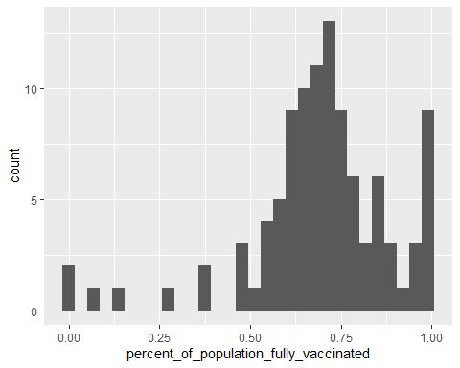

## Focus on UCSD/La Jolla

ucsd <- filter(sd, zip_code_tabulation_area=="92037")  
ucsd[1,]$age5_plus_population

## [1] 36144

Q15. Using ggplot make a graph of the vaccination rate time course for the 92037 ZIP code area:

ggplot(ucsd) +  
 aes(as_of_date, percent_of_population_fully_vaccinated) +  
 geom_point() +  
 geom_line(group=1) +  
 ylim(c(0,1)) +  
 labs(x="Date", y="Percent Vaccinated")

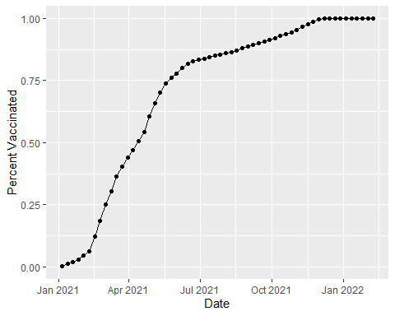

## Comparing 92037 to Other SImilarly Sized Areas

# Subset to all CA areas with a population as large as 92037  
vax.36 <- filter(vax, age5_plus_population > 36144 &  
 as_of_date == "2021-11-16")  
  
head(vax.36)

## as_of_date zip_code_tabulation_area local_health_jurisdiction county  
## 1 2021-11-16 93063 Ventura Ventura  
## 2 2021-11-16 92591 Riverside Riverside  
## 3 2021-11-16 91745 Los Angeles Los Angeles  
## 4 2021-11-16 93311 Kern Kern  
## 5 2021-11-16 95240 San Joaquin San Joaquin  
## 6 2021-11-16 92505 Riverside Riverside  
## vaccine_equity_metric_quartile vem_source  
## 1 4 Healthy Places Index Score  
## 2 3 Healthy Places Index Score  
## 3 3 Healthy Places Index Score  
## 4 3 Healthy Places Index Score  
## 5 1 Healthy Places Index Score  
## 6 2 Healthy Places Index Score  
## age12_plus_population age5_plus_population persons_fully_vaccinated  
## 1 49342.3 53192 35688  
## 2 34147.8 38439 21584  
## 3 48344.2 52318 39646  
## 4 37656.8 42439 30104  
## 5 39228.8 44646 24225  
## 6 44919.3 50178 27181  
## persons_partially_vaccinated percent_of_population_fully_vaccinated  
## 1 2933 0.670928  
## 2 2516 0.561513  
## 3 3265 0.757789  
## 4 3286 0.709348  
## 5 4228 0.542602  
## 6 2947 0.541692  
## percent_of_population_partially_vaccinated  
## 1 0.055140  
## 2 0.065454  
## 3 0.062407  
## 4 0.077429  
## 5 0.094701  
## 6 0.058731  
## percent_of_population_with_1_plus_dose booster_recip_count redacted  
## 1 0.726068 7001 No  
## 2 0.626967 3487 No  
## 3 0.820196 8195 No  
## 4 0.786777 5635 No  
## 5 0.637303 3069 No  
## 6 0.600423 3271 No

Q16. Calculate the mean “Percent of Population Fully Vaccinated” for ZIP code areas with a population as large as 92037 (La Jolla) as_of_date “2021-11-16”. Add this as a straight horizontal line to your plot from above with the geom_hline() function?

mean(vax.36$percent_of_population_fully_vaccinated, na.rm = TRUE)

## [1] 0.6716873

ggplot(ucsd) +  
 aes(as_of_date, percent_of_population_fully_vaccinated) +   
 geom_hline(yintercept = 0.6716873, linetype = "dashed", color = "red") +  
 geom_point() +  
 geom_line(group=1) +  
 ylim(c(0,1)) +  
 labs(x="Date", y="Percent Vaccinated")

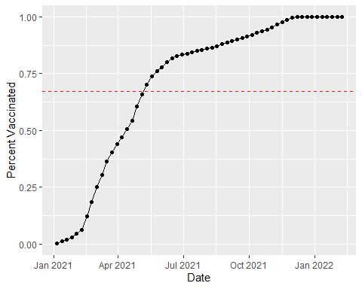

Q17. What is the 6 number summary (Min, 1st Qu., Median, Mean, 3rd Qu., and Max) of the “Percent of Population Fully Vaccinated” values for ZIP code areas with a population as large as 92037 (La Jolla) as_of_date “2021-11-16”?

summary(vax.36$percent_of_population_fully_vaccinated)

## Min. 1st Qu. Median Mean 3rd Qu. Max.   
## 0.3675 0.5992 0.6738 0.6717 0.7408 1.0000

Q18. Using ggplot generate a histogram of this data.

ggplot(vax.36) +  
 aes(x = percent_of_population_fully_vaccinated) +  
 geom_histogram()

## `stat_bin()` using `bins = 30`. Pick better value with `binwidth`.

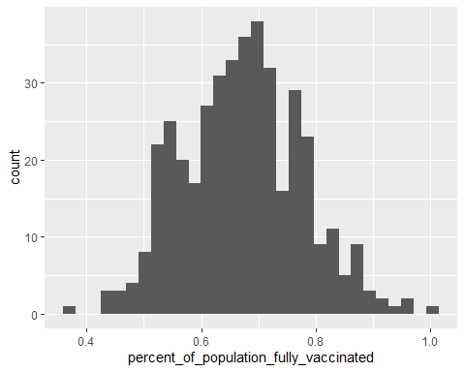

Q19. Is the 92109 and 92040 ZIP code areas above or below the average value you calculated for all these above?

vax %>% filter(as_of_date == "2021-11-16") %>%   
 filter(zip_code_tabulation_area=="92109") %>%  
 select(percent_of_population_fully_vaccinated)

## percent_of_population_fully_vaccinated  
## 1 0.717349

vax %>% filter(as_of_date == "2021-11-16") %>%   
 filter(zip_code_tabulation_area=="92040") %>%  
 select(percent_of_population_fully_vaccinated)

## percent_of_population_fully_vaccinated  
## 1 0.535312

92109 is above the average while 92040 is below the average.

Q20. Finally make a time course plot of vaccination progress for all areas in the full dataset with a age5_plus_population > 36144

vax.36.all <- filter(vax, age5_plus_population > 36144)  
  
mean(vax.36.all$percent_of_population_fully_vaccinated, na.rm = TRUE)

## [1] 0.472364

ggplot(vax.36.all) +  
 aes(as_of_date,  
 percent_of_population_fully_vaccinated,   
 group=zip_code_tabulation_area) +  
 geom_line(alpha=0.2, color="blue") +  
 ylim(0,1) +  
 labs(x="Date", y="Percent Vaccinated",  
 title="Vaccination Rate Across California",  
 subtitle="Only areas with a population above 36k are shown") +  
 geom_hline(yintercept = 0.472364, linetype="dashed")

## Warning: Removed 174 row(s) containing missing values (geom_path).

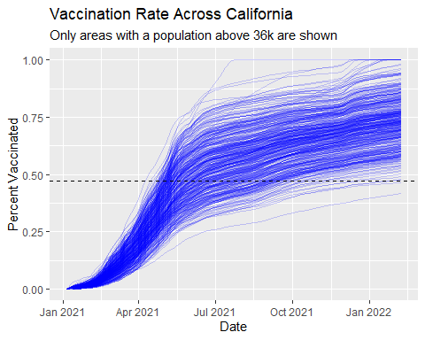

Q21. How do you feel about traveling for Thanksgiving and meeting for in-person class next Week?

I feel a bit uncomfortable going to in person classes, but am okay with going if necessary.

sessionInfo()

## R version 4.1.2 (2021-11-01)  
## Platform: x86_64-w64-mingw32/x64 (64-bit)  
## Running under: Windows 10 x64 (build 19043)  
##   
## Matrix products: default  
##   
## locale:  
## [1] LC_COLLATE=English_United States.1252   
## [2] LC_CTYPE=English_United States.1252   
## [3] LC_MONETARY=English_United States.1252  
## [4] LC_NUMERIC=C   
## [5] LC_TIME=English_United States.1252   
##   
## attached base packages:  
## [1] stats graphics grDevices utils datasets methods base   
##   
## other attached packages:  
## [1] ggplot2_3.3.5 dplyr_1.0.7 zipcodeR_0.3.3 lubridate_1.8.0  
## [5] skimr_2.1.3   
##   
## loaded via a namespace (and not attached):  
## [1] httr_1.4.2 tidyr_1.2.0 bit64_4.0.5 jsonlite_1.7.3   
## [5] assertthat_0.2.1 sp_1.4-6 highr_0.9 blob_1.2.2   
## [9] yaml_2.2.1 tidycensus_1.1 pillar_1.7.0 RSQLite_2.2.9   
## [13] lattice_0.20-45 glue_1.6.0 uuid_1.0-3 digest_0.6.27   
## [17] rvest_1.0.2 colorspace_2.0-2 htmltools_0.5.1.1 pkgconfig_2.0.3   
## [21] raster_3.5-15 purrr_0.3.4 scales_1.1.1 terra_1.5-17   
## [25] tzdb_0.2.0 tigris_1.5.1 tibble_3.1.6 proxy_0.4-26   
## [29] farver_2.1.0 generics_0.1.2 ellipsis_0.3.2 withr_2.4.3   
## [33] cachem_1.0.6 repr_1.1.4 cli_3.1.1 magrittr_2.0.1   
## [37] crayon_1.4.2 memoise_2.0.1 maptools_1.1-2 evaluate_0.14   
## [41] fansi_1.0.2 xml2_1.3.3 foreign_0.8-82 class_7.3-20   
## [45] tools_4.1.2 hms_1.1.1 lifecycle_1.0.1 stringr_1.4.0   
## [49] munsell_0.5.0 compiler_4.1.2 e1071_1.7-9 rlang_0.4.11   
## [53] classInt_0.4-3 units_0.8-0 grid_4.1.2 rstudioapi_0.13   
## [57] rappdirs_0.3.3 labeling_0.4.2 base64enc_0.1-3 rmarkdown_2.11   
## [61] gtable_0.3.0 codetools_0.2-18 DBI_1.1.2 curl_4.3.2   
## [65] R6_2.5.1 knitr_1.37 rgdal_1.5-28 fastmap_1.1.0   
## [69] bit_4.0.4 utf8_1.2.2 KernSmooth_2.23-20 readr_2.1.2   
## [73] stringi_1.7.6 Rcpp_1.0.8 vctrs_0.3.8 sf_1.0-6   
## [77] tidyselect_1.1.1 xfun_0.29