Class 5 Data Visualization Lab

Cindy Tran (A15830581)

Winter 2022

# Week 4 Data Visualization Lab  
  
# Install the package ggplot2  
#install.packages("ggplot2")  
  
# Any time I want to use this package, I need to load it  
library(ggplot2)  
  
View(cars)  
  
# A quick baseR plot - this is not ggplot  
plot(cars)

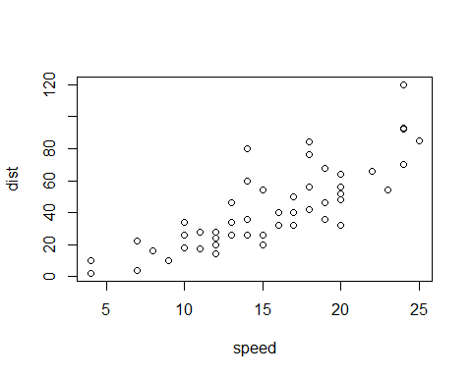

# Our first ggplot  
#We need data + aes + geom  
ggplot(data = cars) +  
 aes(x = speed, y = dist) +  
 geom_point()

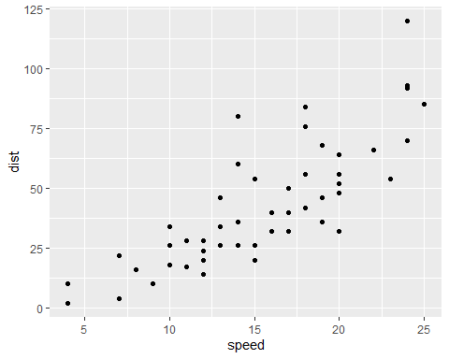

p <- ggplot(data = cars) +  
 aes(x = speed, y = dist) +  
 geom_point()   
  
# Add a line geom with geom_line()  
p + geom_line()

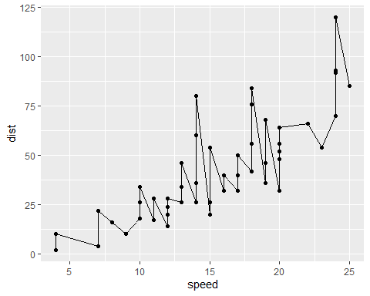

# Add a trend line close to the data  
  
p + geom_smooth()

## `geom_smooth()` using method = 'loess' and formula 'y ~ x'

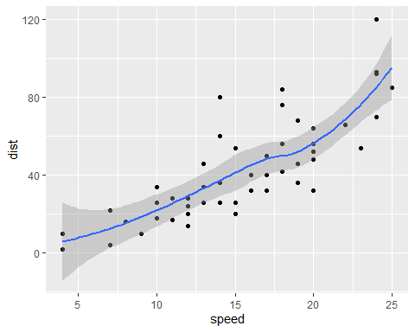

p + geom_smooth(method = "lm")

## `geom_smooth()` using formula 'y ~ x'

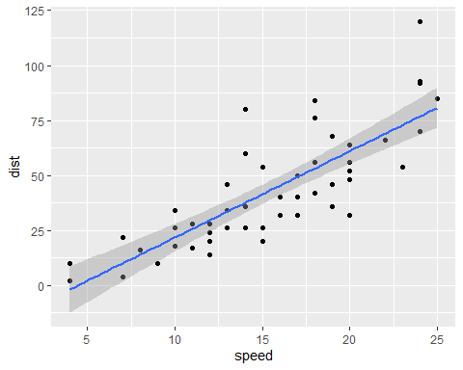

# Adding labels  
p + geom_smooth(method = "lm", se = FALSE) +  
 labs(title = "Speed and Stopping Distances of Cars",  
 x = "Speed (MPH)",  
 y = "Stopping Distance (ft)",  
 subtitle = "Your informative subtitle text here",  
 caption = "Dataset: 'cars'") +   
 theme_bw()

## `geom_smooth()` using formula 'y ~ x'

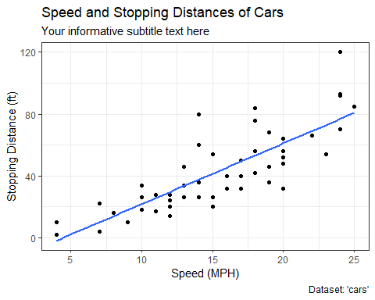

##  
  
#Read in drug expression data  
  
url <- "https://bioboot.github.io/bimm143_S20/class-material/up_down_expression.txt"  
  
genes <- read.delim(url)  
head(genes)

## Gene Condition1 Condition2 State  
## 1 A4GNT -3.6808610 -3.4401355 unchanging  
## 2 AAAS 4.5479580 4.3864126 unchanging  
## 3 AASDH 3.7190695 3.4787276 unchanging  
## 4 AATF 5.0784720 5.0151916 unchanging  
## 5 AATK 0.4711421 0.5598642 unchanging  
## 6 AB015752.4 -3.6808610 -3.5921390 unchanging

# How many genes  
nrow(genes)

## [1] 5196

# Column names and number of columns  
colnames(genes)

## [1] "Gene" "Condition1" "Condition2" "State"

ncol(genes)

## [1] 4

#How many upreglated genes  
table(genes$State)

##   
## down unchanging up   
## 72 4997 127

#Fraction of genes up-regulated  
round ( (table(genes$State) / nrow(genes)) * 100, 2)

##   
## down unchanging up   
## 1.39 96.17 2.44

# Let's make a first plot attempt  
ggplot(data = genes) +   
 aes(x = Condition1, y = Condition2, col = State) +   
 geom_point()

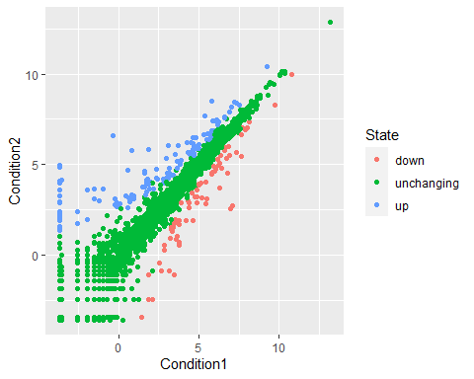

#Change colors  
ggplot(data = genes) +  
 aes(x = Condition1, y = Condition2, col = State) +  
 geom_point() +  
 scale_color_manual(values = c("blue", "gray", "red")) +  
 labs(title = "Gene Expression Changes Upon Drug Treatment",  
 x = "Control (no drug)",  
 y = "Drug Treatment") +  
 theme_bw()

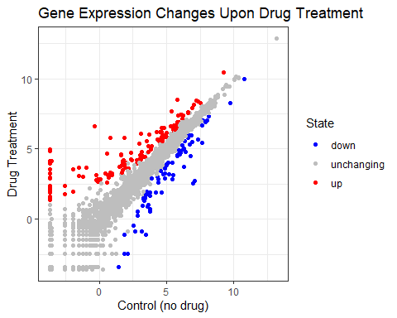

##  
  
#Optional Part 6  
  
#install.packages("gapminder")  
library(gapminder)  
  
# File location online  
url2 <- "https://raw.githubusercontent.com/jennybc/gapminder/master/inst/extdata/gapminder.tsv"  
gapminder <- read.delim(url2)  
  
#install.packages(dplyr)  
library(dplyr)

##   
## Attaching package: 'dplyr'

## The following objects are masked from 'package:stats':  
##   
## filter, lag

## The following objects are masked from 'package:base':  
##   
## intersect, setdiff, setequal, union

gapminder_2007 <- gapminder %>%  
 filter(year == 2007)  
  
ggplot(gapminder_2007) +  
 aes(x = gdpPercap, y = lifeExp, color = continent, size = pop) +  
 geom_point(alpha = 0.5)

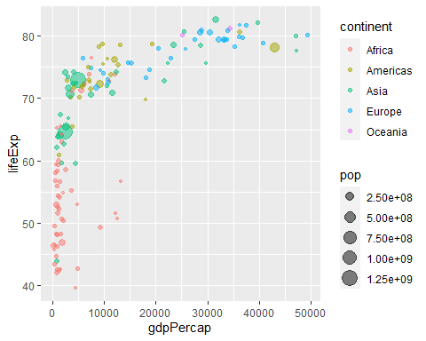

# Color by pop  
ggplot(gapminder_2007) +   
 aes(x = gdpPercap, y = lifeExp,  
 size = pop) +  
 geom_point(alpha = 0.5)

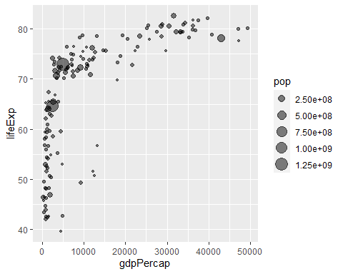

#Scale to reflect actual population differences  
ggplot(gapminder_2007) +   
 geom_point(aes(x = gdpPercap, y = lifeExp,  
 size = pop),  
 alpha = 0.5) +  
 scale_size_area(max_size = 10)

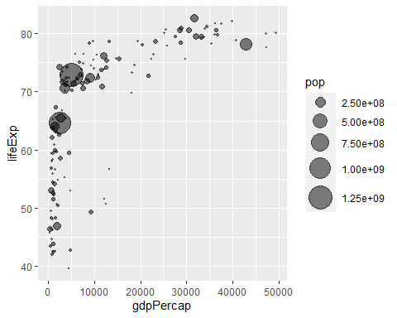

#1957 Plot  
gapminder_1957 <- gapminder %>%   
 filter(year == 1957)  
  
ggplot(gapminder_1957) +  
 aes(x = gdpPercap, y = lifeExp,  
 color = continent,  
 size = pop) +  
 geom_point(alpha = 0.7)

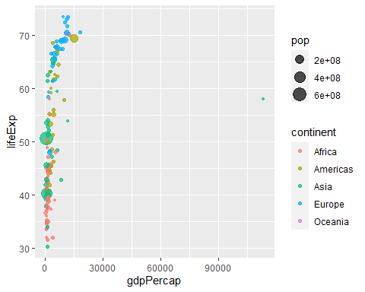

scale_size_area(max_size = 10)

## <ScaleContinuous>  
## Range:   
## Limits: 0 -- 1

#Combine 1957 and 2007  
gapminder_combined <- gapminder %>%  
 filter(year == 1957 | year == 2007)  
  
ggplot(gapminder_combined) +   
 geom_point(aes(x = gdpPercap, y = lifeExp,  
 color=continent,  
 size = pop), alpha=0.7) +  
 scale_size_area(max_size = 10) +  
 facet_wrap(~year)

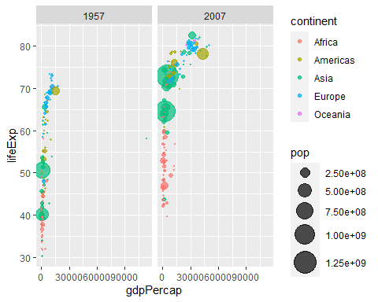

##  
  
#Optional Part 7  
  
gapminder_top5 <- gapminder %>%   
 filter(year == 2007) %>%   
 arrange(desc(pop)) %>%   
 top_n(5, pop)  
gapminder_top5

## country continent year lifeExp pop gdpPercap  
## 1 China Asia 2007 72.961 1318683096 4959.115  
## 2 India Asia 2007 64.698 1110396331 2452.210  
## 3 United States Americas 2007 78.242 301139947 42951.653  
## 4 Indonesia Asia 2007 70.650 223547000 3540.652  
## 5 Brazil Americas 2007 72.390 190010647 9065.801

#Creating a bar chart  
ggplot(gapminder_top5) +  
 geom_col(aes(x = country, y = pop))

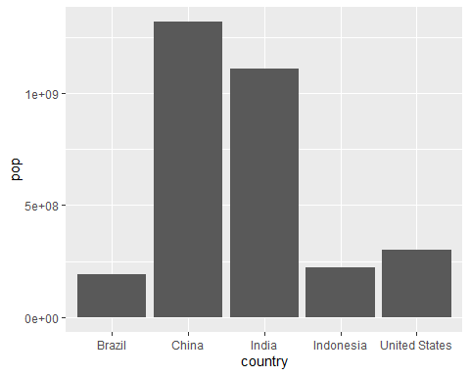

ggplot(gapminder_top5) +  
 geom_col(aes(x = country, y = lifeExp))

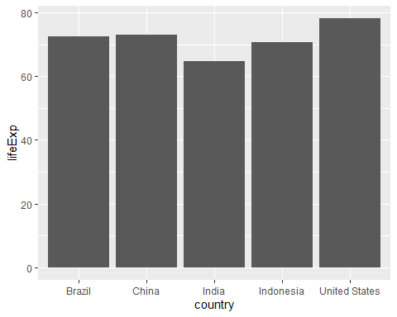

#Filling bars with color  
ggplot(gapminder_top5) +   
 geom_col(aes(x = country, y = pop, fill = continent))

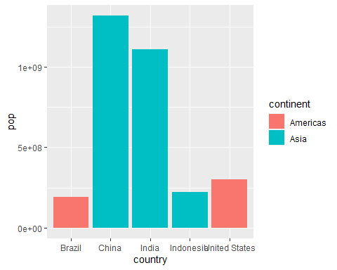

ggplot(gapminder_top5) +   
 geom_col(aes(x = country, y = pop, fill = lifeExp))

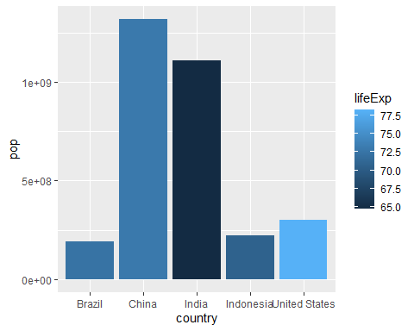

#Population size by country  
ggplot(gapminder_top5) +  
 aes(x = country, y = pop, fill = gdpPercap) +  
 geom_col()

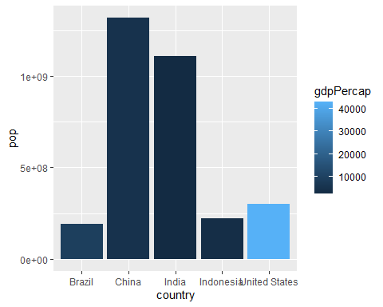

#Change order of bars  
ggplot(gapminder_top5) +  
 aes(x = reorder(country, -pop), y=pop,  
 fill = gdpPercap) +  
 geom_col()

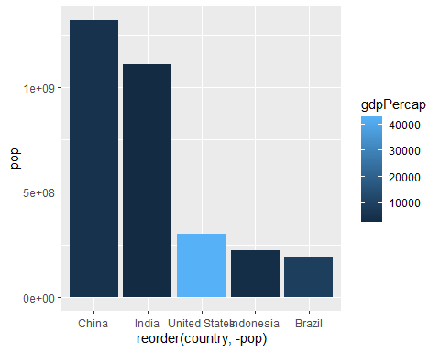

ggplot(gapminder_top5) +  
 aes(x = reorder(country, -pop), y = pop,  
 fill = country) +  
 geom_col(col = "gray30") +  
 guides(fill = FALSE)

## Warning: `guides(<scale> = FALSE)` is deprecated. Please use `guides(<scale> =  
## "none")` instead.

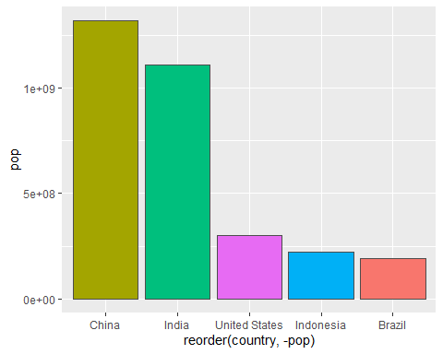

#Flipping bar charts  
head(USArrests)

## Murder Assault UrbanPop Rape  
## Alabama 13.2 236 58 21.2  
## Alaska 10.0 263 48 44.5  
## Arizona 8.1 294 80 31.0  
## Arkansas 8.8 190 50 19.5  
## California 9.0 276 91 40.6  
## Colorado 7.9 204 78 38.7

USArrests$State <- rownames(USArrests)  
  
ggplot(USArrests) +  
 aes(x = reorder(State, Murder), y = Murder) +  
 geom_col() +  
 coord_flip()

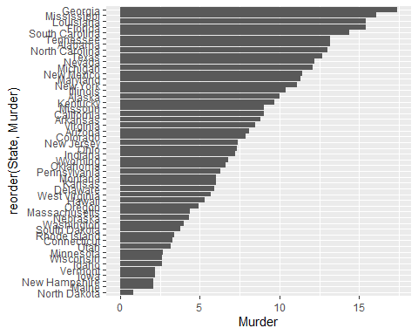

ggplot(USArrests) +  
 aes(x = reorder(State, Murder), y = Murder) +  
 geom_point() +  
 geom_segment(aes(x=State,   
 xend=State,   
 y=0,   
 yend=Murder),  
 color = "blue") +  
 coord_flip()

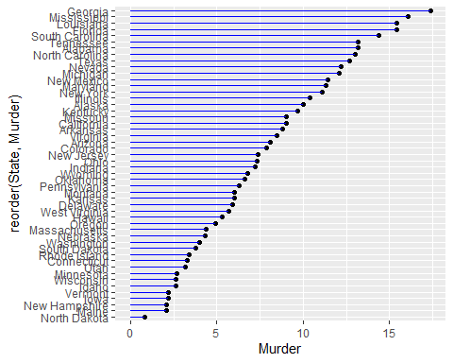

##  
  
#Optional Part 8  
  
#install.packages("gifski")  
#install.packages("gganimate")  
  
library(gapminder)  
library(gganimate)  
  
# Setup nice regular ggplot of the gapminder data  
ggplot(gapminder, aes(gdpPercap, lifeExp, size = pop, colour = country)) +  
 geom_point(alpha = 0.7, show.legend = FALSE) +  
 scale_colour_manual(values = country_colors) +  
 scale_size(range = c(2, 12)) +  
 scale_x_log10() +  
 # Facet by continent  
 facet_wrap(~continent) +  
 # Here comes the gganimate specific bits  
 labs(title = 'Year: {frame_time}', x = 'GDP per capita', y = 'life expectancy') +  
 transition_time(year) +  
 shadow_wake(wake_length = 0.1, alpha = FALSE)



##  
  
#Optional Part 9  
  
#Combining Plots  
  
#install.packages("patchwork")  
library(patchwork)  
  
# Setup some example plots   
p1 <- ggplot(mtcars) + geom_point(aes(mpg, disp))  
p2 <- ggplot(mtcars) + geom_boxplot(aes(gear, disp, group = gear))  
p3 <- ggplot(mtcars) + geom_smooth(aes(disp, qsec))  
p4 <- ggplot(mtcars) + geom_bar(aes(carb))  
  
# Use patchwork to combine them here:  
(p1 | p2 | p3) /   
 p4

## `geom_smooth()` using method = 'loess' and formula 'y ~ x'

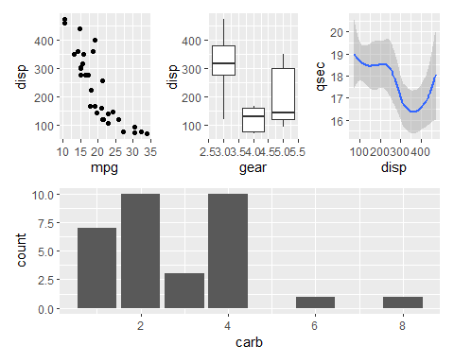

sessionInfo()

## R version 4.1.2 (2021-11-01)  
## Platform: x86_64-w64-mingw32/x64 (64-bit)  
## Running under: Windows 10 x64 (build 19043)  
##   
## Matrix products: default  
##   
## locale:  
## [1] LC_COLLATE=English_United States.1252   
## [2] LC_CTYPE=English_United States.1252   
## [3] LC_MONETARY=English_United States.1252  
## [4] LC_NUMERIC=C   
## [5] LC_TIME=English_United States.1252   
##   
## attached base packages:  
## [1] stats graphics grDevices utils datasets methods base   
##   
## other attached packages:  
## [1] patchwork_1.1.1 gganimate_1.0.7 dplyr_1.0.7 gapminder_0.3.0  
## [5] ggplot2_3.3.5   
##   
## loaded via a namespace (and not attached):  
## [1] Rcpp_1.0.8 plyr_1.8.6 pillar_1.6.4 compiler_4.1.2   
## [5] highr_0.9 prettyunits_1.1.1 progress_1.2.2 tools_4.1.2   
## [9] digest_0.6.27 lattice_0.20-45 nlme_3.1-155 evaluate_0.14   
## [13] lifecycle_1.0.1 tibble_3.1.6 gtable_0.3.0 mgcv_1.8-38   
## [17] pkgconfig_2.0.3 rlang_0.4.11 Matrix_1.4-0 DBI_1.1.2   
## [21] yaml_2.2.1 xfun_0.29 withr_2.4.3 stringr_1.4.0   
## [25] knitr_1.37 hms_1.1.1 generics_0.1.1 vctrs_0.3.8   
## [29] grid_4.1.2 tidyselect_1.1.1 glue_1.6.0 R6_2.5.1   
## [33] gifski_1.4.3-1 fansi_0.5.0 rmarkdown_2.11 tweenr_1.0.2   
## [37] purrr_0.3.4 farver_2.1.0 magrittr_2.0.1 splines_4.1.2   
## [41] scales_1.1.1 ellipsis_0.3.2 htmltools_0.5.1.1 assertthat_0.2.1   
## [45] colorspace_2.0-2 labeling_0.4.2 utf8_1.2.2 stringi_1.7.6   
## [49] munsell_0.5.0 crayon_1.4.2