# CPSC 411 Spring 2020

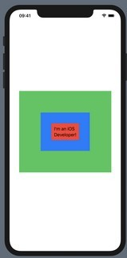Code section: SwiftUI

1. **In SwiftUI, write the code that would show the view to the right when running.**

struct ContentView: View {

var body: some View {

Text("I’m an iOS Developer!")

.padding()

.background(Color.red)

.padding()

.background(Color.blue)

.padding()

.background(Color.green)

.padding()

}

}

1. 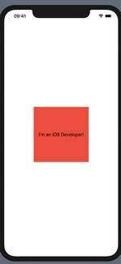**In SwiftUI, write the code that would show the view to the right when running (“Live long and prosper” is written in the center)**

struct ContentView: View {

var body: some View {

Button("Live long and prosper!") {

print(type(of: self.body))

}

.background(Color.red)

.frame(width: 200, height: 200)

}

}

1. **In SwiftUI, write the code to show a form with “Hello, world” shown twice, and with with a Navigation bar with the text “SwiftUI” shown in its title.**

var body: some View {

NavigationView {

Form {

Section {

Text("Hello World")

Text("Hello World")

}

}

.navigationBarTitle("SwiftUI")

}

}

1. **Write the SwiftUI code to have a button that shows its tapCount when tapped on.**

struct **ContentView: View {**

**@State** var **tapCount = 0**

var **body: some View {**

**Button("Tap Count: \(tapCount)") {**

self**.tapCount += 1**

**}**

**}**

**}**

CS-411: MIDTERM-Code --- SwiftUI page 1 of 1